9.a) Write shell script that takes a login name as command – line argument and reports when that person logs in.

SHELL SCRIPT:

[root@linux ~]$ vi whouser.sh

echo "who are you"

read user

echo $user

name=$(whoami)

if [ $user == $name ]

then

top -u $user

else

echo "not logged in"

fi

:wq

Output:

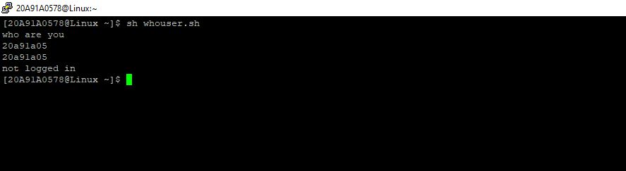

9.b) Write a shell script which receives two file names as arguments. It should check whether the two file contents are same or not. If they are same then second file should be deleted.

Shell script:

[root@Linux ~]$ vi samefilnot.sh

echo "enter file1"

read file1

echo "enter file2"

read file2

`cmp $file1 $file2 >equal`

if [ ! -s equal ]

then

echo same

rm $file2

echo "$file2 is removed"

else

echo differnt

fi

output:

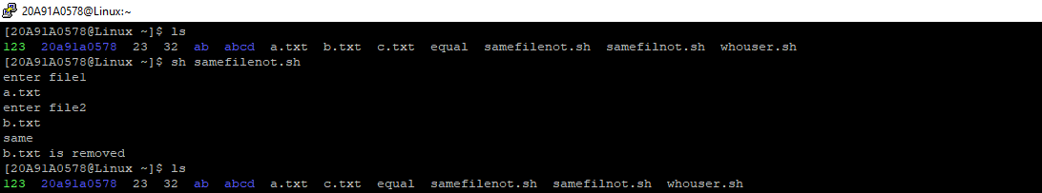

10. Write a C program that takes one or more file or directory names as a command line input and reports the following information on the file: i) File type. ii) Number of links. iii) Read, write and execute permissions. iv) Time of last access (Note : Use stat/fstat systemcalls)

Code:

#include<stdio.h>

#include<unistd.h>

#include<sys/stat.h>

#include<sys/types.h>

#include<fcntl.h>

void main()

{

int fd;

struct stat buf;

fd=open("f5.txt",O_RDONLY|O_CREAT,600);

if(fd!=-1)

{

if(fstat(fd,&buf)==0)

{

printf("mode of file is %u",buf.st_mode);

printf("\n size of the file is %u",buf.st_size);

printf("\n device name is %u",buf.st_dev);

printf("\n inode of file is %u",buf.st_ino);

printf("\n no of links are %u",buf.st_nlink);

printf("\n owner of the file is %u",buf.st_uid);

printf("\n no of blocks is %u",buf.st_blocks);

printf("\n group owner is %u",buf.st_gid);

printf("\n block size of file is %u",buf.st_blksize);

printf("\n time of last modified is %u",buf.st_ctime);

}

else

printf("error in fstat() systemcall");

}

else

printf("error in open() systemcall");

}

Output:

