**5.1) Write a Java program to sort given set of strings.**

**PROGRAM:**

import java.util.*;

class Strsort

{

public static void main(String args[])

{

Scanner s=new Scanner(System.in);

int i,n,j;

String t;

System.out.println("enter no of strings to sort");

n=s.nextInt();

String a[]=new String[n];

System.out.println("enter the strings to sort");

for(i=0;i<n;i++)

a[i]=s.next();

for(i=0;i<n-1;i++)

{

for(j=0;j<n-i-1;j++)

{

if(a[j].compareTo(a[j+1])>0)

{

t=a[j];

a[j]=a[j+1];

a[j+1]=t;

}

}

}

System.out.println("STRINGS AFTER SORTING:");

for(i=0;i<n;i++)

System.out.println(a[i]);

}

}

**OUTPUT:-**

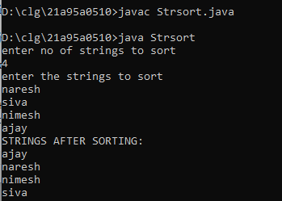

**5.2) Write a Java program for using String Buffer to remove or delete a character**

**PROGRAM:**

import java.util.*;

class Strbuf

{

public static void main(String ar[])

{

StringBuffer s=new StringBuffer("WELCOME to JAVA");

System.out.println("GIVEN STRING : "+s);

s.delete(1,5);

System.out.println("AFTER DELETING CHARACTERS IN STRING FROM INDEX 1-5 : "+s);

s.deleteCharAt(4);

System.out.println("AFTER DELETING CHARACTER AT INDEX 4 : "+s);

}

}

**OUTPUT:-**

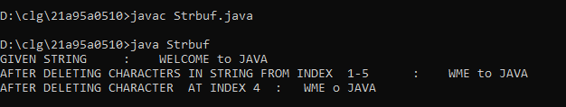

**6.1) Write a Java program to implement Single Inheritance**

**PROGRAM:**

import java.util.*;

class Person

{

Scanner s=new Scanner(System.in);

int age;

String name,gender;

Person()

{

System.out.println("Enter Name\nAge\nGender");

name=s.nextLine();

age=s.nextInt();

gender=s.next();

}

void show()

{

System.out.println("\n DETAILS OF EMPLOYEE:\n");

System.out.println("NAME:"+name+"\nAGE:"+age);

System.out.println("GENDER:"+gender);

}

}

class Employee extends Person

{

int eid;

float salary;

String dep;

Employee()

{

System.out.println("Enter EId\n Salary\n Department");

eid=s.nextInt();

salary=s.nextFloat();

dep=s.nextLine();

}

void showe()

{

show();

System.out.println("EID:"+eid+"\nSalary:"+salary+"\nDEPARTMENT:"+dep);

}

public static void main(String args[])

{

Employee e=new Employee();

e.showe();

}

}

**OUTPUT:-**

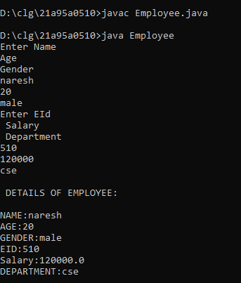

**6.2) Write a Java program to implement multi level Inheritance**

**PROGRAM:**

import java.util.*;

class Student

{

Scanner s=new Scanner(System.in);

int pin;

String name;

Student()

{

System.out.println("Enter name and pinno");

name=s.nextLine();

pin=s.nextInt();

}

void shows()

{

System.out.println("NAME:"+name+"\nPINNO:"+pin);

}

}

class Marks extends Student

{

int n,sum=0;

Marks(){

System.out.println("Enter number of subjects:");

n=s.nextInt();

int a[]=new int[n];

System.out.println("enter subject marks");

for(int i=0;i<n;i++)

{

a[i]=s.nextInt();

sum+=a[i];

}

}

}

class Percentage extends Marks

{

float p;

void percent()

{

p=(float)sum/(n*100);

System.out.println("\n\n\nDETAILS OF STUDENT\n\n\n");

shows();

System.out.println("PERCENTAGE : :"+p*100);

}

public static void main(String args[])

{

Percentage l=new Percentage();

l.percent();

}

}

**OUTPUT:-**

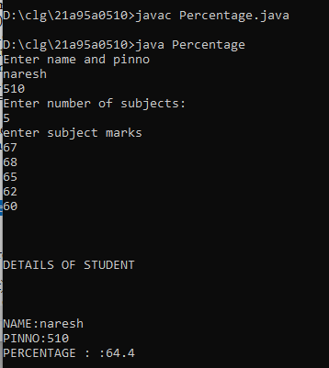

**6.3) Write a Java program to find the areas of different shapes using abstract classes.**

**PROGRAM:**abstract class Shapes

{

abstract void area(float l,float b);

}

class Triangle extends Shapes

{

void area(float l,float b)

{

System.out.println("\nAREA OF TRIANGLE::"+((l*b)/2));

}

}

class Rectangle extends Shapes

{

void area(float l,float b)

{

System.out.println("\nAREA OF RECTANGLE::"+(l*b));

}

}

class Rhombus extends Shapes

{

void area(float l,float b)

{

System.out.println("\nAREA OF RHOMBUS::"+((l*b)/2));

}

}

class Demoabst

{

public static void main(String args[])

{

Triangle t=new Triangle();

Rectangle r=new Rectangle();

Rhombus y=new Rhombus();

t.area(8,9);

r.area(5.6f,8);

y.area(28,47);

}

}

**OUTPUT:-**

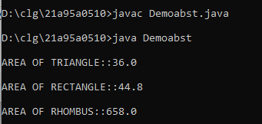

**7.1) Write a Java program for “super” keyword.**

**PROGRAM:**

import java.util.*;

class Person

{

Scanner s=new Scanner(System.in);

int age;

String name,gender;

Person()

{

System.out.println("Enter Name\nAge\nGender");

name=s.next();

age=s.nextInt();

gender=s.next();

}

void show()

{

System.out.println("\n DETAILS OF EMPLOYEE:\n");

System.out.println("NAME:"+name+"\nAGE:"+age);

System.out.println("GENDER:"+gender);

}

}

class Employees extends Person

{

int eid;

float salary;

String dep;

Employees()

{

System.out.println("Enter EId\n Salary\n Department");

eid=s.nextInt();

salary=s.nextFloat();

dep=s.nextLine();

}

void show()

{

super.show();//SUPER KEYWORD USED

System.out.println("EID:"+eid+"\nSalary:"+salary+"\nDEPARTMENT:"+dep);

}

public static void main(String args[])

{

Employees e=new Employees();

e.show();

}

}

**OUTPUT:-**

