8)Write an Interactive file-handling shell program. Let it offer the user the choice of copying, removing, renaming, or linking files. Once the user has made a choice, have the program ask the user for the necessary information, such as the file name, new name and so on.

AIM: To Write an Interactive file-handling shell program. Let it offer the user the choice of copying, removing, renaming, or linking files. Once the user has made a choice, have the program ask the user for the necessary information, such as the file name, new name and so on.

PROGRAM:

echo 1.copy echo 2.rename echo 3.remove echo 4.link echo 5.exit

echo "Enter Your Choice" read ch

case $ch in

1. echo "Enter Source File" read s

echo "Enter the Destination File" read d

cp $s $d

;;

1. echo "Enter Old File Name" read of

echo "Enter Neew File Name" read nf

mv $of $nf

;;

1. echo "Enter the Filename to delete" read df

rm $df

;;

1. echo "Enter File1" read f1

echo "Enter File2" read f2

ln $f1 $f2

;;

1. exit 0

;;

Esac

OUTPUT:

[20A91A0566@Linux ~]$ vi switch.sh [20A91A0566@Linux ~]$ sh switch.sh 1.copy

2.rename 3.remove 4.link 5.exit

Enter Your Choice 1

Enter Source File oldfile

Enter the Destination File newfile

[20A91A0566@Linux ~]$ cat newfile Hai

Hello

[20A91A0566@Linux ~]$ sh switch.sh 1.copy

2.rename 3.remove 4.link 5.exit

Enter Your Choice 3

Enter the Filename to delete oldfile

[20A91A0566@Linux ~]$ cat oldfile cat: oldfile : No such File or directory

9a)Write a Shell Script that takes a login name as command line Argument and reports when that person logs in

AIM: A Shell Script that takes a login name as command line Argument and reports when that person logs in

PROGRAM:

echo "Who are You?" read user

echo $user name=$(whoami) if [ $user==$name ] then

top -u $user else

echo "Not logged in" fi

OUTPUT:

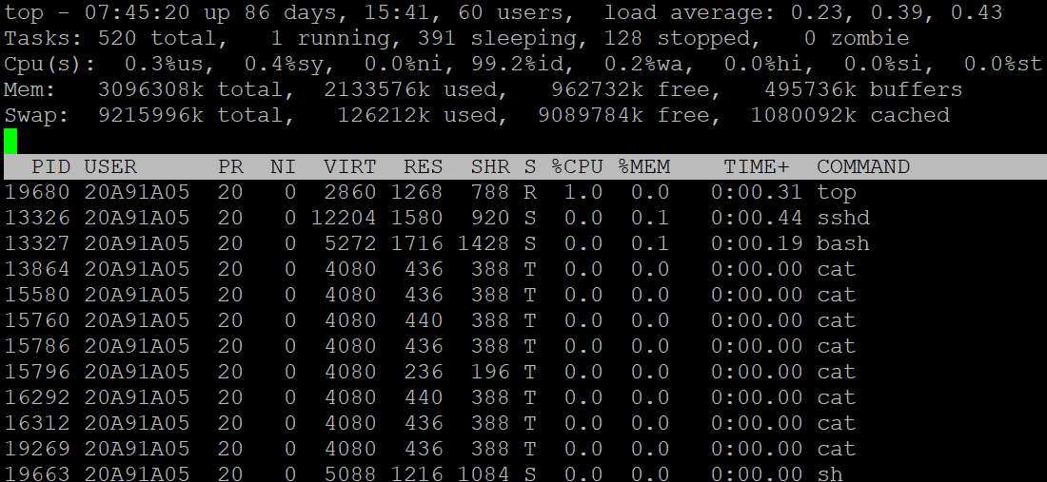

9b) Write a shell script which receives two file names as arguments. It should check whether the two file contents are same or not. If they are same then second file should be deleted

AIM: A shell script which receives two file names as arguments. It should check whether the two file contents are same or not. If they are same then second file should be deleted.

PROGRAM:

echo -n "Enter file1:" read file1

echo -n "Enter File2:" read file2

`cmp $file1 $file2>equal` if [ ! -s equal ]

then

echo Same rm $file2 else

echo Different fi

OUTPUT:

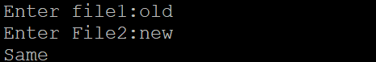

10) Write a C program that takes one or more file or directory names as a command line input and reports the following information on the file:

1. File type.
2. Number of links.
3. Read, write and execute permissions.
4. Time of last access (Note : Use stat/fstat system calls).

PROGRAM:

#include<stdio.h> #include<unistd.h> #include<sys/stat.h> #include<sys/types.h> #include<fcntl.h>

void main()

{

int fd;

struct stat buf; fd=open("hello.txt",O_RDONLY|O_CREAT,600); if(fd!=-1)

{

if(fstat(fd,&buf)==0)

{

printf("Mode of File is %u",buf.st_mode); printf("\nSize of the File is %u",buf.st_size); printf("\nDevice Name %u",buf.st_dev); printf("\ninode of File is %u",buf.st_ino); printf("\nNo of Links are %u",buf.st_nlink); printf("\nOwner of a File is %u",buf.st_uid); printf("\nNo of Blocks is %u",buf.st_blocks); printf("\nGroup Owner is %u",buf.st_gid); printf("\nBlock Size of the File is %u",buf.st_blksize);

printf("\nTime of Last Modified is %u",buf.st_ctime);

}

else

printf("Error in fstat() syscall");

}

else

printf("Error in open() syscall");

}

OUTPUT:

