**Shaik Heena Shifa (Student)**

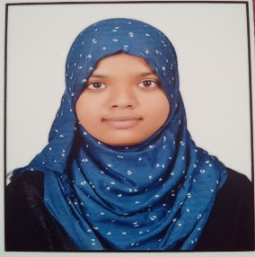

Email: shaikheenashifa@gmail.com Ph no: 8555869404

# Objective

I am a dedicated, organized and methodical individual. I have good interpersonal skills, Am an excellent team worker and am keen and very willing to learn and develop new skills. I am reliable and dependable and often seek new responsibilities within a wide range of employment areas. I have an active and dynamic approach to work and getting things done, determined and decisive. I identify and develop opportunities to get satisfy with complete knowledge of my interest.

# Education

* **Degree** – **Bachelor of Technology** from G. Pullaiah College of Engineering and technology, Kurnool – 7.84 CGPA (2022-Present)
* **Intermediate (MPC)** from Sri Chaitanya Junior College, Kurnool – 8.5 CGPA (2020)
* **Secondary (High School)** from Keshava Reddy School, Kurnool – 9.3 Marks (2018)

# Technical Proficiency

* Python
* Basics of SQL
* DBMS
* Computer Networks
* Web Development Languages like HTML, CSS
* C Programming
* PHP

# Certifications

* Python for Beginners (IBM)
* National E-VEDA event (2021) Poster Presentation Participation certificate
* C Programming (Solo learn)
* Python Programming (Solo learn)
* SQL (Hackerank)
* SQL (Solo learn)

# Skills

* Attentive Listening and Oral Communication Skills
* Great at Problem Solving
* Ability to quickly Create Ideas and Solutions
* Good Leadership Skills
* Good listener
* Collaboration
* Computer skills (coding)
* Management Skills
* Time Management

# Languages

* English
* Urdu
* Hindi
* Telugu

# Projects

* Weather station (IOT):

Weather station using different types of sensors that can predict surrounding environment and give appropriate data.

* Training and Placements (Web application):
  1. website which shows the data of registered and placed students in so and so company.

Place – Kurnool

Date – 21.09.2022