**Practical – 11**

Demonstrate following pre-processing operations in given sequence using Knowledge flow: -

1. Load weather numeric dataset.
2. Add Attribute name “rain” at index 1.
3. Discretize the attribute i.e., temperature & humidity.
4. Apply association rule applying “apriori” algorithm.
5. Use text viewer component to display the dataset.
6. Save the dataset as “.arff” files.

Solution:

1. (i) Open “Knowledge Flow” tab from WEKA main window.  
   (ii) Add “ArffLoader” in the Knowledge Flow environment.  
   (iii) Select the “weather.numeric.arff” data and Click “OK” button.  
   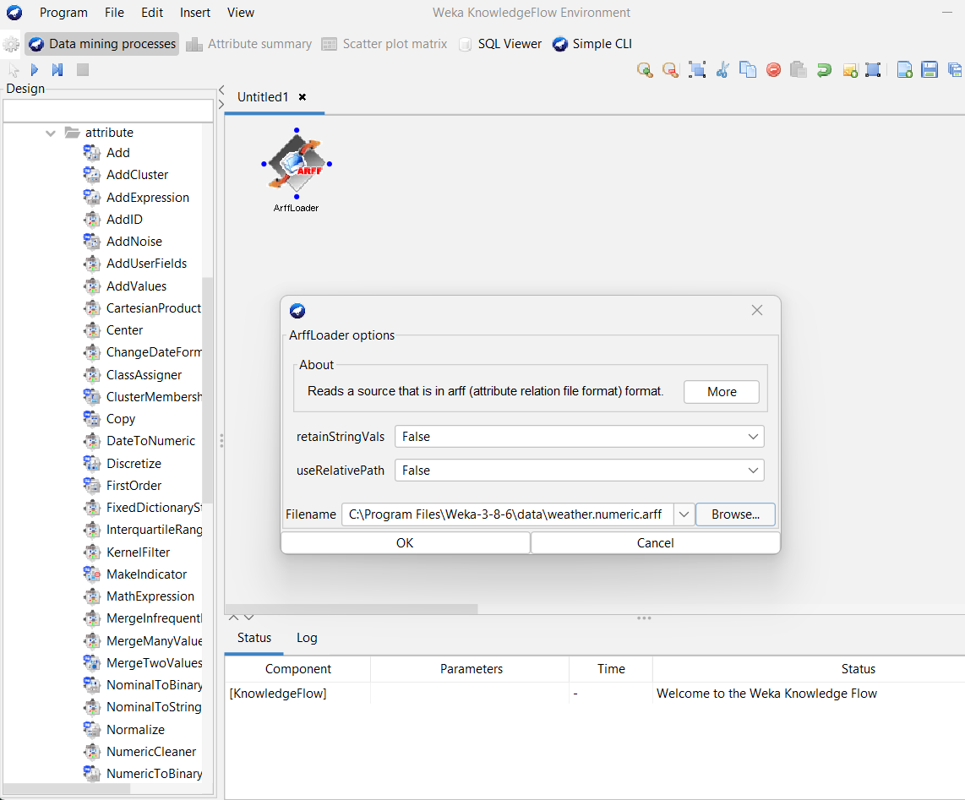
2. (i) Insert “Add” component from “Unsupervised” filters.  
   (ii) Set the index and the name of the index and the name of the attribute.  
   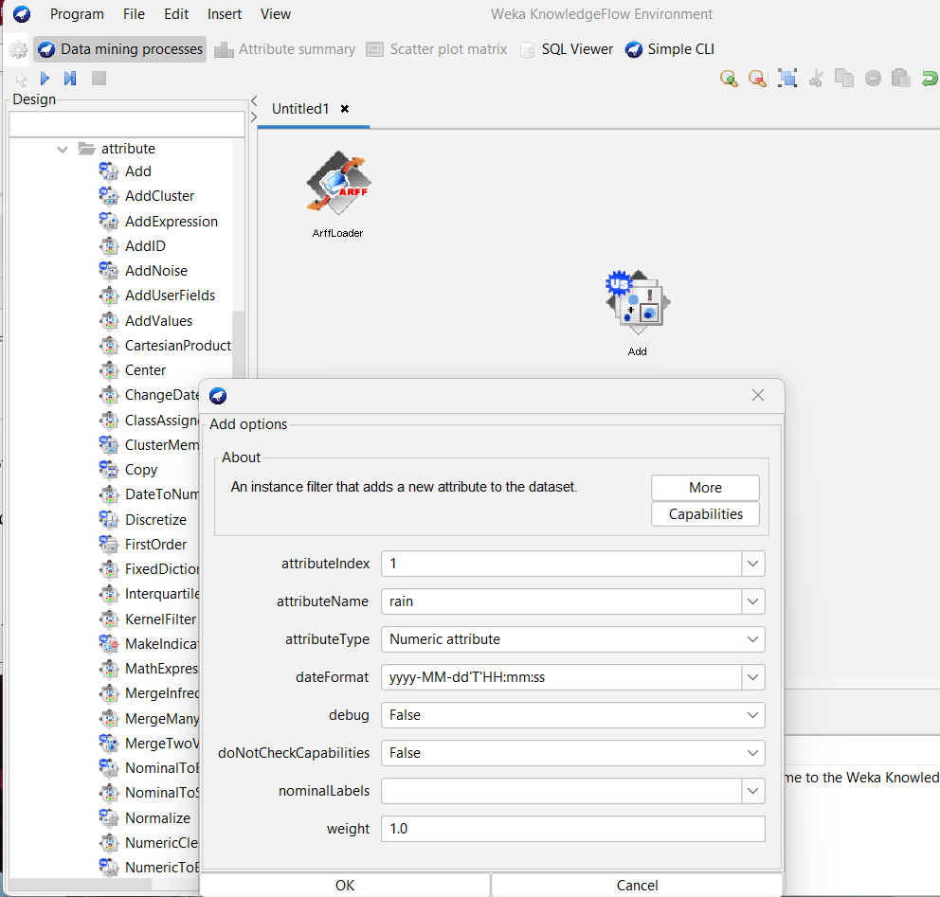
3. (i) Add “Discretize” filter from “Unsupervised” filters.  
   (ii) Type “2,3” values in attribute indices to discretize temperature and humidity attributes.  
   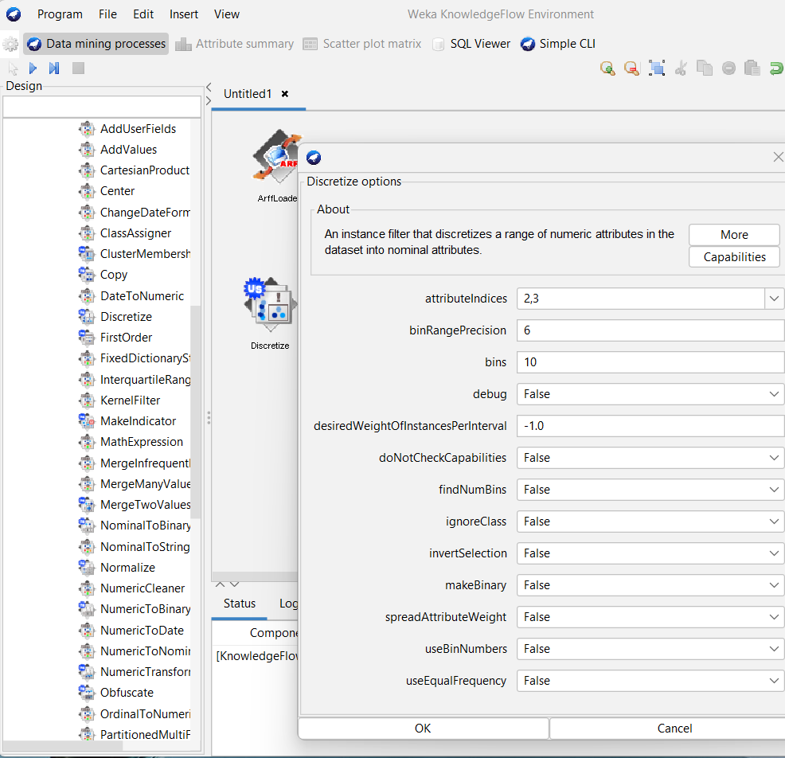
4. Add “Apriori” component from “Associations”.  
   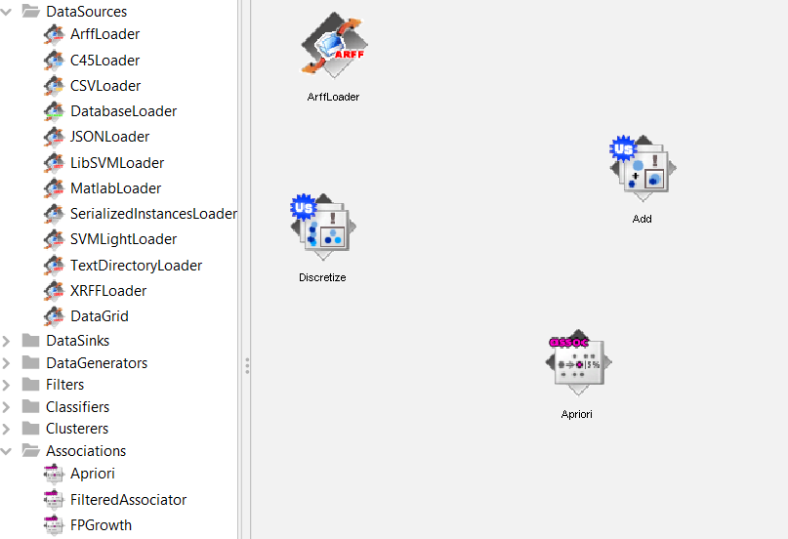
5. (i) Add “TextViewer” from “Visualization”.  
   (ii) Run the “Knowledge Flow” and see the results in “TextViewer” by clicking on “Show Results” option.
6. (i) Load the “ArffLoader” and specify the directory where we want to save and run the “Knowledge Flow”.  
   (ii) The “.arff” file will be saved.

**Practical – 12**

Following pre-processing in given sequence by using Unsupervised filters using Knowledge Flow:-

1. Load the “Diabetes.arff” dataset.
2. Introduce the 30% missing values in the dataset
3. Replace the missing values in the dataset using mean and mode.

Solution:

1. (i) Open “Knowledge Flow” tab from WEKA main window.  
   (ii) Add “ArffLoader” in the Knowledge Flow environment.  
   (iii) Select the Diabetes data and click “OK” button.  
   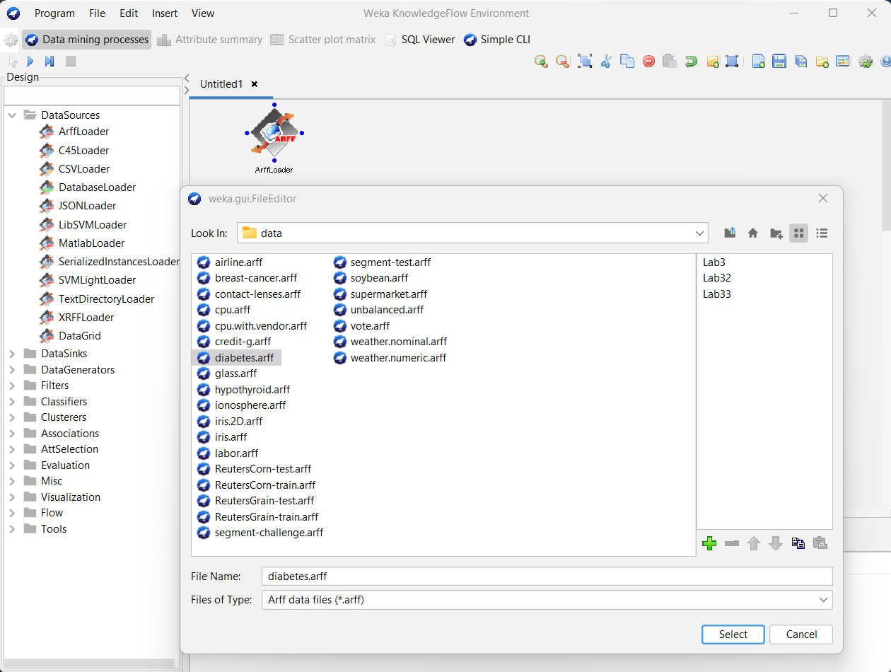
2. (i) Add “ReplaceWithMissingValue” filter from “Unsupervised” filters.  
   (ii) And, type “0.3” in probability i.e. 30%  
   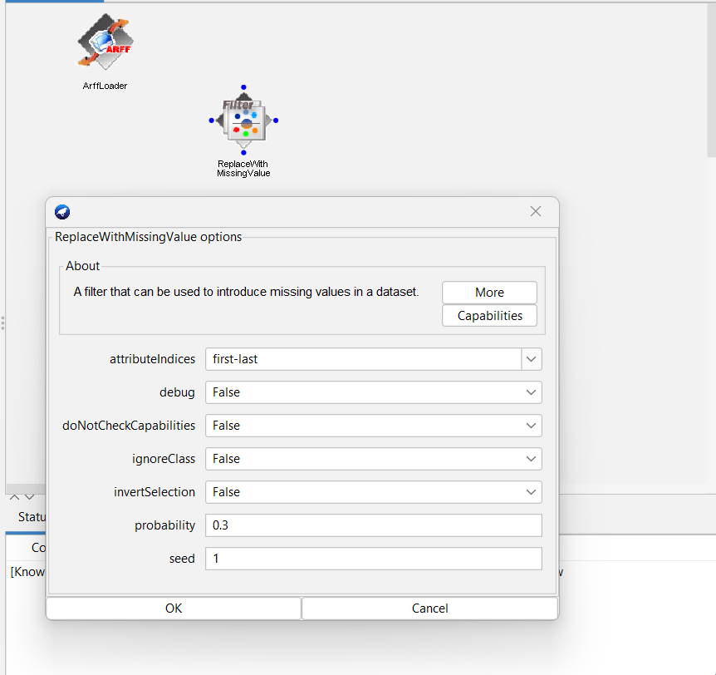
3. Finally, add “ReplaceMissingValue” filter from “Unsupervised” filter.  
   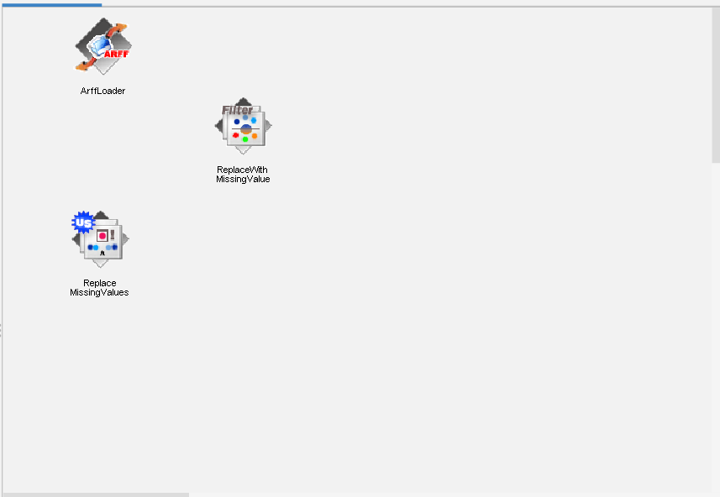

Connect the components together, run the “Knowledge Flow” and see the result in “TextViewer” by clicking on option.  
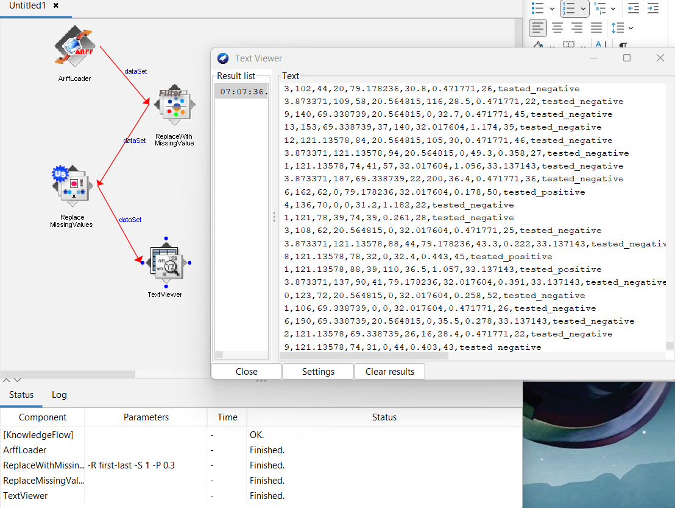

**Practical – 13**

Replace the missing value with constant value, for example, replace missing numerical value with one and replace missing nominal “N/A”, using unsupervised filter using both interfaces (“Explorer” and “Knowledge Flow”)

Solution:

Step 1: In Explorer, open the “vote.arff” file and select the “ReplaceMissingWithUserConstant” filter from “Unsupervised” filter.  
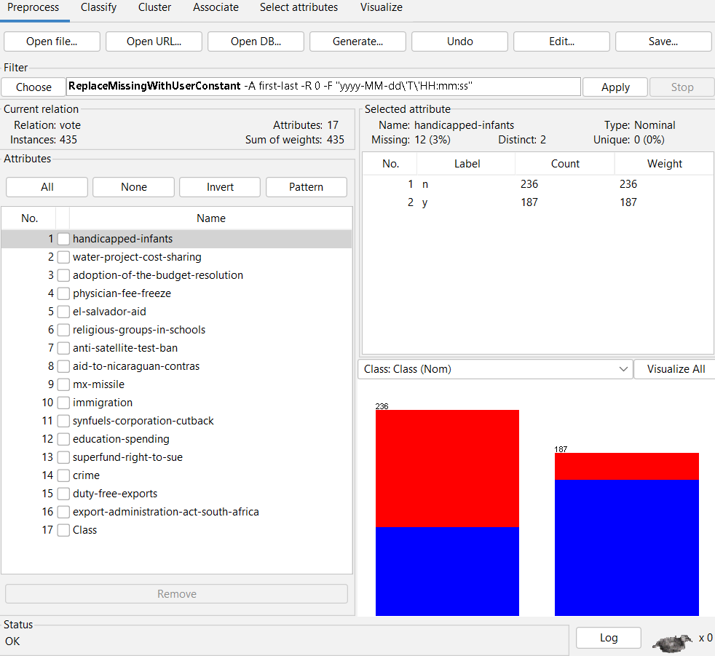

Step 2: Now, change nominal value to “N/A”, numeric to one and apply filter.

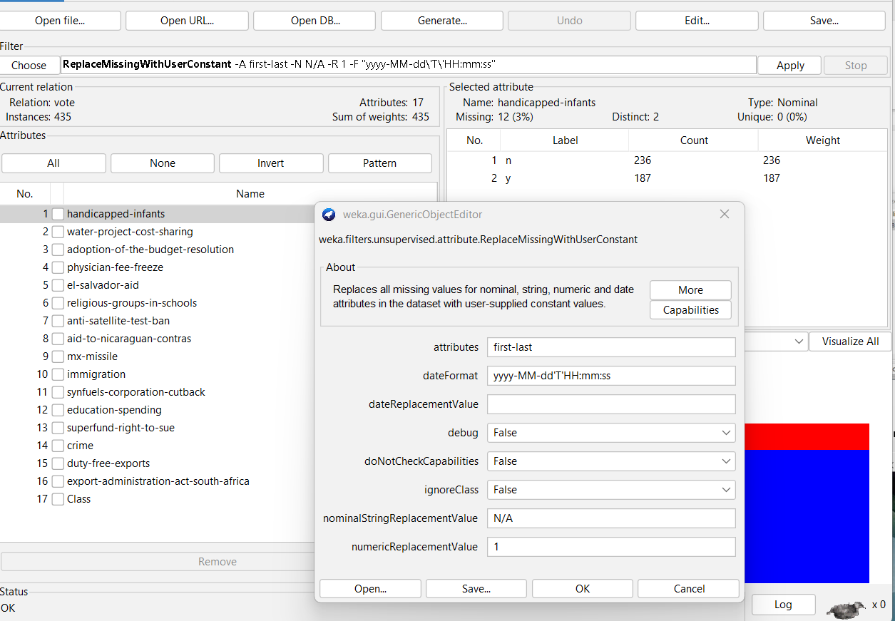

Step 3: Click on the “Edit” button to see the results.

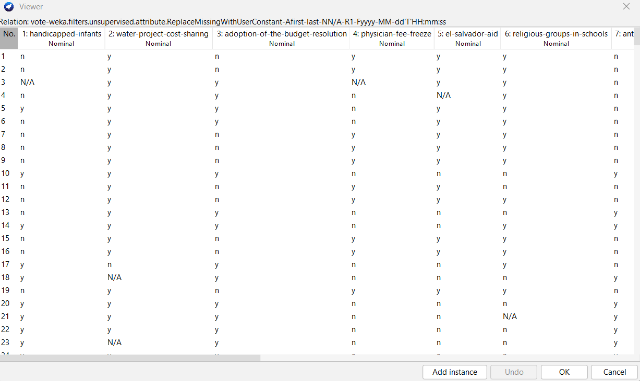

In Knowledge Flow interface,

Step 1:

1. Open “Knowledge Flow” tab from WEKA main window.
2. Add “ArffLoader” in the “Knowledge Flow” environment.  
   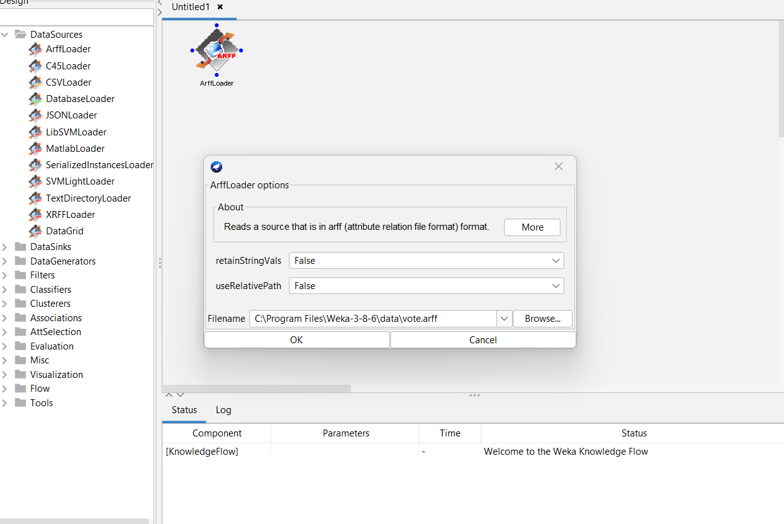

Step 2: Add “ReplaceMissingWithUserConstant” filter from “Unsupervised” filter and change nominal value to “N/A” and numeric to 1.

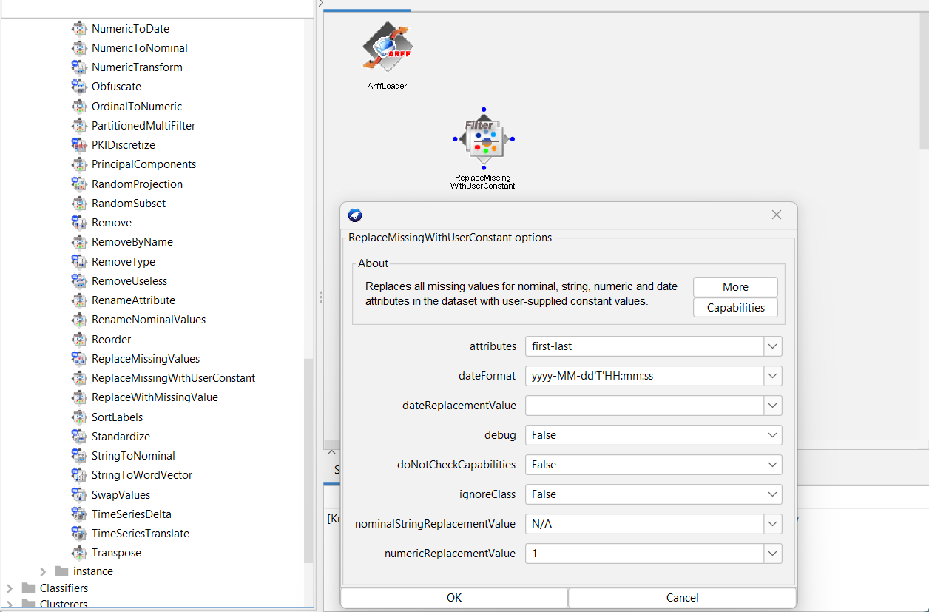

Step 3: Finally, run the “Knowledge Flow” tab and see the result by clicking on “Show Results” opton.

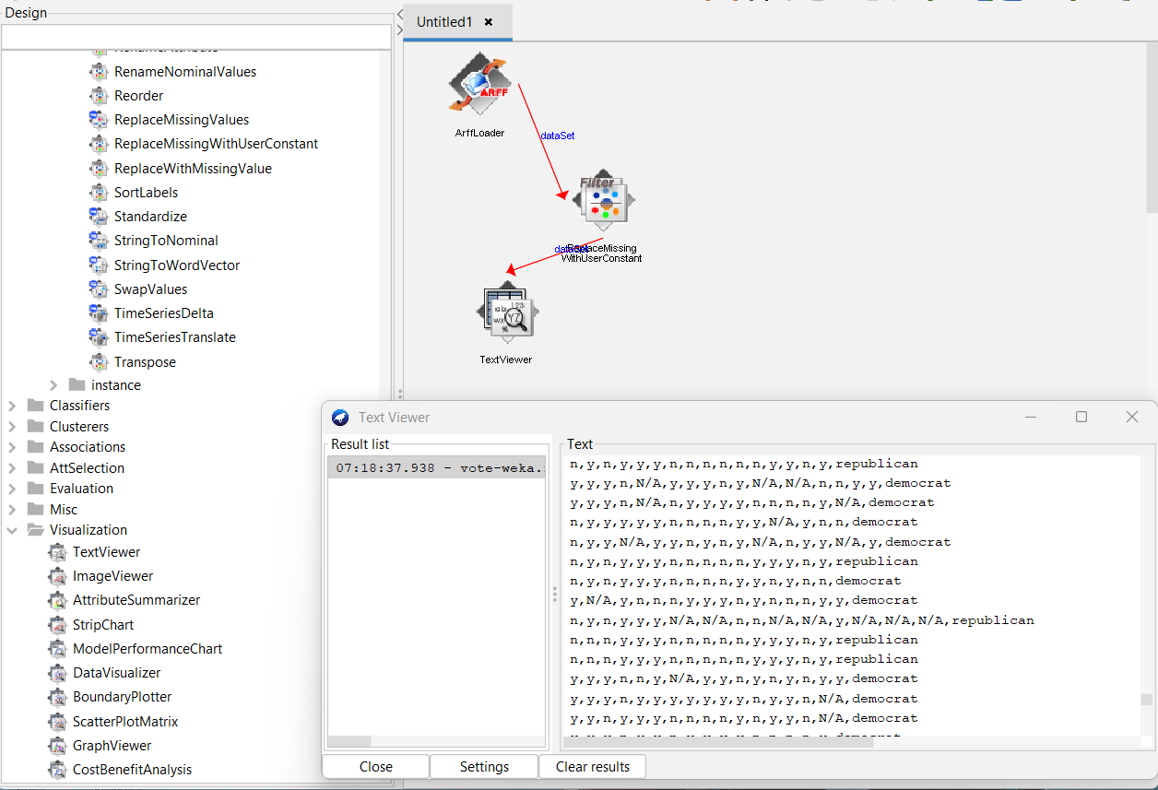

**Practical – 14**

Apply “Unsupervised” filter to fetch all instances from dataset “Diabetes.arff” having age above 30.

Solution:

Step 1: Open the “Diabetes.arff” file and select the “RemoveWithValues” filter from “Unsupervised > instance” filter.  
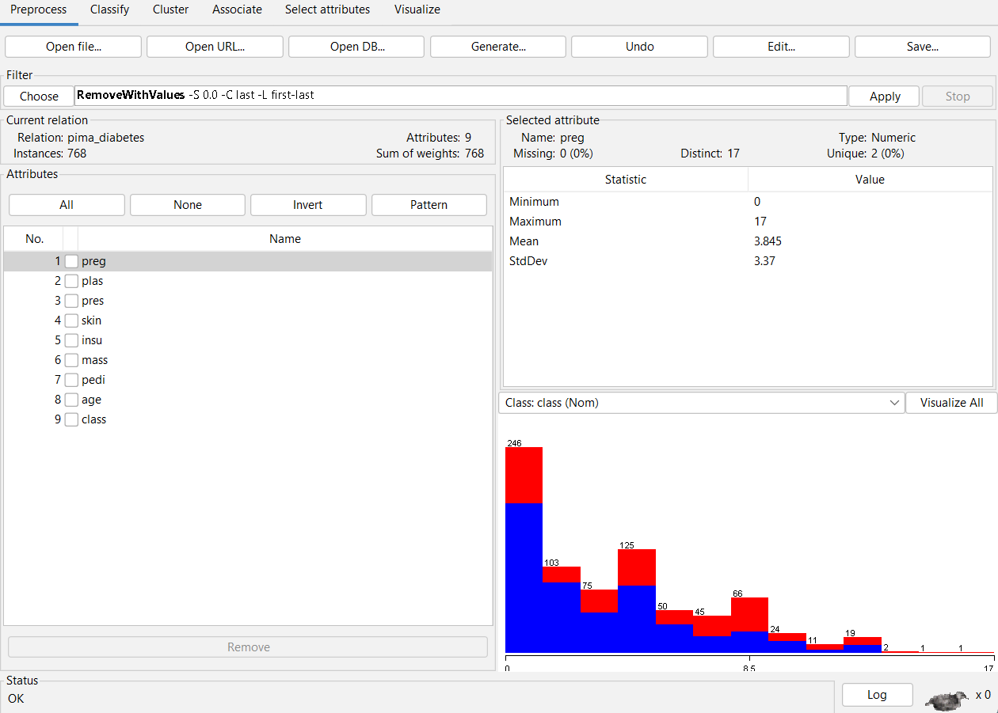

Step 2: Now, change the attribute index to “8” and set split point to “30”.  
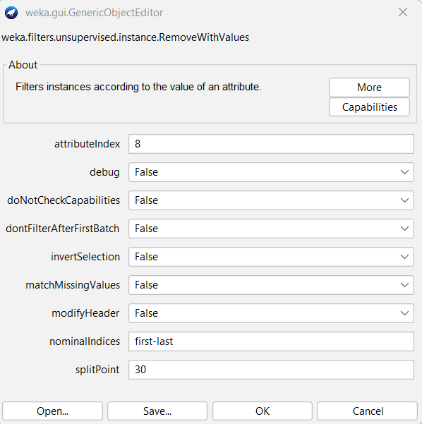

Step 3: Click “Edit” button and we will see instances of age of 30 and above.

