9/9/2023

Abhishek Roka

10621019

Python Practical File

Full Time Diploma in Computer Engineering 5th Semester

INDEX

Calculate the multiplication and sum of two numbers 4

Print the sum of the current number and the previous number 5

Print characters from a string that are present at an even index number 6

Remove first n characters from a string 7

Check if the first and last number of a list is the same 8

Display numbers divisible by 5 from a list 9

Return the count of a given substring from a string 10

Print the following pattern 11

Check Palindrome Number 12

Create a new list from a two list using the following condition 13

Write a Program to extract each digit from an integer in the reverse order. 14

Calculate income tax for the given income by adhering to the below rules 15

Print multiplication table form 1 to 10 17

Print downward Half-Pyramid Pattern with Star (asterisk) 19

Write a function called exponent(base, exp) that returns an int value of base raises to the power of exp. 20

Write a program to create a function that takes two arguments, name and age, and print their value. 21

Write a program to create function func1() to accept a variable length of arguments and print their value. 22

Write a program to create function calculation() such that it can accept two variables and calculate addition and subtraction. Also, it must return both addition and subtraction in a single return call 23

Write a program to create a function show_employee() using the following conditions. 24

Create an inner function to calculate the addition in the following way 25

Write a program to create a recursive function to calculate the sum of numbers from 0 to 10. 26

Assign a different name to function and call it through the new name 27

Generate a Python list of all the even numbers between 4 to 30 28

Find the largest item from a given list 29

Write a program that defines a function count_lower_upper() that accepts a string and calculates the number of uppercase and lowercase alphabets in it. It should return these values as a dictionary. Call this function for some sample strings. 30

Write a program that defines a function compute() that calculates the value of n + nn + nnn + nnnn, where n is digit received by the function. Test the function for digits 4 and 7. 32

Write a program that defines a function create_array() to create and return a 3D array whose dimensions are passed to the function. Also initialize each element of this array to a value passed to the function. 33

Write a program that defines a function create_list() to create and return a list which is an intersection of two lists passed to it. 35

Write a program that defines a function sanitize_list() to remove all duplicate entries from the list that it receives. 36

Write a program to receive three integers from keyboard and get their sum and product calculated through a user-defined function cal_sum_prod(). 37

Pangram is a sentence that uses every letter of the alphabet. Write a program that checks whether a given string is pangram or not, through a user-defined function ispangram(). 38

Write a Python program that accepts a hyphen-separated sequence of words as input and calls a function convert() which converts it into a hyphen-separated sequence after sorting them alphabetically. 40

Write a python function to create and return a list containing tuples of the form (x, x2, x3) for all x between 1 and 20 (both included). 41

Write a program that defines a function ispalindrome() which checks whether a given string is a palindrome or not. Ignore spaces and case mismatch while checking for palindrome. 42

Write a program that defines a function convert() that receives a string containing a sequence of whitespace separated words and returns a string after removing all duplicate words and sorting them alphanumerically. 44

Write a program that defines a function count_alphabets_digits() that accepts a string and calculates the number of alphabets and digits in it. It should return these values as a dictionary. Call this function for some sample strings. 45

Write a program that defines a function called frequency() which computes the frequency of words present in a string passed on it. The frequencies should be returned in sorted order by words in the string. 47

Write a program that defines two functions called create_sent1() and create_sent2(). 48

**Practical 1**

Calculate the multiplication and sum of two numbers

**Code**

num1 = int(input("Enter num1: "))

num2= int(input("Enter num2: "))

mul = num1*num2

if mul <= 1000:

print(num1, " * ", num2, " = ", mul)

else:

print(num1, " + ", num2, " = ", num1+num2)

**Output:**

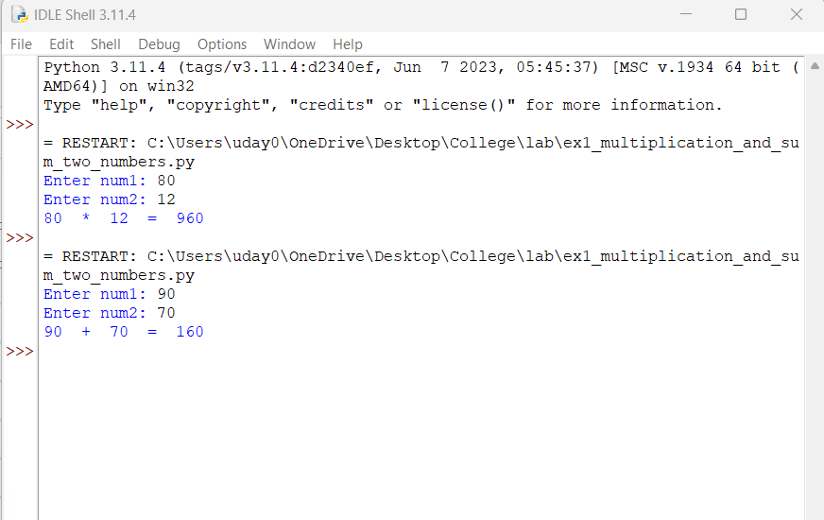

**Practical 2**

Print the sum of the current number and the previous number

**Code:**

prev_num = 0

rangelen = range(10)

currentnum=0

for i in rangelen:

currentnum = prev_num + i

print("Previous number is ", prev_num, " currentnum is ", currentnum)

prev_num = currentnum

**Output:**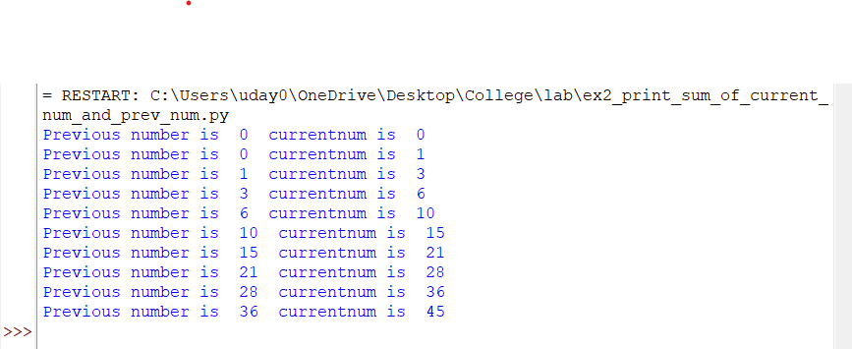

**Practical 3**

Print characters from a string that are present at an even index number

**Code:**

user_string = input("Enter string: ")

length = len(user_string)

range_len = range(0,length,2)

for i in range_len:

print(user_string[i])

**Output:**

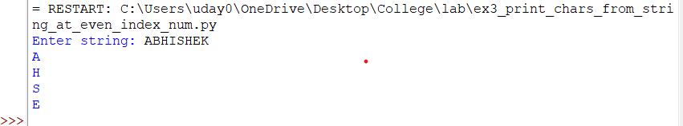

**Practical 4**

Remove first n characters from a string

**Code:**

user_string = input("Enter string: ")

num_of_chars = int(input("Enter number of characters to remove from beginning: "))

new_string = user_string[num_of_chars:-1]

print("Your string after removing first ", num_of_chars, " is: ", new_string)

**Output:**

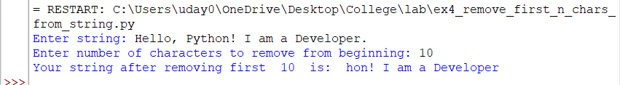

**Practical 5**

Check if the first and last number of a list is the same

**Code:**

num = int(input("Enter number of elements to add in list: "))

rangeLen = range(num)

user_list = []

for i in rangeLen:

print("Enter element no.", i+1, " : ", end="")

user_num = int(input())

user_list.append(user_num)

if user_list[0] == user_list[-1]:

print("First and last numbers are same.")

else:

print("First and last numbers are not same.")

**Output:**

### 

**Practiaal 6**

Display numbers divisible by 5 from a list

**Code:**

user_list = []

length = int(input("Enter number of elements to be entered in list: "))

rangeLen = range(length)

for i in rangeLen:

print("Enter element no.", i, " : ", end="")

num = int(input())

user_list.append(num)

for i in user_list:

if i%5==0:

print(i," is divisible by 5.")

**Output:**

### 

**Practiacal 7**

Return the count of a given substring from a string

**Code:**

string_to_examin = "Hello, World! I am a Python Developer. I am a freelancer. Also work on web development. Hello, Development"

to_find_string = "Hello"

print(to_find_string, " occured ", string_to_examin.count(to_find_string), " times in ", string_to_examin)

**Output:**

### 

**Practical 8**

Print the following pattern

### 1

### 2 2

### 3 3 3

### 4 4 4 4

### 5 5 5 5 5

**Code:**

num= int(input("Enter number for triangle: "))

heightRangeLen = range(num)

for i in heightRangeLen:

lengthRangelen = range(i+1)

for j in lengthRangelen:

print(i+1, end=" ")

print()

**Output:**

### 

**Practical 9**

Check Palindrome Number

**Code:**

user_num = input("Enter number: ")

if user_num == user_num[::-1]:

print(user_num, " is a palindrome number.")

else:

print(user_num," is not a palindrome number.")

**Output:**

### 

**Practical 10**

Create a new list from a two list using the following condition

* new list should contain odd numbers from the first list and even numbers from the second list.

**Code:**

list1= [23,44,567,67,88,987]

list2 = [24, 45, 89, 90, 33]

new_list = []

for i in list1:

if i%2==1:

new_list.append(i)

for i in list2:

if i%2==0:

new_list.append(i)

print("New list is: ", new_list)

**Output:**

### 

**Practical 11**

Write a Program to extract each digit from an integer in the reverse order.

**Code:**

num = int(input("Enter integer: "))

new_num=0

store_orginal_num = num

while num>0:

new_num = new_num*10 + num%10

num = num // 10

print("Digits of ", store_orginal_num, " extracted in reverse order is: ", new_num)

**Output:**

### 

**Practical 12**

Calculate income tax for the given income by adhering to the below rules

|  |  |
| --- | --- |
| Taxable Income | Rate (in %) |
| First $10,000 | 0 |
| Next $10,000 | 10 |
| The remaining | 20 |

**Code:**

"""

Taxable income Rate

10,000 0

next 10,000 10

remaining 20

"""

income_tax = 0

your_income = float(input("Your income is $ "))

income_division = []

if your_income<10000:

income_tax=0

elif your_income < 20000:

income_division.append(10000)

income_division.append(your_income-10000)

else:

income_division.append(10000)

income_division.append(10000)

income_division.append(your_income-20000)

length = len(income_division)

rangeLen = range(length)

for i in rangeLen:

if i == 1:

income_tax += income_division[i]*0.1

elif i > 1:

income_tax += income_division[i]*0.2

print("Your income tax is: $", income_tax, "/-")

**Output:**

### 

**Practical 13**

Print multiplication table form 1 to 10

**Code:**

table_of = range(1,11)

table_numbers = range(1,11)

for i in table_of:

print("Table of ", i)

for j in table_numbers:

print(i, " x ", j, " = ", i*j)

print()

**Output:**

### 

### 

**Practical 14**

Print downward Half-Pyramid Pattern with Star (asterisk)

* * * * *

* * * *

* * *

* *

*

**Code:**

length_of_triangle_height = int(input("Enter height of triangle: "))

order_of_height = range(length_of_triangle_height,0,-1)

for i in order_of_height:

elements_range = range(i)

for j in elements_range:

print("*",end=" ")

print()

**Output:**

### 

**Practical 15**

Write a function called exponent(base, exp) that returns an int value of base raises to the power of exp.

**Code:**

def exponent(base, exp):

return base ** exp

base = float(input("base= "))

exp = float(input("exponent= "))

print(base, " ^ ", exp, " = ", exponent(base,exp))

**Output:**

### 

**Practical – 16**

Write a program to create a function that takes two arguments, name and age, and print their value.

### Code:

### def function(name, age):

### print("name is: ", name)

### print("age is: ", age)

### function("John","20")

### Output:

### 

**Practical 17**

Write a program to create function func1() to accept a variable length of arguments and print their value.

**Note**: Create a function in such a way that we can pass any number of arguments to this function, and the function should process them and display each argument’s value.

### Code:

### def func1(*args):

### print("sum",args, " is: ", sum(args))

### 

### func1(20,30,40)

### func1(10,30,50,60,100)

### Output:

### 

**Practical-18**

Write a program to create function calculation() such that it can accept two variables and calculate addition and subtraction. Also, it must return both addition and subtraction in a single return call

### Code:

### def calculation(num1,num2):

### return num1+num2, num1-num2

### 

### x = float(input("x = "))

### y = float(input("y = "))

### result = calculation(x,y)

### print("x + y = ", result[0])

### print("x - y = ", result[1])

### Output:

### 

**Practical 19**

Write a program to create a function show_employee() using the following conditions.

* It should accept the employee’s name and salary and display both.
* If the salary is missing in the function call then assign default value 9000 to salary

### Code:

### def show_employee(name, salary=9000):

### print("Employee name: ", name)

### print("Employee salary: ", salary)

### name = input("Enter name: ")

### salary = int(input("Enter salary: "))

### print("\nPassing name only:-")

### show_employee(name)

### print("\nPassing name and salary")

### show_employee(name, salary)

### Output:

### 

**Practical – 20**

Create an inner function to calculate the addition in the following way

* Create an outer function that will accept two parameters, a and b
* Create an inner function inside an outer function that will calculate the addition of a and b
* At last, an outer function will add 5 into addition and return it

### Code:

### def calculation(a,b):

### result = 0

### def addition():

### return a+b

### result += addition()

### result += 5

### return result

### print(calculation(3,5))

### Output:

### 

**Practical – 21**

Write a program to create a recursive function to calculate the sum of numbers from 0 to 10.

### Code:

### def sumNumbers(n):

### if n==0:

### return 0

### else:

### return n+sumNumbers(n-1)

### print(sumNumbers(10))

### Output:

### 

**Practical – 22**

Assign a different name to function and call it through the new name

Below is the function display_student(name, age). Assign a new name show_tudent(name, age) to it and call it using the new name.

### Code:

### def display_student(name, age):

### print("Student name is: ", name)

### print("Student age is: ", age)

### show_student = display_student

### show_student("Rohan",18)

### Output:

### 

**Practical – 23**

Generate a Python list of all the even numbers between 4 to 30

### Code:

### def even_numbers_4_to_30():

### return list(range(4,30,2))

### print("List is: ", even_numbers_4_to_30())

### Output:

### 

**Practical – 24**

Find the largest item from a given list

### Code:

### myList = [4,6,5,8,80,90,10,3,2]

### print("Largest item in the list: ", max(myList))

### Output:

### 

**Practical-25**

Write a program that defines a function count_lower_upper() that accepts a string and calculates the number of uppercase and lowercase alphabets in it. It should return these values as a dictionary. Call this function for some sample strings.

### Code:

### def count_lower_upper(userstring):

### record = {"lower":0, "upper":0}

### characterRange = list(range(65,91)) + list(range(97,123))

### for i in userstring:

### if ord(i) in characterRange:

### if i.islower():

### record["lower"]+=1

### elif i.isupper():

### record["upper"]+=1

### return record

### while True:

### user = input("Enter String: ")

### print(count_lower_upper(user))

### Output:

### 

**Practical – 26**

Write a program that defines a function compute() that calculates the value of n + nn + nnn + nnnn, where n is digit received by the function. Test the function for digits 4 and 7.

### Code:

### def compute(n):

### return n * (1+11+111+1111)

### print(compute(4))

### print(compute(7))

### Output:

### 

**Practical – 27**

Write a program that defines a function create_array() to create and return a 3D array whose dimensions are passed to the function. Also initialize each element of this array to a value passed to the function.

### Code:

### def create_array(dims,values):

### l=0

### array = []

### if len(values)==dims[0]*dims[1]*dims[2]:

### for i in range(dims[0]):

### subarray=[]

### for j in range(dims[1]):

### subsubarray=[]

### for k in range(dims[2]):

### subsubarray.append(values[l])

### l+=1

### subarray.append(subsubarray)

### array.append(subarray)

### return array

### aList = []

### for i in range(3*8*3):

### aList.append(i)

### print(create_array((3,8,3), aList))

### Output:

### 

**Practical – 28**

Write a program that defines a function create_list() to create and return a list which is an intersection of two lists passed to it.

### Code:

### def create_array(list1,list2):

### list3=[]

### for i in list1:

### if i in list2:

### list3.append(i)

### return list3

### print(create_array([3, 2, 5, 2, 8, 8, 8, 7, 4, 2],[8, 1, 7, 7, 1, 8, 5, 4, 2, 6]))

### Output:

### 

**Practical – 29**

Write a program that defines a function sanitize_list() to remove all duplicate entries from the list that it receives.

### Code:

### def sanitize_list(givenList):

### newList = []

### for i in set(givenList):

### newList.append(i)

### return newList

### print(sanitize_list([8, 8, 6, 4, 1, 6, 1, 5, 8, 5]))

### Output:

### 

**Practical – 30**

Write a program to receive three integers from keyboard and get their sum and product calculated through a user-defined function cal_sum_prod().

### Code:

### def cal_sum_prod(num1,num2,num3):

### return num1+num2+num3, num1*num2*num3

### n1 = int(input("Enter first integer: "))

### n2 = int(input("Enter second integer: "))

### n3 = int(input("Enter third integer: "))

### result = cal_sum_prod(n1,n2,n3)

### print("Sum is: ", result[0])

### print("Product is: ", result[1])

### Output:

### 

**Practical – 31**

Pangram is a sentence that uses every letter of the alphabet. Write a program that checks whether a given string is pangram or not, through a user-defined function ispangram().

### Code:

### def ispangram(sentence):

### alphabets = [chr(i) for i in range(65,91)] + [chr(i) for i in range(97,123)] #list of all alphabets lowercase and uppercase

### for i in set(sentence):

### if i not in alphabets:

### return False

### return True

### statement = input("Enter statment to check for pangram: ")

### if ispangram(statement):

### print("It is a pangram.")

### else:

### print("It is not a pangram.")

### Output:

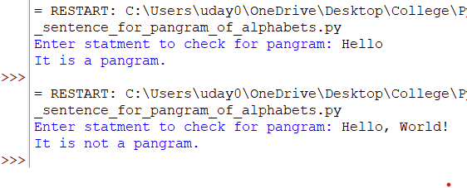

**Practical – 32**

Write a Python program that accepts a hyphen-separated sequence of words as input and calls a function convert() which converts it into a hyphen-separated sequence after sorting them alphabetically. For example, if the input string is

here-come-the-dots-followed-by-dashes

Then, the output must be:

by-come-dashes-dots-followed-here-the

### Code:

### def convert(sentence):

### return "-".join(sorted(sentence.split("-")))

### user_input = input("Enter string: ")

### print(convert(user_input))

### Output:

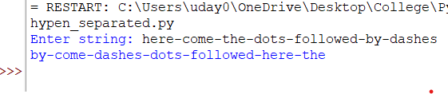

**Practical – 33**

Write a python function to create and return a list containing tuples of the form (x, x2, x3) for all x between 1 and 20 (both included).

### Code:

### def x_square_cube():

### returnList = []

### for x in range(1,21):

### returnList.append((x,x**2,x**3))

### return returnList

### print(x_square_cube())

### Output:

### 

**Practical – 34**

Write a program that defines a function ispalindrome() which checks whether a given string is a palindrome or not. Ignore spaces and case mismatch while checking for palindrome.

### Code:

### def ispalindrome(arg_string):

### arg_string = arg_string.replace(" ","").lower()

### if arg_string == arg_string[::-1]:

### return True

### return False

### user_string = input("Enter string: ")

### print("Palindrome condition: ",ispalindrome(user_string))

### Output:

### 

**Practical – 35**

Write a program that defines a function convert() that receives a string containing a sequence of whitespace separated words and returns a string after removing all duplicate words and sorting them alphanumerically.

### Code:

### def convert(arg_string):

### x = sorted(set(arg_string.split(" ")))

### return " ".join(x)

### sentence = input("Enter string: ")

### print(convert(sentence))

### Output:

### 

**Practical – 36**

Write a program that defines a function count_alphabets_digits() that accepts a string and calculates the number of alphabets and digits in it. It should return these values as a dictionary. Call this function for some sample strings.

### Code:

### def count_alphabets_digits(userstring):

### record = {"alphabets":0, "digits":0}

### characterRange = list(range(65,91)) + list(range(97,123)) + list(range(48,58))

### for i in userstring:

### if ord(i) in characterRange:

### if i.isalpha():

### record["alphabets"]+=1

### elif i.isdigit():

### record["digits"]+=1

### return record

### while True:

### user = input("Enter String: ")

### print(count_alphabets_digits(user))

### Output:

### 

**Practical – 37**

Write a program that defines a function called frequency() which computes the frequency of words present in a string passed on it. The frequencies should be returned in sorted order by words in the string.

### Code:

### def frequency(arg_string):

### returnDict = {}

### arg_string = arg_string.split(" ")

### for i in set(arg_string):

### returnDict[i] = 0

### for i in arg_string:

### returnDict[i] +=1

### return returnDict

### user_string = input("Enter string: ")

### print(frequency(user_string))

### Output:

### 

**Practical – 38**

Write a program that defines two functions called create_sent1() and create_sent2().

### Both receive following 3 lists:

### subjects = [‘He’,’She’]

### verb = [‘loves’,’hates’]

### objects = [‘TV Serials’,’Netflix’]

### Both functions should form sentences by picking elements from the lists and returns them. Use for loops in create_sent1() and list comprehension in create_sent2().

### Code:

### def create_sent1(sub,verb,obj):

### # using for loop

### sentences = []

### for i in sub:

### for j in verb:

### for k in obj:

### sentences.append(" ".join((i,j,k)))

### return sentences

### def create_sent2(sub,verb,obj):

### # Using list comprehension

### return [" ".join((i,j,k)) for i in sub for j in verb for k in obj]

### subject = ['He','She']

### verb = ['loves', 'hates']

### obj = ['TV Serial','Netflix']

### print("Using create_sent1() function which uses for loop:")

### for i in create_sent1(subject,verb,obj):

### print(i)

### 

### print("\nUsing create_sent2() function which uses list comprehension:")

### for i in create_sent2(subject,verb,obj):

### print(i)

### Output:

### 