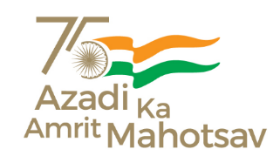  

**DELHI SKILL AND ENTREPRENEURSHIP UNIVERSITY, DWARKA CAMPUS**

**E-Cell Connect - Navigating Your Placement Journey | DSEU**

**28 September, 2023**

**About the event**

This report provides an overview of the online competition, "E-Cell Connect: Navigating Your Placement Journey | DSEU," organized by E-Cell in collaboration with Coding Ninjas. The event aimed to empower participants with opportunities and insights relevant to their placement journey.

**Event Details:**

- **Date:** September 28, 2023

- **Venue:** Coding Ninja Platform (Online)

- **Registration Link:** <https://tinyurl.com/E28dseu>

- **Window for Contests:** 3 PM to 10 PM

- **Test Duration:** 30 minutes

- **Total Number of Questions:** 30

The competition offered a diverse set of questions, with 75% focused on aptitude testing and 25% centred on basic operating systems.

**Prizes:**

Exciting prizes awaited the participants, with the top 3 winners receiving Coding Ninja merchandise, including bags, bottles, mugs, and more.

**Event Coordinators:**

Participants had the opportunity to reach out for inquiries or clarifications to the Event Coordinators:

- Kalash Thakur: 85277 78237

- Divyansh Aggarwal: 88514 94727

**Conclusion:**

The "E-Cell Connect: Navigating Your Placement Journey | DSEU" online competition was a significant success, providing students with the opportunity to enhance their skills and knowledge. The event coordinators ensured a smooth and efficient experience, and Coding Ninjas' collaboration added significant value to the competition.

This initiative reflects the commitment of E-Cell and the T&P Committee of the Computer Science Branch at DSEU Dwarka to empower students with valuable resources and insights as they navigate their placement journey.

