DSEU, Dwarka

Blue Planet InfoSolutions

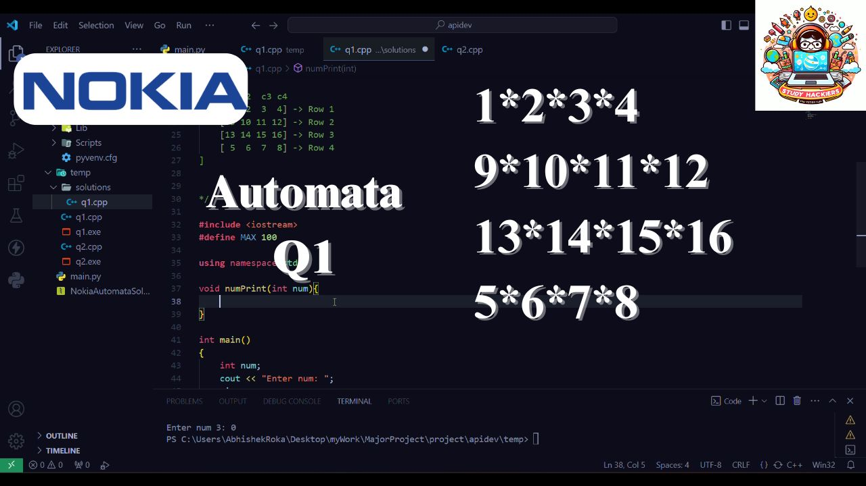

[Company Logo]

19-04-2024

Blue Planet

Dwarka Sector 9, New Delhi - 110007

[Number List Projects Purpose]

[Number List Projects Context]

Alpha CafeAlpha CafeAlpha Cafe

Beta CafeBeta CafeBeta Cafe

Alpha Cafe

Beta Cafe

[Annexure Table]

[Annexure II Table]