**Stock Price Prediction**

### A Project Work Report

*Submitted in the partial fulfillment for the award of the degree of*

# BACHELOR OF ENGINEERING

### IN

### COMPUTER SCIENCE ENGINEERING IN BIG DATA

### Submitted by:

### SUSHANT BISHT

### 20BCS6148

### Under the Supervision of:

### GURPREET SINGH PANESAR



# DEPARTMENT OF COMPUTER SCIENCE AND ENGINEERING APEX INSTITUE OF TECHNOLOGY

### CHANDIGARH UNIVERSITY, GHARUAN, MOHALI - 140413,

**PUNJAB**

#### MONTH & YEAR

2020-2024

**DECLARATION**

I, **‘Sushant Bisht**, student of **‘Bachelor of Engineering in Computer Science in Big Data**, **session:2020- 2024**, Department of Computer Science and Engineering, Apex Institute of Technology, Chandigarh University, Punjab, hereby declare that the work presented in this Project Work entitled ‘**Stock Price Prediction** is the outcome of our own bona fide work and is correct to the best of our knowledge and this work has been undertaken taking care of Engineering Ethics. It contains no material previously published or written by another person nor material which has been accepted for the award of any other degree or diploma of the university or other institute of higher learning, except where due acknowledgment has been made in the text.

#### Date: 17-04-2022

**Place: Punjab**

### Sushant Bisht Candidate UID: 20BCS6148

ii

# Table of Contents

|  |  |  |
| --- | --- | --- |
|  | Title Page  Declaration of the Student Abstract Acknowledgement  List of Figures  List of Tables (optional) | i |
| ii |
| iii |
| iv |
| v |
| vi |
|  |
| **1.** | **INTRODUCTION\*** | **1** |
|  | * 1. Problem Definition   2. Project Overview/Specifications* (page-1 and 3)   3. Hardware Specification   4. Software Specification 1.3.1   1.3.2  … | 1  2  3  4  4 |
| 1. **LITERATURE SURVEY** 2. **PROBLEM FORMULATION** | | **5** |
| 5  6  7 |
| 9  16  18  19  22 |
| 1. **OBJECTIVES** 2. **METHODOLOGY** 3. **CONCLUSIONS AND DISCUSSION** 4. **REFERENCES** | |

# INTRODUCTION

#### 1.1

#### "What other people think” has always been an important piece of information for most of us during the

#### decision-making process. The Internet and the Web have now (among other things) made it possible to find

#### out about the opinions and experiences of those in the vast pool of people that are neither our acquaintances

#### nor well-known professional critics — that is, people we have never heard of. And conversely, more and

#### more people are making their opinions available to strangers via the Internet. The interest that individual

#### users show in online opinions about products and services, and the potential influence such opinions wield,

#### is something that is the driving force for this area of interest. And there are many challenges involved in this

#### process that needs to be walked all over to attain proper outcomes out of them. In this survey, I have

#### analyzed the basic methodology that usually happens in this process and measures that are to be taken to

#### overcome the challenges being faced.

1. **LITERATURE REVIEW**

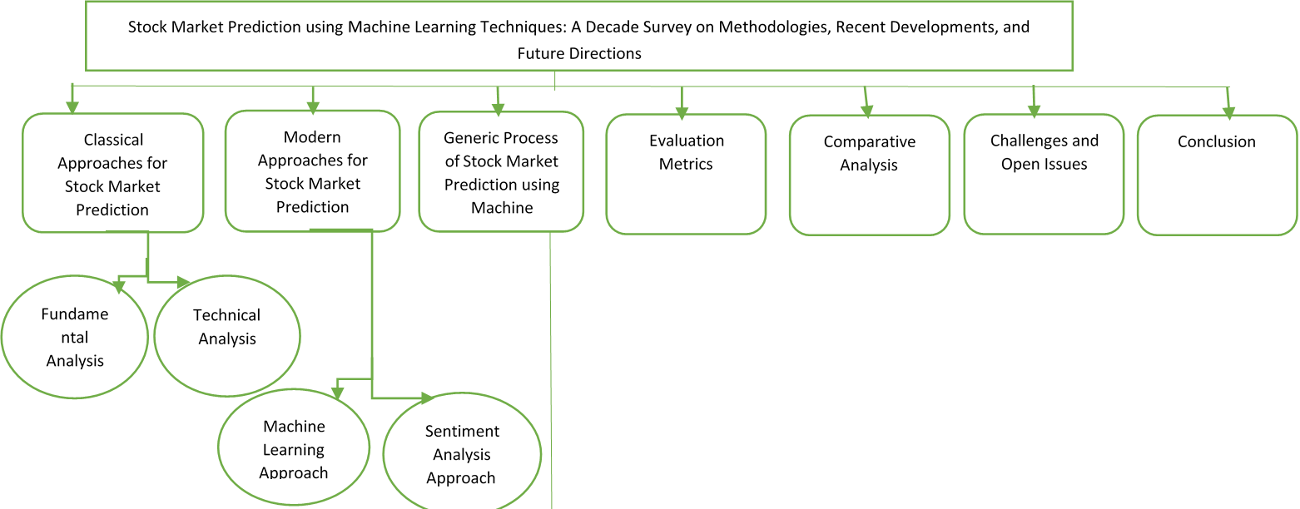

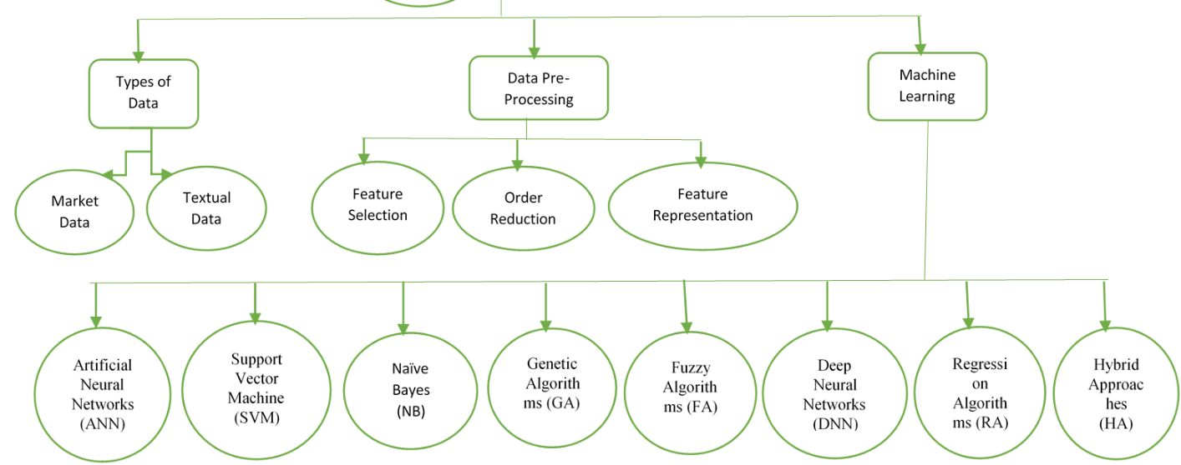

**2.1 Literature Review Summary**

Table 2.1: Literature review summary

|  |  |  |  |  |  |  |  |  |
| --- | --- | --- | --- | --- | --- | --- | --- | --- |
| **Year and citation** | **Article Title** | **Purpose of study** | **Tools / Software Used** | **Comparison of technique** | **Source (Journal / Conference)** | **Findings** | **Data set (if used)** | **Evaluation parameters** |
| 2022 | Stock Price  Prediction | Forecast the  Price Trend | Machine Learning  Android Studio  Python  Heroku  Git | We usually test our data with a Machine learning algorithm which provides best prediction | StackOverflow | Yahoo Finance | Apple, Google, Microsoft, SBI, Kotak and many more | displot |

# PROBLEM FORMULATION

* Most people don’t know the relationship between all financial assets.
* It is difficult to predict what drives the price of each asset.
* It is difficult to find a link between financial assets and the real economy.
* The aim of the project is to examine a number of different forecasting techniques to predict future stock returns based on past returns to construct a portfolio of multiple stocks in order to diversify the risk. We do this by applying supervised learning methods for stock price forecasting by interpreting the seemingly chaotic market data.

# RESEARCH OBJECTIVES

The proposed research is aimed to carry out work leading to the development of an approach for vulnerable code clone detection. The proposed aim will be achieved by dividing the work into following objectives:

* To examine a number of different forecasting techniques to predict future stock returns based on past returns.
* To determine values that particular stock will have in the near future
* To provide a platform where stock movements of the major companies are displayed.

# METHODOLOGY

The following methodology will be followed to achieve the objectives defined for proposed research work:

* 1. Collect data from source

We will collect the data from yahoo finance from were we can get dataset for all kind of companies.

* 1. Normalize Data

We need to normalization the data within a range -1 to 1.

* 1. Scale Data

Scale the data using StandardScaler module in python

* 1. Create a Training and Testing dataset

Here we need to create the training and testing data. In which we will train the model using training data and then check prediction on test data.

* 1. Train all the models using the training dataset
  2. Test the model and determine the score

We can calculate R2 score or accuracy of the model prediction

* 1. Predict the stocks using trained models
  2. Compare the predictions of all models using a graph

We can create a distplot which generally give the graphical representation of accuracy and errors.

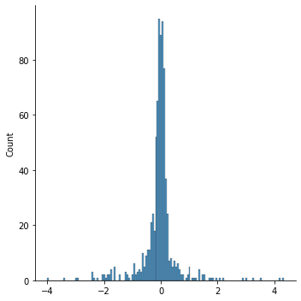

* 1. Choose the best model between the algorithm

Choose the best algo for creating the model where we get better accuracy and a low rate of error. practically data_predicted – actual data = 0

* 1. Save trained model

Save the model as a pickle file so that we can use that model for different datasets

* 1. Display the model on the website

Deploy your model in Heroku for have a subdomain to public present your website.

* 1. Show prediction of stock prices
  2. An approach will be developed for vulnerable code clone detection.
  3. Various parameters will be identified to evaluate the proposed system.
  4. Comparison of new implemented approach with exiting approaches will be done.

1. **RESULTS AND DISCUSSION**

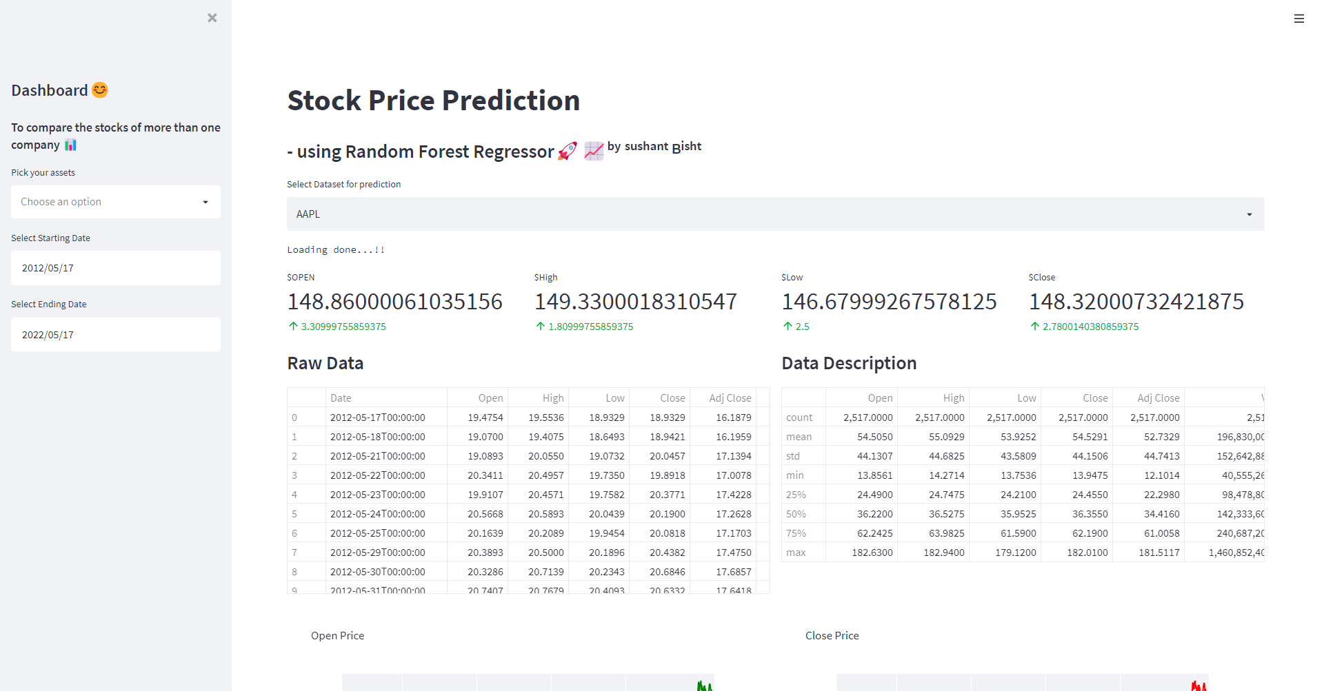

**We have custom user input option, where user can input his or her open, high price to predict closing price**

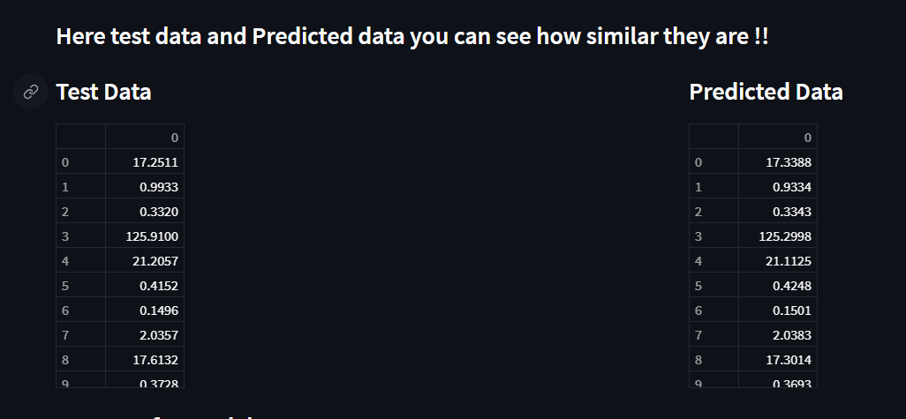

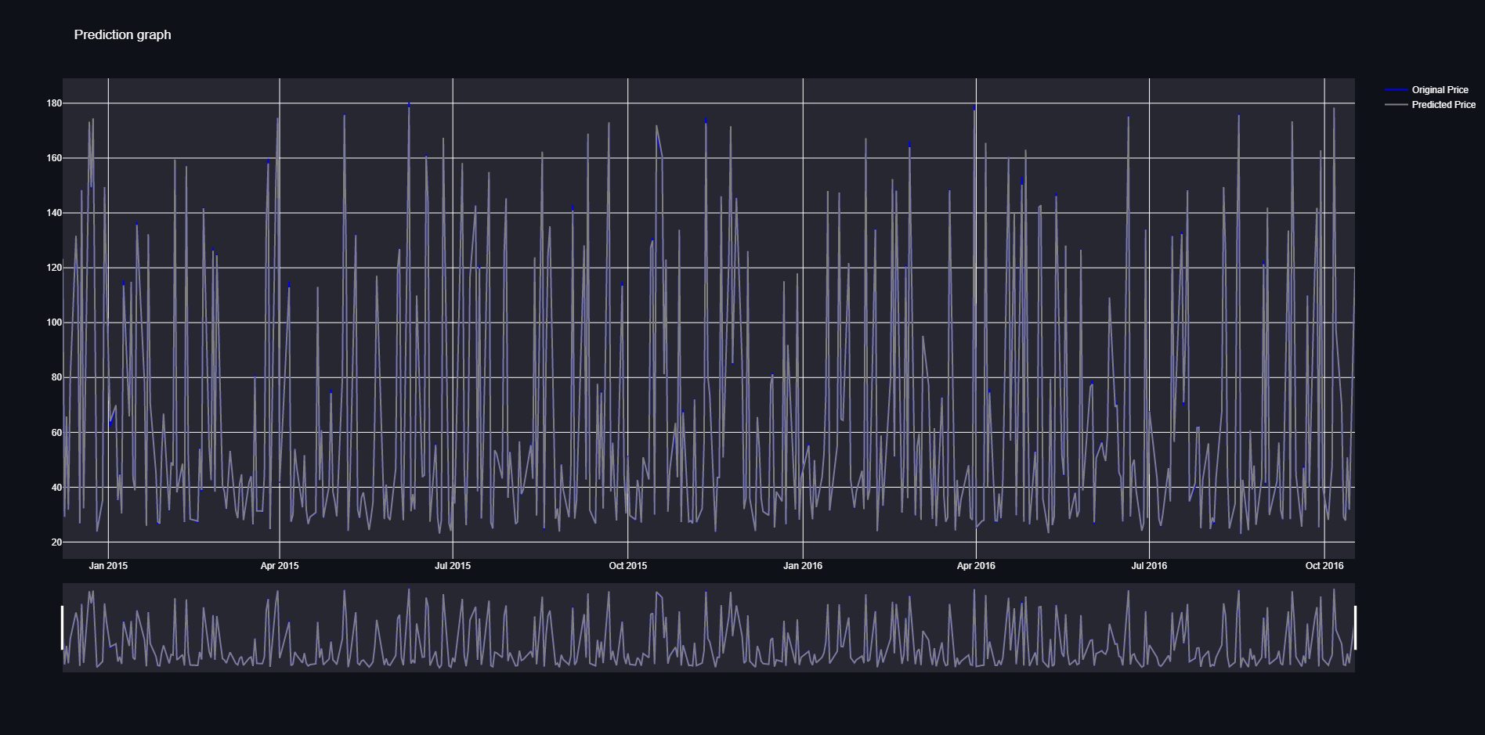

# REFERENCES

1. Yahoo Finance for dataset
2. <https://creativecommons.org/licenses/by/4.0/> for templates.