**20CE034 GUNDALIA DEV Practical 5: Swap Case**

# GitHub Link - [link](https://github.com/20CE034/PIP-II) **Code** –

s= input()

print(s.swapcase())

# Output –

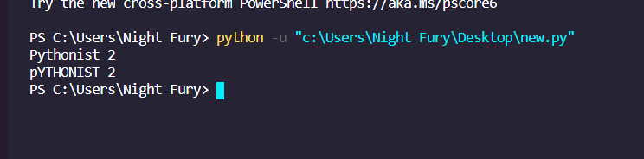

1