Software Requirements Specification

for

Fire Safety website

Guided by: Dhaval Bhoi

**Prepared by 20CE035, 20CE037**

**CSPIT-CE**

**28-01-22**

**Table of Contents**

**1*.* Introduction*………………………………………………………………………………******.*1**

1.1 Objective………………………………………………………………………………….1

1.2 Project Scope ……………………………………………………………………………..1

1.3 References………………………………………………………………………………...1

**2. Overall Description……………………………………………………………………….2**

2.1 Product Perspective……………………………………………………………………….2

2.2 Product Features…………………………………………………………………………..2

2.3 Operating Environment……………………………………………………………...……2

2.4 Design Constraints …..…………………………………………………………………...2

2.5 User Documentation ……………………………………………………………………..3

2.6 Assumptions and Dependencies………………………………………………………….3

**3. External Interface Requirements……………………………………………….…….....3**

3.1 User interface …………………………………………………………………………….3

3.2 Hardware interface ……………………………………………………………………….4

3.3 Software interface ………………………………………………………………………..5

3.4 Communications Interface……………………………………………………………..…5

**4. Other Nonfunctional Requirements……………………………………………………..6**

4.1 Performance Requirements ………………………………………………………………6

4.2 Safety Requirements ……………………………………………………………………..6

4.3 Security Requirements ………………..……………………………………………….....6

4.4 Software Quality Attributes ……………………………………………………………...6

**5.Other Requirements………………………………………………………………………6**

Appendix : Glossary………………………………………………………………………….6

**1. Introduction**

1.1 Objective:

The objective of this project is to develop an online fire NOC system. This service can be accessed from the fire department portal. The applicant can apply online for any service instead of personally visiting the fire department office. This system is web-based in which can only be accessed from the Internet. Applicants can download the NO OBJECTION CERTIFICATE(NOC) through our website.

* 1. Project Scope:

The basic moto of this project is to give the applicant relief to apply online for any service instead of personally visiting the fire department office. This website aims to give the customers the knowledge of actions taken when a fire takes place in their surroundings. Our website provides all the necessary details needed by the customer and helps them select the right products from the comfort of their homes.

* 1. References:
* <https://www.youtube.com/watch?v=Edsxf_NBFrw>

Youtube playlist for learning

* <https://www.youtube.com/watch?v=1SnPKhCdlsU&t=1174s>

Youtube playlist for learning

* <https://www.youtube.com/watch?v=fV8ointgMeQ>

Reference youtube playlist for website backend

**2. Overall Description**

2.1 Product Perspective:

Our Web Application is Fire Safety Based Which Has

Online NOC Application: Users can apply for No Objection Certificate(NOC),Without visiting the fire department.

Equipment Purchase: Users Can Purchase Safety Equipments based on their choice and budget.

Safety Precautions: Users will get to know about what safety measures and precautions should be taken when fire accidents occurs.

2.2 Product Features :

Manage NOC - Administrator can see details of NOC form. Manage Order – The administrator can display of the order. Manage Order Information - It will give specific information about the product. Manage for NOC Information - It provides step-by-step information for the NOC form.

2.3 Operating Environment:

The operating environment for our website is as listed below.

* Client/server system
* Operating system: Windows, MacOs.
* Platform: HTML/JavaScript/CSS

## 2.4 Design and Implementation Constraints:

Describe any items or issues that will limit the options available to the developers. These might include corporate or regulatory policies; hardware limitations (timing requirements, memory requirements); interfaces to other applications; specific technologies, tools, and databases to be used; parallel operations; language requirements; communications protocols; security considerations; design conventions or programming standards.

## 2.5 User Documentation :

In the About Us section of the project, there will be a brief description of the Website. The section will also consist of the details regarding precautions taken during the occurrence of fire.

## 2.6 Assumptions and Dependencies :

The main assumption of this project is that the user will be provided with ample information regarding fire safety products which will help the customer review our products and select the products they wish to purchase and the customer will be provided with the best price.

**3. External Interface Requirements**

* 1. User interface:

Front-end Software: Sublime Text, Notepad

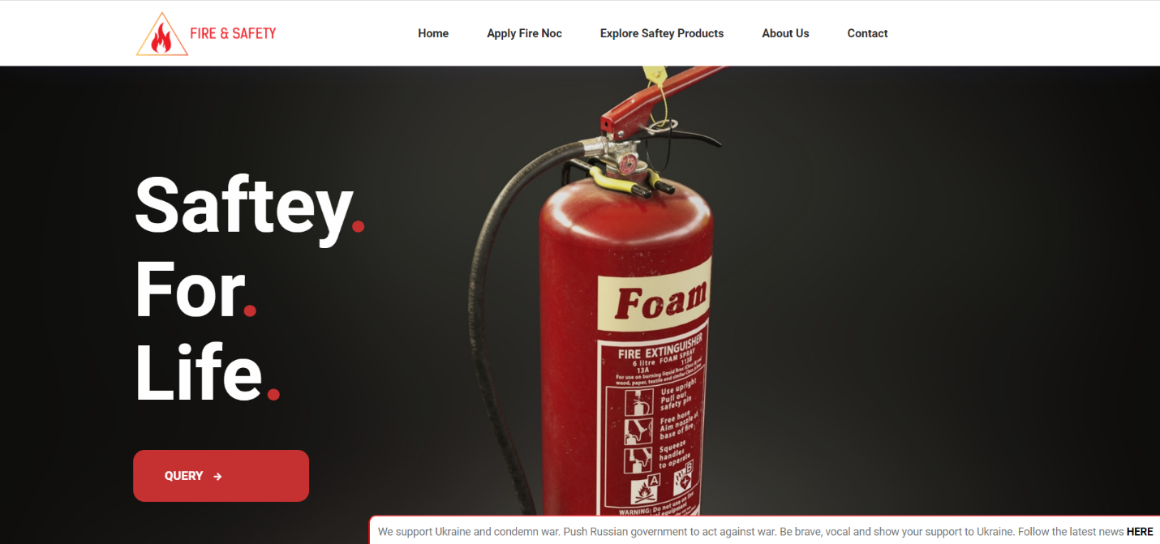

Figure 3.1

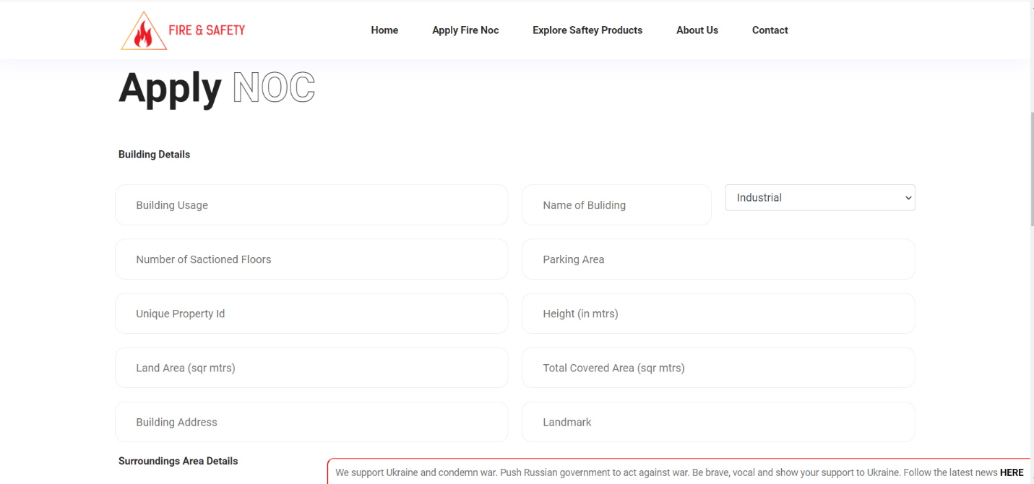

Figure 3.2

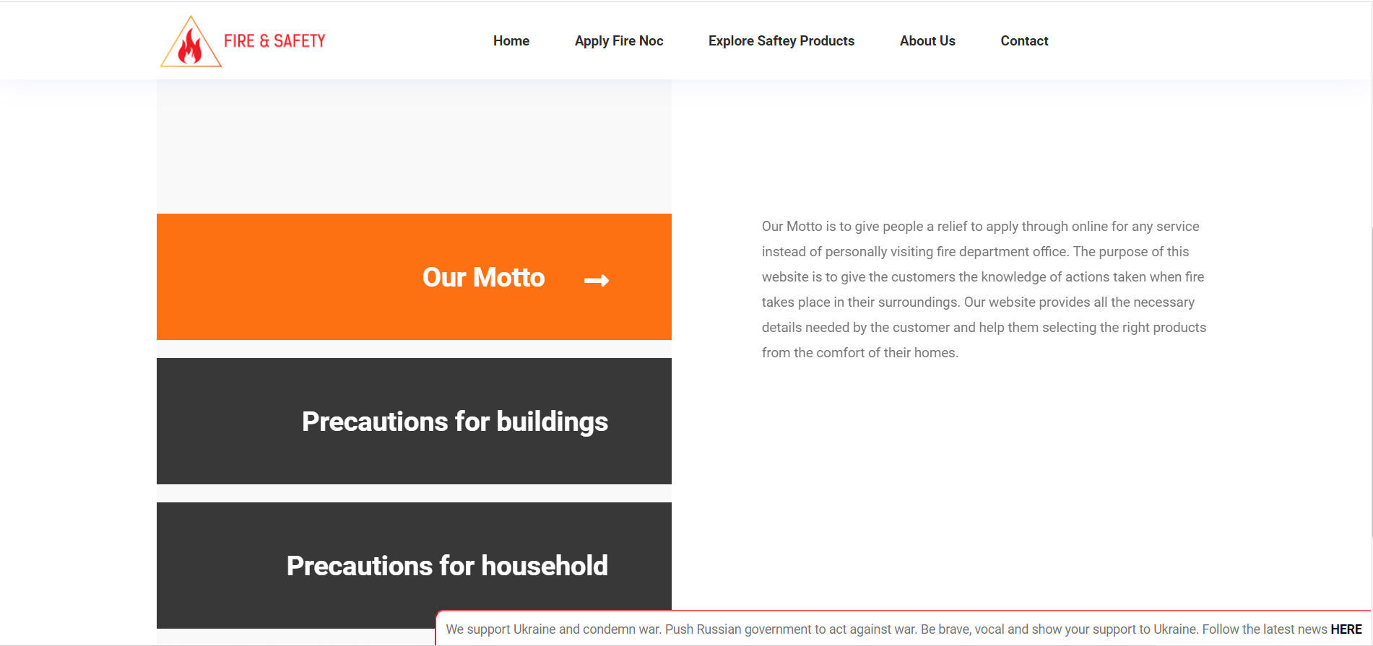

Figure 3.3

3.2 Hardware interface:

Windows Browser which supports CSS, HTML, JavaScript

3.3 Software interface:

Table 3.1 Software Interface

|  |  |
| --- | --- |
| **Software used** | **Description** |
| Operating system | We have chosen Web Browser, Windows operating system for its best support and user-friendliness. |
| Database | To save the flight records, passengers records we have chosen    XAMPP,PHP. |
| Visual studio code | To implement the project we have chosen HTML, CSS, JavaScript language for its more interactive support. |

3.4 Communications Interface:

* This project supports all types of web browsers.

**4. Other Nonfunctional Requirements**

4.1 Performance Requirements:

* The system must be interactive and the delays involved must be less

4.2 Safety Requirements:

Information transmission should be securely transmitted to the server without any information changes. Backups of the databases should be done hourly and be kept for one week.

4.3 Security Requirements:

Id registration is a way to spam check for increased security. Hence, security is provided from the unwanted use of recognization software. Only the API should be able to connect to the databases. Databases should be behind a firewall.

4.4 Software Quality Attributes

* Availability:

If the internet service gets disrupted while sending information to the server, the information can be sent again for verification.

* Usability:

As the system is easy to handle and navigates most expectedly with no delays. In that case, the system program reacts accordingly and transverses quickly between its states.

* Maintainability:

The system should use continuous integration so that features and bug fixes can be deployed quickly without downtime.

**5. Other Requirements**

Appendix : Glossary

No Objection Certificate(NOC): A type of legal certificate issued by any agency, organization, institute, or, in certain cases, an individual. It does not object to the covenants of the certificate. The certification is a requirement at most government-based departments predominantly from the Indian subcontinent.

Application Programming Interface (API): A system of tools and resources (e.g., subroutine

definitions, protocols) in an operating system that enables developers to create

software applications.

HyperText Markup Language (HTML) The standard markup language for creating

web pages and web applications by ISO/IEC 15445 and W3C HTML5.

Cross-platform, Apache server, Mysql, PHP, Perl programming language. (XAMPP)

X=Cross-platform,

A=Apache server,

M=Mysql,

P=PHP,

P=Perl programming language.

it allows you to build WordPress sites offline, on a local web server on your

computer.

Cascading Style Sheets(CSS): used for styling and laying out webpages. It can be used to adjust the content size, spacing, color, and font or add decorative features, such as animations or split content into columns.