**COUNTERFEIT BRAND IDENTIFICATION**

**PROBLEM STATEMENT:** Today in the market most of the consumers choosing online platforms for purchasing the products ,where online websites don’t verify whether the product seller is genuine or not. Due to fake manufacturers most of the buyers gets cheated.

To overcome this problem, we are using blockchain technology to build a network for the verification of genuinity of the product.

**SOLUTION:**

The uniqueness of the batch no is well established using the block chain and helps to detect whether the product is genuine or not by the user .As the manufacturer includes the batch number to the product indicating it’s genuinity,databases of both manufacturer and user are linked through blockchain. User can easily verify the purchased product by searching the product’s batch number in the manufacture , through which fake and original brands can be idenitified easily.

**SOLUTION FABRIC COMPONENTS:**

**ORG 1 ORG 2 ORG 3**

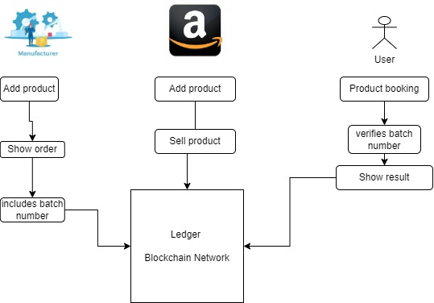

**HIGH-LEVEL FLOW:**

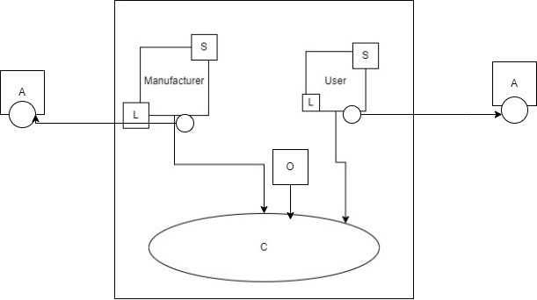

Ledger:

Batch numbers of product

Organizations:

Manufacturer

user

**SMART CONTRACT:**

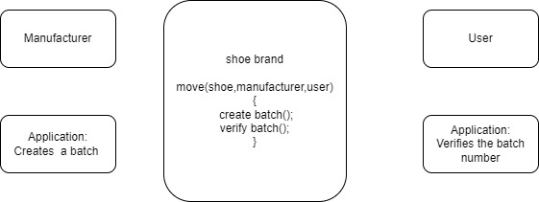

**PSEUDO** **CODE :**

Manufacturer=ORG1;

User=ORG3;

s1=501,s2=502,s3=503,s4=504,s5=505;

Search(int ORG1[],int ORG3)

for(i<0;i<5;i++)

if(ORG1[i]==ORG3)

Return 1;

Return 0;

int main()

int ORG1[5]={s1,s2,s3,s4,s5};

ORG3=s2;

Int I;

Int result=search(ORG1,ORG3);

(result==1)?printf(“original product”): printf(“fake product”);