TC_02

Verify the login functionality for invalid credentials

1. User enters invalid username

User enters valid password

User is able to click on login button but views a error message stating "Invalid credentials"

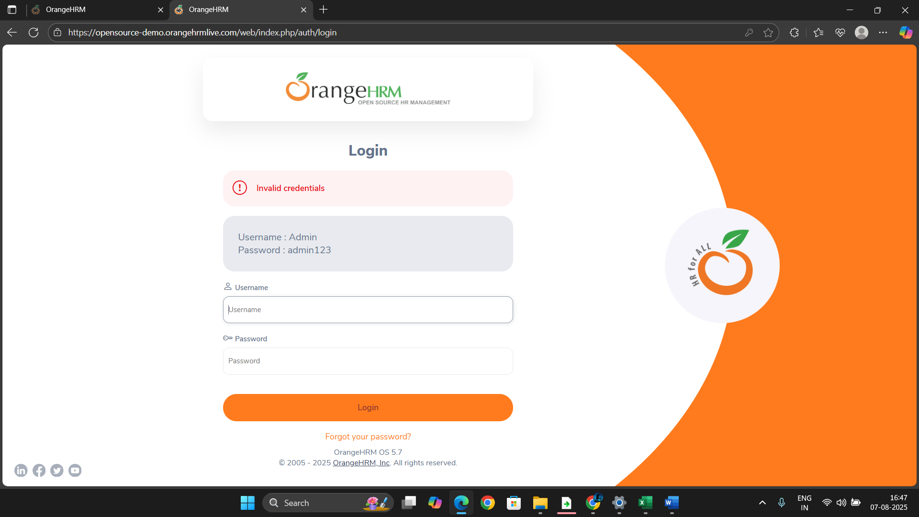

User enters valid username

User enters invalid password

User is able to click on login button but views a error message stating "Invalid credentials"

