TC_03

Verify the social media links

user click on fb button

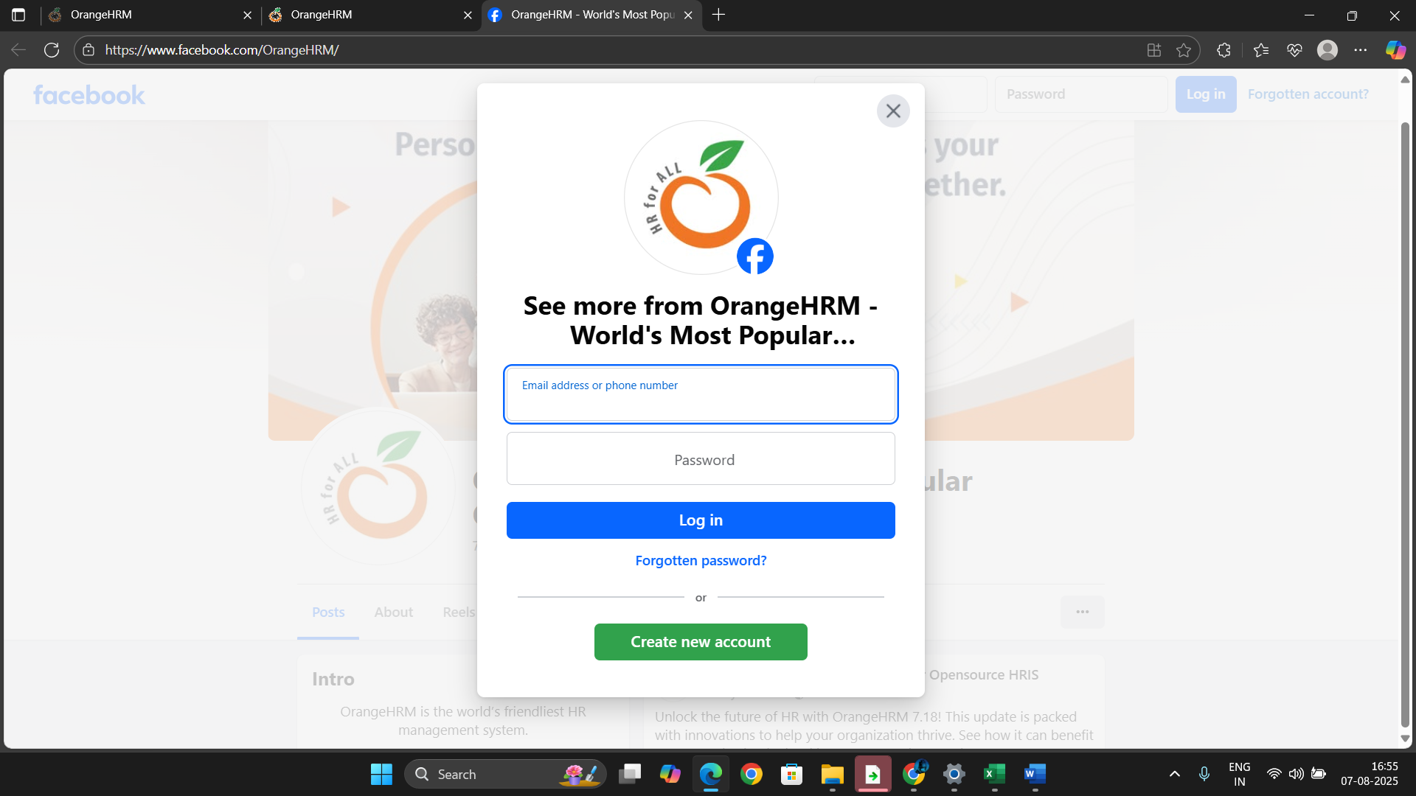

User is able to click on fb button

User click on linkedin button

User is able to click on linkedin button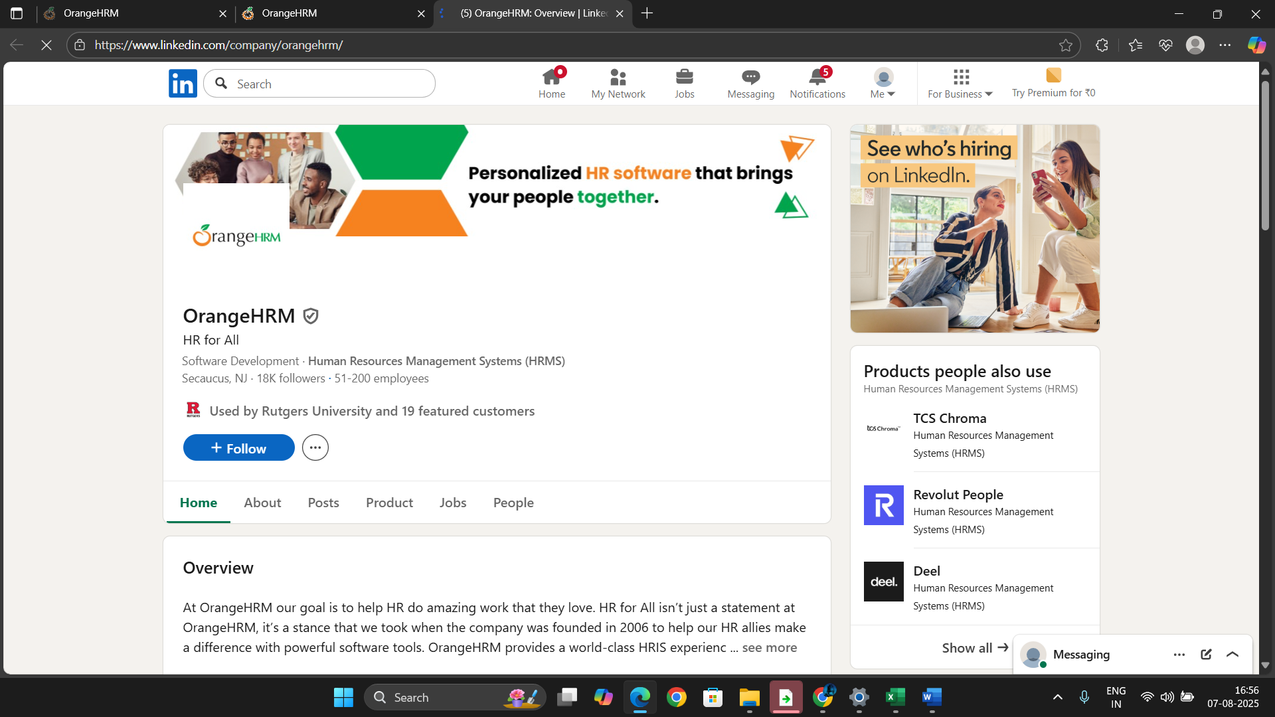

User is able to click on twitter button

