TC_06

Verify the functionality of forgot password button

User is able to click on the forgot password button

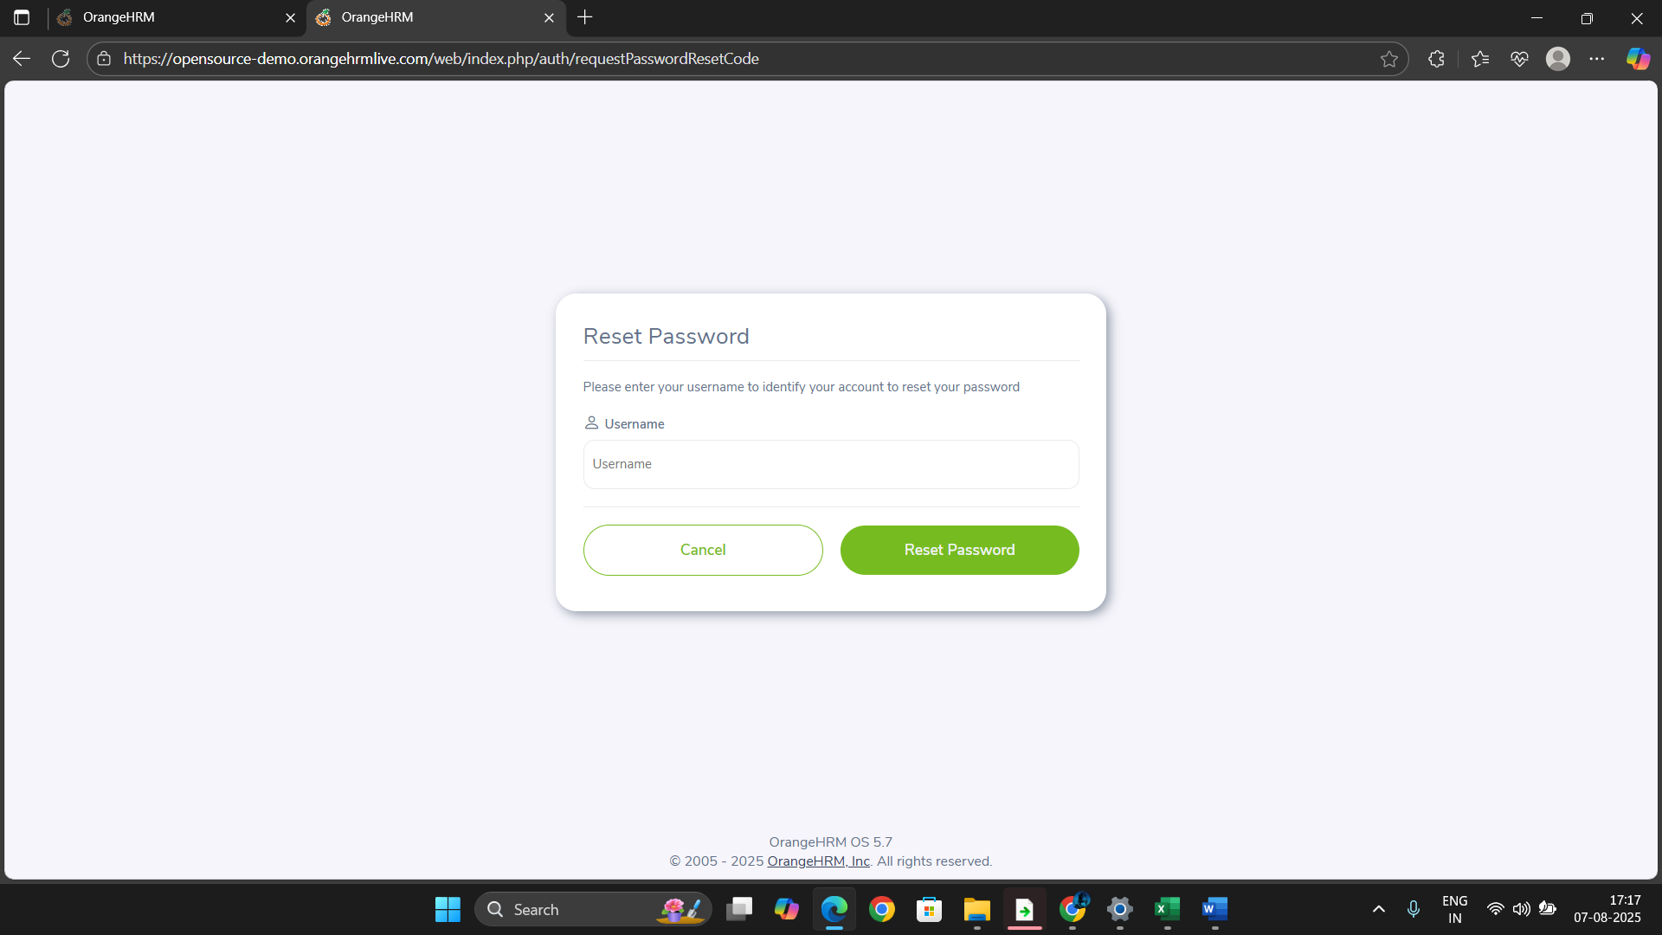

User is able to enter the valid user name.

User is able to click on Reset Password link

