TC_07

Verify the functionality of hrm logo

User should be able to website logo

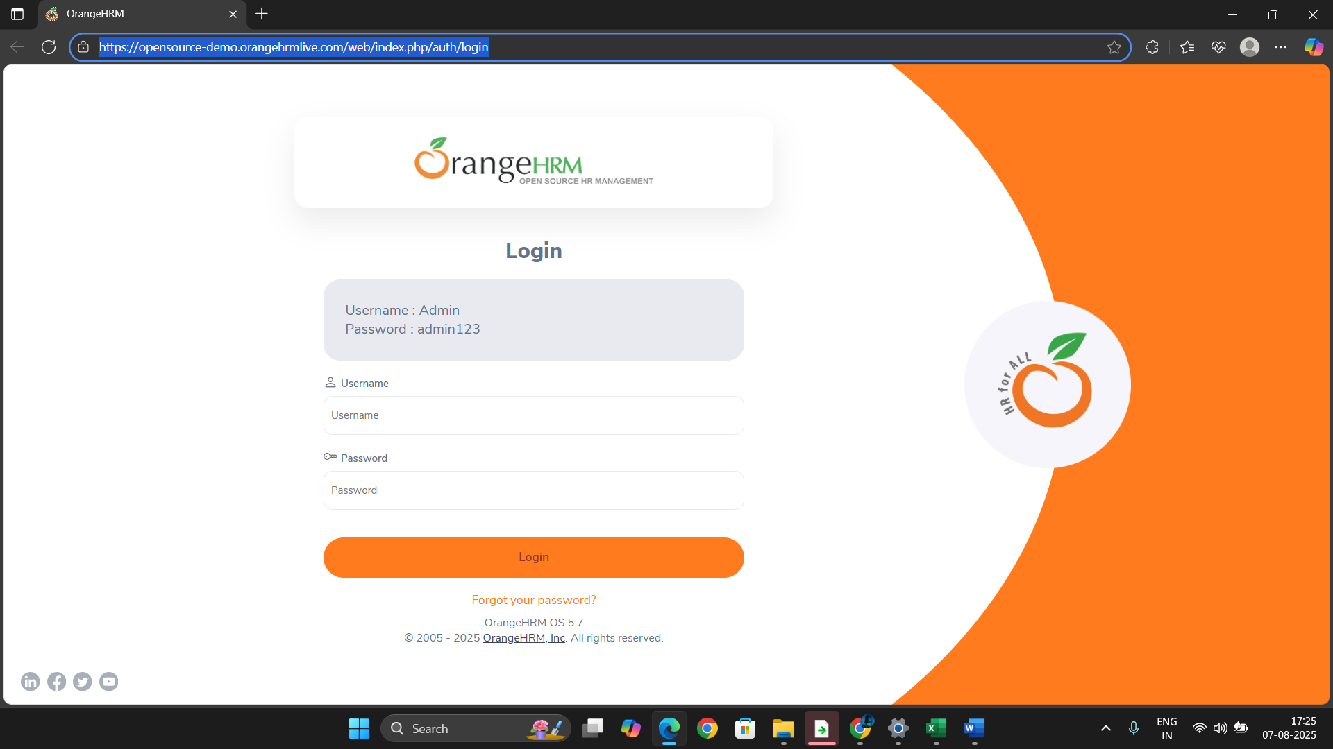

User is able to see the website logo