Lab: CSS Selectors and Rules

# Plan Page

You are given the HTML for the Web page shown below. Write the missing CSS:

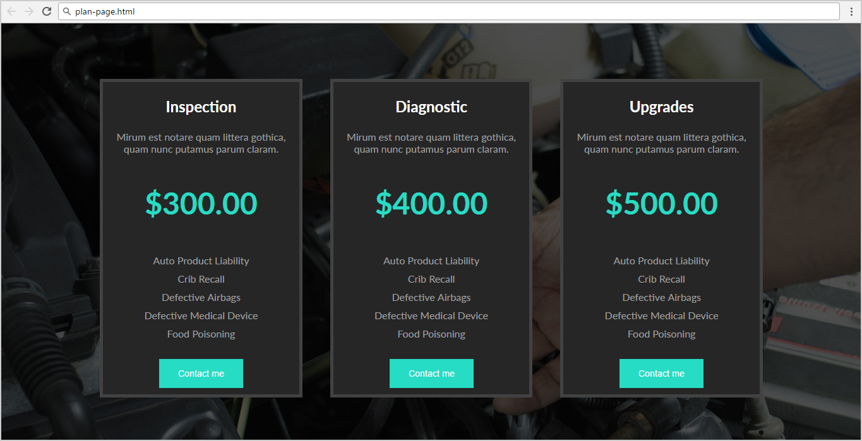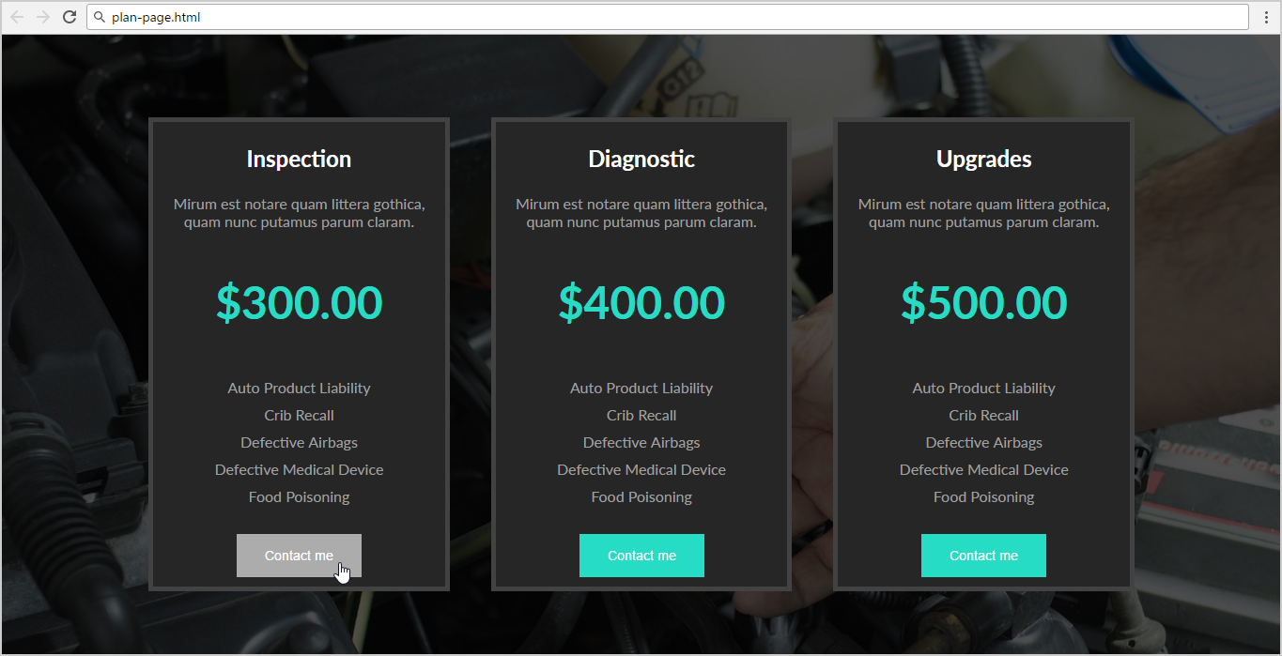

* Use the following HTML file: "**plan-page.html**".
  + You are **NOT** allowed to change the HTML code.
* Write the missing CSS file: "**plan-page.css**".

### Constrains

* **Body**
  + Font Family: **Lato, sans-serif;**
  + Background: **url(plan-page.jpg);**
  + Text size: 16px
  + Width:1180px;
* **Section**
  + Center the **container**
* **Article**
  + Background: **#262626;**
  + Display: **inline-block;**
  + Margin: **80px 20px 0 20px;**
  + Border: **5px solid #424242;**
  + Color: **#a1a1a1;**
* **Article <h1>**
  + Text size: **1.5em;**
  + Color: **#FFF;**
* **<p> with class="price"**
  + Text size: **3em;**
  + Text weight: **bold;**
  + Color: **#27dcc4;**
* **<ul>**
  + Padding: **0;**
* **<button>**
  + Background: **#27dcc4;**
  + Color: **#FFF;**
  + Padding: **15px 30px;**
  + Margin: **10px 0;**
  + Text size: **0.9em;**
  + Cursor: **pointer;**
  + Border: **none;**
* **<button> on hover**
  + Background: **#ACACAC;**
* **<li>**
  + List-style-type: **none;**
  + Padding: **5px 0;**