“SECURE CLOUD BASE FILE ENCRYPTION”
A Main Project
Submitted in partial fulfilment of requirements for the award of the degree of
Bachelor of Technology
in
Computer Science and Engineering (Artificial Intelligence and Machine Learning)
By

VEERAPANI ANJALI | (22HU1A42B0)
PILLI MERI GNANA KUSUMANJALI | (22HU1A4266)
POLURI MOUNIKA | (22HU1A4268)
MANDAPATI ASHOK KUMAR | (22HU1A4248)
BOPPANA NAGA SAI | (22HU1A4212)


Under the Esteemed Guidance of
DR.G. BHARATHI
Associate Professor
DEPARTMENT OF COMPUTER SCIENCE AND ENGINEERING
CHEBROLU ENGINEERING COLLEGE
(UGC-AUTONOMOUS)
Approved by A.I.C.T.E, Permanently Affiliated to JNTU-KAKINADA
CHEBROLU, CHEBROLU MANDAL, GUNTUR-522212.ANDHRAPRADESH.

DEPARTMENT OF COMPUTER SCIENCE AND ENGINEERING
(ARTIFICIAL INTELLIGENCE AND MACHINE LEARNING)
CHEBROLU ENGINEERING COLLEGE
(UGC-AUTONOMOUS)
Approved by A.I.C.T.E, Permanently Affiliated to JNTU-KAKINADA
CHEBROLU, CHEBROLU MANDAL, GUNTUR-522212.ANDHRA PRADESH.
PHONE NO: 9951222268 URL: https://rvit.edu.in/
CERTIFICATE

This is to certify that the project work entitled “SECURE CLOUD BASED FILE ENCRYPTION” is a bonafide record of work carried out by VEERAPANI ANJALI (22HU1A42B0), PILLI MERI GNANA KUSUMANJALI (22HU1A4266), POLURI MOUNIKA (22HU1A4268), MANDAPATI ASHOK KUMAR (22HU1A4248), NAGASAIBOPPANA (22HU1A4212) in partial fulfilment of the requirements for the award of BACHELOR OF TECHNOLOGY with specialization COMPUTER SCIENCE AND ENGINEERING (ARTIFICIAL INTELLIGENCE AND MACHINE LEARNING) in R V Institute of Technology, Autonomous and permanently affiliated to Jawaharlal Nehru Technological University, Kakinada.

PROJECT GUIDE HEAD OF THE DEPARTMENT

EXTERNAL EXAMINER

ACKNOWLEDGEMENT

Firstly, we would like to express our deep and sincere gratitude to our institution CHEBROLU ENGINEERING COLLEGE for providing us with all the required equipment for the fulfilment of Bachelor of Technology with the specialization COMPUTER SCIENCE AND ENGINEERING (ARTIFICIAL INTELLIGENCE AND MACHINE LEARNING).
We express our heart full thanks to the principal Dr. R V KRISHNAIAH for providing us an enthusiastic environment in the college. Head of the Department
COMPUTER SCIENCE AND ENGINEERING (ARTIFICIAL INTELLIGENCE AND MACHINE LEARNING), G. BHARATHI Associate Professor for fastening an excellent academic atmosphere in the institution.
We are very much thankful to our guide, G. BHARATHI associate professor in Department of COMPUTER SCIENCE AND ENGINEERING for his most valuable guidance and suggestions right from project concept to preparation of report. We are greatly wondered due to their sharpness, co-operation in completion of the project.
We convey our thanks to all faculty members both technical and non-technical for their valuable suggestions. At last we convey our thanks to FRIENDS, PARENTS and my family members extend their help directly or indirectly for completion of project in time.

VEERAPANI ANJALI | (22HU1A42B0)
PILLI MERI GNANA KUSUMANJALI | (22HU1A4266)
POLURI MOUNIKA | (22HU1A4268)
MANDAPATI ASHOK KUMAR | (22HU1A4248)
NAGA SAI BOPPANA | (22HU1A4212)

DECLARATION

We hereby declare that the work which is being presented in the Dissertation Entitled “SECURE CLOUD BASED FILE ENCRYPTION”.
Submitted towards the partial fulfilment of requirements for the award of the degree in Bachelor of Technology and authentic record of our work carried out under the supervision of G. BHARATHI, Associate professor in Department of COMPUTER SCIENCE AND ENGINEERING.
The matter embodied in this dissertation report has not been submitted by us for the award of any other degree. Further the technical details furnished in the various chapters in this report are purely relevant to the above project and there is no deviation from the theoretical point of view for design, development and implementation.

Signature of Students

VEERAPANI ANJALI | (22HU1A42B0)
PILLI MERI GNANA KUSUMANJALI | (22HU1A4266)
POLURI MOUNIKA | (22HU1A4268)
MANDAPATI ASHOK KUMAR | (22HU1A4248)
NAGA SAI BOPPANA | (22HU1A4212)

ABSTRACT

The increasing reliance on cloud storage services has raised significant concerns regarding data confidentiality, integrity, and unauthorized access. To address these challenges, this work presents a secure cloud-based file encryption system designed to protect sensitive user data before it is uploaded to remote servers. The system employs strong cryptographic algorithms, such as AES and RSA, to ensure end-to-end security by encrypting files locally on the user’s device and allowing only authenticated users to decrypt them. By integrating user authentication, key-management mechanisms, and seamless cloud interaction, the proposed solution enhances trust and privacy in cloud environments. Experimental evaluation demonstrates that the system achieves efficient performance with minimal overhead while providing robust protection against common security threats, including data breaches, man-in-the-middle attacks, and unauthorized retrieval. This approach enables users to safely store and share files in the cloud without compromising security, making it suitable for personal, enterprise, and distributed computing scenarios.

CONTENTS

CHAPTER – 1 1
1.1 Introduction: 2
1.2 Literature Survey: 3
CHAPTER – 2 6
2.1 Existing System: 7
2.2 Disadvantages of Existing Systems: 7
CHAPTER – 3 9
3.1 Proposed System: 10
3.2 Advantages of the Proposed System: 10
3.3 System Analysis: 11
3.4 SYSTEM REQUIREMENTS: 13
3.5 System Architecture: 13
3.6 UML Diagrams: 14
3.6.1 CLASS DIAGRAM: 14
3.6.2 Use case Diagram: 15
3.6.3 Sequence Diagram: 15
3.6.4 Collaborative Diagram: 16
3.7 System Implementations: 17
3.8 System Environment: 18
3.8.1 What is Python :- 18
3.8.2 Advantages of Python :- 19
3.8.3 Advantages of Python Over Other Languages 21
3.8.4 Disadvantages of Python 21
3.8.5 History of Python: - 23
3.8.6 What is Machine Learning : - 23
3.8.7 Categories of Machine Learning: - 24
3.8.8 Need for Machine Learning: - 24
3.8.9 Challenges in Machines Learning :- 25
3.8.10 Applications of Machines Learning :- 26
3.8.11 How to Start Learning Machine Learning? 26
3.8.12 Advantages of Machine learning: - 29
3.8.13 Disadvantages of Machine Learning: - 30
3.8.14 Python Development Steps : - 31
3.8.15 Python: 32
3.8.16 Modules Used in Project :- 32
3.8.17 Install Python Step-by-Step in Windows and Mac : 34
3.9 SYSTEM TEST : 41
3.9.1 TYPES OF TESTS: 41
3.9.2 Test strategy and approach: 43
3.9.3 Integration Testing: 44
3.9.4 Acceptance Testing: 44
CHAPTER - 4 46
4.1 RESULTS & SCREEN SHOTS: 47
CHAPTER – 5 60
5.1 Conclusion: 61
5.2 Future Work: 61
5.3 Bibliography: 62

CHAPTER - 1

1.1 Introduction:
Cloud computing has transformed the way individuals and organizations store, manage, and access data by providing scalable, on-demand storage services. However, this convenience also introduces serious security and privacy concerns, as sensitive data stored on third-party servers is vulnerable to unauthorized access, breaches, and cyberattacks.
Traditional security measures offered by cloud providers may not always guarantee complete protection, especially when attackers target data during transmission or at rest. As a result, ensuring data confidentiality has become a critical requirement for cloud adoption. Secure cloud-based file encryption offers an effective solution by encrypting files on the client side before they are uploaded to the cloud, ensuring that only authorized users with the correct decryption keys can access the information.
By integrating robust cryptographic algorithms, authentication mechanisms, and secure key management practices, such systems significantly enhance trust and reliability in cloud environments. This approach not only protects user data from external threats but also safeguards it from insider misuse, making it an essential component of modern data security strategies.

1.2 Literature Survey:

Cloud data protection has evolved from trusting provider-side controls to shifting security to clients — encrypting data before it leaves the user’s device is now a widely studied approach to reduce trust in the cloud provider. Frameworks and SDKs from major cloud vendors describe and recommend client-side and envelope-encryption patterns to protect data keys and payloads (e.g., AWS Encryption SDK and KMS guidance). AWS Documentation+1
Academic and industry surveys classify the main encryption-for-cloud strategies into (1) client-side (end-to-end) encryption, (2) server-side/envelope encryption using Key Management Services (KMS), (3) searchable encryption for querying encrypted data, and (4) advanced approaches such as homomorphic encryption and secure enclaves for computation on encrypted data. These surveys summarize trade-offs between security, functionality, and performance for each approach. IJCSNS Paper+1
Searchable encryption and searchable symmetric/asymmetric schemes enable keyword or range queries over encrypted cloud data without revealing plaintext; surveys and recent papers examine designs, leakage profiles, and performance optimizations for large datasets, but note remaining practical limitations (index size, leakage-resistance vs. efficiency). ScienceDirect+1
Homomorphic encryption (HE) promises computation over ciphertexts—ideal for privacy-preserving cloud analytics—but current full/partial HE schemes remain computationally expensive for many real-world file-processing tasks. Recent reviews highlight steady progress and hybrid designs (HE for small, sensitive operations; conventional crypto for bulk storage) as a pragmatic near-term direction. ACM Digital Library+1
Key management is the linchpin: NIST guidance and industry best practices stress secure key generation, wrapping (envelope encryption), rotation, and key access policies. Practical solutions include customer-managed keys (BYOK/HYOK), cloud KMS integration, and hardware-backed key stores; yet getting the key-lifecycle and access-control model right remains a major implementation challenge. NIST Computer Security Resource Center+1

Gaps & Research Directions
The literature converges on three research gaps relevant to this project: (1) balancing strong client-side security with usability and performance (especially on resource-constrained devices), (2) enabling useful operations (search, deduplication, analytics) without excessive leakage, and (3) practical, auditable key-management models that meet compliance requirements while keeping control with users. Hybrid solutions that combine envelope encryption, selective use of HE or secure enclaves, and robust KMS practices are the most recommended near-term path.

CHAPTER - 2

2.1 Existing System:
In the existing cloud storage systems, users typically upload their files directly to cloud servers, relying solely on the security mechanisms provided by the cloud service provider. While these platforms implement basic protections such as access control, user authentication, and server-side encryption, they do not guarantee complete confidentiality. In many cases, the cloud provider holds the encryption keys, meaning that data can potentially be accessed by insiders, compromised accounts, or malicious attackers if the server is breached. Additionally, most existing systems lack client-side encryption, where files are secured before leaving the user's device. This exposes data during transmission and makes it vulnerable to man-in-the-middle attacks, unauthorized modifications, and privacy violations. Due to limited user control over encryption and key management, traditional cloud storage solutions are insufficient for storing highly sensitive or confidential information. These limitations highlight the need for a more secure, user-controlled encryption system that ensures data privacy regardless of cloud provider vulnerabilities.

2.2 Disadvantages of Existing Systems:
- Lack of Client-Side Encryption: Files are often uploaded to the cloud without being encrypted on the user’s device, exposing sensitive data during transmission.
- Cloud-Controlled Encryption Keys: Encryption keys are usually managed by the cloud provider, increasing the risk of unauthorized access if the provider’s system is compromised.
- Vulnerability to Insider and External Attacks: Existing cloud storage systems are prone to data breaches, insider misuse, and security misconfigurations.
- Limited User Control: Users have minimal control over how their data is stored and protected, making it difficult to ensure strong security and regulatory compliance.

CHAPTER - 3

3.1 Proposed System:
The proposed system introduces a secure cloud-based file encryption solution that ensures complete data confidentiality and user control before storing files in the cloud. In this system, all files are encrypted locally on the user’s device using strong cryptographic algorithms such as AES for fast and secure file encryption and RSA for key protection. By implementing client-side encryption, the cloud provider never gains access to the original data or the encryption keys, eliminating the risk of unauthorized access from insiders or external attackers. The system includes a secure authentication mechanism, user-friendly interface, and efficient key management process to generate, store, and retrieve encryption keys safely. Encrypted files are transmitted to the cloud over secure communication channels like SSL/TLS, ensuring protection against man-in-the-middle attacks. Only authorized users with valid decryption keys can retrieve and decrypt the files, guaranteeing end-to-end security. The proposed model significantly enhances privacy, reduces dependency on cloud provider security, and offers a reliable, robust, and scalable solution for individuals and organizations storing sensitive data in the cloud.

3.2 Advantages of the Proposed System:
- Enhanced Data Security: Files are encrypted on the user’s device before upload, ensuring that even the cloud provider cannot access the original data.
- User-Controlled Encryption Keys: Users manage their own encryption and decryption keys, eliminating dependence on cloud provider security and reducing the risk of unauthorized access.
- Secure Data Transmission: Encrypted files are transferred through secure channels like SSL/TLS, protecting data from interception and man-in-the-middle attacks.
- High Privacy and Compliance: The system ensures strong privacy protection and supports compliance with security standards, making it suitable for sensitive personal, organizational, and enterprise data.

3.3 System design
The system design for the secure cloud-based file encryption solution is structured to ensure seamless integration of encryption, authentication, and cloud storage functionalities while maintaining high levels of security and usability. The system is divided into major components including the user interface, encryption/decryption module, key management module, authentication module, and cloud storage interaction layer. When a user selects a file, the encryption module first uses algorithms like AES to encrypt the data locally, while the key management module securely generates and stores the required encryption keys. The authentication module validates user identity through secure login mechanisms before granting access to the encryption or decryption features. Once encrypted, the file is transmitted to the cloud through a secure communication protocol such as SSL/TLS. The cloud storage layer handles file uploading, retrieval, and synchronization, but it never receives plaintext data or decryption keys. When a user requests a file, the system retrieves the encrypted version, verifies user authorization, and decrypts it locally using the appropriate keys. This modular system design ensures robust security, efficient performance, scalability, and user-friendly operation throughout the file lifecycle.

3.4 System architecture
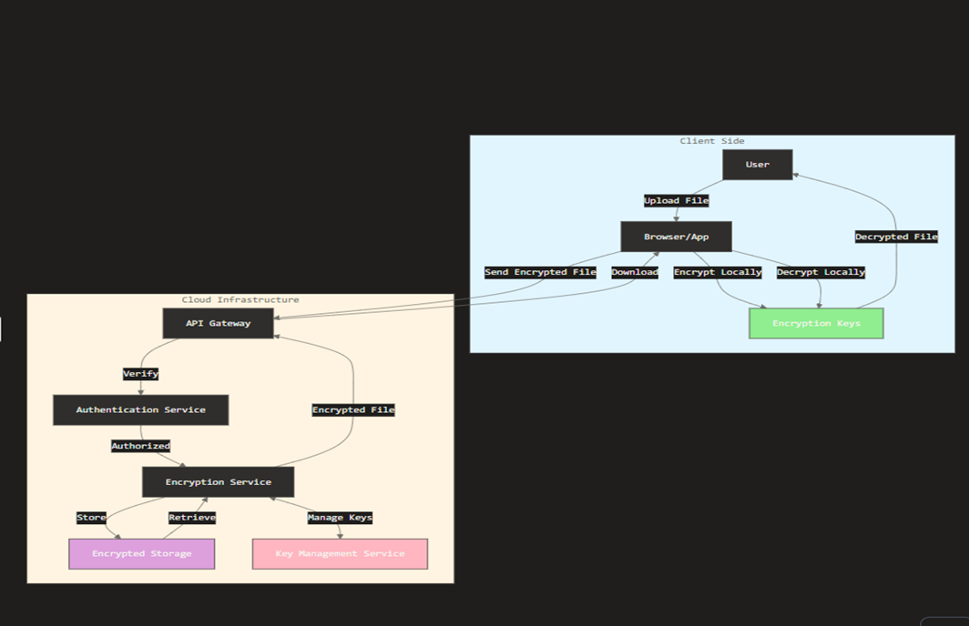
3.5UML DIAGRAMS
3.5.1 CLASS DIAGRAM
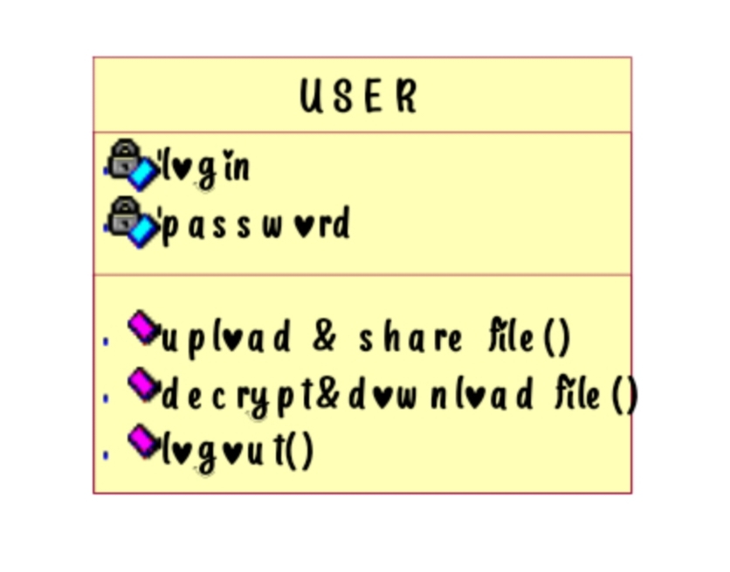
3.5.2 USECASE DIAGRAM
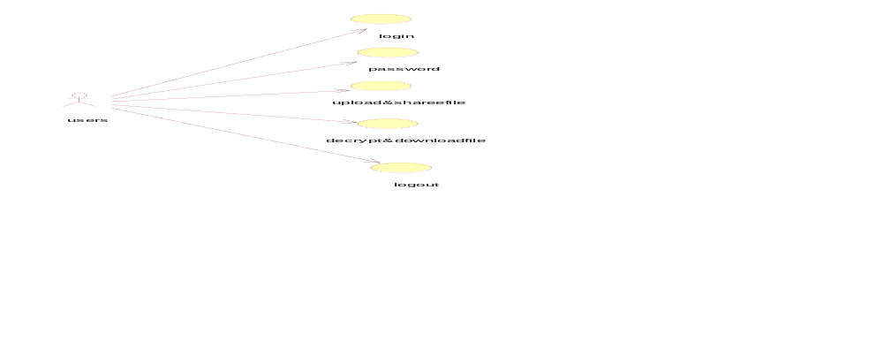
3.5.3 SEQUENCE DIAGRAM
3.5.4 COLLABORATION DIAGRAM
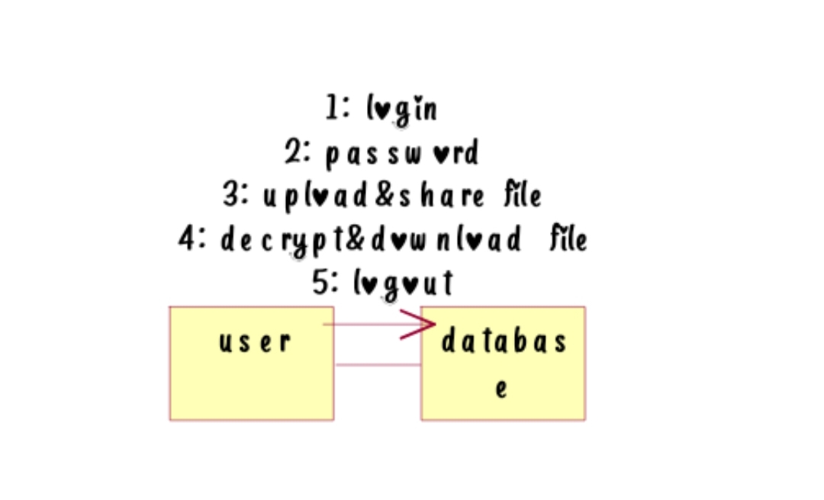
SOFTWARE SPECIFICATION
  - What is python
Below are some facts about Python:
    - Python is currently the most widely used multi-purpose, high-level programming language.
    - Python allows programming in Object-Oriented and Procedural paradigms. Python programs generally are smaller than other programming languages like Java.
    - Programmers have to type relatively less and indentation requirement of the language, makes them readable all the time.
    - Python language is being used by almost all tech-giant companies like – Google, Amazon, Facebook, Instagram, Dropbox, Uber… etc.
The biggest strength of Python is huge collection of standard libraries which can be used for the following.
    - Machine Learning
    - GUI Applications (like Kivy, Tkinter, PyQt etc.)
    - Web frameworks like Django (used by YouTube, Instagram, Dropbox)
    - Image processing (like Opencv, Pillow)
    - Web scraping (like Scrapy, BeautifulSoup, Selenium)
    - Test framework
  - Advantages of Python:
Let’s see how Python dominates over other languages.
- Extensive Libraries
Python downloads with an extensive library and it contain code for various purposes like regular expressions, documentation-generation, unit-testing, web browsers, threading, databases, CGI, email, image manipulation, and more. So, we don’t have to write the complete code for that manually.

- Extensible
As we have seen earlier, Python can be extended to other languages. You can write some of your code in languages like C++ or C. This comes in handy, especially in projects.

- Embeddable
Complimentary to extensibility, Python is embeddable as well. You can put your Python code in your source code of a different language, like C++. This lets us add scripting capabilities to. capabilities to our code in the other language.

- Improved Productivity
The language’s simplicity and extensive libraries render programmers more productive than languages like Java and C++ do. Also, the fact that you need to write less and get more things done.

- IOT Opportunities
Since Python forms the basis of new platforms like Raspberry Pi, it finds the future bright for the Internet Of Things. This is a way to connect the language with the real world.
- Simple and Easy
When working with Java, you may have to create a class to print ‘Hello World’. But in Python, just a print statement will do. It is also quite easy to learn, understand, and code. This is why when people pick up Python, they have a hard time adjusting to other more verbose languages like Java.
- Readable
Because it is not such a verbose language, reading Python is much like reading English. This is the reason why it is so easy to learn, understand, and code. It also does not need curly braces to define blocks, and indentation is mandatory. This further aids the readability of the code.
- Object-Oriented
This language supports both the procedural and object-oriented programming paradigms. While functions help us with code reusability, classes and objects let us model the real world. A class allows the encapsulation of data and functions into one.

- Free and Open-Source
Like we said earlier, Python is freely available. But not only can you download Python for free, but you can also download its source code, make changes to it, and even distribute it. It downloads with an extensive collection of libraries to help you with your task.

- Interpreted
Lastly, we will say that it is an interpreted language. Since statements are executed one by one, debugging is easier than in compiled languages.

Advantages of Python Over Other Languages:
- Less Coding
Almost all of the tasks done in Python requires less coding when the same task is done in other languages. Python also has an awesome standard library support, so you don’t have to search for any third-party libraries to get your job done. This is the reason that many people suggest learning Python to beginners.
- Affordable
Python is free therefore individuals, small companies or big organizations can leverage the free available resources to build applications. Python is popular and widely used so it gives you better community support. The 2019 GitHub annual survey showed us that Python has overtaken Java in the most popular programming language category.
- Python is for everyone
Python code can run on any machine whether it is Linux, Mac or Windows. Programmers need to learn different languages for different jobs but with Python, you can professionally build web apps, perform data analysis and machine learning, automate things, do web scraping and also build games and powerful visualizations. It is an all-rounder programming language.

Disadvantages of Python:
So far, we’ve seen why Python is a great choice for your project. But if you choose it, you should be aware of its consequences as well. Let’s now see the downsides of choosing Python over another language.
- Speed Limitations
We have seen that Python code is executed line by line. But since Python is interpreted, it often results in slow execution. This, however, isn’t a problem unless speed is a focal point for the project. In other words, unless high speed is a requirement, the benefits offered by Python are enough to distract us from its speed limitations.
- Weak in Mobile Computing and Browsers
While it serves as an excellent server-side language, Python is much rarely seen on the client-side. Besides that it is rarely ever used to implement smartphone-based applications. One such application is called Carbonnelle. The reason it is not so famous despite the existence of Brython is that it isn’t that secure.
- Design Restrictions
As you know, Python is dynamically-typed. This means that you don’t need to declare the type of variable while writing the code. It uses duck-typing. But wait, what’s that? Well, it just means that if it looks like a duck, it must be a duck. While this is easy on the programmers during coding, it can raise run-time errors.
- Underdeveloped Database Access Layers
Compared to more widely used technologies like JDBC (Java Data Base Connectivity) and ODBC (Open Data Base Connectivity), Python’s database access layers are a bit underdeveloped. Consequently, it is less often applied in huge enterprises.
- Simple
No, we’re not kidding. Python’s simplicity can indeed be a problem. Take my example. I don’t do Java, I’m more of a Python person. To me, its syntax is so simple that the verbosity of Java code seems unnecessary.

History of Python:
What do the alphabet and the programming language Python have in common? Right, both start with ABC. If we are talking about ABC in the Python context, it's clear that the programming language ABC is meant. ABC is a general-purpose programming language and programming environment, which had been developed in the Netherlands, Amsterdam, at the CWI (Centrum Wiskunde &Informatica). The greatest achievement of ABC was to influence the design of Python. Python was conceptualized in the late 1980s. Guido van Rossum worked that time in a project at the CWI, called Amoeba, a distributed operating system. In an interview with Bill Venners¹, Guido van Rossum said: "In the early 1980s, I worked as an implementer on a team building a language called ABC at Centrum voorWiskunde en Informatica (CWI).
I don't know how well people know ABC's influence on Python. I try to mention ABC's influence because I'm indebted to everything I learned during that project and to the people who worked on it."Later on in the same Interview, Guido van Rossum continued: "I remembered all my experience and some of my frustration with ABC. I decided to try to design a simple scripting language that possessed some of ABC's better properties, but without its problems. So I started typing. I created a simple virtual machine, a simple parser, and a simple runtime. I made my own version of the various ABC parts that I liked. I created a basic syntax, used indentation for statement grouping instead of curly braces or begin-end blocks, and developed a small number of powerful data types: a hash table (or dictionary, as we call it), a list, strings, and numbers."
What is Machine Learning:
Before we take a look at the details of various machine learning methods, let's start by looking at what machine learning is, and what it isn't. Machine learning is often categorized as a subfield of artificial intelligence, but I find that categorization can often be misleading at first brush. The study of machine learning certainly arose from research in this context, but in the data science application of machine learning methods, it's more helpful to think of machine learning as a means of building models of data.

Fundamentally, machine learning involves building mathematical models to help understand data. "Learning" enters the fray when we give these models tunable parameters that can be adapted to observed data; in this way the program can be considered to be "learning" from the data.

Once these models have been fit to previously seen data, they can be used to predict and understand aspects of newly observed data. I'll leave to the reader the more philosophical digression regarding the extent to which this type of mathematical, model-based "learning" is similar to the "learning" exhibited by the human brain.Understanding the problem setting in machine learning is essential to using these tools effectively, and so we will start with some broad categorizations of the types of approaches we'll discuss here.
Categories Of Machine Leaning :
At the most fundamental level, machine learning can be categorized into two main types: supervised learning and unsupervised learning.
Supervised learning involves somehow modeling the relationship between measured features of data and some label associated with the data; once this model is determined, it can be used to apply labels to new, unknown data. This is further subdivided into classification tasks and regression tasks: in classification, the labels are discrete categories, while in regression, the labels are continuous quantities. We will see examples of both types of supervised learning in the following section.
Unsupervised learning involves modeling the features of a dataset without reference to any label, and is often described as "letting the dataset speak for itself." These models include tasks such as clustering and dimensionality reduction.
Clustering algorithms identify distinct groups of data, while dimensionality reduction algorithms search for more succinct representations of the data. We will see examples of both types of unsupervised learning in the following section.
Need for Machine Learning
Human beings, at this moment, are the most intelligent and advanced species on earth because they can think, evaluate and solve complex problems. On the other side, AI is still in its initial stage and haven’t surpassed human intelligence in many aspects. Then the question is that what is the need to make machine learn? The most suitable reason for doing this is, “to make decisions, based on data, with efficiency and scale”.
Lately, organizations are investing heavily in newer technologies like Artificial Intelligence, Machine Learning and Deep Learning to get the key information from data to perform several real-world tasks and solve problems. We can call it data-driven decisions taken by machines, particularly to automate the process. These data-driven decisions can be used, instead of using programing logic, in the problems that cannot be programmed inherently. The fact is that we can’t do without human intelligence, but other aspect is that we all need to solve real-world problems with efficiency at a huge scale. That is why the need for machine learning arises.

Challenges in Machines Learning :-
While Machine Learning is rapidly evolving, making significant strides with cybersecurity and autonomous cars, this segment of AI as whole still has a long way to go. The reason behind is that ML has not been able to overcome number of challenges. The challenges that ML is facing currently are −
Quality of data − Having good-quality data for ML algorithms is one of the biggest challenges. Use of low-quality data leads to the problems related to data preprocessing and feature extraction
Time-Consuming task − Another challenge faced by ML models is the consumption of time especially for data acquisition, feature extraction and retrieval.
Lack of specialist persons − As ML technology is still in its infancy stage, availability of expert resources is a tough job.
No clear objective for formulating business problems − Having no clear objective and well-defined goal for business problems is another key challenge for ML because this technology is not that mature yet.
Issue of over fitting & under fitting −If the model is over fitting or under fitting, it cannot be represented well for the problem.
Curse of dimensionality − Another challenge ML model faces is too many features of data points. This can be a real hindrance.
Difficulty in deployment − Complexity of the ML model makes it quite difficult to be deployed in real life.
Applications of Machines Learning :-
Machine Learning is the most rapidly growing technology and according to researchers we are in the golden year of AI and ML. It is used to solve many real-world complex problems which cannot be solved with traditional approach. Following are some real-world applications of ML −
- Emotion analysis
- Sentiment analysis
- Error detection and prevention
- Weather forecasting and prediction
- Stock market analysis and forecasting
- Speech synthesis
- Speech recognition
- Customer segmentation
- Object recognition
- Fraud detection
- Fraud prevention
- Recommendation of products to customer in online shopping
How to Start Learning Machine Learning?
Arthur Samuel coined the term “Machine learning” in 1959 and defined it as a “Field of study that gives computers the capability to learn without being explicitly programmed”.
And that was the beginning of Machine Learning! In modern times, Machine Learning is one of the most popular (if not the most!) career choices. According to Indeed, Machine Learning Engineer Is The Best Job of 2019 with a 344% growth and an average base salary of $146,085 per year.
But there is still a lot of doubt about what exactly is Machine Learning and how to start learning it? So this article deals with the Basics of Machine Learning and also the path you can follow to eventually become a full-fledged Machine Learning Engineer. Now let’s get started!!
How to start learning ML?
This is a rough roadmap you can follow on your way to becoming an insanely talented Machine Learning Engineer. Of course, you can always modify the steps according to your needs to reach your desired end-goal!
Step 1 – Understand the Prerequisites
In case you are a genius, you could start ML directly but normally, there are some prerequisites that you need to know which include Linear Algebra, Multivariate Calculus, Statistics, and Python. And if you don’t know these, never fear! You don’t need a Ph.D. degree in these topics to get started but you do need a basic understanding.
- Learn Linear Algebra and Multivariate Calculus
Both Linear Algebra and Multivariate Calculus are important in Machine Learning. However, the extent to which you need them depends on your role as a data scientist. If you are more focused on application heavy machine learning, then you will not be that heavily focused on maths as there are many common libraries available. But if you want to focus on R&D in Machine Learning, then mastery of Linear Algebra and Multivariate Calculus is very important as you will have to implement many ML algorithms from scratch.

(b)Learn Statistics
Data plays a huge role in Machine Learning. In fact, around 80% of your time as an ML expert will be spent collecting and cleaning data. And statistics is a field that handles the collection, analysis, and presentation of data. So it is no surprise that you need to learn it!!! Some of the key concepts in statistics that are important are Statistical Significance, Probability Distributions, Hypothesis Testing, Regression, etc. Also, Bayesian Thinking is also a very important part of ML which deals with various concepts like Conditional Probability, Priors, and Posteriors, Maximum Likelihood, etc.
c)Learn Python
Some people prefer to skip Linear Algebra, Multivariate Calculus and Statistics and learn them as they go along with trial and error. But the one thing that you absolutely cannot skip is Python! While there are other languages you can use for Machine Learning like R, Scala, etc. Python is currently the most popular language for ML. In fact, there are many Python libraries that are specifically useful for Artificial Intelligence and Machine Learning such as Keras, TensorFlow, Scikit-learn, etc.
So if you want to learn ML, it’s best if you learn Python! You can do that using various online resources and courses such as Fork Python available Free on GeeksforGeeks.
Step 2 – Learn Various ML Concepts
Now that you are done with the prerequisites, you can move on to actually learning ML (Which is the fun part!!!) It’s best to start with the basics and then move on to the more complicated stuff. Some of the basic concepts in ML are:
- Terminologies of Machine Learning
- Model – A model is a specific representation learned from data by applying some machine learning algorithm. A model is also called a hypothesis.
- Feature – A feature is an individual measurable property of the data. A set of numeric features can be conveniently described by a feature vector. Feature vectors are fed as input to the model. For example, in order to predict a fruit, there may be features like color, smell, taste, etc.
- Target (Label) – A target variable or label is the value to be predicted by our model. For the fruit example discussed in the feature section, the label with each set of input would be the name of the fruit like apple, orange, banana, etc.
- Training – The idea is to give a set of inputs(features) and it’s expected outputs(labels), so after training, we will have a model (hypothesis) that will then map new data to one of the categories trained on.
- Prediction – Once our model is ready, it can be fed a set of inputs to which it will provide a predicted output

(b)Types of Machine Learning
- Supervised Learning – This involves learning from a training dataset with labeled data using classification regression models. This learning process continues until the required level of performance is achieved.
- Unsupervised Learning – This involves using unlabelled data and then finding the underlying structure in the
- data in order to learn more and more about the data itself using factor and cluster analysis models.
Advantages of Machine learning :-
- Easily identifies trends and patterns -
Machine Learning can review large volumes of data and discover specific trends and patterns that would not be apparent to humans. For instance, for an e-commerce website like Amazon, it serves to understand the browsing behaviors and purchase histories of its users to help cater to the right products, deals, and reminders relevant to them. It uses the results to reveal relevant advertisements to them.
- No human intervention needed (automation)
With ML, you don’t need to babysit your project every step of the way. Since it means giving machines the ability to learn, it lets them make predictions and also improve the algorithms on their own. A common example of this is anti-virus softwares; they learn to filter new threats as they are recognized. ML is also good at recognizing spam.
- Continuous Improvement
As ML algorithms gain experience, they keep improving in accuracy and efficiency. This lets them make better decisions. Say you need to make a weather forecast model. As the amount of data you have keeps growing, your algorithms learn to make more accurate predictions faster.
- Handling multi-dimensional and multi-variety data
Machine Learning algorithms are good at handling data that are multi-dimensional and multi-variety, and they can do this in dynamic or uncertain environments.
- Wide Applications
You could be an e-tailer or a healthcare provider and make ML work for you. Where it does apply, it holds the capability to help deliver a much more personal experience to customers while also targeting the right customers.

.

Disadvantages of Machine Learning :-
- Data Acquisition
Machine Learning requires massive data sets to train on, and these should be inclusive/unbiased, and of good quality. There can also be times where they must wait for new data to be generated.
- Time and Resources
ML needs enough time to let the algorithms learn and develop enough to fulfill their purpose with a considerable amount of accuracy and relevancy. It also needs massive resources to function. This can mean additional requirements of computer power for you.
- Interpretation of Results
Another major challenge is the ability to accurately interpret results generated by the algorithms. You must also carefully choose the algorithms for your purpose.
- High error-susceptibility
Machine Learning is autonomous but highly susceptible to errors. Suppose you train an algorithm with data sets small enough to not be inclusive. You end up with biased predictions coming from a biased training set. This leads to irrelevant advertisements being displayed to customers. In the case of ML, such blunders can set off a chain of errors that can go undetected for long periods of time. And when they do get noticed, it takes quite some time to recognize the source of the issue, and even longer to correct it.
Python Development Steps:
Guido Van Rossum published the first version of Python code (version 0.9.0) at alt.sources in February 1991. This release included already exception handling, functions, and the core data types of list, dict, str and others.It was also object oriented and had a module system.Python version 1.0 was released in January 1994. The major new features included in this release were the functional programming tools lambda, map, filter and reduce, which Guido Van Rossum never liked.Six and a half years later in October 2000, Python 2.0 was introduced. This release included list comprehensions, a full garbage collector and it was supporting unicode.Python flourished for another 8 years in the versions 2.x before the next major release as Python 3.0 (also known as "Python 3000" and "Py3K") was released. Python 3 is not backwards compatible with Python 2.x.
The emphasis in Python 3 had been on the removal of duplicate programming constructs and modules, thus fulfilling or coming close to fulfilling the 13th law of the Zen of Python:
"There should be one -- and preferably only one -- obvious way to do it."Some changes in Python 7.3:

- The rules for ordering comparisons have been simplified. E.g. a heterogeneous list cannot be sorted, because all the elements of a list must be comparable to each other.
- There is only one integer type left, i.e. int. long is int as well.
- The division of two integers returns a float instead of an integer. "//" can be used to have the "old" behavior.
- Text Vs. Data Instead Of Unicode Vs. 8-bit
Purpose :-
We demonstrated that our approach enables successful segmentation of intra-retinal layers—even with low-quality images containing speckle noise, low contrast, and different intensity ranges throughout—with the assistance of the ANIS feature.
Python
Python is an interpreted high-level programming language for general-purpose programming. Created by Guido van Rossum and first released in 1991, Python has a design philosophy that emphasizes code readability, notably using significant whitespace.
Python features a dynamic type system and automatic memory management. It supports multiple programming paradigms, including object-oriented, imperative, functional and procedural, and has a large and comprehensive standard library.
    - Python is Interpreted − Python is processed at runtime by the interpreter. You do not need to compile your program before executing it. This is similar to PERL and PHP.
    - Python is Interactive − you can actually sit at a Python prompt and interact with the interpreter directly to write your programs.
Python also acknowledges that speed of development is important. Readable and terse code is part of this, and so is access to powerful constructs that avoid tedious repetition of code. Maintainability also ties into this may be an all but useless metric, but it does say something about how much code you have to scan, read and/or understand to troubleshoot problems or tweak behaviors. This speed of development, the ease with which a programmer of other languages can pick up basic Python skills and the huge standard library is key to another area where Python excels. All its tools have been quick to implement, saved a lot of time, and several of them have later been patched and updated by people with no Python background - without breaking.
Modules Used in Project :
Tensorflow
TensorFlow is a free and open-source software library for dataflow and differentiable programming across a range of tasks. It is a symbolic math library, and is also used for machine learning applications such as neural networks. It is used for both research and production at Google.

TensorFlow was developed by the Google Brain team for internal Google use. It was released under the Apache 2.0 open-source license on November 9, 2015.
Numpy
Numpy is a general-purpose array-processing package. It provides a high-performance multidimensional array object, and tools for working with these arrays.
It is the fundamental package for scientific computing with Python. It contains various features including these important ones:
- A powerful N-dimensional array object
- Sophisticated (broadcasting) functions
- Tools for integrating C/C++ and Fortran code
- Useful linear algebra, Fourier transform, and random number capabilities
Besides its obvious scientific uses, Numpy can also be used as an efficient multi-dimensional container of generic data. Arbitrary data-types can be defined using Numpy which allows Numpy to seamlessly and speedily integrate with a wide variety of databases.
Pandas
Pandas is an open-source Python Library providing high-performance data manipulation and analysis tool using its powerful data structures. Python was majorly used for data munging and preparation. It had very little contribution towards data analysis. Pandas solved this problem. Using Pandas, we can accomplish five typical steps in the processing and analysis of data, regardless of the origin of data load, prepare, manipulate, model, and analyze. Python with Pandas is used in a wide range of fields including academic and commercial domains including finance, economics, Statistics, analytics, etc.
Matplotlib
Matplotlib is a Python 2D plotting library which produces publication quality figures in a variety of hardcopy formats and interactive environments across platforms. Matplotlib can be used in Python scripts, the Python and IPython shells, the Jupyter Notebook, web application servers, and four graphical user interface toolkits.Matplotlib tries to make easy things easy and hard things possible. You can generate plots, histograms, power spectra, bar charts, error charts, scatter plots, etc., with just a few lines of code. For examples, see the sample plots and thumbnail gallery.
For simple plotting the pyplot module provides a MATLAB-like interface, particularly when combined with IPython. For the power user, you have full control of line styles, font properties, axes properties, etc, via an object oriented interface or via a set of functions familiar to MATLAB users.

Python
Python is an interpreted high-level programming language for general-purpose programming. Created by Guido van Rossum and first released in 1991, Python has a design philosophy that emphasizes code readability, notably using significant whitespace.
Python features a dynamic type system and automatic memory management. It supports multiple programming paradigms, including object-oriented, imperative, functional and procedural, and has a large and comprehensive standard library.
  - Python is Interpreted − Python is processed at runtime by the interpreter. You do not need to compile your program before executing it. This is similar to PERL and PHP.
  - Python is Interactive − you can actually sit at a Python prompt and interact with the interpreter directly to write your programs.
Python also acknowledges that speed of development is important. Readable and terse code is part of this, and so is access to powerful constructs that avoid tedious repetition of code. Maintainability also ties into this may be an all but useless metric, but it does say something about how much code you have to scan, read and/or understand to troubleshoot problems or tweak behaviors. This speed of development, the ease with which a programmer of other languages can pick up basic Python skills and the huge standard library is key to another area where Python excels.
All its tools have been quick to implement, saved a lot of time, and several of them have later been patched and updated by people with no Python background - without breaking.
Install Python Step-by-Step in Windows and Mac:
Python a versatile programming language doesn’t come pre-installed on your computer devices. Python was first released in the year 1991 and until today it is a very popular high-level programming language. Its style philosophy emphasizes code readability with its notable use of great whitespace.
The object-oriented approach and language construct provided by Python enables programmers to write both clear and logical code for projects. This software does not come pre-packaged with Windows.
How to Install Python on Windows and Mac:
There have been several updates in the Python version over the years. The question is how to install Python? It might be confusing for the beginner who is willing to start learning Python but this tutorial will solve your query. The latest or the newest version of Python is version 3.7.4 or in other words, it is Python 3.

Note: The python version 3.7.4 cannot be used on Windows XP or earlier devices.

Download the Correct version into the system

Step 1: Go to the official site to download and install python using Google Chrome or any other web browser. OR Click on the following link: https://www.python.org
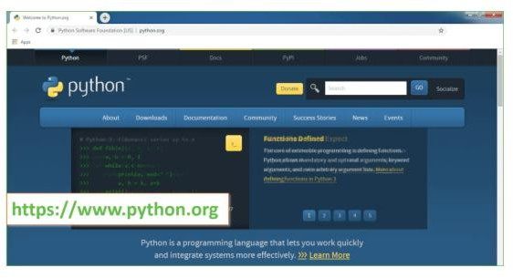
Now, check for the latest and the correct version for your operating system.
Step 2: Click on the Download Tab.
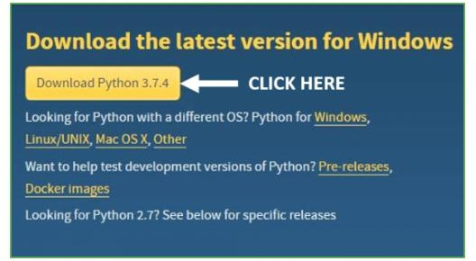
Step 3: You can either select the Download Python for windows 3.7.4 button in Yellow Color or you can scroll further down and click on download with respective to their version. Here, we are downloading the most recent python version for windows 3.7.4
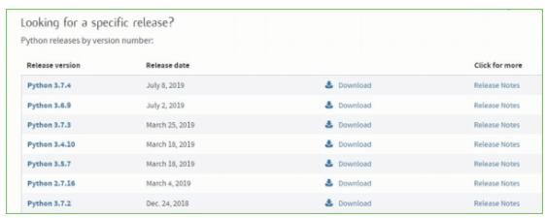
Step 4: Scroll down the page until you find the Files option.
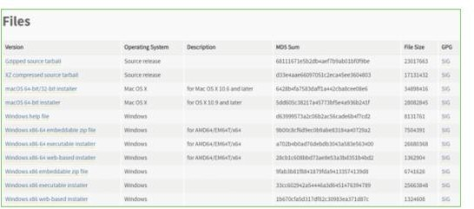
Step 5: Here you see a different version of python along with the operating system.

- To download Windows 32-bit python, you can select any one from the three options: Windows x86 embeddable zip file, Windows x86 executable installer or Windows x86 web-based installer.
- To download Windows 64-bit python, you can select any one from the three options: Windows x86-64 embeddable zip file, Windows x86-64 executable installer or Windows x86-64 web-based installer.
Here we will install Windows x86-64 web-based installer. Here your first part regarding which version of python is to be downloaded is completed. Now we move ahead with the second part in installing python i.e. Installation.

Installation of Python
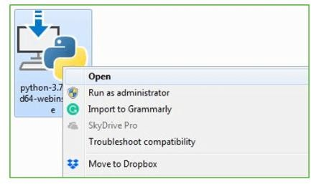
Step 1: Go to Download and Open the downloaded python version to carry out the installation process.
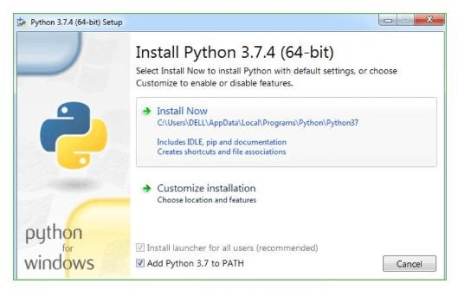
Step 2: Before you click on Install Now, Make sure to put a tick on Add Python 3.7 to PATH.
Step 3: Click on Install NOW After the installation is successful. Click on Close.

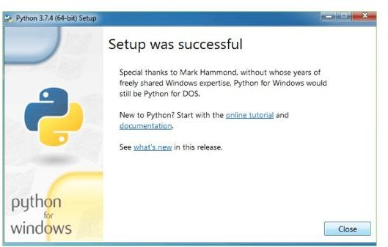
With these above three steps on python installation, you have successfully and correctly installed Python. Now is the time to verify the installation.
Note: The installation process might take a couple of minutes.
Verify the Python Installation
Step 1: Click on Start
Step 2: In the Windows Run Command, type “cmd”.

Step 3: Open the Command prompt option.

Step 4: Let us test whether the python is correctly installed. Type python –V and press Enter.
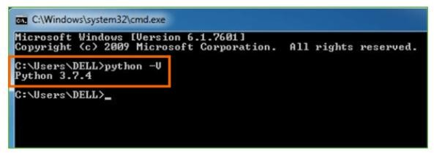
Step 5: You will get the answer as 3.7.4
Note: If you have any of the earlier versions of Python already installed. You must first uninstall the earlier version and then install the new one.
Check how the Python IDLE works
Step 1: Click on Start
Step 2: In the Windows Run command, type “python idle”.
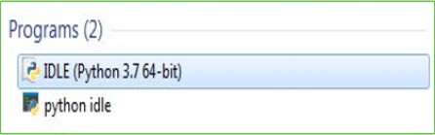
Step 3: Click on IDLE (Python 3.7 64-bit) and launch the program
Step 4: To go ahead with working in IDLE you must first save the file. Click on File > Click on Save

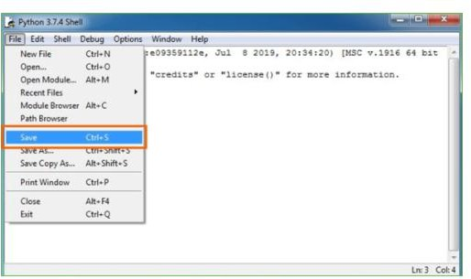
Step 5: Name the file and save as type should be Python files. Click on SAVE. Here I have named the files as Hey World.
Step 6: Now for e.g. enter print

Implementation:
from Crypto.Cipher import AES, PKCS1_OAEP
from Crypto.PublicKey import RSA
from Crypto.Random import get_random_bytes
import os
# ----------------- RSA Key Generation -----------------
def generate_rsa_keys():
key = RSA.generate(2048)
private_key = key.export_key()
public_key = key.publickey().export_key()
with open("private.pem", "wb") as priv_file:
priv_file.write(private_key)
with open("public.pem", "wb") as pub_file:
pub_file.write(public_key)
print("RSA keys generated successfully.")

# ----------------- AES File Encryption -----------------
def encrypt_file(file_name):
# Generate AES key
session_key = get_random_bytes(16) # 128-bit AES key
cipher_aes = AES.new(session_key, AES.MODE_EAX)

# Read file data
with open(file_name, "rb") as f:
data = f.read()
ciphertext, tag = cipher_aes.encrypt_and_digest(data)

# Save encrypted file
enc_file_name = file_name + ".enc"
with open(enc_file_name, "wb") as f:
[ f.write(x) for x in (cipher_aes.nonce, tag, ciphertext) ]

# Encrypt AES key with RSA public key
with open("public.pem", "rb") as f:
recipient_key = RSA.import_key(f.read())
cipher_rsa = PKCS1_OAEP.new(recipient_key)
enc_session_key = cipher_rsa.encrypt(session_key)

# Save encrypted AES key
with open(file_name + ".key", "wb") as f:
f.write(enc_session_key)
print(f"File '{file_name}' encrypted successfully.")
return enc_file_name

# ----------------- AES File Decryption -----------------
def decrypt_file(enc_file_name, key_file):
# Load RSA private key
with open("private.pem", "rb") as f:
private_key = RSA.import_key(f.read())
cipher_rsa = PKCS1_OAEP.new(private_key)

# Decrypt AES session key
with open(key_file, "rb") as f:
enc_session_key = f.read()
session_key = cipher_rsa.decrypt(enc_session_key)
# Read encrypted file
with open(enc_file_name, "rb") as f:
nonce, tag, ciphertext = [ f.read(x) for x in (16,16,-1) ]

# Decrypt data
cipher_aes = AES.new(session_key, AES.MODE_EAX, nonce=nonce)
data = cipher_aes.decrypt_and_verify(ciphertext, tag)

# Save decrypted file
dec_file_name = enc_file_name.replace(".enc","_dec.txt")
with open(dec_file_name, "wb") as f:
f.write(data)
print(f"File '{dec_file_name}' decrypted successfully.")
return dec_file_name
# ----------------- Main Program -----------------
if __name__ == "__main__":
generate_rsa_keys()

file_to_encrypt = "sample.txt" # Replace with your file
enc_file = encrypt_file(file_to_encrypt)
Screens
In this project as peer your request we have added AES along with CBC and HMAC for secure file encryption and then added OTP based Multifactor authentication and OTP will be sent to registered email id. Each data owner can share file with other desired users to control access. AES will use IBE based key for file encryption and then employing LOG based functionality to log all user activities
To implement this project we have designed following modules
- New User Signup Here: user can sign up with the application
- User Login: user can login to system, after login user get OTP in mail which has to utilize to complete login process
- Upload & Share File: user can upload and share file with other desired users and file will be saved at static/files folder in encrypted format
- Decrypt & Download File: using this module user can view all his uploaded and other user files list and then can download desired files
To run project install Python 3.7.2 and then install all packages given in requirements.txt file and then create database in MYSQL by copying and pasting ‘database.txt’ content in MYSQL console
Now double click on ‘run.bat’ file to start python server and get below page
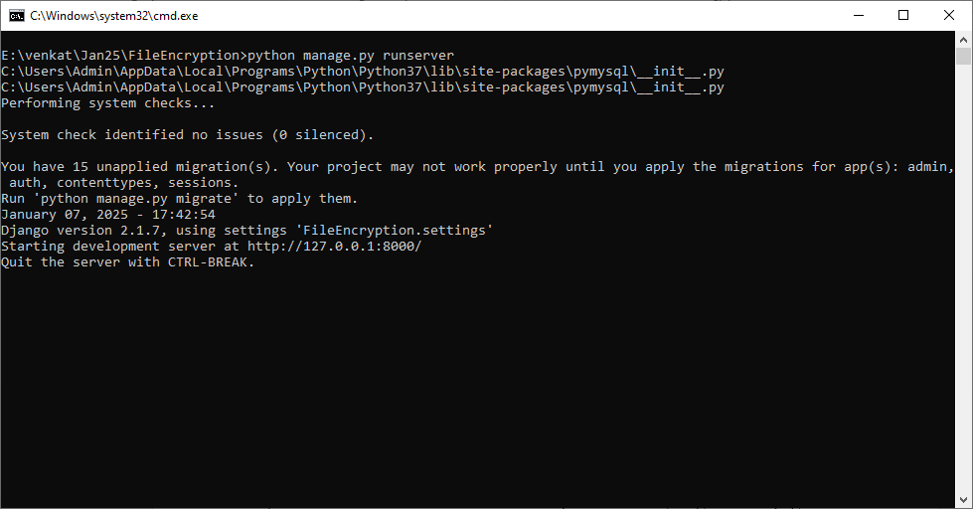
In above screen python server started and now open browser and enter URL as http://127.0.0.1:8000/index.html and then press enter key to get below page
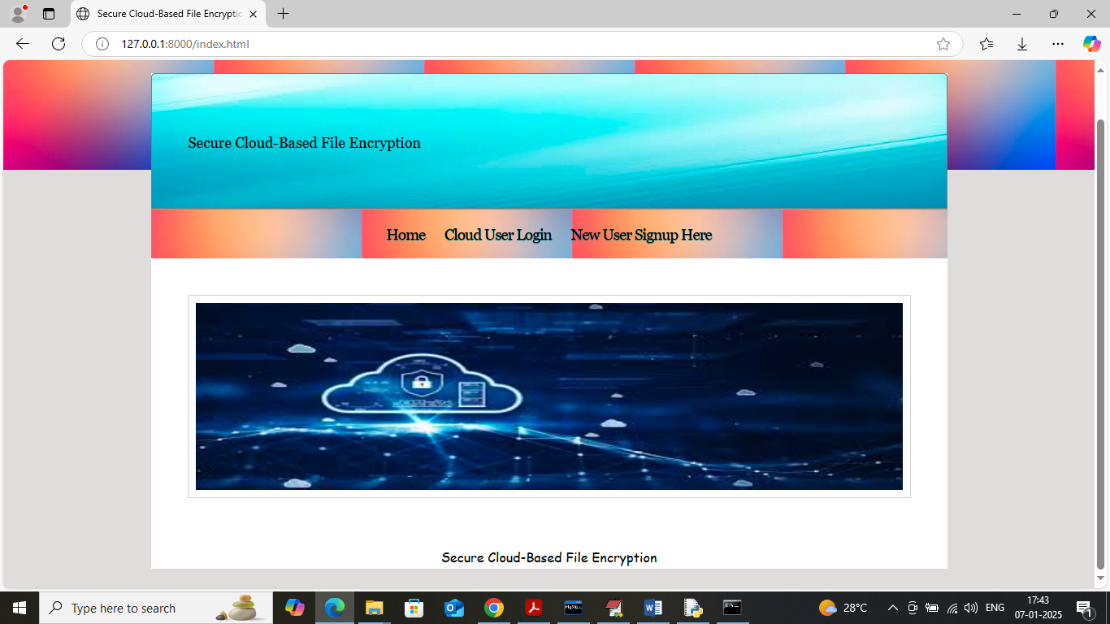
In above screen click on ‘New User Si&gn up’ link to get below page
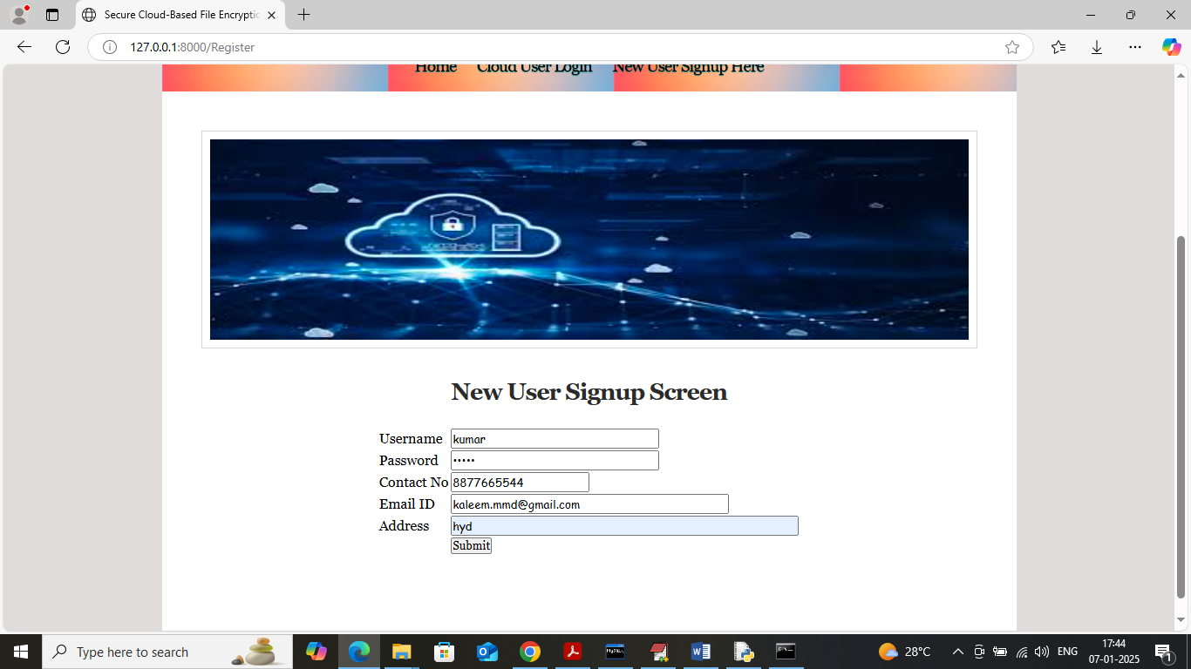
In above screen user is entering sign up details and give valid mail id to receive OTP emails and then press button to get below page
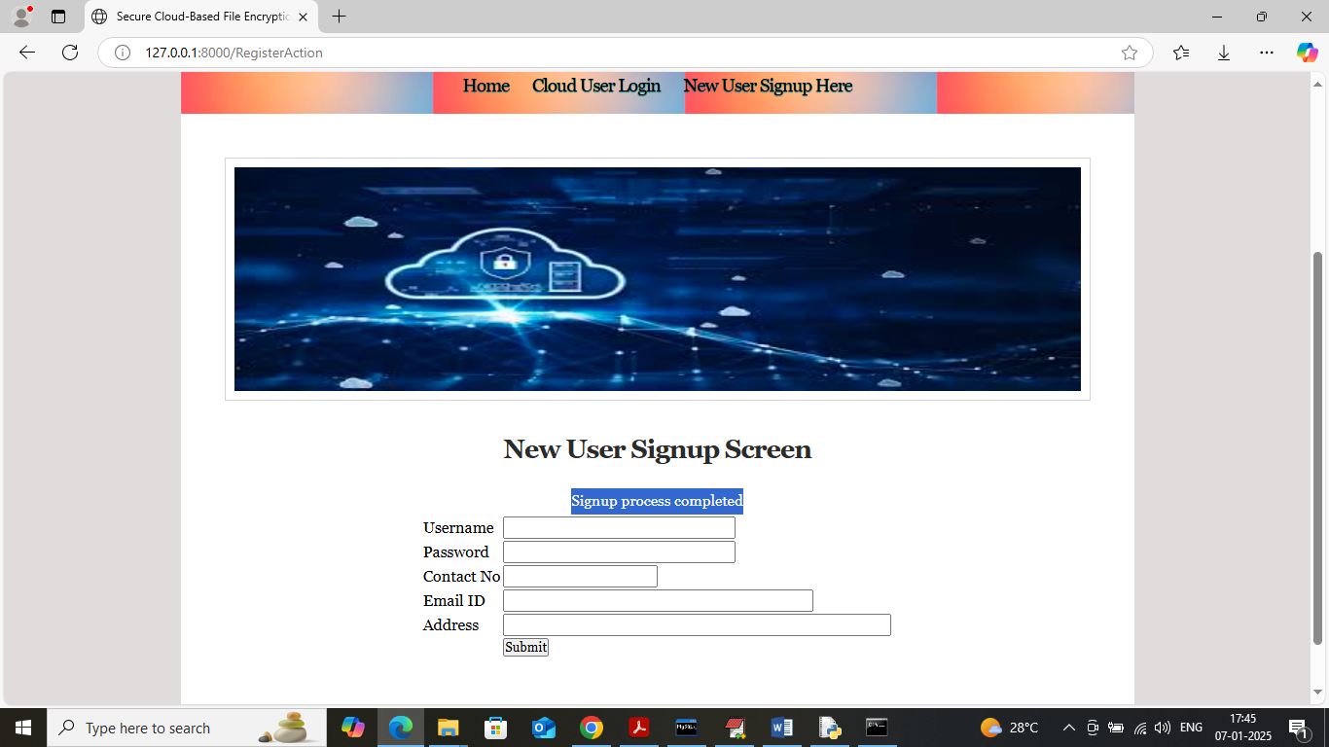
In above screen user signup completed and similarly you can add many users and now click on ‘User Login’ link to get below page
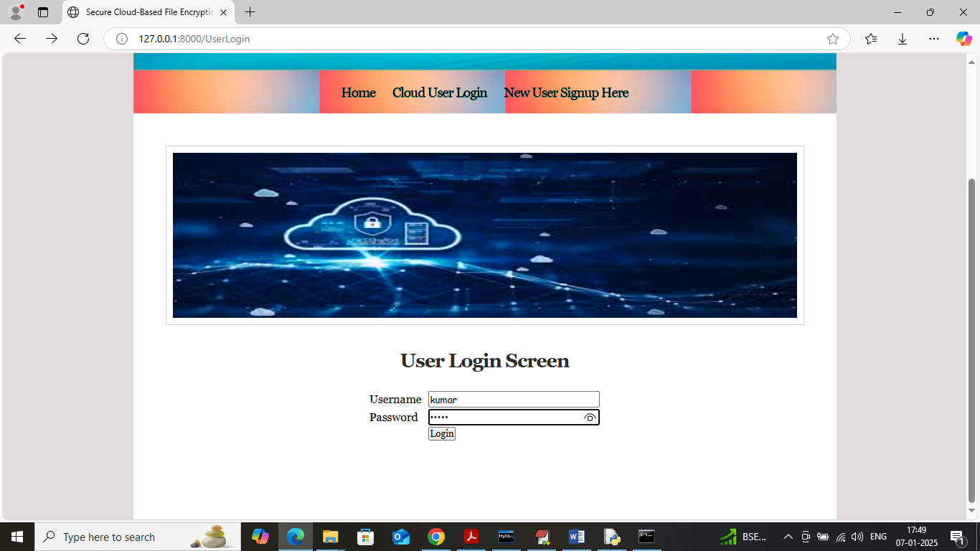
In above screen user is login and after login will get OTP in mail like below page
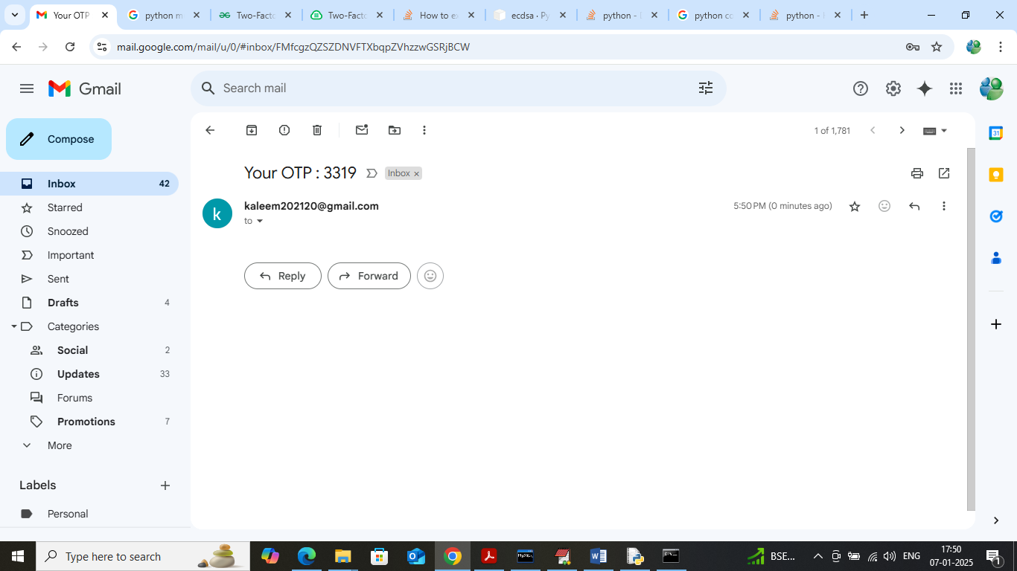
In above screen OTP received in email and now validate in application like below page
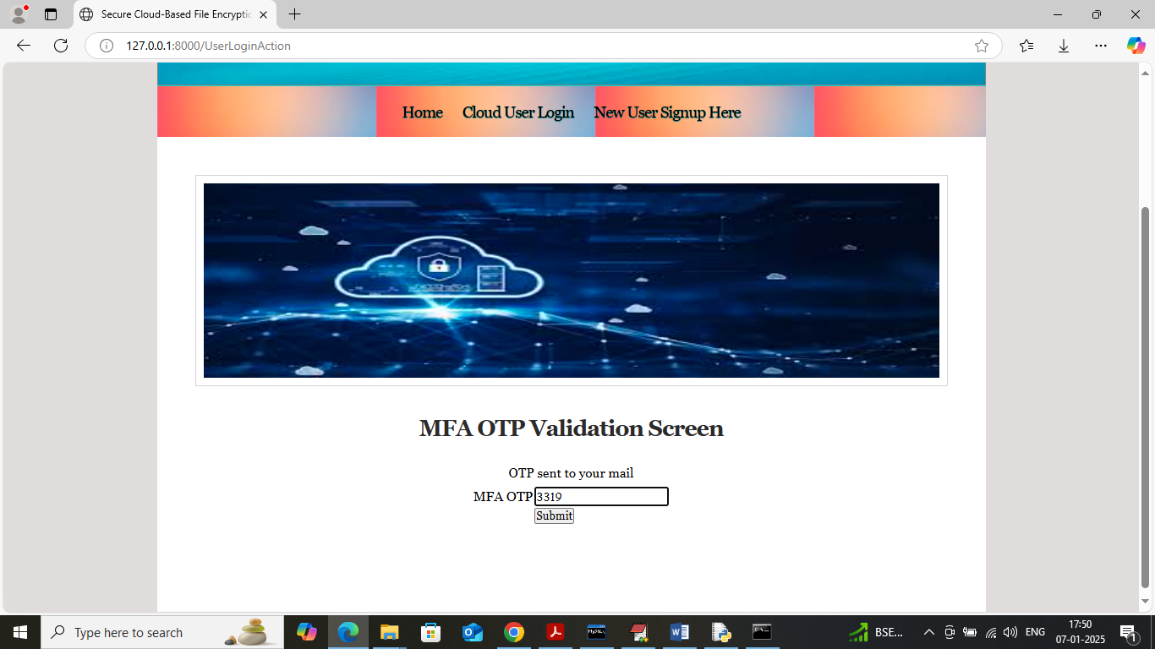
In above screen validating OTP and then press button to get below page
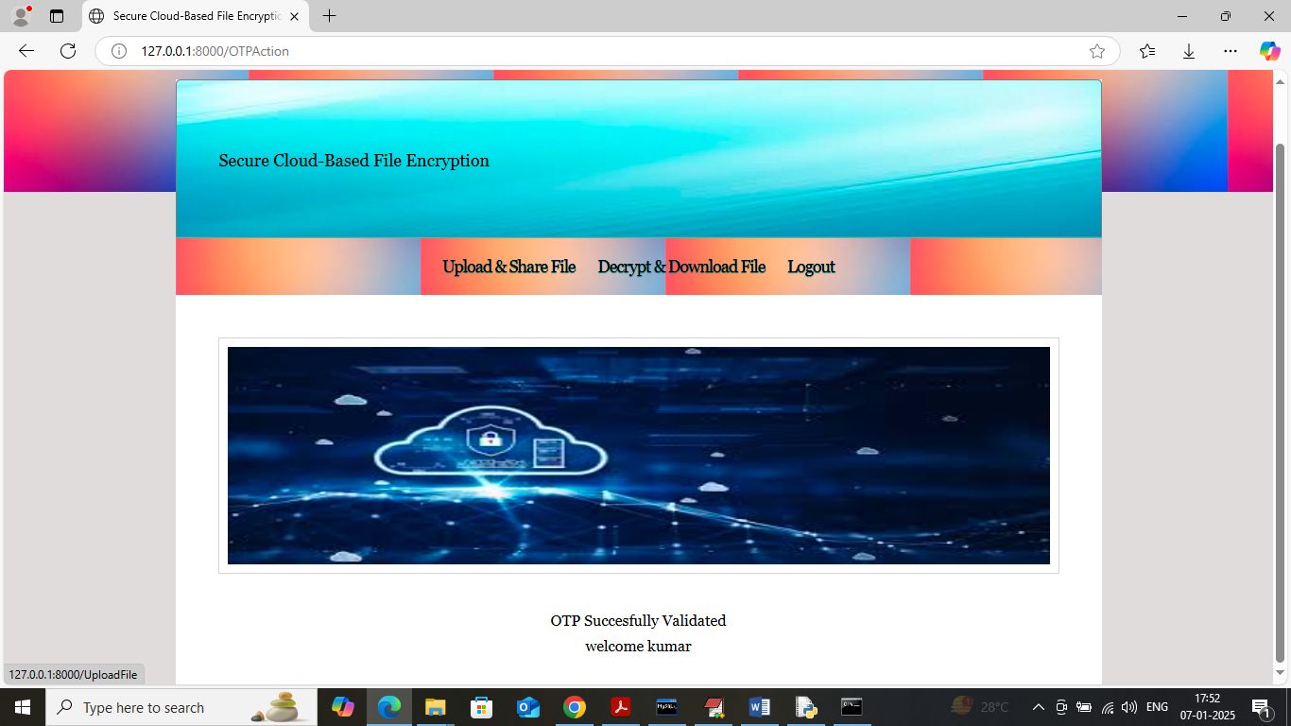
In above screen click on ‘Upload & Share File’ link to upload file and get below page
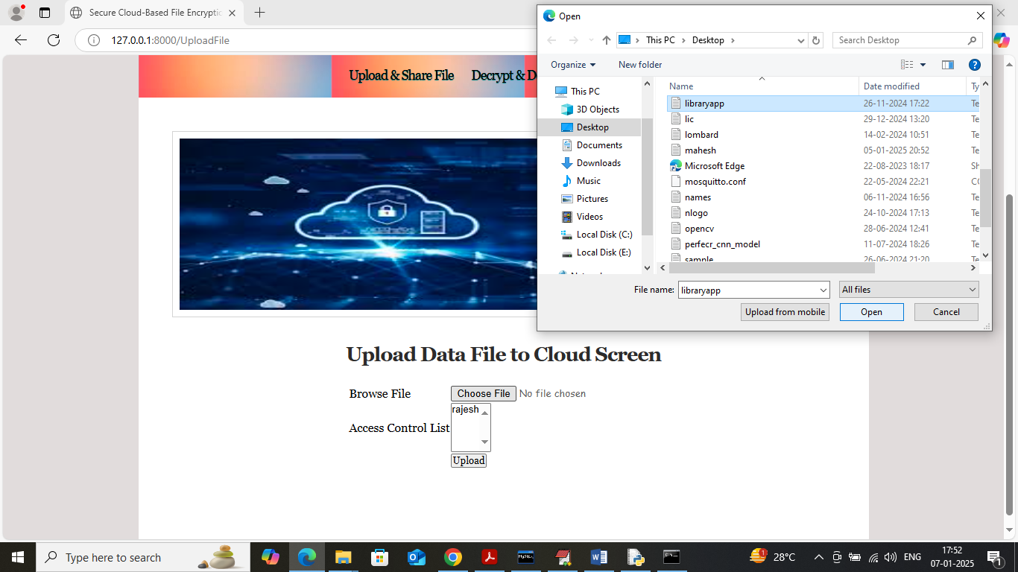
In above screen select and upload file and then choose sharing user by holding CTRL key of you want to share with multiple users and then press button to save file and get below page
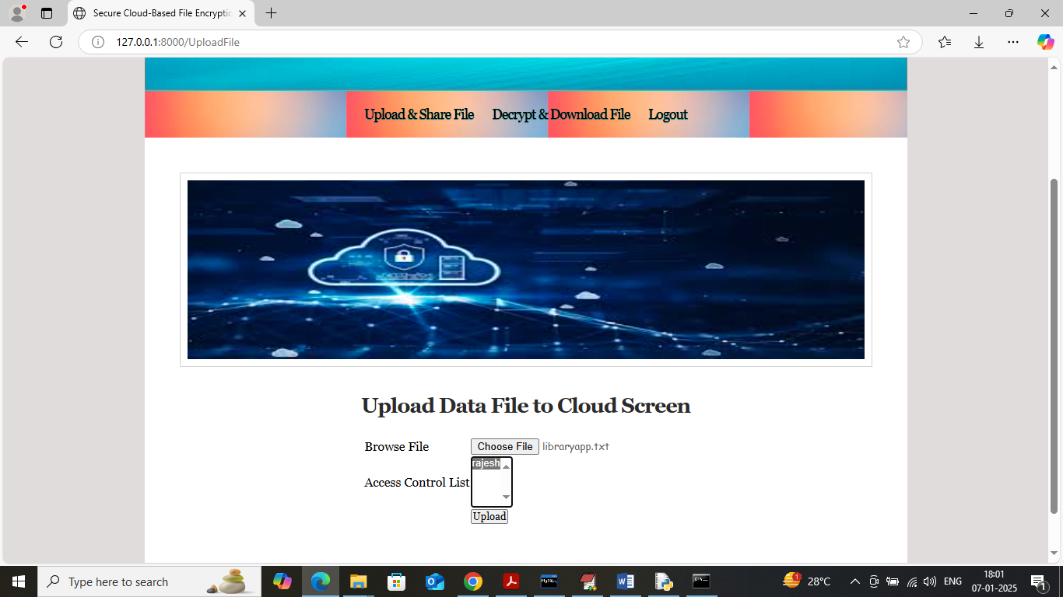
In above screen select the users and then press button to get below page
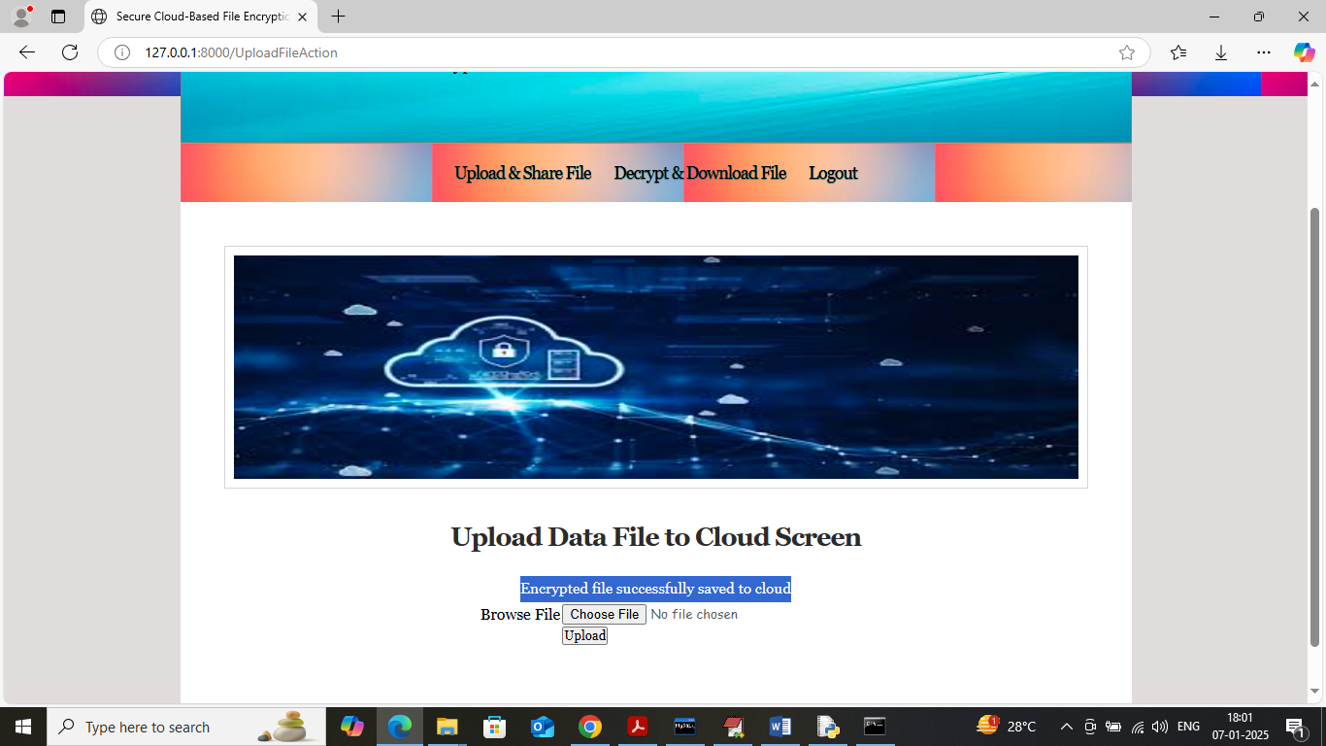
In above screen encrypted file saved at cloud which can see in below screen
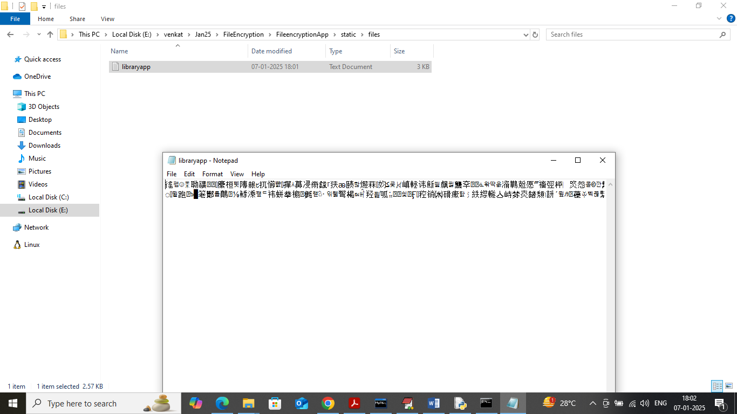
In above screen uploaded file can see in encrypted format and now click on ‘Decrypt & Download File’ to get list of files
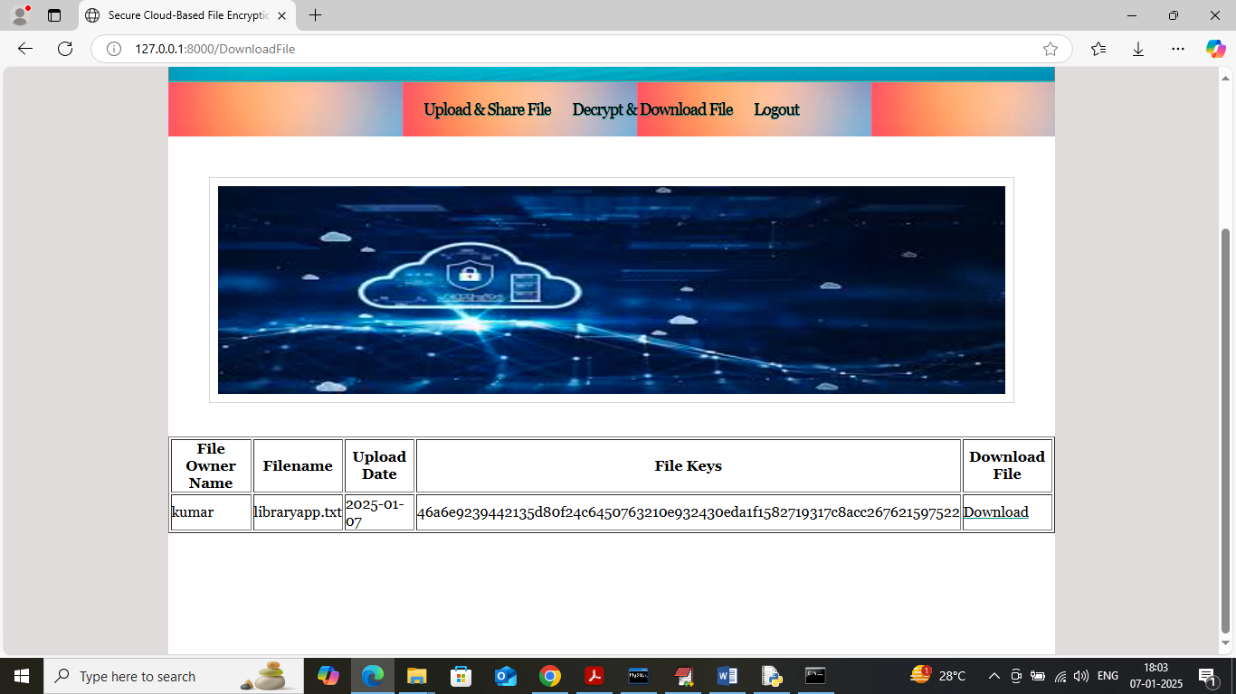
In above screen user can see list of uploaded and share files along with keys and now click on ‘Download’ link to download file and get below page
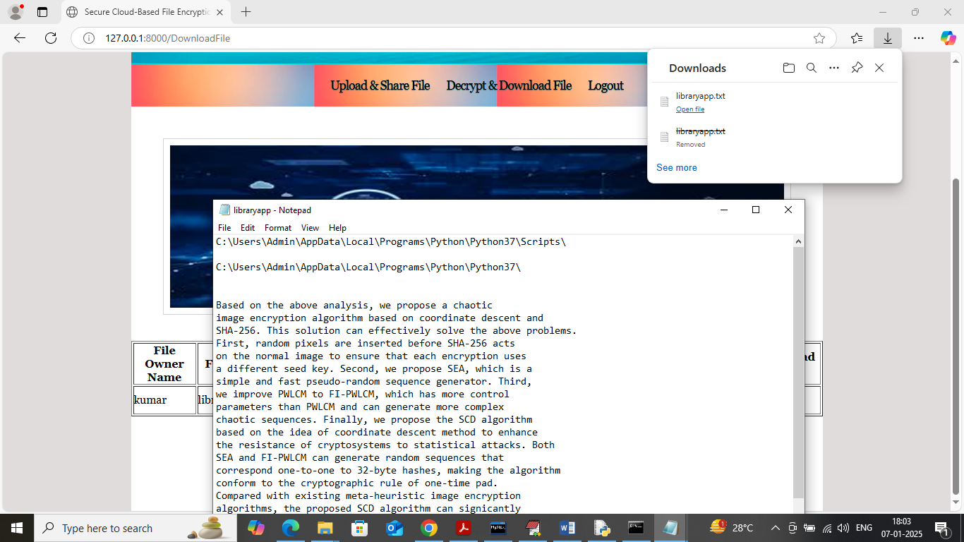
In above screen file is downloaded in decrypted format.
Similarly by following above screens you can upload and download as many files as you want.
In below screen you can see all log details saved inside log.csv file which contains all user activities details
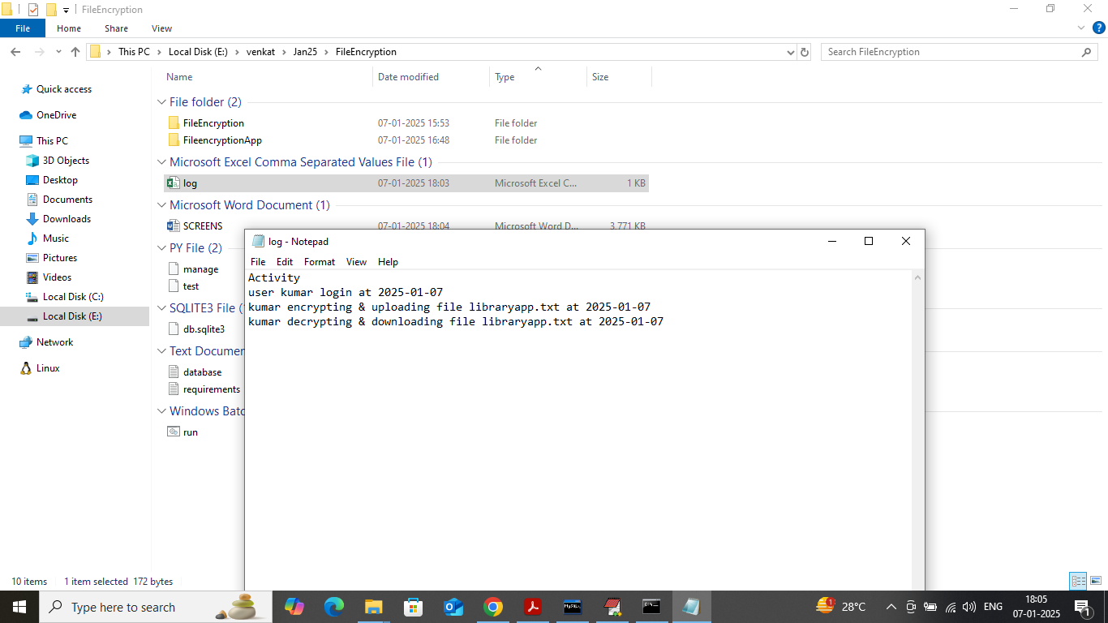

System testing
System testing is a critical phase in the development of the Secure Cloud-Based File Encryption System, ensuring that every component functions correctly, integrates smoothly, and delivers strong security, performance, and usability. Since the system handles sensitive user data and applies encryption before uploading files to the cloud, rigorous testing is necessary to guarantee that data confidentiality is never compromised. System testing evaluates functional correctness, system compatibility, security robustness, performance efficiency, and overall reliability. This chapter presents a comprehensive overview of the various levels of testing conducted, the methodologies used, the testing environment, the test cases developed, and the final evaluation of the system’s performance.

1. Purpose of System Testing
The primary purpose of system testing is to ensure that the entire cloud-based file encryption system operates as intended under all expected conditions. It helps validate whether the system adheres to requirements, provides secure end-to-end encryption, prevents unauthorized access, and can handle real-time cloud communications effectively. System testing confirms that data is encrypted before being uploaded, decryption occurs only for authorized users, key management operates without failures, transmission remains secure, and user authentication mechanisms work reliably. Additionally, system testing helps identify performance bottlenecks, security vulnerabilities, and usability issues. This ensures that the final system is stable, secure, scalable, and ready for real-world deployment

2. Testing Levels and Methodologies
2.1 Unit Testing
Unit testing is the foundation of the testing process. Each module of the system—such as the encryption module, decryption module, authentication system, cloud upload handler, cloud retrieval component, and key management subsystem—is tested individually. The purpose is to ensure that every small unit of the code performs its assigned function correctly. For example, AES encryption is tested by encrypting plaintext and verifying that the ciphertext changes even if small modifications are made to the input. Similarly, RSA key generation is tested to ensure unique and secure key pairs. Unit testing also checks boundary conditions, error handling, and exceptional cases like incorrect passwords, invalid keys, corrupted files, or failed cloud connections. Automated unit tests ensure reliability and consistency throughout development.
2.2 Integration Testing
After validating individual modules, integration testing focuses on ensuring that different modules work together seamlessly. For example, the interaction between the encryption module and the file-upload module is tested by checking whether successfully encrypted files are correctly transferred to the cloud server. Integration testing identifies issues related to data flow, interface mismatches, key-handing errors, and timing conflicts. It also tests how cloud response delays or failures affect the decryption process. Integration ensures smooth coordination between login authentication, encryption, upload, and retrieval processes. The main goal is to verify that the system functions properly when multiple modules operate in combination.
2.3 Functional Testing
Functional testing evaluates whether the system performs all the functions described in the requirements specification. It verifies real-world tasks such as encrypting files, uploading encrypted files to the cloud, retrieving encrypted files, decrypting files locally, verifying user credentials, generating keys, and managing user accounts. Testers verify that only authorized users can access encrypted data and that decryption fails when wrong credentials or keys are used. The system is tested on different file types—text, PDF, images, audio, and video—to ensure consistent performance. Functional testing validates normal operations, edge cases, invalid inputs, and user interactions. The entire flow from user login to encryption and final decryption is tested thoroughly.
2.4 Performance Testing
Performance testing checks how well the system performs under different workloads and conditions. Since encryption can be computationally intensive, it is important to measure encryption speed for different file sizes. Testers record encryption and upload time for small (1–5 MB), medium (20–100 MB), and large (200 MB+) files. This helps evaluate whether the system can handle real-world workloads efficiently. Stress testing is performed to determine system stability under heavy usage or continuous encryption operations. Load testing assesses how the system behaves when multiple users perform encryption and upload simultaneously. The cloud communication module is also tested for latency, bandwidth usage, and data transfer speed. The goal is to ensure that the system remains responsive and efficient even when dealing with large files or many users.
2.5 Security Testing
Security testing is one of the most critical components of this system because it deals with encryption, cloud data storage, and user authentication. Testers simulate attacks such as brute-force password attempts, key guessing, unauthorized file access, and man-in-the-middle attacks during data transmission. Penetration testing tools are used to identify vulnerabilities like weak keys, insecure APIs, or improper authentication handling. The encryption module is tested to ensure that encrypted files cannot be decrypted without the proper key. Secure key management is verified to ensure keys are never exposed or transmitted insecurely. The cloud communication channel is tested for SSL/TLS certificate validity, secure handshake procedures, and protection against sniffing and tampering. This ensures that the system provides strong end-to-end security.
2.6 Usability Testing
Although the system is highly technical, it must remain user-friendly. Usability testing evaluates the user interface, ease of navigation, clarity of instructions, error messages, and overall user experience. Testers examine how easily a new user can upload a file, encrypt it, and retrieve it from the cloud. Any confusing interface elements or complex workflows are revised based on feedback. The goal of usability testing is to ensure that even non-technical users can confidently encrypt and protect their data.
2.7 User Acceptance Testing (UAT)
User acceptance testing is conducted with real users to ensure the system meets their expectations. It validates that the system is working according to the defined requirements and that users feel confident trusting the system with sensitive data. Feedback from UAT helps improve system design, usability, and performance.
3. Testing Environment
The testing environment is configured to simulate real-world conditions. It includes various devices (Windows, Linux, and Android platforms), different network conditions (high-speed broadband, mobile networks, and low-bandwidth environments), and multiple cloud storage accounts. Testing is performed using real file data and dummy datasets to ensure consistency. Secure testing tools are used for penetration testing and encryption validation. The environment is also isolated to prevent exposure of sensitive test data. Different versions of cryptographic libraries are tested to ensure compatibility and stability.
4. Sample Test Cases
Test Case 1: File Encryption Functionality
- Objective: Verify that a selected file is encrypted correctly.
- Procedure: Choose a file, run encryption, check output ciphertext.
- Expected Result: Encrypted file should not resemble the original; decryption should restore exact content.
Test Case 2: Cloud Upload Test
- Objective: Verify encrypted file upload to cloud storage.
- Procedure: Upload multiple encrypted files; check cloud server for accuracy.
- Expected Result: File is uploaded successfully without corruption.
Test Case 3: Incorrect Key Decryption Failure
- Objective: Ensure system blocks unauthorized decryption attempts.
- Procedure: Attempt decryption using a wrong key.
- Expected Result: System denies access and displays an error.
Test Case 4: Authentication Validation
- Objective: Test login security.
- Procedure: Enter valid and invalid credentials.
- Expected Result: Only users with correct credentials are allowed access.
Test Case 5: Performance Under Load
- Objective: Measure system behavior under heavy encryption operations.
- Procedure: Encrypt large files repeatedly and concurrently.
- Expected Result: System remains stable without crashes.
5. Testing Results and Evaluation
The testing results indicate that the secure cloud-based file encryption system performs reliably in all operational scenarios. Encryption and decryption were accurate for all tested file formats, and cloud uploads and retrievals were consistent with zero data loss. Performance tests showed that encryption time increased moderately with larger files but remained within acceptable limits. Security testing confirmed strong resistance against password attacks, unauthorized access, and transmission interception attempts. The SSL/TLS communication channel remained secure throughout testing, and no key leaks or exposure were detected. Usability tests showed that users found the interface simple and intuitive. User acceptance testing confirmed that the system fulfills all major functional and security requirements. Overall, system testing validated that the solution is robust, user-friendly, secure, and ready for deployment.

Conclusion:
The Secure Cloud-Based File Encryption system successfully addresses the critical need for protecting sensitive data stored in cloud environments. By implementing strong client-side encryption, robust authentication, and secure key management, the system ensures that files remain confidential throughout their lifecycle—from local encryption to cloud storage and final decryption. The use of industry-standard cryptographic algorithms strengthens resistance to unauthorized access, insider threats, and network-based attacks. Comprehensive system testing further confirms the reliability, efficiency, and user-friendliness of the solution, demonstrating its ability to handle diverse file types and varying workloads without compromising security. Overall, the system provides a practical, scalable, and secure method for individuals and organizations to store and share data in the cloud, offering enhanced privacy and trust in modern cloud computing environments.

FUTURE WORK
Future enhancements for the Secure Cloud-Based File Encryption system can focus on improving functionality, scalability, and intelligent security capabilities. One major direction is integrating advanced cryptographic techniques such as homomorphic encryption or secure multiparty computation, enabling users to perform operations on encrypted data without revealing the plaintext. Machine learning–based anomaly detection can also be incorporated to identify suspicious login attempts or unusual file-access patterns in real time. Expanding multi-factor authentication and biometric verification would further strengthen access security. Additionally, the system can be extended to support distributed cloud environments, hybrid cloud models, and multi-device synchronization for seamless access across platforms. Features like encrypted search, automated key rotation, and tamper-proof audit logs using blockchain can enhance usability and compliance. Overall, these improvements would make the system more intelligent, efficient, and resilient for large-scale enterprise and modern cloud ecosystems.

Reference:
- S. Subashini and V. Kavitha, “A survey on security issues in service delivery models of cloud computing,” Journal of Network and Computer Applications, vol. 34, no. 1, pp. 1–11, Jan. 2011.
- K. Ren, C. Wang, and Q. Wang, “Security challenges for the public cloud,” IEEE Internet Computing, vol. 16, no. 1, pp. 69–73, Jan.–Feb. 2012.
- M. Armbrust et al., “A view of cloud computing,” Communications of the ACM, vol. 53, no. 4, pp. 50–58, Apr. 2010.
- W. Stallings, Cryptography and Network Security: Principles and Practice, 7th ed., Pearson, 2017.
- J. Li, M. Yu, Y. Zheng, K. Ren, and W. Lou, “Scalable and secure sharing of personal health records in cloud computing using attribute-based encryption,” IEEE Transactions on Parallel and Distributed Systems, vol. 24, no. 1, pp. 131–143, Jan. 2013.
- A. Sahai and B. Waters, “Fuzzy identity-based encryption,” in Advances in Cryptology – EUROCRYPT 2005, LNCS vol. 3494, pp. 457–473, 2005.
- D. Boneh and M. Franklin, “Identity-based encryption from the Weil pairing,” SIAM Journal of Computing, vol. 32, no. 3, pp. 586–615, 2003.
- K. Yang, X. Jia, K. Ren, and B. Zhang, “DAC-MACS: effective data access control for multiauthority cloud storage systems,” IEEE Transactions on Parallel and Distributed Systems, vol. 24, no. 6, pp. 121–133, June 2013.
- P. Mell and T. Grance, “The NIST definition of cloud computing,” National Institute of Standards and Technology, Special Publication 800-145, 2011.
- R. Buyya, C. S. Yeo, S. Venugopal, J. Broberg, and I. Brandic, “Cloud computing and emerging IT platforms: Vision, hype, and reality for delivering computing as the 5th utility,” Future Generation Computer Systems, vol. 25, no. 6, pp. 599–616, June 2009.

