To-do List

A PROJECT REPORT

Submitted by

Avinash Yadav(20BCS1330)

Selendra Kumar(20BCS9960)

Yashveer Choudhary(20BCS9934)

in partial fulfillment for the award of the degree

To-do List

A PROJECT REPORT

Submitted by

Avinash Yadav(20BCS1330)

Selendra Kumar(20BCS9960)

Yashveer Choudhary(20BCS9934)

in partial fulfillment for the award of the degree

-do List

A PROJECT REPORT

Submitted by

-do List

A PROJECT REPORT

Submitted by

-do List

A PROJECT REPORT

Submitted by

A to-do list is a list of tasks that need to be completed, typically organized in order of

priority. It is one of the simplest solutions for task management and provides a

minimal and elegant way for managing tasks a person wishes to accomplish

**An Internship Report submitted in partial fulfillment of the requirements for the award of degree of**

# BACHELOR OF TECHNOLOGY

# In

# COMPUTER SCIENCE and ENGINEERING

**Submitted by:**

CH. B. T. SAINADH (20MH1A0576)

P. RAMYA SRI(20MH1A05A5)

T. GANESH BABU (20MH1A05B5)

P. H. B. N. ALEKHYA (21MH5A0509)



**Department Of Computer Science and Engineering**

# ADITYA COLLEGE OF ENGINEERING

**Approved by AICTE, Permanently affiliated to JNTUK & Accredited by NAAC**

**Recognized by UGC under the sections 2(f) and 12(B) of the UGC act 1956**

**Aditya Nagar, ADB Road –Surampalem 533437, E.G. Dist., A.P.,2022-2023.**

**ADITYA COLLEGE OF ENGINEERING**

**(Affiliated to JNTUK, Kakinada & Approved by AICTE, New Delhi and accredited by NAAC) Surampalem, ADB road, East Godavari District, AP-533437**

**DEPARTMENT OF COMPUTER SCIENCE AND ENGINEERING**



**CERTIFICATE**

This is to certify that **CH. BADHREE TRINETHRA SAINADH** (20MH1A0576), **P. RAMYA SRI** (20MH5A05A5), **T. GANESH BABU** (21MH5A05B5), **P. HIMA BINDU NAGA ALEKHYA** (21MH5A0509) has completed his/her Internship in **SmartInternz** through **APSCHE** and worked on a project on **To-do App** as **FrontEnd Web Developer**,as a part of partial fulfillment of the requirement for the Degree of **Bachelor of Technology** in the Department of **Computer Science and Engineering** for the academic year 2022-2023.

**Head of the Department**

**Dr.G.S.N.Murthy ,Ph.D**

Professor

Department of CSE

**EXTERNAL EXAMINER______________**

## **DECLARATION**

We, **C. BADHREE TRINETHRA SAINADH** (20MH1A0576), **P. RAMYA SRI** (20MH5A05A5), **T. GANESH BABU** (20MH1A05B5), **P. HIMA BINDU NAGA ALEKHYA** (21MH5A0509) of the Department of **Computer Science and Engineering, Aditya College Of Engineering** do hereby declare that we have completed the mandatory internship from 18-06-2023 to 18-08-2023 in **SmartInternz** through **APSCHE** and worked on a project on **To-do App** as **FrontEnd Web Developer** under the Faculty Guideship of , Department of **Computer Science and Engineering ,Aditya College Of Engineering.**

**by:**

CH. BADHREE (20MH1A0576)

P. RAMYA SRI(20MH1A05A5)

T. GANESH BABU (20MH1A05B5)

P. H. B. N. ALEKHYA (21MH5A0509)

**ABSTRACT**

A to-do list is a list of tasks that need to be completed, typically organized in order of priority. It is one of the simplest solutions for task management and provides a minimal and elegant way for managing tasks a person wishes to accomplish.

Our aim is to design a simple and elegant website for people to keep a track of the status of their tasks. Making a to-do list is an easy and important task that everyone should do. The immense satisfaction that one gets when completing the task and marking it on the list are incomparable. Moreover, creating a list of tasks ensure you don't miss out on anything. It's a scientific fact that when you write the tasks that you need to complete, you are even more motivated to complete it. With this in mind, we come to build a platform which will help people create their own task list.

With the help of modern tools and technologies, we strive to build a minimal and efficient to-do list which minimizes distractions and helps people achieve task management with ease and without hassle.

**INTRODUCTION**

A to-do list is a simple prioritized list of the tasks a person must complete. People make a list of everything they need to do, ranked according to priority from the most critical task at the top to the least critical task at the bottom

A few of the features of a good to-do list application include:

• Plan and execute simple actions.

• Prioritize, manage, and reason about tasks.

• Record notes, action items and ideas.

To-dos are the tasks or the atomic entities that make up a to-do list. To-dos are made quickly, the bulk of them do not specify the work; instead, they are typically just comprehensive enough to serve as a valuable indicator. To be sure, to-do terminology like "Groceries" or "Car Wash" is frequently grammatically correct. Because the signal is so quick, it is only useful for a short period of time while the task is remembered. In certain cases, a simple item like a stack is enough to recall the job without the need for a note.

There are clear immediate implications to adding a to-do list to a person's productivity system. The functionalities provided by a good to-do list application/system help declutter the user's mind as their pending tasks are recorded safely and they won't be forgotten.

The To-do list project is a user-friendly website which helps them to keep a track of their tasks. It is a simple site which requires no sign-in/log-in or any personal details but still records your task, mark the completed tasks, and stores them even if you visit the site after a few days.

**The Benefits of Using a To Do List:**

**1. Improves your memory:**

A to do list acts as an external memory aid. It's only possible to hold a few pieces of information at one time. Keep a to do list and you'll be able to keep track of everything, rather than just a few of the tasks you need to do. Your to do list will also reinforce the information, which makes it less likely you're going to forget something.

**2. Increases productivity:**

A to do list allows you to prioritize the tasks that are more important. This means you don't waste time on tasks that don't require your immediate attention. Your list will help you stay focused on the tasks that are the most important.

**3. Helps with motivation:**

To do lists are a great motivational tool because you can use them to clarify your goals. You can divide your long-term goal into smaller, more achievable short-term goals and as you tick each one off your list, your confidence will increase.

**TASK MANAGEMENT**

From an articulation standpoint, task management entails more than just organizing

virtual and physical collections and scheduling activities.

Recent research has begun to address the problem of generic task management in the context of email. This development is hardly surprising, given that many digital device users are overloaded by the number of chores done through email. According to this research, any successful productivity tool must be tightly connected with email functionalities. Recent researches looked at task management strategies more generally because email and related technologies are unlikely to be the whole picture.

* **To-do list as a solution to task management**

The concept of to-do list has existed for a very long time and it is one of the primary methods for management of tasks, use of a to-dos as a reminder system, to-dos as a system for note management, etc. In the simplest and most primitive form, a to-do list can be implemented on a pen and paper as a checklist of items which can be crossed of or ticked against when completed.

This can be further extended to calendars, by writing tasks against dates where the dates can also act as deadlines for particular tasks. Other possible extensions of to-do lists can be on whiteboards, journals, text editors.etc.

The functionalities of to-do lists naturally evolve to perfectly fit web applications and applications on digital devices. Equipped with modern tools and technologies, engineers can build an application to create a minimal and powerful application that can help boost productivity without loss of focus and attention.

With the computing power and persistence of modern devices and databases, losing track of tasks will not be a problem people will have to face anymore and they can rest assured, only focused on the tasks they will have to accomplish as with modern technology and the power of digital devices, integration will be seamless and tasks can be synced across multiple devices all at once, without any hassle.

**Evolution of to-do list:**

The idea of plan for the day has existed for quite a while and it is one of the essential techniques for the board of assignments, utilization of a tasks as an update framework, tasks as a framework for note the executives, and so on. In the least difficult and most crude structure, a plan for the day can be executed on a pen and paper as an agenda of things which can be crossed of or ticked against when finished.

This can be additionally reached out to schedules, by composing undertakings against dates where the dates can likewise go about as cutoff times for specific assignments. Other potential augmentations of plans for the day can be on whiteboards, diaries. text editors.etc.

The functionalities of plans for the day normally develop to fit web applications and applications on advanced gadgets flawlessly. Furnished with current apparatuses and advancements, specialists can fabricate an application to make a negligible and strong application that can assist with supporting efficiency without loss of concentration and consideration.

With the processing power and steadiness of current gadgets and data sets, forgetting about assignments won't be an issue individuals should confront any longer and they can have confidence, just centered around the errands they should achieve similarly

as with present day innovation and the force of advanced gadgets, combination will be consistent and undertakings can be adjusted across different gadgets at the same time, with next to no problem.

**Essential Functionalities:**

* An assortment of strategies for analyzing and figuring out how tasks that go past records and mirror the upsides of current assets.
* The awkward property, for example, when it turns into the default spot for ordinary errands where updates can be fulfilled.
* Promptly turns on, taking into consideration fast information and clear view.
* Regular plans for the day are ordinarily deserted because of slow, tedious information and frail result.
* No conventional set of working responsibilities, order, or deterioration is expected from clients, and any level of reflection for nuclear errand sections should be allowed.
* An instrument for managing old, low-need tasks that are turning out to be less inclined to be performed yet have not been expressly erased.

**OBJECTIVE (OF PROJECT):**

To-do lists offer a way to increase productivity, stopping you from forgetting things, helps prioritize tasks, manage tasks effectively, use time wisely and improve time management as well as workflow.

Making a to-do list is an easy and important task that everyone should do. The immense satisfaction that one gets when completing the task and marking it on the list is incomparable. Moreover, creating a list of tasks ensures you don't miss out on anything. It's a scientific fact that when you write the tasks that you need to complete, you are even more motivated to complete it.

With this in mind, we come to build a platform which will help people create their own task list. The main goals we hope to accomplish with this project include:

* **MINIMAL INTERFACE:**

The primary focus of our application on the user interface aspect is minimalism. It should only provide the basic functionalities of a to-do list and not anything unnecessary as that is a hinderance to focus and productivity of a user.

* **FREE TO USE:**

The to-do list application build for this project is completely free to use to any and everyone.The only requirement of this application is to have a device capable of running a web browser.

* **OPEN SOURCE:**

To-do list is open source and its code repository is publicly available on GitHub. It is open to contributions and improvements by anyone who wishes to contribute to it. It is also free for modification and personal use.

**A brief overview of open source projects:**

Open source software is software with source code that anyone can inspect, modify, and enhance. "Source code" is the part of software that most computer users don't ever see.

It's the code computer programmers can manipulate to change how a piece of software-a "program" or "application"-works. Programmers who have access to a computer program's source code can improve that program by adding features to it or fixing parts that don't always work correctly.

**CONCLUSION**

The to-do list developed for this project is meant to be a minimal, free and open source application that can help improve the productivity of a user without taking anything. It aims to solve at least some of the problems discussed earlier in this report.

**PROJECT**

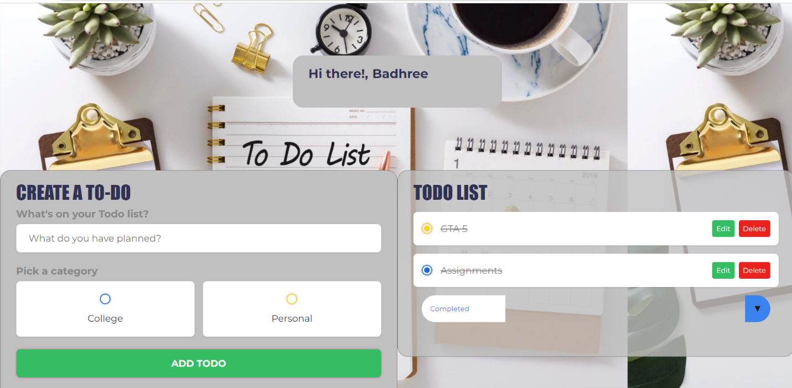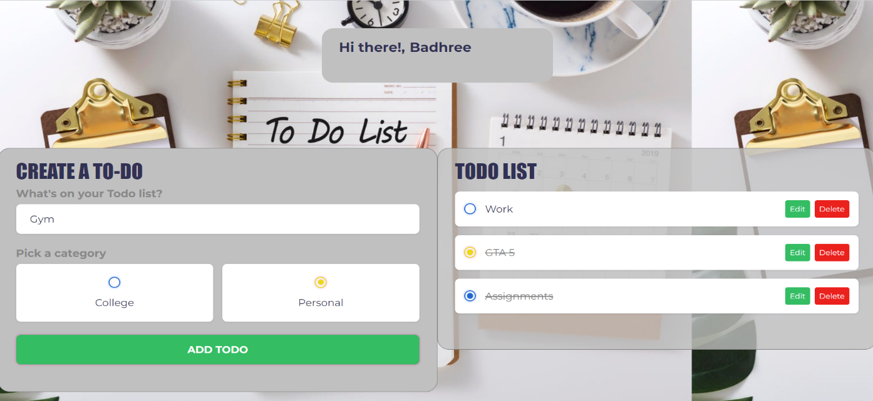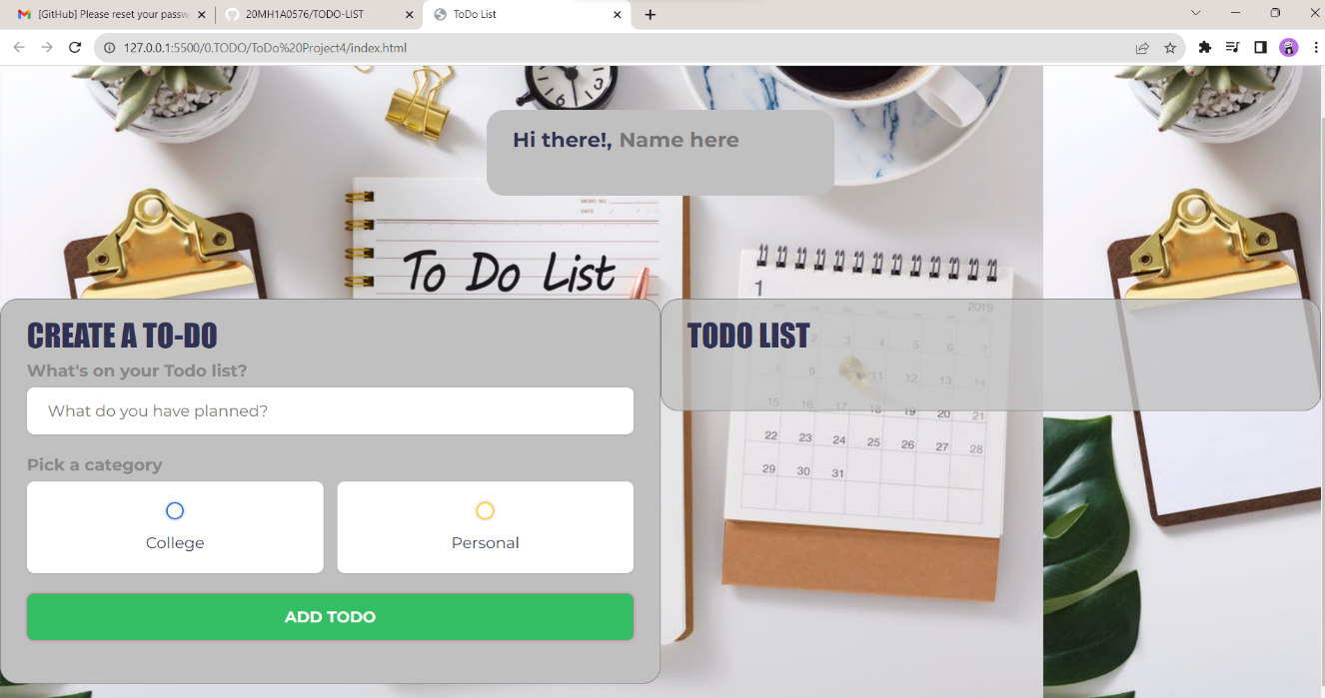

Acknowledgement

In successfully completing this project, many people have helped us. We would like

to thank all those who are related to this project.

Primarily, we would thank my Supervisor Puneetparsad Singh and Co. Supervisor

Palvi Sharma, under whose guidance we learned a lot about this project. Their

suggestions and directions have helped in the completion of this project.

Finally, we would like to thank our parents and friends who have helped me with their

valuable suggestions and guidance and have been very helpful in various stages of

project completio