**ASSIGNMENT-3**

**A simple RESTFUL API using React.js, Database Creation, and Creating Index**

**RestFul API code**

**Route.js**

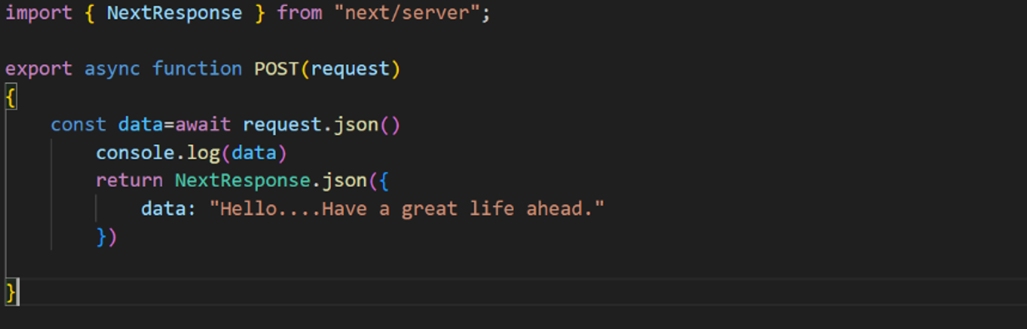

**Rest Output on ThunderClient**

**This is the output when we create an REST API using POST Method.**

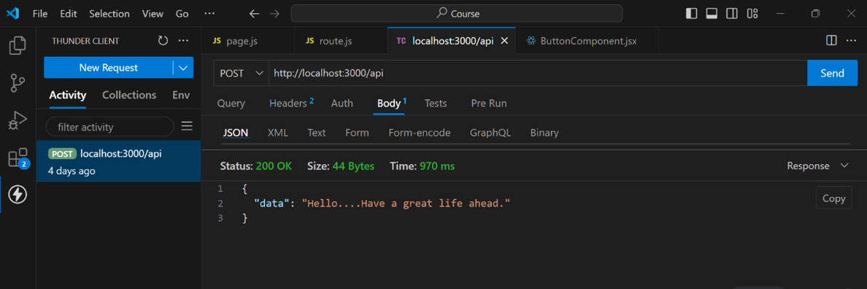

**DataBase Creation by using MONGO DB**

**1st we created a database named blog2**

**In that blog2 we created a collection named Comments**

**And finally by using ADD DATA , we added data of the comments like name, lang, and member_since.**

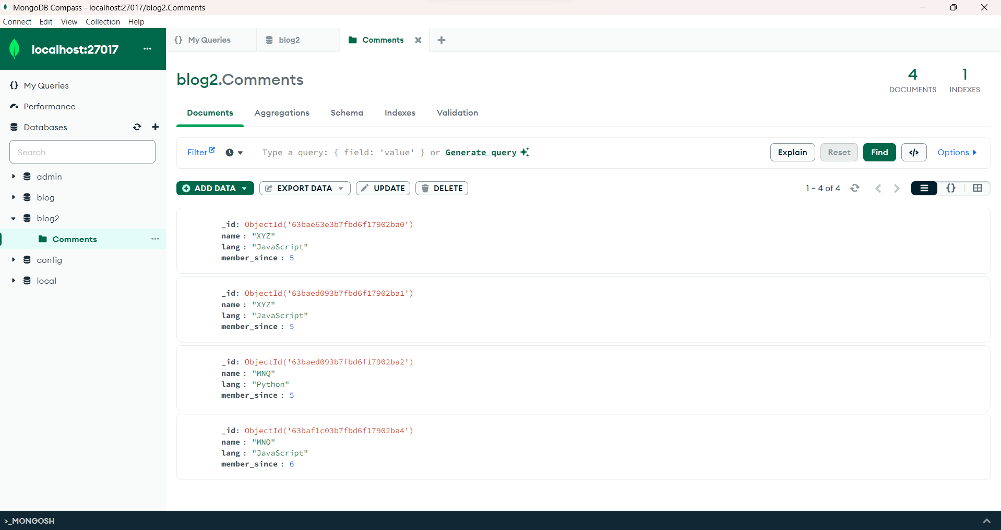

**Indexing Creation**

**As _id is the unique attribute through which we identify a comment uniquely. So, here I created an index based on_id. And assigned unique key to it.**

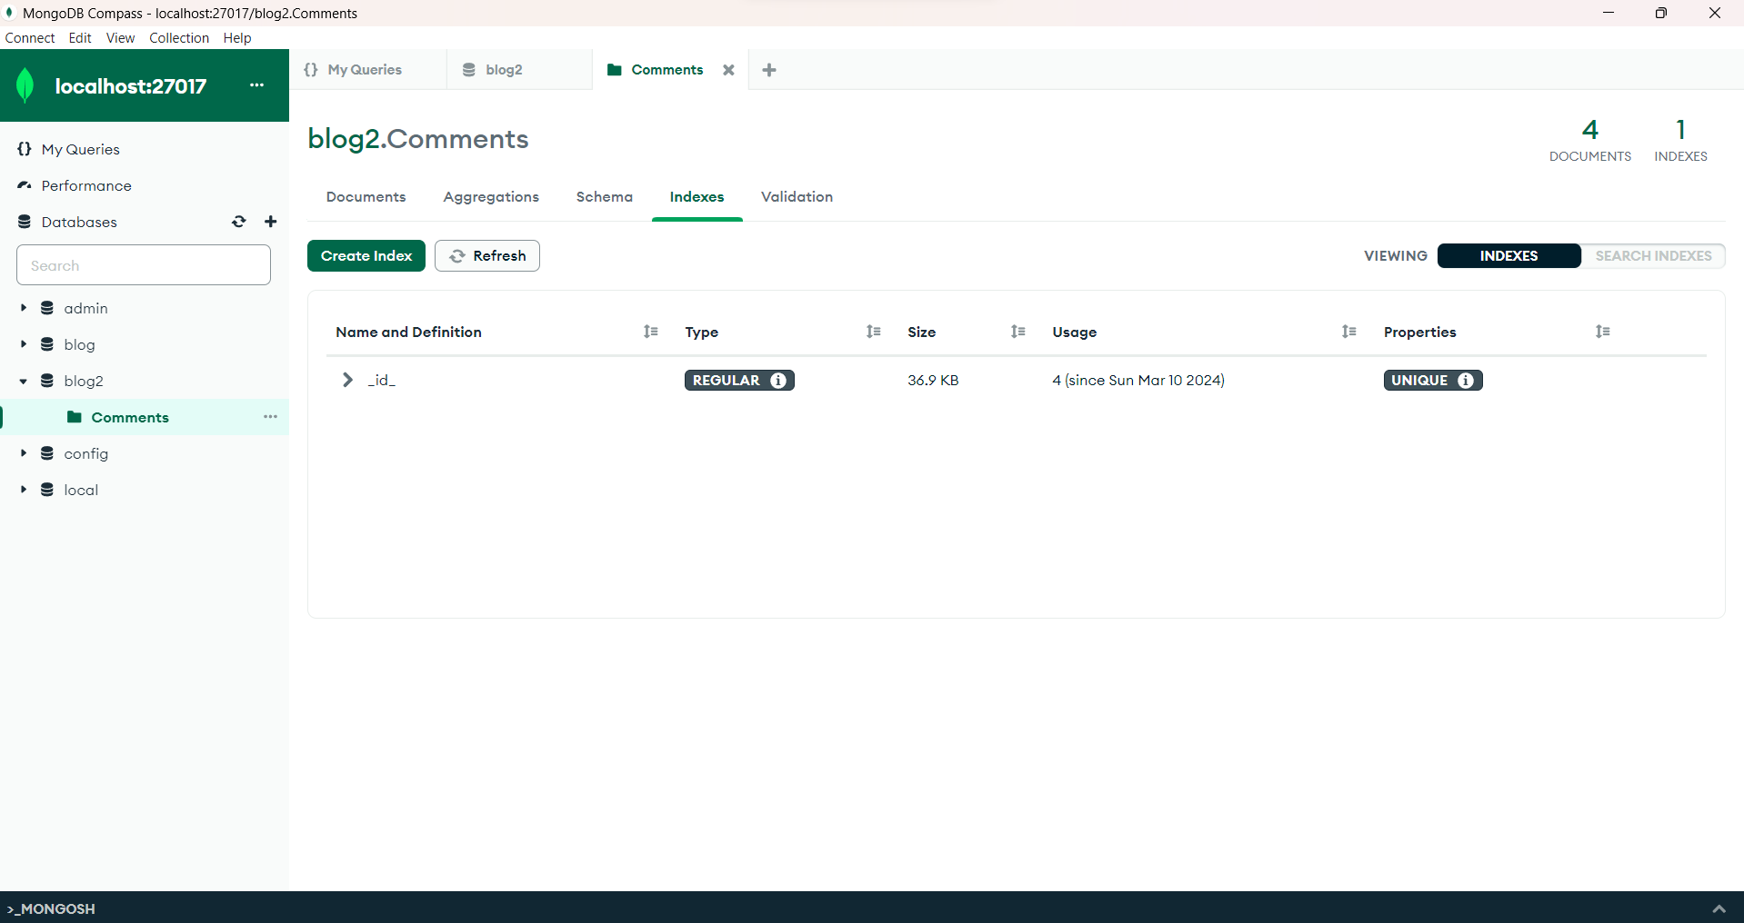

**Indexing usage**

**If we give the columns in non-sequence while adding the data in the database. It will create an error like shown in below picture.**

