**Apple Gadgets**

Name: G.Sriishwarya

E-Mail: [sriishwarya94@gmail.com](mailto:sriishwarya94@gmail.com)

PhoneNo: 8919115231

RollNo: 20NN1A1219

College No: Vignan’s Nirula Institute of Technology and Science for Women.

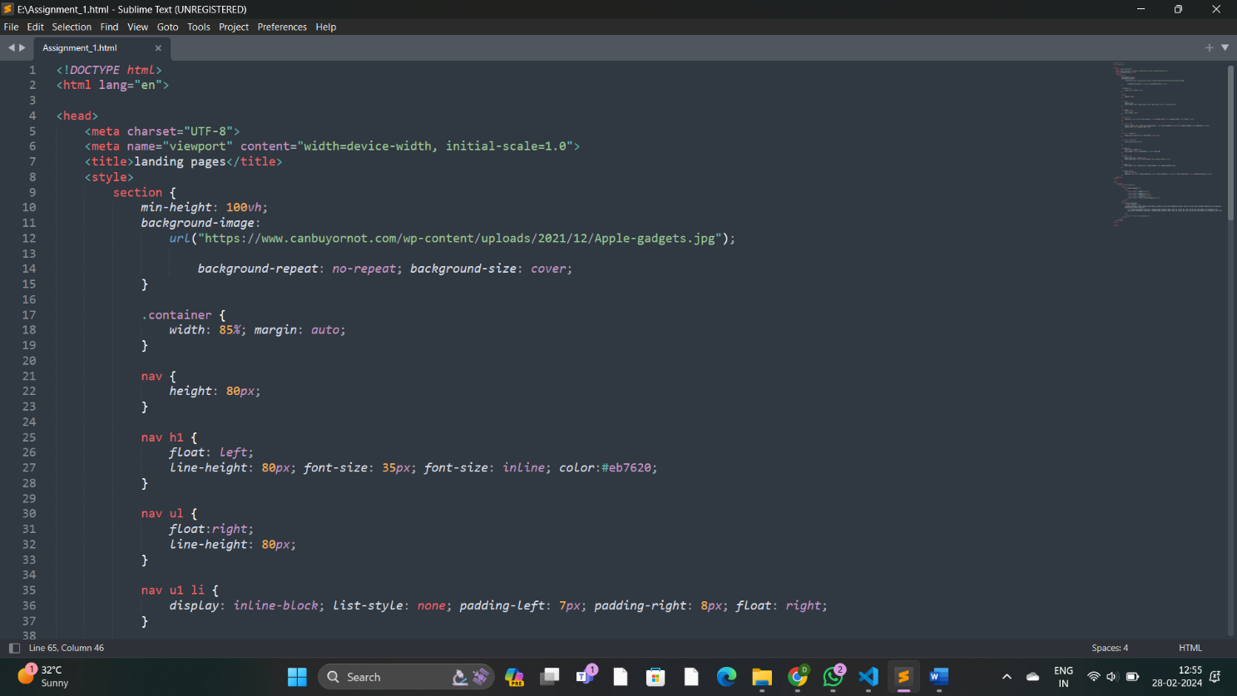**Source Code:**

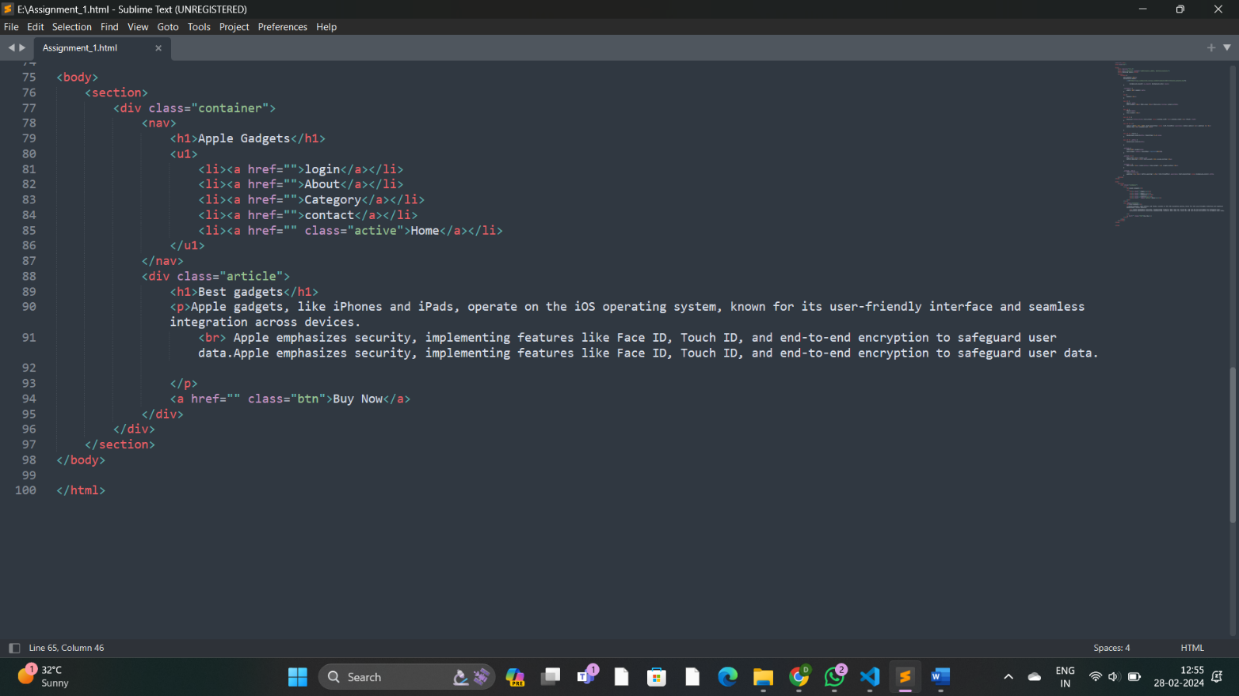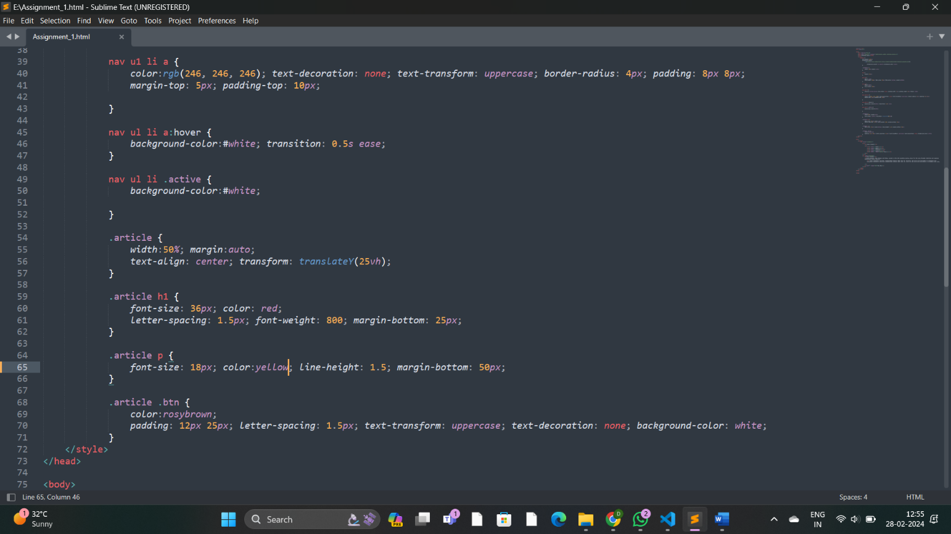

Output:

