**PSG COLLEGE OF TECHNOLOGY, COIMBATORE 641004**

**DEPARTMENT OF APPLIED MATHEMATICS AND COMPUTATIONAL SCIENCES**

**List of Commands, Shell concepts**

|  |  |  |  |  |  |  |
| --- | --- | --- | --- | --- | --- | --- |
| **Essential Commands** | **General Pur. Utilities** | | **Simple Filters** | **Regular**  **Expressions** | **Process Cmds** | **Advanced Filters** |
| man  more  mkdir -m -p  cd  rmdir  ls -a, -r, -F,  ls -R, -x  cat ><file>  echo ‘‘ ><file>  cat -n  mv  rm  cp  ls –l –i | Pwd  date  passwd  wc  who  file  script  cal  calendar  tty  uname  tput  banner  df  du  chmod  chgrp | chown  find  cmp  comm.  diff  spell  umask  basename  split  finger  stty  sleep  history  alias  unalias  bc  join | head  tail  cut  paste  expr  sort  tr  pr  nl  uniq | introd  grep –v –w grep –c –n  grep –l –i  egrep –e -f  fgrep -f  expr  sed =  {intro,  Syntax,  addr,  print, insert,  append,  delete,  write,  subs.,  REM. patt,  REP patt,  BRE, TRE} | ps -u -e -f  nohup  at  batch  nice  kill  jobs -l  fg  bg | awk =  {intro,  syntax,  line filter,  RE filter,  Field split,  Format o/p,  Operators: logical, real, RE,  Numeric processing,  Variables: built-in, user defn.  -f –v options,  Functions: built-in, user defn.,  Interface: |, <, >  If, case,Loops,  BEGIN,END,  Positionl params,  getline,} |
| **Communication Commands** | **Shell variables** | | **Backup Commands** | **Shell Prog.** | **Adv. Shell Prog.** |  |
| ifconfig,  netstat,  ftp,  route,  whois  tracepath  ip  ping | shell vars: SHELL, TERM, MAIL, PS1, PS2, USER, LOGNAME  set –, -x, +x,  set no clobber,  set ` `  setenv,  unset,  merging streams,  wait,  . profile  vacation,  .plan,  .project | | compress  uncompress  gzip  gunzip  tar | { }, ( ), <<,  export, read  $0, …….$9  $*, $#, $@, $?, $!, !!  arrays  if - fi  case-esac  for  while  until  break, continue,  functions,  trap | eval,  exec,  getopts,  conditional var.subs,  time,  $()  $(())  [[ ]] |  |

**System Calls List**

|  |  |  |  |  |
| --- | --- | --- | --- | --- |
| **File System Calls** | **Process System Calls** | **Time System Calls** | **IPC** | |
| open  read,  lseek,  write  close  create  mknod  chmod  chdir  chgrp  stat,  fstat,  link,  unlink,  dup,  pipes-intro,  named,  unnamed,  reading,  writing | fork,  exec,  brk,  exit,  uids-  getuid,  geteuid  setuid,  seteuid,  signal,  psig,  issig,  kill,  nice | time,  stime,  **Error**  perror, | Intro,  Sock types,  Sockets={ socket,  bind,  connect,  listen  accept,  shutdown,  write,  send,  recv,  close,}  messages={  structure,  msgget,  msgsnd,  msgrcv,  msgctl} | Shared memory={  shmget,  shmat,  shmdt,  shmctl}  semaphores={  semget,  semop,  semctl} |

1) Manipulate directory structures.

1. Display the absolute path of your home directory.



1. Create a new subdirectory called OS in your home directory.



1. Create a new subdirectory called assign1 in OS.

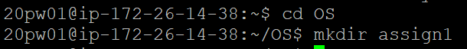

1. Create a new subdirectory called assign2 in OS.



1. Display the contents of the directory OS.



1. Delete the directory assign2.



1. Display the contents of the directory OS.



2) Manipulate files.

1. Change your current working directory to OS.
2. Create a new subdirectory called assign2 in OS.
3. Create a new file called MyFile.txt using the touch command and insert two lines into the file.
   * The first line should be a sentence that tells me your favorite movie.
   * The second line should be a sentence that tells me your favorite food.
4. Display the contents of the file MyFile.txt to the standard output (screen).
5. Copy the file MyFile.txt to directory assign1 and rename it to t_1.txt.
6. Change your working directory to assign1.
7. Make a copy of t_1.txt with the name t_2.txt (in the same directory).
8. Display the contents of the directory assign1.
9. Copy the t_1.txt file to directory assign2. 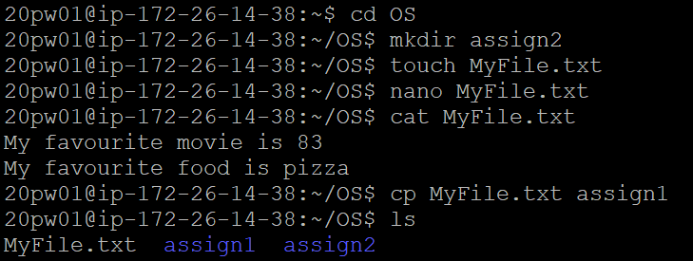

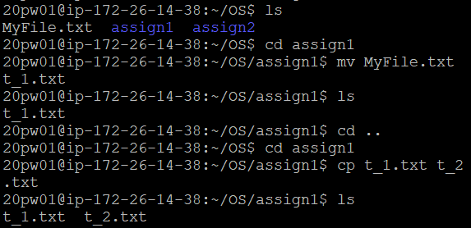

1. Display the contents of the directory assign2.

Ls assign

1. Delete the file t_1.txt in the directory assign1.



1. Display the contents of the directory assign1.

Ls assign1

3) Manipulate files using wildcards.

1. Change your current working directory to OS. (Stay in this directory for the rest of the steps )
2. Create a new directory called assign3 in your working directory.
3. Create 9 new files (in directory OS) named as follows:

Test_1.txt

Test_2.txt

Test_1-1.txt

Test_2-1.txt

Test_1-2.xtxt

Test_2-2.xtxt

Test_1-1.bak

Test_2-2.bak

File_1.bat

1. Display a listing of all the files in the working directory.

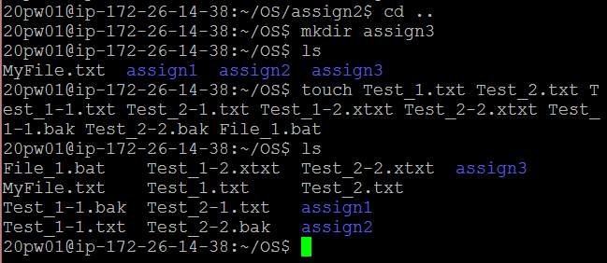

1. Display a listing of all the files ending in txt using one command.



1. Display a listing of all the files ending in t using one command.



1. Copy all the files containing "t_1" to the directory assign3 using one command.



1. Display a listing of the contents of the directory assign3.
2. Use the "ls" command and list all files that contains "Test_2" in the filename.
3. Copy the content of all files that contain "Test_1" in their filename, into a file called "tot.txt".

1. Write a single command that shows how many files you have in your current working directory.
2. Make a list of your files into a file.
3. Assume that you are NOT currently in your home directory.  Enter a command to copy all files in your home directory beginning with the  
   letter 'a' to the current directory.

1. Issue a command to delete all files in your current directory with 2-character names.



1. Issue a command to delete one of the directory (in your home directory) and all of its children. Use an absolute pathname.

1. Enter a command to make the root directory your current directory.

4)

1. Print the disk usage of directory OS in bytes.

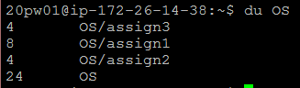

1. Print the disk usage of the directory and all its files.

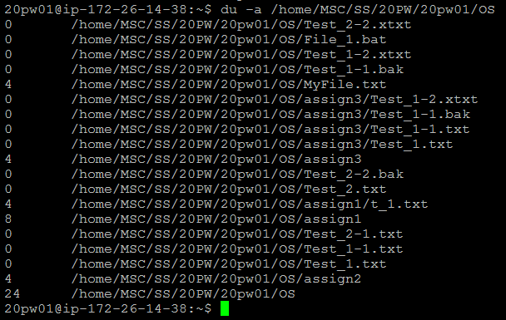

1. Print the newline count, the byte count and the longest line length for the file MyFile.txt in the directory OS.

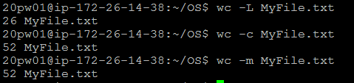

1. Print the current date using the default format.



1. Print the current date in the format *mm*/*dd*/*yy* (example: 09/04/09).



1. What is the option to "ls" to list all files?  
   Try it in your home directory.  
   Which files do you see now that you don't see with "ls" alone?

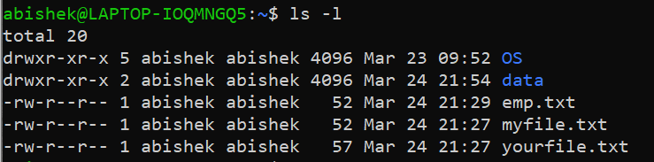

1. What is the option to "ls" to list all files in all subdirectories. Try it.

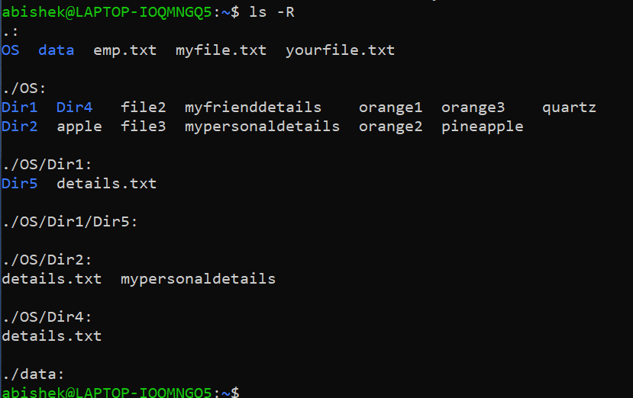

1. What is the command to count lines, words and characters in a file?



1. How do you make this command display only the number of lines?



1. Display the file "tot.txt" on the screen using "cat" command.

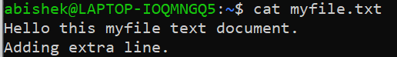

1. Display the file "tot.txt" on the screen using more.

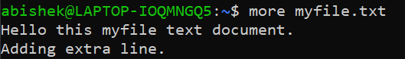

1. Test to walk upwards and downwards in the file using the "more" program.



1. Search for the word "Length" using the "more" and the "less" program, compare the results.

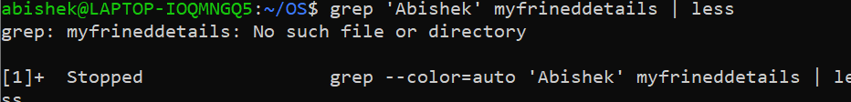

1. Display the first 5 lines of the file "verylong.seq" on the screen.

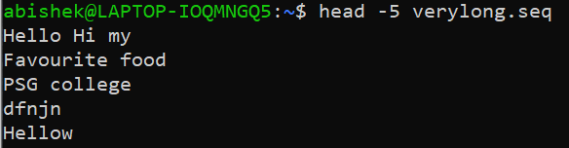

1. Do a case insensitive search for the string "length" in all files.

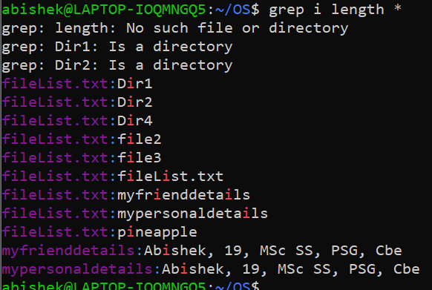

1. Compare the files "1.txt", "2.txt" and "3.txt". Which one is different from the others?





1. Put the first 7 and last 7 lines of the file "verylong.seq" into a file called "first-and-last".

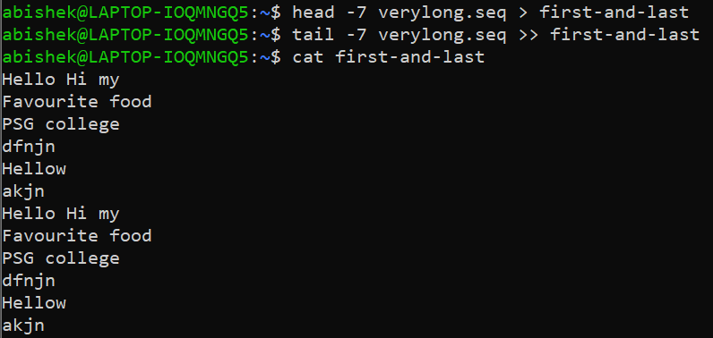

1. List the names of all files in your whole account that end with "seq" in their filename.



1. List all files created or changed during the last 24 hours.

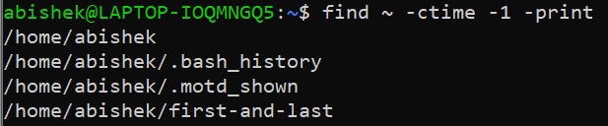

1. Find out who is logged on using "w", "who" and "finger".

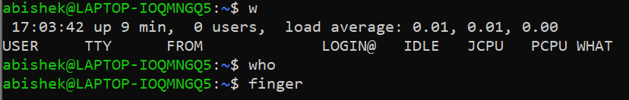

1. Find out which processes that are running using "top".

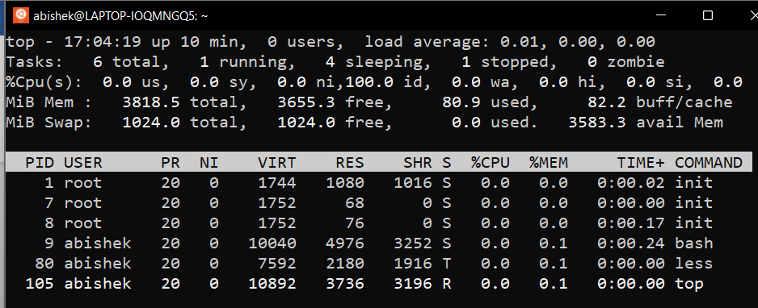

1. Get more information about one account using "finger accountname" where accountname is the name of the account.



V)

1. Create several empty files ‘File1’, ‘mypersonaldetails’, ‘myfrienddetails’, ‘file2’, ‘file3’ quickly by one command.
2. Store your personal data such as name, age, course, college, and city (separated by comma) into a file File1 and display the contents.
3. Copy the contents of the file File1 into another file mypersonaldetails.
4. Create another file myfrienddetails to store the details given in question 2.
5. Combine the contents of the files mypersonaldetails and myfrienddetails into another file details.txt.
6. Append the current date and time into the file details.txt.

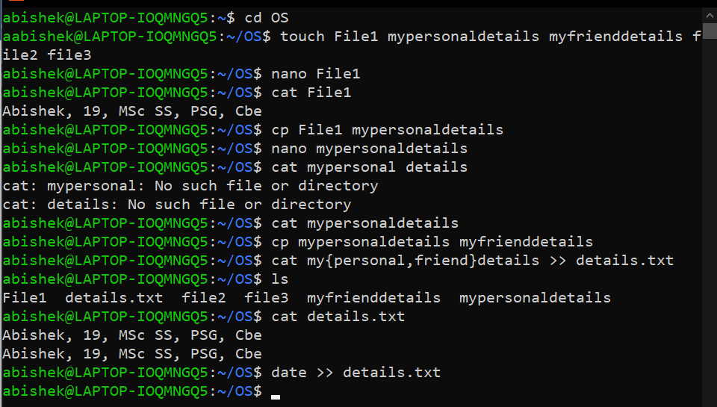

1. Create the following directories using a single line command in your home directory.

Dir1, Dir2, Dir3 and Dir4

1. Move the file details.txt into Dir1.
2. Delete the file File1.
3. Change your current working directory to Dir1.
4. Write the path of your current working directory.
5. Go back to your home directory without using its name.

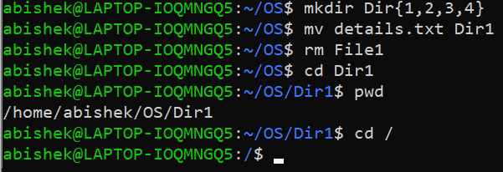

1. Copy the file details.txt into the directories Dir2, Dir3 and Dir4.
2. Create a directory Dir5 under Dir1.
3. Go to Dir5 using a single line command.
4. List all the files in your home directory.

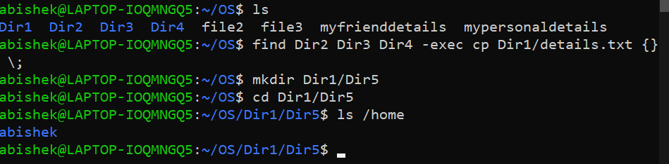

1. Copy the file mypersonaldetails into Dir2 without changing the working directory.
2. List all the files in your home directory.



1. Delete the directory Dir3.

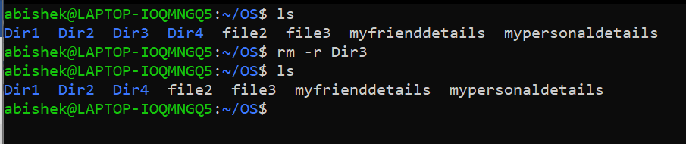

1. Create the following files : apple, orange1, orange2, orange3, pineapple, quartz. Write the output of the following commands.

a) ls a?

b)ls a*

c)ls *.*

d)ls[!abc]ange

e) ls[a!bc]ange

f)ls[b-efg-z]*

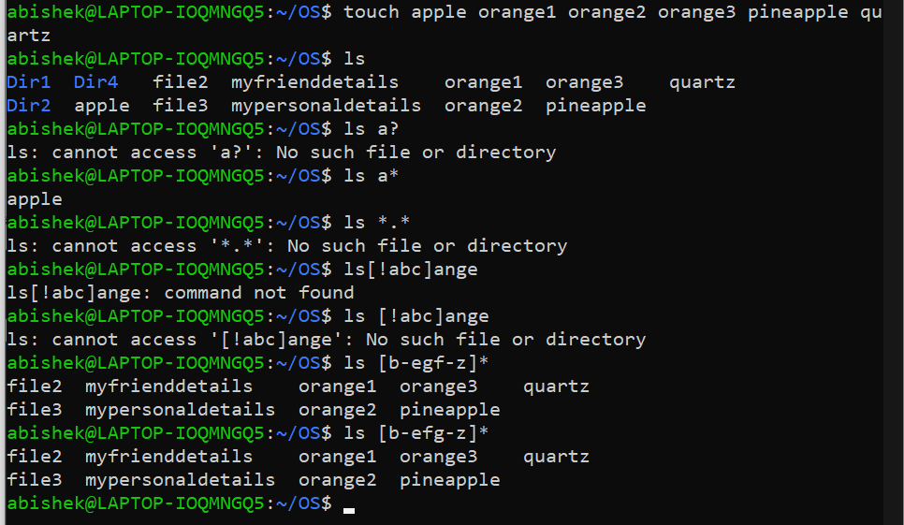

1. List all the file names in which the character just before the last character is a digit.
2. List all the files that starts with the letter a or b or c.

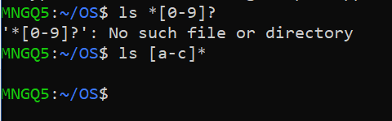

1. Write the access permissions of files after each of the following command is executed.
2. chmod  777 details.txt    b) chmodu+w g-w details.txt   c)chmod 000 details.txt    d) chmodug+rw a=x details.txt  e) chmodu+t Dir1

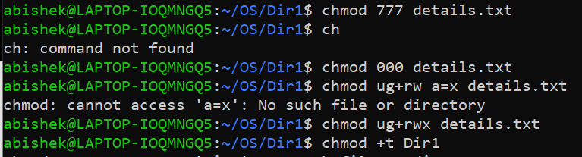

1. Remove read and execute permissions for the owner of the file details.txt.



1. List all the files in your home directory along with the inode number.



1. Create a soft link for the file sum.txt and check the inode numbers.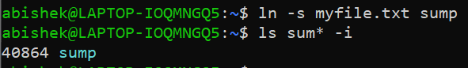
2. Create a hard link for the file sum1.txt and place it under Dir2 and check the inode numbers.

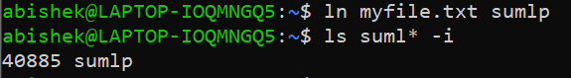

1. Create a link for the directory Dir1( check both hard and soft links).
2. Change the modification time of the file mypersonaldetails .
3. List the files of the parent directory.
4. Append A Text File's Contents To Another Text File

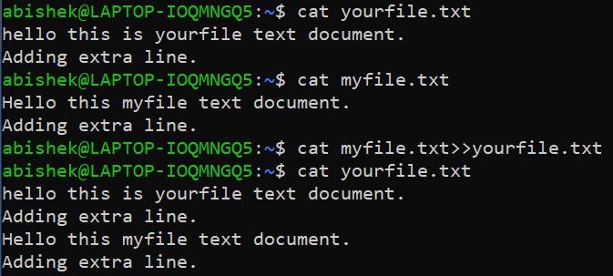

1. Display Line Numbers in File

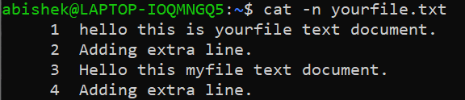

1. Find out the number of files in a directory.

diff

1. *Create two regular files ‘file1’ and ‘file2’. Fill up the files with some text. Write a command to display the differences in the files, if any.*

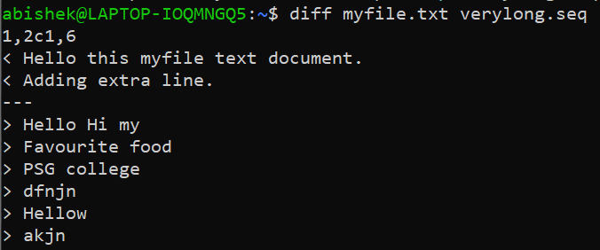

1. Display the time in 12-Hour and 24 Hour Notations

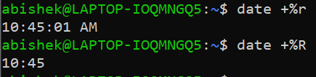

1. Display Today’s date and time in the following format. DATE: 12/08/15 TIME:15:50:44



1. Display the calendar for the month of July in the year 2020

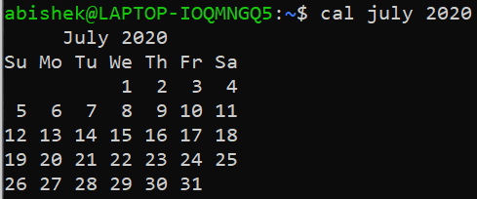

1. Create the two files namely f1 and f2 with the following contents.

**f1 f2**

Henry Charlie

Monty Julie

Sumit Monty

Charlie Bob

Julie Harry

Sumit

* Write a command to display the names available in f2 but not in f1.
* Combine the contents of f1 and f2 and display the details.

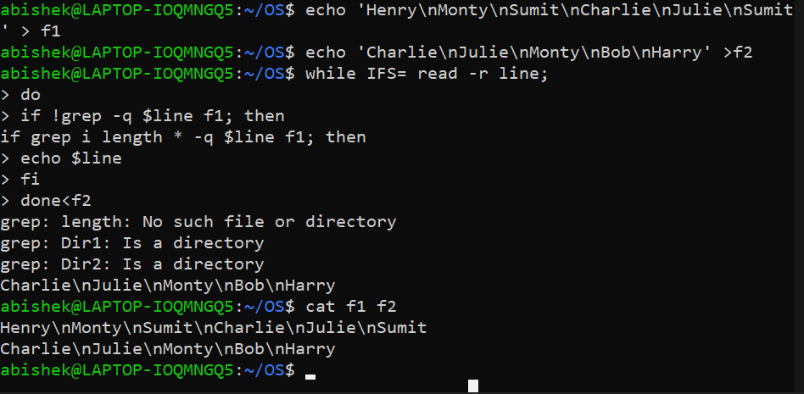

#### Sorting Contents of Multiple Files in a Single File

1. *Write a command to display the following: “There are ______ files in the current directory.” (without the quotes)*



1. *The ______ (dash) is to be replaced with the number of files in the current directory.* 

VI)

1. Obtain the following results

(i) To print the name of operating system

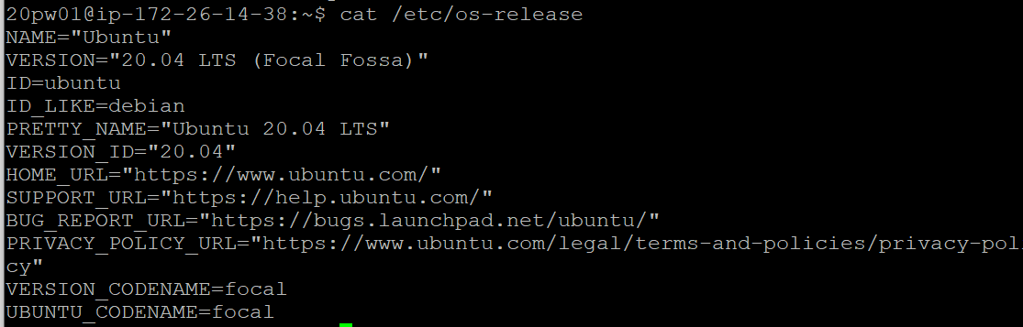

(ii) To print the login name

(iii) To print the host name

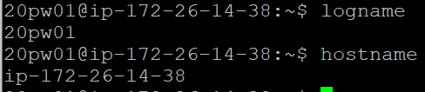

2. Find out the users who are currently logged in and find the particular user too.

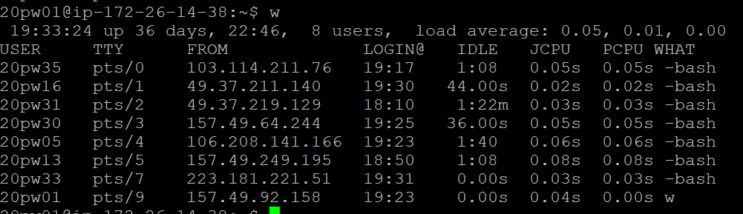

3. Find out total number of users in the system and print how many of them are currently logged in.



4. Display the calendar for

(i) Jan 2000

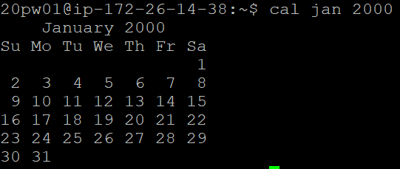

(ii) Feb 1999

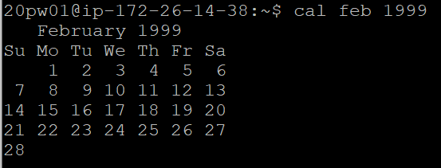

(iii) 9th month of the year 7 A.D

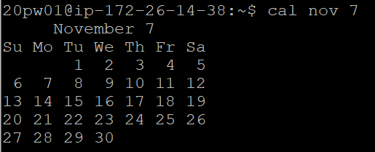

(iv) For the current month

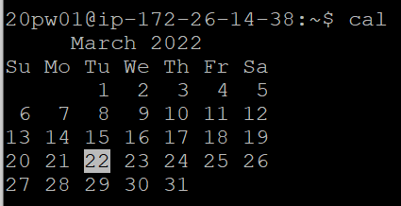

(v) Current Date Day Abbreviation , Month Abbreviation along with year



5. Display the time in 12-Hour and 24 Hour Notations.

6. Display the Current Date and Current Time.

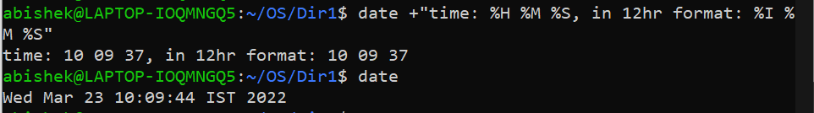

7. Display the message “GOOD MORNING” in enlarged characters.



8. Display the name of your home directory.



9. Create a directory SAMPLE under your home directory.

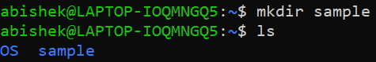

10. Create a sub-directory by name TRIAL under SAMPLE.

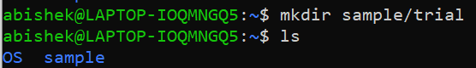

11. Change to SAMPLE.

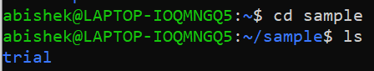

12. Change to your home directory.



13. Change from home directory to TRIAL by using absolute and relative pathname.

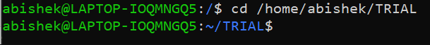

14. Remove directory TRIAL.



15. Create a directory TEST using absolute pathname.



16. Using a single command change from current directory to home directory.

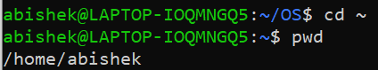

17. Create empty files myfile and yourfile under Present Working Directory.

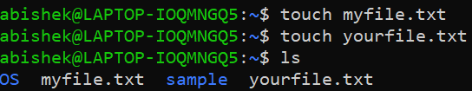

18. Add some lines in the myfile and yourfile files.

19. Display the files myfile and yourfile.

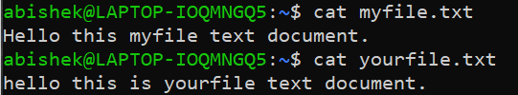

20. Append some more lines in the myfile and yourfile files.

21. Display the files myfile and yourfile.

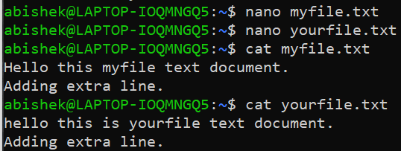

22. Create a hidden file myhid.

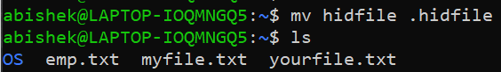

23. Display all files in the current working directory



24. Display all files including hidden files in the current working directory

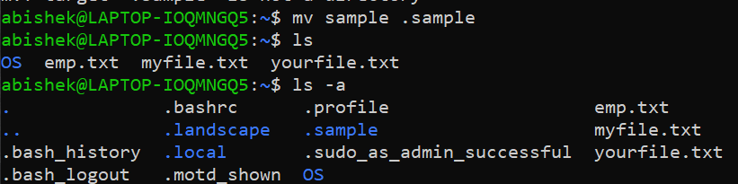

25. Copy myfile file to another file emp.

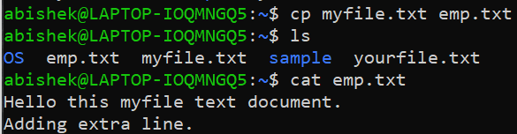

26. Write the command to create alias name for the file myfile.

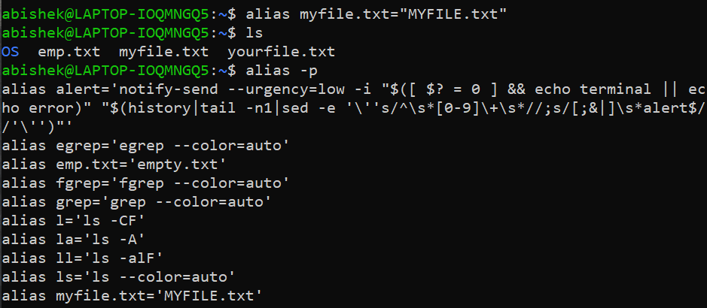

27 Move yourfile file to another file dept.

28. Copy emp file and dept file to TRIAL directory

27,28

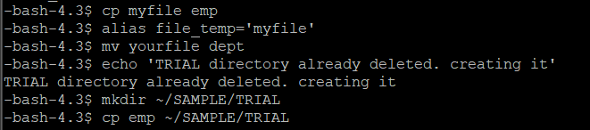

29. Compare a file with itself.

30. Compare myfile file and emp file.

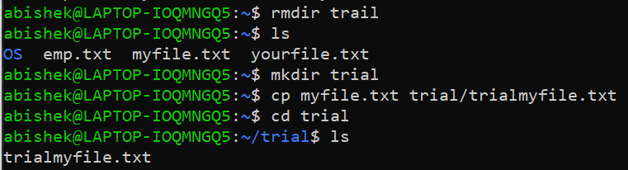

31. Append two more lines in emp file existing in TRIAL directory.

32. Compare employee file with emp file in TRIAL directory.

33. Find the difference between the above file.

34. Remove the files in the TRIAL directory.

35. Remove a directory with files by using a single command?



36. Is there any command available to get back a deleted file?

extundelete is a possible choice for ext filesystems

37. Rename TRIAL as DATA.

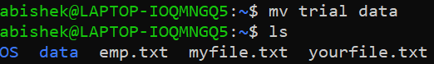

38. Copy DATA to another directory by name TRIAL.



39. Create a file called dummy in TRIAL and link it to another file by name star. 

40. Link the dummy file in TRIAL to another file by name power in DATA.



41. Print “Hello Welcome to OS Class”



42. Get a value from the user and store it in a variable.



43. Print the value of the variable.



44. Make a variable as global

45. Write a command to perform numeric operation 11 + 11.



46. Print the result of 11 + 11 as ‘Result is 22’ (Do not store use any variable)

( Learn command substitution )



47. Read two integers into two variables and add them & store it in a variable.



49. Do all other arithmetic operations and print the result.

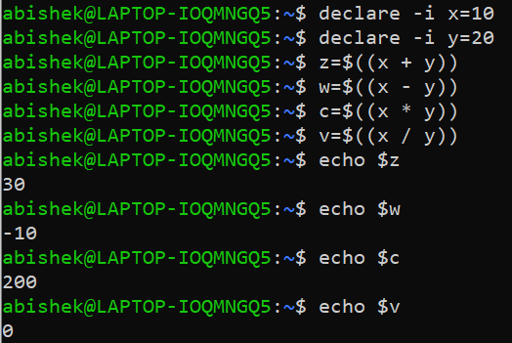

50. Try for floating point numbers.

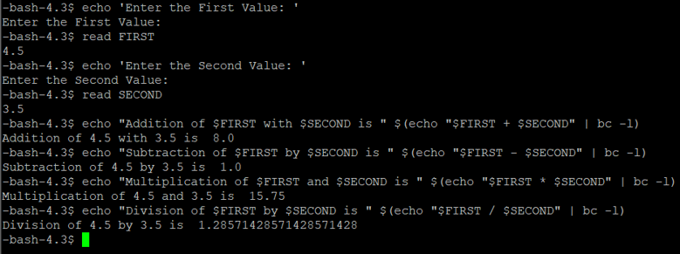

51. Login as root and create group as SS with id 501 & DS with id 555

52. Create the following list of users

User name UID GID Working Shell Secondary Comments Group

User1 501 501 Bourne shell 555 User1 user

User2 502 501 C shell NULL User2user

User3 503 501 BASH Shell 555 User3 user

User4 504 555 Bourne shell NULL User4 user

User5 505 555 Bash Shell NULL User5 user

53. Examine the content of the /etc/passwd file.



54. Examine the content of the /etc/shadow file. Name the text that is found in the second field for the users created.

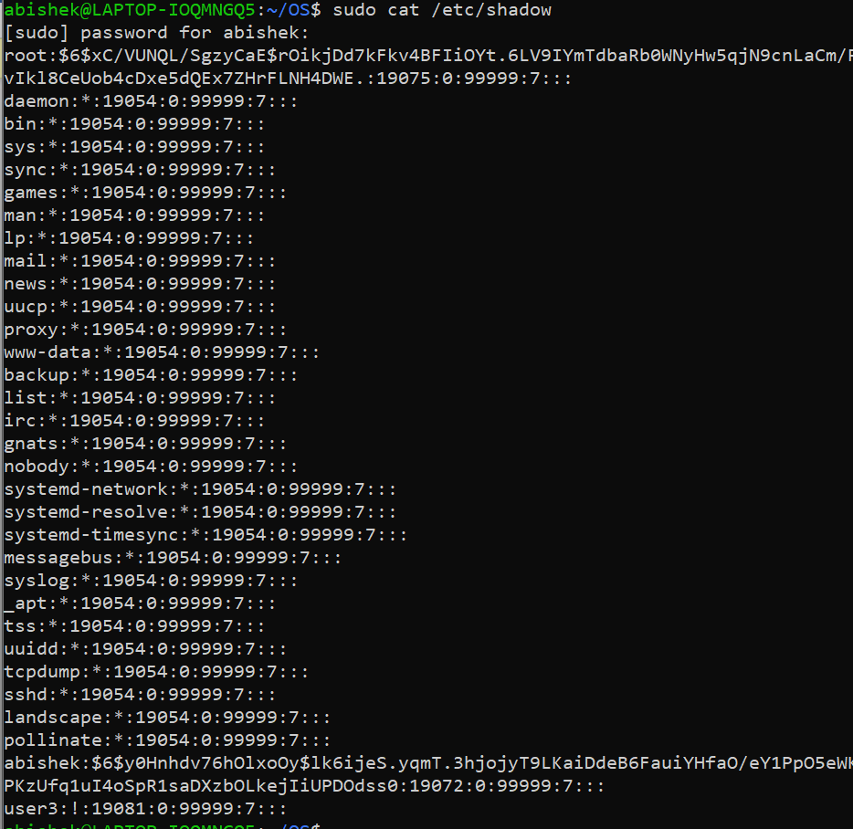

55. Set password for the users User1, User2, User3

56. Select user2 from the list of users. Change the passwd aging information for user2 so that it matches the following information.

Max inactive 2 days

Expiry 4 days

57. Logout of login session. Attempt to log as user2. What happens?



58. Change the shell for the user2 to Bourne shell.



59. Delete user2 including his home directory and his comments.



60. Lock the user1 with the help of a single command.

61. Identify the available memory in the system. 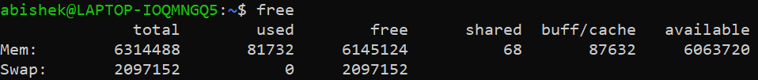

62. Display the list of devices connected to your system including the physical names and its instance number. 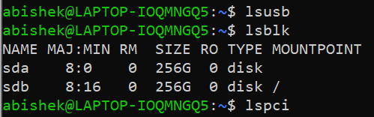

63. Identify the number of hard disks connected to the system.

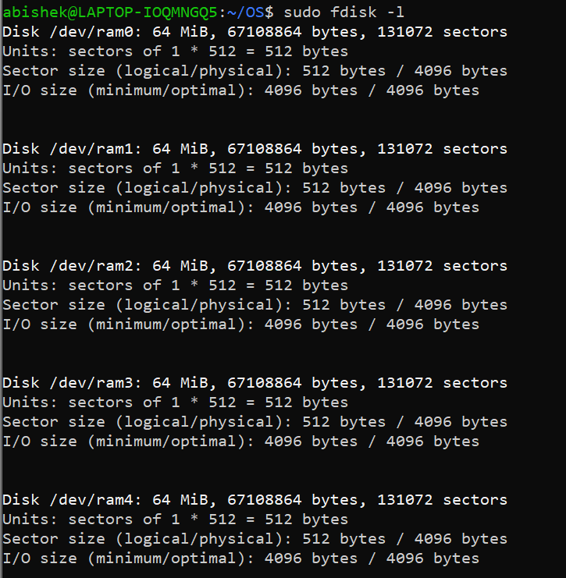`

64. Login as a normal user



65. Create file test

67. Change the ownership of the file to user1

68. Find the current umask setting

69. Change the umask setting

70. Create file test1 m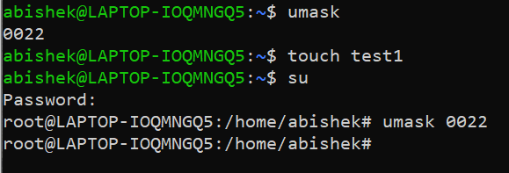

71. Find out the difference

The umask 0002 enables write access to group member

72. Switch to Super User Account

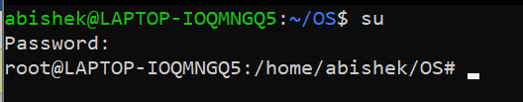

73. Change group of file test



74. Change ownership and group of file test1 with a single command



75. Change the ownership of all the files in user1’s home directory with a single command



76. Create a file abc and turn the execute bit on

77. Set setuid permission on the file abc

78. Determine if the setuid permission is enabled on the file abc

79. Create a directory testdir

80. Set setgid permission on the testdir

81. Logout and login as user1

82. Create a file testfile in testdir

76-82

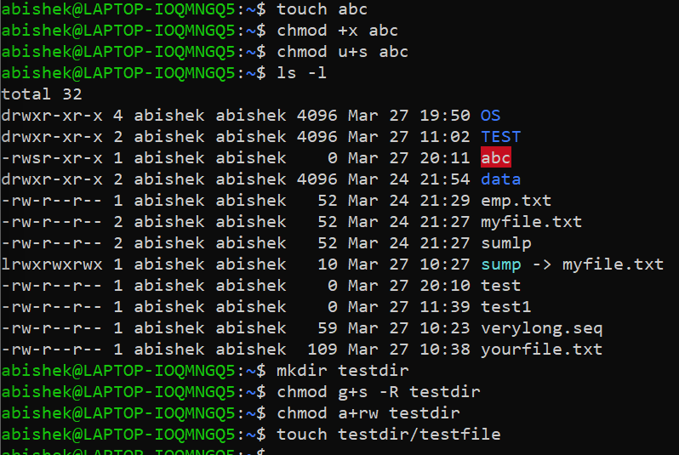

83. Verify the ownership and the group of the testfile

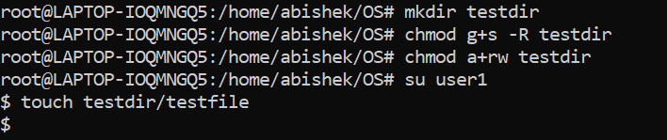

84. Switch to Superuser account



85. Create a public directory dir1

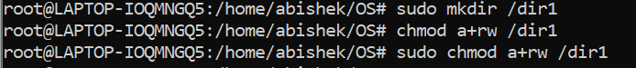

86. Set stickybit (save text attribute) on dir1



87. Logout and login as a normal user user1

88. Create a file userfile1 in dir1



89. Login as a different user user2



90. Try to edit or remove the file



91. Temporarily disable user logins



92. List the processes for the current shell.

93. Display information about processes. 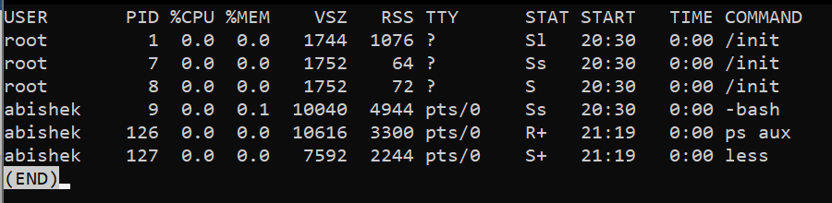

94. Display the global priority of a process and find out the column that provides.

95. Change the priority of a process with default arguments. 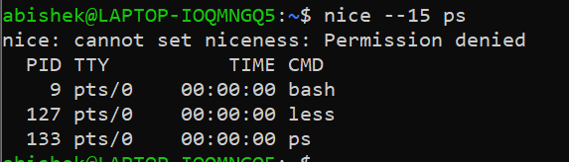

96. Display Virtual Memory Statistics.

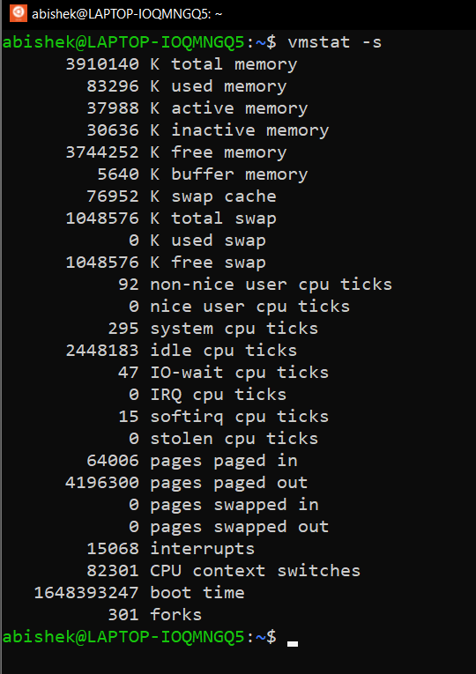

97. Display System Event Information.

98. Display Swapping Statistics.

99. Check File Access statistics. 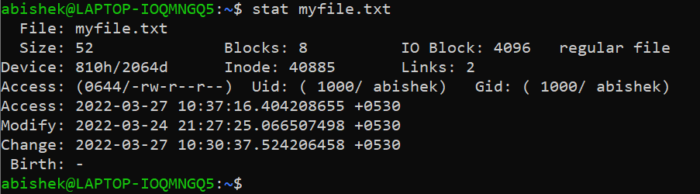

100. Check Buffer Activity statistics.

101. Check Disk Activity statistics.

102. Check Inter process Communication statistics.

103. Check Unused Memory in the server.

104. Check Swap Activities 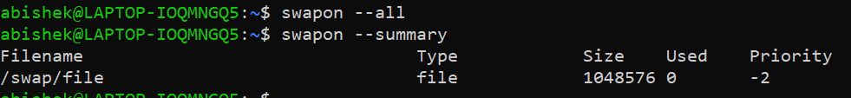

VII)

1. Create a file dfile.txt with the following contents

123

123

234

123

234

567

1. Display the no of occurrence of the record
2. Display only the duplicate records
3. Display distinct records

1. The ls –i command displays a filename preceded by the inode number of

the file .

1. Write a command to output inode and filename for the files in the working directory, sorted by inode number.

1. Write a command to output inode and filename for the files in the working directory, sorted by filename.

1. [List the 5 last modified files in the current directory?](https://stackoverflow.com/questions/15691359/how-can-i-list-ls-the-5-last-modified-files-in-a-directory)

1. Write and execute the following UNIX commands
   1. Create a file with a list of 7 names.
   2. Display only the first two characters of all the lines from a file, convert the lower case to uppercase and display the file contents in descending order and store it in a file in a single command using pipes. (Hint: cut, tr, sort)

1. Write and execute the following UNIX commands
   1. Create two files with the name of name.txt, which contain only nasmes, and reg.txt with the content of register number respectively.

* 1. Combine the two files in the form of register number and name column-wise and store it in a new file (Hint: paste)

* 1. Search a specific word from any one of the file.(grep)

* 1. Search a specific file from a directory.(find)
  2. Display the common and distinct line of contents fromnam a file(comm)

1. Write and execute the following UNIX commands
   1. Create two files with list of names in each file.
   2. Combine the two files without duplicate and store it in a new file.(sort,uniq)
   3. To view only the files in a directory.(find)

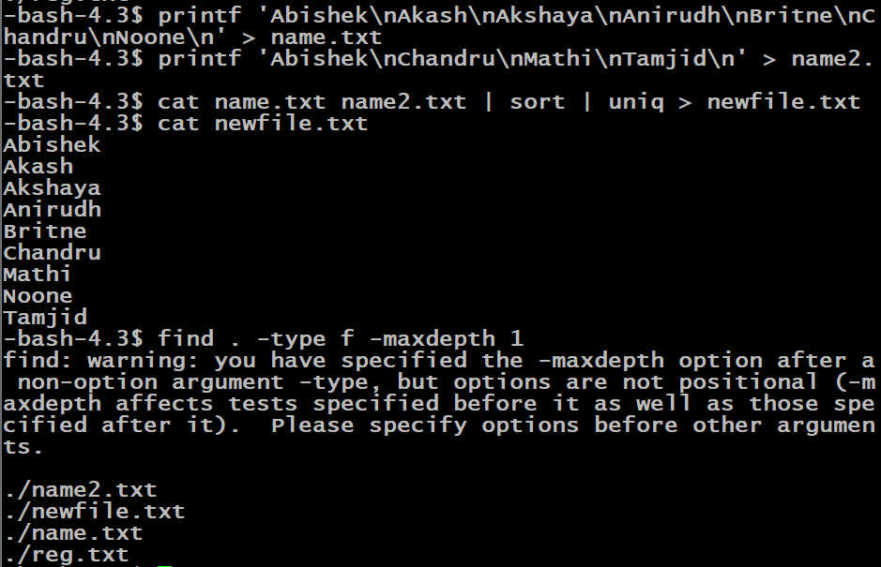

1. Concatenate 3 list files, sort them, remove duplicate lines and finally writes the result to an output file.

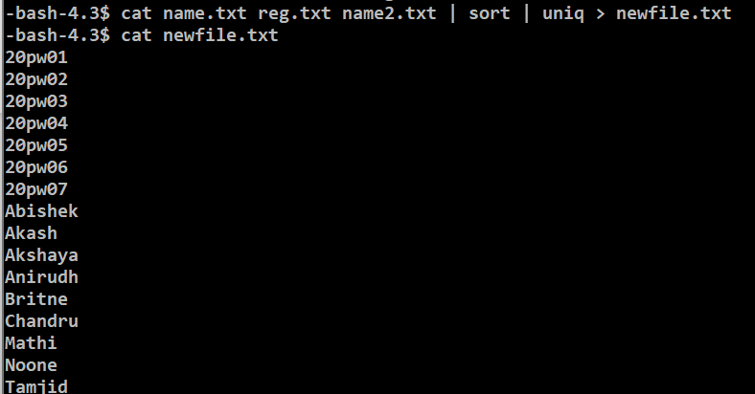

1. Print a file from the second line to the 10th line

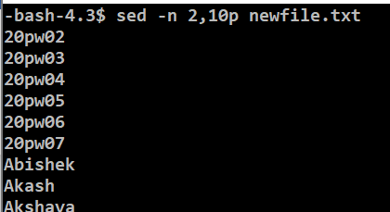

1. Show the 15 most recent items in your command history 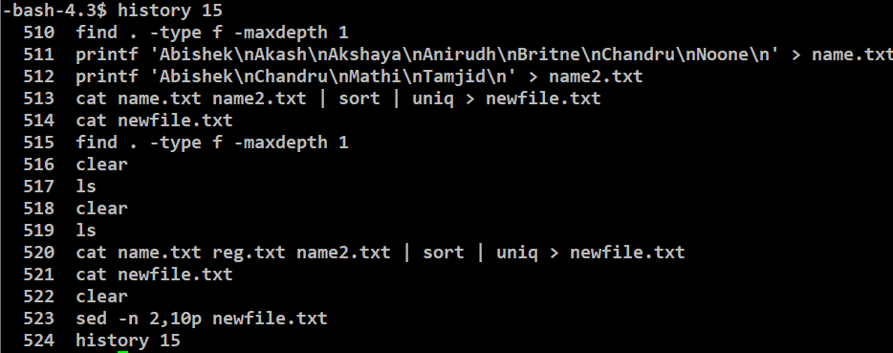
2. Store the history into file hfile. Merge the lines 11-15 from Hfile and lines 26-30 from the same file Hfile and save them both to another file.

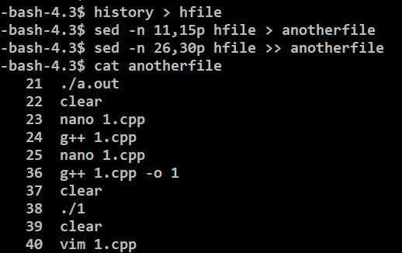

1. How to check for full word “is” in a file, not for sub-strings using grep

1. How to display N lines after match of the “is” word in the file

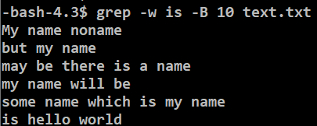

1. Display N lines before matchgrep



1. Display N lines around match



1. Searching in all files recursively



1. to display the lines which does not matches the given string/pattern,



### Display the lines which does not matches all the given pattern.



### Counting the number of matches to a word in a file using grep -c



### Show line number while displaying the output using grep -n



### Show the position of match in the line



1. Search for the lines which starts with a number.

1. Display the file names that do not contain the pattern.



1. Write a sed command that deletes the first character in each line in a file.

1. Write a sed command that deletes the last character in each line in a file.

VIII)

1. Where is the **bash** program located on your system?

1. Use the --version option to find out which version you are running.

1. Create 3 variables, VAR1, VAR2 and VAR3; initialize them to hold the values "thirteen", "13" and "Happy Birthday" respectively.

1. Display the values of all three variables. Remove VAR3.

1. Can you see the two remaining variables in a new terminal window?

NO

1. List the processes running on your terminal window using the ps command. After examining the manual entry for ps can you determine how many processes are running simultaneously on the Linux machine you are using? How many of these can be considered “system-level” processes?”

1. Experiment with the grep command which finds strings in a text files. Can you use grep to see how many of your processes are running? If you use ps -el you will see all the processes. You can find your processes in this list if you know your UID (user ID). How do you find your UID? (Hint: echo $something). Once you have your UID you can pipe to grep and only display your process status information in long format (“-l switch”). The resulting pipe command has the same output format as “ps -U username” (find out what the -U switch means). The output of the two command lines may differ in some cases - why?

1. Experiment with the chmod command. Change the read, write and execute modes (one at a time) on one of your subdirectories and see how this affects the ls command, your ability to create files in the directory and your ability to change into the directory.

**you need read permission to list the files of a directory.**

**You need write permission to create a file**

1. Use a combination of cat (or more) and grep to display information in /etc/passwd about your own details and others in addressing the following questions:a) use cat and grep in a pipe line to only print your information. What does this line mean? Checkout [the /etc/passwd file format](http://www.cyberciti.biz/faq/understanding-etcpasswd-file-format/); b) Which character is used to separate fields in the file? c) How is your password stored? If you try and access /etc/shadow what happens? d) How many different shells can you find when looking at /etc/passwd file - which are they?

1. Setup your .bash_profile file. Set your prompt to something you like. Set up your .bashrc file and add in the important aliases (e.g., mygcc, rm). Use the source command to execute your new .bash_profile when you have finished editing it.

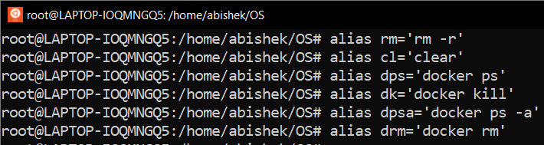

1. Edit /etc/profile so that all users are greeted upon login (test this).



1. For the *root* account, set the prompt to something like "Danger!! root is doing stuff in \w", preferably in a bright color such as red or pink.



1. The ls command seems to have every option you’d ever need. However, older versions of ls did not provide a facility to list files sorted by their size (on today’s Linux machines we can use ls -lrS ). Can you write a shell pipeline to provide this listing? You can look at the manual to find which switches help to solve this problem.

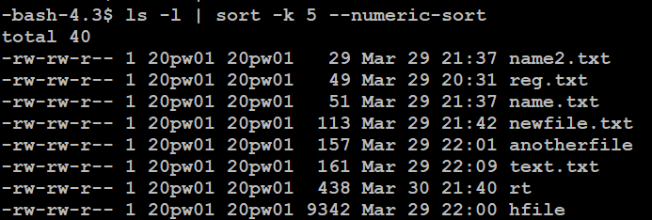

1. Display a list of all the users on your system who log in with the Bash shell as a default.



1. From the /etc/group directory, display all lines starting with the string "daemon".



1. Print all the lines from the same file that don't contain the string.



1. Display localhost information from the /etc/hosts file, display the line number(s) matching the search string and count the number of occurrences of the string.

1. Display a list of /usr/share/doc subdirectories containing information about shells.
2. How many README files do these subdirectories contain? Don't count anything in the form of "README.a_string".



1. Make a list of files in your home directory that were changed less than 10 hours ago, using **grep**, but leave out directories.

1. Can you find an alternative for **wc -l**, using **grep**?



1. Using the file system table (/etc/fstab for instance), list local disk devices.

1. Display configuration files in /etc that contain numbers in their names.

1. The command *top*shows all processes (and other information about the system). Check it out.

top

1. What command will display the contents of /etc/hosts text file to your screen to answer the question? What is the IP address? (Hint: The IP address takes the form xxx.xxx.xxx, where x is a number 0-9).

1. You wish to display detailed contents of another user’s home directory. What command lets you do this for the home directory of another user account?

Sol: getfacl and setfacl