**M. Sc. SOFTWARE SYSTEMS – Semester IV**

**20XW48 – Web Designing Lab**

**PROBLEM SHEET 1 – HTML Basic Tags**

**By 20pw01-Abishek.A**

1.

<html>

<body bgcolor="red">

<title>My first page</title>

<p>hellow</p>

</body>

</html>

2.

<html>

<body>

<h1 style="color:black">1</h1>

<h1 style="color:pink">2</h1>

<h1 style="color:orange">3</h1>

<h1 style="color:Red">4</h1>

<h1 style="color:yellow">5</h1>

<h1 style="color:green">6</h1>

<h1 style="color:blue">7</h1>

<h1 style="color:gray">8</h1>

<h1 style="color:purple">9</h1>

<h1 style="color:cyan">10</h1>

</body>

</html>

3.

<html>

<pre>

<body align="center">

<p><b>Name: </b>Abishek</p>

<p><b>Age: </b>18</p>

<p><b>Mobile No.: </b>9824398800</p>

<p><b>Address: </b>Trichy</p>

<p><b>Enrollment no.: </b>20pw01</p>

</body>

</pre>

</html>

4.

<html>

<body>

<h1>Abishek</h1>

<h2>Abishek</h2>

<h3>Abishek</h3>

<h4>Abishek</h4>

<h5>Abishek</h5>

<h6>Abishek</h6>

<h7>Abishek</h7>

</body>

</html>

5.

<html>

<body>

<title>Book review</title>

<h1 align = "center"><u>Harry potter</u></h1>

<h2 align = "left"><u>By J.K.Rowling</u></h2>

<p>Harry Potter and the Philosopher’s Stone is one of the most <b><i>popular</i></b> children’s books ever written. It is a story about the triumph of love and <b><i>bravery</i></b> over evil.</p>

</body>

</html>

6.

<html>

<body>

<font face ="Times new roman">Harry Potter and the Philosopher’s Stone is one of the most popular children’s books ever written.</font>

<font face ="Verdana">Harry Potter and the Philosopher’s Stone is one of the most popular children’s books ever written.</font>

<font face ="Arial">Harry Potter and the Philosopher’s Stone is one of the most popular children’s books ever written.</font>

<font face ="Arial black">Harry Potter and the Philosopher’s Stone is one of the most popular children’s books ever written.</font>

<font face ="calibiri">Harry Potter and the Philosopher’s Stone is one of the most popular children’s books ever written.</font>

</body>

</html>

7.

<html>

<body bgcolor="cyan">

<title>Title</title>

<p><font face="Arial" size="30" color="red"><center><strong><small><i><u>This is a line printed</u></i></small></strong></center></font></p>

</body>

</html>

8.

<html>

<body>

<p>1<sup>2</sup>=1</p>

<p>2<sup>2</sup>=4</p>

<p>3<sup>2</sup>=9</p>

<p>4<sup>2</sup>=16</p>

<p>5<sup>2</sup>=25</p>

<p>6<sup>2</sup>=36</p>

<p>7<sup>2</sup>=49</p>

<p>8<sup>2</sup>=64</p>

<p>9<sup>2</sup>=81</p>

<p>10<sup>2</sup>=100</p>

<p>11<sup>2</sup>=121</p>

<p>12<sup>2</sup>=144</p>

<p>13<sup>2</sup>=169</p>

<p>14<sup>2</sup>=196</p>

<p>15<sup>2</sup>=225</p>

<p>16<sup>2</sup>=256</p>

<p>17<sup>2</sup>=289</p>

<p>18<sup>2</sup>=324</p>

<p>19<sup>2</sup>=361</p>

<p>20<sup>2</sup>=400</p>

</body>

</html>

9.

<html>

<body bgcolor='Orange'>

<h1>

xyz<br>

Abishek<br>

Sai<br>

Shyam<br>

Mainan<br>

Raghavan<br>

Karthikeyan<br>

Karthik<br>

Pravin<br>

Vijay<br><br><br>

Abishek<sub>1</sub><br>

Karthik<sub>2</sub><br>

Karthikeyan<sub>3</sub><br>

Manian<sub>4</sub><br>

Pravin<sub>5</sub><br>

Raghavan<sub>6</sub><br>

Sai<sub>7</sub><br>

Shyam<sub>8</sub><br>

Vijay<sub>9</sub><br>

xyz<sub>10</sub><br>

</h1>

</body>

</html>

10.

<html>

<title>P10</title>

<body>

<p>&nbsp;Prints 10 names with a line break between each name. The list should be alphabetized, and to do this place a subscripted number next to each name based on where it will go in the alphabetized list. (Example: Alan1). Print first, the unalphabetized list with a subscript number next to each name, then the alphabetized list. Both lists should have an level heading.

<p>&nbsp;Prints 10 names with a line break between each name. The list should be alphabetized, and to do this place a subscripted number next to each name based on where it will go in the alphabetized list. (Example: Alan1). Print first, the unalphabetized list with a subscript num. Both lists should have an level heading.

</body>

</html>

11.

<html>

<title>P11</title>

<body>

<ul>

<li>PUBG</li>

<li>COD</li>

<li>Valorant</li>

<li>GTA</li>

<li>CS GO</li>

</ul>

<ol type='a'>

<li>PUBG</li>

<li>COD</li>

<li>Valorant</li>

<li>GTA</li>

<li>CS GO</li>

</ol>

</body>

</html>

12.

<html>

<title>P12</title>

<body>

<ul>

<li>Ice cream</li>

<ul>

<li>Vannila</li>

<li>Butterscotch</li>

<li>Chocolate</li>

</ul>

<li>soft serve</li>

<ul>

<li>Grape</li>

<li>Blackcurrent</li>

<li>Vannila</li>

</ul>

<li>frozen yogurt</li>

<ul>

<li>CottonCandy</li>

<li>Red velvet</li>

<li>Milkywhite</li>

</body>

</html>

13.

<html>

<title>P13</title>

<body bgcolor='pink'>

<H1><marquee>Blockchain</marquee></H1>

<hr style=width:100%>

<p>Blockchain.com Institutional Markets is a full-stack crypto services platform that works with crypto-native businesses and institutional clients on lending, trading, and custody solutions tailored to your needs.</p>

</body>

</html>

14.

<html>

<title>P14</title>

<body>

<pre>

Using pre tag .

Hello Hi

P S G College of technology

</pre>

</body>

</html>

15.

<html>

<title>P15</title>

<body>

<q>Winners are not those who never fail but those who never quit</q>

<pre> -APJ Abdul Kalam</pre>

<q>Nothing can dim the light that shines from within</q>

<pre> -Maya angelou</pre>

</body>

</html>

16.

<html>

<title>P16</title>

<body>

<p>My favourite sport is <del>cricket</del><ins>football.</ins></p>

</body>

</html>

17.

<html>

<title>P17</title>

<body>

<dl>

<dt>Coffee</dt>

<dd>Black hot drink</dd>

<dt>Milk</dt>

<dd>White cold drink</dd>

</dl>

</body>

</html>

18.

<html>

<title>P18</title>

<body>

<address align='left'>

From<br>

Abishek.A,<br>

Software systems,<br>

AMCS,<br>

PSGCT.<br><br>

</address>

<address align='center'>

To<br>

PR,<br>

AMCS,<br>

Software systems,<br>

PSGCT.<br>

</body>

</html>

19.

<html>

<title>P19</title>

<body>

<p>NASA-National Aeronautics and Space Administration</p>

<p>UNESCO-United Nations Educational, Scientific and Cultural Organization</p>

</body>

</html>

20.

<html>

<body bgcolor="blue">

<p>

This is <a href="https://www.wikipedia.com" style="color:red;">Wikipedia</a><br>

This is <a href="https://www.geeksforgeeks" style="color:red;">Geeks for geeks</a>

</p>

</body>

</html>

21.

<html>

<body>

<p>

<a href="https://google.com">Google</a><br>

<a href="https://yahoo.com">Yahoo</a><br>

<a href="https://altavista.com">Altvista</a><br>

<a href="https://lycos.com">lycos</a><br>

</p>

</body>

</html>

22.

<html>

<body>

<a href="https://google.co.in"

onclick="window.open('https://google.co.in',

'newwindow',

'width=1000,height=1250');

return false;">Google</a><br>

<a href="https://gmail.com"

onclick="window.open('https://gmail.com',

'newwindow',

'width=1000,height=1250');

return false;">Gmail</a><br>

<a href="https://wikipedia.com"

onclick="window.open('https://wikipedia.com',

'newwindow',

'width=1000,height=1250');

return false;">Wikipedia</a><br>

<a href="https://wikihow.com"

onclick="window.open('https://wikihow.com',

'newwindow',

'width=1000,height=1250');

return false;">Wiki how</a><br>

<a href="https://amazon.com"

onclick="window.open('https://amazon.com',

'newwindow',

'width=1000,height=1250');

return false;">Amazon</a><br>

</body>

</html>

23.

<html>

<body>

<h1>Top<a name="Top"></a></h1>

<a href="#Bottom">Go to Bottom</a>

<pre>

</pre>

<h1>Bottom<a name="Bottom"></a></h1>

<a href="#Top">Go to Top</a>

</body>

</html>

24.

<html>

<body>

<h2>Peaky blinders</h2>

<img src="https://hips.hearstapps.com/hmg-prod.s3.amazonaws.com/images/tommy-shelby-cillian-murphy-peaky-blinders-1569234705.jpg?crop=0.737xw:0.493xh;0.263xw,0.0276xh&resize=480:*" width="200" height="200" border="2"><br>

<br><h2>Stranger Things</h2>

<img src="https://upload.wikimedia.org/wikipedia/commons/3/38/Stranger_Things_logo.png" width="200" height="200" border="2"><br>

<br><h2>Black Hole</h2>

<img src="https://news.artnet.com/app/news-upload/2021/03/m87_lo_april11_polarimetric_average_image_ml_deband-cc-8bit-srgb.jpg" width="200" height="200" border="2"><br>

<br><h2>83</h2>

<img src="https://static-koimoi.akamaized.net/wp-content/new-galleries/2021/12/83-movie-review-1.jpg" width="200" height="200" border="2"><br>

<br><h2>Dark</h2>

<img src="https://i.pinimg.com/736x/87/4d/e2/874de2753bf4f2dbc6e29dde5dbfe8ea.jpg" width="200" height="200" border="2"><br>

</body>

</html>

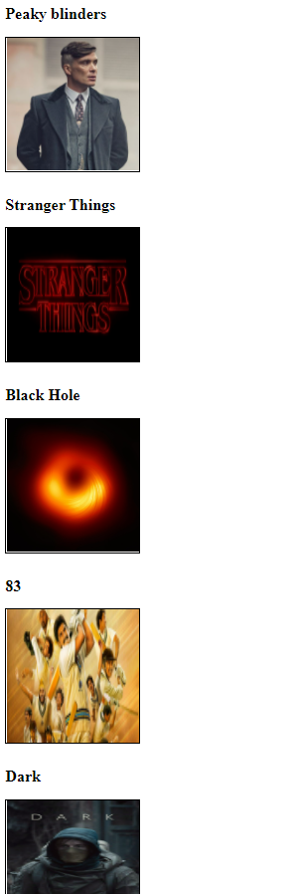s

25.

<html>

<body>

<a href="https://www.google.com/">

<img src="https://hips.hearstapps.com/hmg-prod.s3.amazonaws.com/images/tommy-shelby-cillian-murphy-peaky-blinders-1569234705.jpg?crop=0.737xw:0.493xh;0.263xw,0.0276xh&resize=480:*">

</a>

<a href="https://upload.wikimedia.org/wikipedia/commons/thumb/9/97/The_Earth_seen_from_Apollo_17.jpg/1200px-The_Earth_seen_from_Apollo_17.jpg">

<img src="https://upload.wikimedia.org/wikipedia/commons/thumb/9/97/The_Earth_seen_from_Apollo_17.jpg/1200px-The_Earth_seen_from_Apollo_17.jpg" width="100" height="100">

</a>

</body>

</html>

26.

<html>

<body>

<h1>The Bookworm: A Better Book Store</h1>

<pre>

<q>Cold hooke ara hat-how Tale and rhyma

Flud wale wth was the stress of timel</q>

--Cilamanca Urmy, Old Nonge are one

<address>

The Bookworm Bookshop

1345 Applewood Dr

Spring field, CA 94325

(415) 555-0034

</address>

Since 1933, The Bookworm Bookshop has offered rare and hard-en-find this for the decarming reader Unisks the

bigger bookstore chaine, the Bookwozu offers:

<ul>

<li>Friendly, knowledgeable, and courteous help</li>

<li>Free coffee and juice for our customers</li>

<li>A well lit reading room on so you can <q>try before you buyq</q></li>

<li>Four friendly came 1 Comamida, Carhane, Emlemes and 11AICA</li>

</ul>

Our hours are <b>10am to 7pm</b> weekdays, <b>noen to 7</b> on weekends

<h2><b>Titles (as of 25-Sept-94)</b></h2>

<ul><li>Sandra Bellweather, <i>Belladorinia</i></li>

<li>Joluohon Tin, <i>20-Marie Meals for One</i></li>

<li>Marwall Hurgana, <i>Lagion of Thunder</i></li>

<li>Alison Caix,<i>Bungu's Chout</i></li>

</ul>

<h2><b>Upcoming Events</b></h2>

<ul><li><b>The Wednesday Evening Book Review</b> mame, appropriate on Wednesday eveninge M for coffee and a round table discussion Call the Bookwurm for information on joining du group sand this week's reacting assignment </li>

<li><b>The Children's Hour</b> happens every Saturday at 1pm and includes reading, games, and other activation.Cookies and milk are served.</li>

<li><b>Carais Fenney</b> will be at the Bookworm on Friday, September 16, to read from her book of poema.Spiders in the Web.</li>

<li><b>The Hamlewarm will he closed</b> Octobar 1 to mmerve a family of hare that has named in the tower. We like

the comparo, but not the mess they leave behdind!</li>

<hr width="100%">

<i>Last updated:9/25/95<br>40 copyright 1995 the Bookworm</i>

</body>

</html>

27.

<html>

<body>

<h1 style="text-align:center">John Q. Smith</h1>

<p style="text-align:center">10255 Billings Road, Waxahachie TX 75165</p>

<p style="text-align:center">972-555-8643</p>

<p><strong>Objective</strong></p>

<p>&ensp;&ensp;&ensp;&ensp;&ensp;&ensp;&ensp;A management position in a leading family resaurant<br>&ensp;&ensp;&ensp;&ensp;&ensp;&ensp;&ensp;chain.</p>

<br>

<p><strong>Experience</strong></p>

<p>

&ensp;&ensp;&ensp;&ensp;&ensp;&ensp;&ensp;2002-present

<br>&ensp;&ensp;&ensp;&ensp;&ensp;&ensp;&ensp;Senior Assistant Manager, Great Steaks Steakhouse. Duties

<br>&ensp;&ensp;&ensp;&ensp;&ensp;&ensp;&ensp;include all operational tasks, personnel, ordering and all

<br>&ensp;&ensp;&ensp;&ensp;&ensp;&ensp;&ensp;local advertising and promotional events. Due to extensive

<br>&ensp;&ensp;&ensp;&ensp;&ensp;&ensp;&ensp;local promotion and community involvement, our store's

<br>&ensp;&ensp;&ensp;&ensp;&ensp;&ensp;&ensp;regional sales volume rank has increased from 11 to

<br>&ensp;&ensp;&ensp;&ensp;&ensp;&ensp;&ensp;number 1 and profit margins have increased by 22%.

<br><br>&ensp;&ensp;&ensp;&ensp;&ensp;&ensp;&ensp;<i>1999-2002</i>

<br>&ensp;&ensp;&ensp;&ensp;&ensp;&ensp;&ensp;Line cook and eventual crew chief at Pablo's Mexican restaurant.

<br><br>&ensp;&ensp;&ensp;&ensp;&ensp;&ensp;&ensp;<i>1997-1999</i>

<br>&ensp;&ensp;&ensp;&ensp;&ensp;&ensp;&ensp;Mays department store, sales clerk.<br>

</p>

<p><strong>Education</strong></p>

<p>

&ensp;&ensp;&ensp;&ensp;&ensp;&ensp;&ensp;1997-2001

<br>&ensp;&ensp;&ensp;&ensp;&ensp;&ensp;&ensp;B.A. Business Administration and Food Service

<br>&ensp;&ensp;&ensp;&ensp;&ensp;&ensp;&ensp;Management from Central Texas University<br>

<br>&ensp;&ensp;&ensp;&ensp;&ensp;&ensp;&ensp;1997

<br>&ensp;&ensp;&ensp;&ensp;&ensp;&ensp;&ensp;Valedictorian - West End high School</p>

<p><strong>Interests</strong></p>

<p>

&ensp;&ensp;&ensp;&ensp;&ensp;&ensp;&ensp;ig Brothers of Texas, white water rafting, personal

<br>&ensp;&ensp;&ensp;&ensp;&ensp;&ensp;&ensp;computers, primitive camping, gourmet cooking.

</p>

</body>

</html>

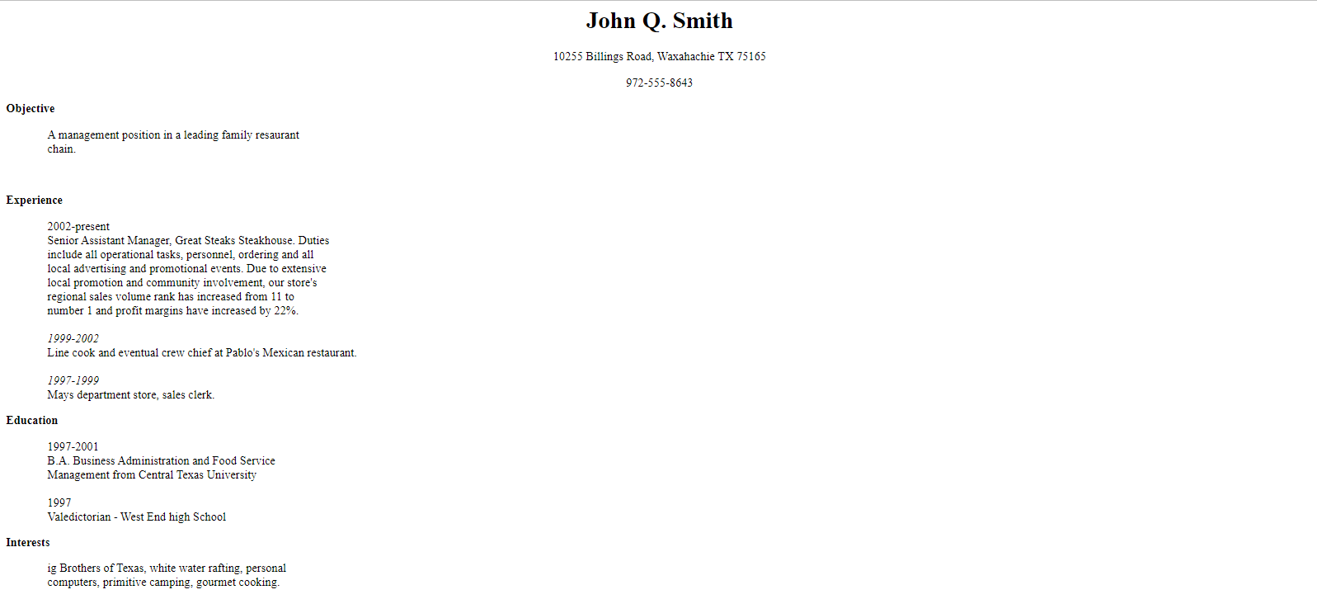

28.

<html>

<head>

<style>

table, th, td {

border: 2px solid black;

border-collapse: collapse;

}

table.center {

margin-left: auto;

margin-right: auto;

}

th, td {

padding: 10px;

}

</style>

</head>

<table class="center" style="width:500px;height:100px">

<tbody>

<tr>

<th rowspan="2">Train no</th>

<th rowspan="2">Name of the train</th>

<th rowspan="2">Place</th>

<th rowspan="2">Destination</th>

<th colspan="2">Time</th>

<th rowspan="2">Fare</th>

</tr>

<tr>

<th>Arrival</th>

<th>Departure</th>

</tr>

<tr>

<td>T6001</td>

<td>sidhal</td>

<td>chennai</td>

<td>cbe</td>

<td>12:00</td>

<td>3:00</td>

<td>300</td>

</tr>

<tr>

<td>T6002</td>

<td>Pold Express</td>

<td>Bombay</td>

<td>Pakistan</td>

<td>12:00</td>

<td>3:00</td>

<td>500</td>

</tr>

<tr>

<td>T2474</td>

<td>City express</td>

<td>srilanka</td>

<td>Chennai</td>

<td>11:00</td>

<td>4:00</td>

<td>800</td>

</tr>

<tr>

<td>T4400</td>

<td>Cheran</td>

<td>Kochi</td>

<td>Pondi</td>

<td>12:00</td>

<td>21:30</td>

<td>600</td>

</tr>

<tr>

<td>T5688</td>

<td>Fravisuba express</td>

<td>Pollachi</td>

<td>Chennai</td>

<td>12:00</td>

<td>3:00</td>

<td>800</td>

</tr>

</tbody>

</table>

</html>

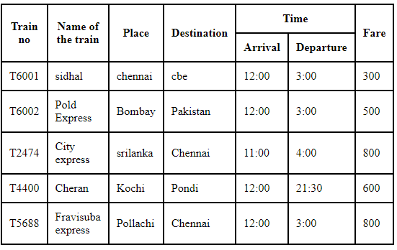

29.

<html>

<style>

table, th, td {

border:1px solid black;

border-collapse:collapse;

text-align: center;

}

</style>

<body>

<table>

<tr>

<td style="height:100; width:250"><img width="100%" height="100%" src="https://encrypted-tbn0.gstatic.com/images?q=tbn:ANd9GcSjm3mAZqlGBe6g0qk56geaF8AiTBMoj_XhgQ&usqp=CAU"></td>

<td style="height:100; width:250"><img width="100%" height="100%" src="https://encrypted-tbn0.gstatic.com/images?q=tbn:ANd9GcQjHp6_dGBZU7mdDvGnygw-dJ_9Iuqf-vcrjA&usqp=CAU"></td>

<td style="height:100; width:250"><img width="100%" height="100%" src="https://encrypted-tbn0.gstatic.com/images?q=tbn:ANd9GcTXPZFp7waQ2zYPmloseWXs0Q9Gh_jeGWNMVg&usqp=CAU"></td>

<td style="height:100; width:250"><img width="100%" height="100%" src="https://encrypted-tbn0.gstatic.com/images?q=tbn:ANd9GcQkX79-ovjn9TY8UqkLZrTE00kk2Bbcys4wAQ&usqp=CAU"></td>

</tr>

<tr>

<td style="height:100; width:250"><img width="100%" height="100%" src="https://encrypted-tbn0.gstatic.com/images?q=tbn:ANd9GcSxJL__uFFHV_mBKg6TDT1QycaNHx8KU_rQsA&usqp=CAU"></td>

<td colspan="2" rowspan="2" style="height:100; width:250">image</td>

<td style="height:100; width:250"><img width="100%" height="100%" src="https://encrypted-tbn0.gstatic.com/images?q=tbn:ANd9GcQTTSqBIWKekPHzmSIKXtRYhSmR6v71ypzS1Q&usqp=CAU"></td>

</tr>

<tr>

<td style="height:100; width:250"><img width="100%" height="100%" src="https://encrypted-tbn0.gstatic.com/images?q=tbn:ANd9GcSLVUI-DPA9TIBty5dmh13I3TyS3MxAvzoyiw&usqp=CAU"></td>

<td style="height:100; width:250"><img width="100%" height="100%" src="https://encrypted-tbn0.gstatic.com/images?q=tbn:ANd9GcT48Jo4Agrhsey1mk7WSJajjwj736IByT5CMg&usqp=CAU"></td>

</tr>

<tr>

<td style="height:100; width:250"><img width="100%" height="100%" src="https://encrypted-tbn0.gstatic.com/images?q=tbn:ANd9GcQKVwWPp0ZGj6w7dTA0VKYhauGetVHrKYxSKQ&usqp=CAU"></td>

<td style="height:100; width:250"><img width="100%" height="100%" src="https://encrypted-tbn0.gstatic.com/images?q=tbn:ANd9GcQbXoEj8jmNdXfdEOnkCooX1SB8t2wWkzqfhQ&usqp=CAU"></td>

<td style="height:100; width:250"><img width="100%" height="100%" src="https://encrypted-tbn0.gstatic.com/images?q=tbn:ANd9GcSDp0wIwuJ5XQuuMv7IScA9fMXDOfo7MefSdQ&usqp=CAU"></td>

<td style="height:100; width:250"><img width="100%" height="100%" src="https://encrypted-tbn0.gstatic.com/images?q=tbn:ANd9GcS3f-yvL6wCnAGELY_GxC5l6lTpsKlKh7WuGQ&usqp=CAU"></td>

</tr>

</table>

</body>

</html>

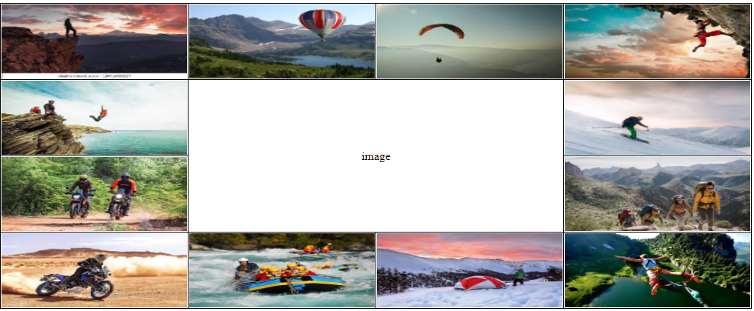

30.

<html>

<head>

<style>

table, th, td {

border: 1px solid black;

}

table.center {

margin-left: auto;

margin-right: auto;

}

th, td {

padding: 10px;

}

</style>

</head>

<table class="center" style="width:500px;height:100px">

<tbody>

<tr>

<th rowspan="3">Day</th>

<th colspan="3">Seminar</th>

</tr>

<tr>

<th colspan="2">Schedule</th>

<th rowspan="2">Topic</th>

</tr>

<tr>

<th>Begin</th>

<th>End</th>

</tr>

<tr>

<td rowspan="2">Monday</td>

<td rowspan="2" bgcolor="yellow">8:00am</td>

<td rowspan="2" bgcolor="violet">5:00pm</td>

<td>Introduction to XML</td>

</tr>

<tr>

<td>Validity:DTD and Relax NG</td>

</tr>

<tr>

<td rowspan="3">Tuesday</td>

<td bgcolor="yellow">8:00am</td>

<td bgcolor="yellow">11:00am</td>

<td rowspan="2">XPath</td>

</tr>

<tr>

<td bgcolor="yellow">11:00am</td>

<td bgcolor="lightgreen">2:00pm</td>

</tr>

<tr>

<td bgcolor="lightgreen">2:00pm</td>

<td bgcolor="violet">5:00pm</td>

<td rowspan="1.5">XML Transformations</td>

<tr>

<td>Wednesday</td>

<td bgcolor="yellow">8:00am</td>

<td bgcolor="lightgreen">12:00pm</td>

<td>XSL Formatting Objects</td>

</tbody>

</table>ss