**“Document Share via QR Code”**

# A Project Report

Submitted in partial fulfilment of the

Requirements of the award of the Degree of

**BACHELOR OF SCIENCE (INFORMATION TECHNOLOGY)**

# By

Student Name Roll No.: 24

**Under the esteemed guidance of**

# Ms. Archana Raut



**DEPARTMENT OF INFORMATION TECHNOLOGY**

# Late Shri Vishnu Waman Thakur Charitable Trust’s Bhaskar Waman Thakur College of Science,

**Yashwant Keshav Patil College of Commerce, Vidya Dayanand Patil College of Arts.**

***(Affiliated to University of Mumbai)***

**VIRAR, 401303 MAHARASHTRA 2022-2023**

# Vishnu Waman Thakur Charitable Trust’s Bhaskar Waman Thakur College of Science,

**Yashwant Keshav Patil College of Commerce, Vidya Dayanand Patil College of Arts.**

***(Affiliated to University of Mumbai)***

**Virar (W)-MAHARASHTRA-401303**

# DEPARTMENT OF INFORMATION TECHNOLOGY



**CERTIFICATE**

**Roll No: 24 Exam Seat No**.

This is to certify that the project entitled, **“Document Share via QR Code "**, is bonafied work of **Student name**

bearing Seat. No: submitted in partial fulfilment of the requirements for the award of degree of BACHELOR OF SCIENCE in INFORMATION TECHNOLOGY from University of Mumbai.

**Internal Guide Head of Department**

**External Examiner**

**Date : College Seal**

# ABSTRACT

**“Document Share via QR Code”** is web-based application which helps student to easy submit or share their document with college or school or education institute just Via submit QR Code . Its fast and Secure . Student can also print their digital Document ID CARD. Documents are saved on server are encrypted so documents are secure. From other users. As students of FYJC/SYJC/engineering/under-graduation/post-graduation those who are searching for admissions in different colleges submitting their documents to perceive admission in that college .It takes so much time to go to that colleges and submit their documents .The colleges are far away from the place the person stays so basically students face time issues to do this important task.

To overcome this above problem this particular topic is chosen to reduce cost of travelling and the most important time of the student.

# ACKNOWLEDGEMENT

I am very grateful to our Principal for providing us with an environment to complete my project successfully.

I am deeply indebted to **Prof. Sampada Deshmukh Head of I.T Department, VIVA College** who modelled us both technically and morally for achieving greater success in life.

I express our sincere thanks to all our lecturers, for their constant encouragement and support throughout our course, especially for the useful suggestions given during the course of the project period.

I am grateful to my internal guide **Prof. Archana Raut** Lecturer, for being instrumental in the completion of our project with her complete guidance.

We would like to thank our parent for providing us with all their support and encouragement right from the project’s budding stage to its current maturity.

Above all we would like to thank the almighty for giving us courage and energy to work day and night to make this project a grand success.

# DECLARATION

I hereby- declare that the project entitled, **“Document Share via QR Code”** submitted by me,under the guidance of my supervisor it is own work and has been presented for a degree in any other university

# Table of Contents

**Chapter 1:Introduction**

* 1. Background
  2. Objective
  3. Purpose, Scope and Applicability
     1. Purpose
     2. Scope
     3. Applicability

**Chapter 2: Survey of Technology**

**Chapter 3: Requirement and Analysis**

3.1 Problem Definition

3.2 Requirement Specification

3.3 Planning and Scheduling

3.3.1 Gant Chart

3.3.2 Pert Chart

3.4 Software and Hardware Requirement

3.5 Preliminary Product Description

3.6 Conceptual model

3.6.1 Event Table

3.6.2 Use Case Diagram

3.63 Sequence Diagram

3.6.4 Class Diagram

3.6.5 State Diagram

**Chapter 4: System Design**

4.1 Basic Module

4.2 Data Design

4.2.1 Schema Design with Data Integrity and Constraints

4.2.2 Database Relationship Design

4.2.3 Security Issues

**Chapter 5: Implementation Design**

5.1 Implementation Approaches

5.2 Coding Details And Coding Efficiency

5.3.1 Unit Testing

5.3.2 Integration Testing

5.3.3 Beta Testing

5.3.4 Test Cases

**Chapter 6: Results And Discussions**

6.1 Test Reports

6.2 User Documentation

**Chapter 7: Conclusions**

7.1 Conclusion

7.2 Significance Of The System

7.3 Limitations Of The System

7.4 Future Scope Of The Project

References

# Chapter 1: Introduction

QR is short for Quick Response (they can be read quickly by a cell phone). They are used to take a piece of information from a transitory media and put it in to your cell phone. You may soon see QR Codes in a magazine advert, on a billboard, a web page or even on someone’s t-shirt. Once it is in your cell phone, it may give you details about that business (allowing users to search for nearby locations), or details about the person wearing the t-shirt, show you a URL which you can click to see a trailer for a movie, or it may give you a coupon which you can use in a local outlet.

The Quick Response Code was developed in 1994 for the automotive industry by a Toyota subsidiary. The QR code is a 2- dimensional barcode that can be read optically, for instance using a mobile phone camera. The code can contain data such as website URLs, product descriptions or vCard’s (electronic business cards). The original purpose of the QR code was to track vehicles during manufacturing. Today QR codes are primarily used for advertising, linking printed media with online media (such as websites, YouTube videos or online product brochures). Another usage area for QR codes that is growing in popularity is for mobile payments. Using QR codes is free, it doesn’t require any form of license. QR codes are not the only way to link the printed and online world, other technologies include Microsoft Tags and NFC (Near Field Communication), but more on those in another blog post.

Document Share is web-based application which helps student to easy submit or share their document with college or school or education institute just Via submit QR Code. Its fast and Secure. Student can also print their digital Document ID CARD. Documents are saved on server are encrypted so documents are secure. From other users.

The Login and Registration module allows the student to create their own profile on the site and Manage their account to upload and download and delete their documents as per requirements.

* QR Code and ID CARD: - This module helps to student generate QR code and Digital

Document card for sharing their document securely and easily with any organization.

Student can generate different QR Code for group of documents.

* OTP: Student can protect their document with Mobile OTP so only real person get access with whom student shared the OTP
* Group Share: Student can create group and so other fellow students can get document access without OTP.
* Block and Recover QR Code: - Any student can block their QR Code show one able to access document. And If student lost ID Card or forgot Account Details can easily recover it with OTP.

Quick Response (QR) codes are versatile. A piece of long multilingual text, a linked URL, an automated SMS message, a business card or just about any information can be embedded into the two-dimensional barcode. Coupled with moderate equipped mobile devices, QR Codes can connect the users to the information quickly and easily. The low technical barrier of creating and reading QR codes allows innovative educators to incorporate them into their educational endeavours. The operations to retrieve or store QR codes are incredibly simple and quick, and with mobile devices, make them the ideal educational tools for teaching and learning. QR codes are everywhere and most people have mobile phones equipped with QR code readers. Although QR codes existed for over fifteen years, there are not so many research applications in this area. QR code was developed by Denso-Wave, a Japanese automatic data capture equipment company (Denso, 2009), in 1994. “QR” stands for “Quick Response.” It is readable by moderately equipped mobile phones with camelinked by the URL quickly, we can send the SMS message directly or we can save the contact information onto the address book easily.

# 1.1 Background

This project will design and develop a QR coding system that tags relevant historical points of interest in Athabasca as a means of enriching the experience of people wanting to learn more about the places, people and events that have shaped the town and the area. The system will provide an easy method of creating QR codes, metadata entry, geo-referencing, and web linking for anyone wishing to update the information in future, or create new information. It will have a statistical tracking and reporting function to help measure use of the system.

Quick Response (QR) codes are easy to use, simple to make and becoming increasingly pervasive. They can be generated instantly, allowing users to access information using QR code readers with a mobile device such as a cell phone. The idea of linking spaces and objects to information is not new; parks and museums 3 have traditionally used interpretive signs for this purpose. But the addition of QR code technology allows for a much richer interaction with places and things by providing people with options to receive their information from an array of images, audio-files, videos as well as text. QR codes essentially provide new levels of meta- tagging that increase flexibility and interactivity with the environment.

QR codes are a simple technology that can be used in many ways. The technology might, for example, be used to deepen a tourist's experience with interpretive signage on-site and then direct her to an array of other sites; the system might encourage school children to collect points along the way in a sort of treasure hunt. AU Library has been working with the Town of Athabasca on a QR Coding such a project aimed at assisting the town to market itself better to tourists. But the information could be of use to others as well. A local teacher, for instance, might choose to use the QR Codes with his students during field trips that focus on Athabasca’s history.

The Town of Athabasca is in the process of updating a series of panels located throughout the community. The current panels, which have historical and nature images and text, will be augmented with QR codes allowing the user to link to timely information and activities in the town. The project will create content and apply fifteen QR tags to objects/places throughout the town, including AU campus.

These QR codes will link to interactive and contextual contents, including short video clips from "experts" speaking about the object/place, and other visual and interpretive text. The information will provide an in-context tour of the town introducing objects, places and people important to the town. This project will include a pilot launch in May to determine the success of the project. It is anticipated that this pilot in Athabasca could be turned into a regional initiative that would attract and keep tourists in the area longer.

# 1.2 Objective

The first objective of this thesis work is to study the concept of QR Code in detail, which involves the development history and the definition of QR Code. Furthermore, the characteristics of QR Code are introduced, and through different types QR Code the features of different QR Code are analysed. In addition, the underlying and feasible technologies of QR Code will be explored and analysed in the thesis. The analysis involves the symbol of QR Code, encoding and decoding procedures of QR 8 Code. Moreover, regarding the QR Code generator and QR Code reader process implementation is demonstrated in this research. To achieve the objective, various resources are used to support this thesis. The second objective of the thesis work aims to find out the benefits of using QR Code within companies and give reasonable recommendations on companies QR Code usage. In order to achieve this objective, this research is to explore the application of QR Code in WeChat and the characteristics of QR Code. Moreover, examples are used to explore and explain the benefits of using QR Code.

The objectives of this project are to:

* Design and develop a QR coding system to tag and code landmarks and attractions in the Town of Athabasca
* Conduct research on the history of the Town of Athabasca and liaise with library, archives, historical society and the public as needed for the QR Codes
* Digitize and develop content (audio, video, images) in support of the project, including short stories, images and other media; these will be recorded, archived, and coded
* Create tags with content for at least 15 locations in the Town of Athabasca and AU campus
* Conduct a pilot launch to test usability and feasibility of using QR codes in the Town of Athabasca
* Prepare a summary report on the technology used and results of the project
* Prepare guidelines or best practices to help other towns regarding QR code technology deployment.

# 1.3 Purpose, scope and Applicability

## 1.3.1 Purpose

In Document share via QR code, the customer can share the Document, he can also add the product. Document Sharing is web-based application which helps student to easy submit or share their document with college or school or education institute just Via submit QR Code. Its fast and Secure. Student can also print their digital Id card Documents are saved on server are encrypted so documents are secure. From other users.

## 1.3.2 Scope

This system will reduce the manual operation required to view or share document and also generates the QR code for analysis. This module helps student generate QR code and Digital Document card for sharing their document securely and easily with any organization. Student can generate different QR Code for group of documents.

## 1.3.3 Applicability

The project entitled “**Document share via QR code**” enables customer to share document from anywhere through online. Its fast and Secure. Student can also print their digital Document ID CARD. Documents are saved on server are encrypted so documents are secure. From other users. The Login and Registration module allows the student to create their own profile on the site and manage their account to upload and download and delete their documents as per requirements.

# Chapter 2: Survey of Technologies

**Front End- ASP.Net**

ASP.NET is one of the most exciting web development technologies on offer today. Here was a powerful platform with lots of built-in functionality, astonishing performance levels, and one of the best IDEs (Integrated Development Environments) around: Visual Studio. ASP.NET showed the way for the faster, easier and more disciplined development of dynamic web sites, and the results were impressive.

ASP.NET is a server-side Web application framework designed for Web development to produce dynamic Web pages. It was developed by Microsoft to allow programmers to build dynamic web sites, web applications and web services. It was first released in January 2002 with version 1.0 of the .NET Framework, and is the successor to Microsoft's Active Server Pages (ASP) technology. ASP.NET is built on the Common Language Runtime (CLR), allowing programmers to write ASP.NET code using any supported .NET language.

**Back End –SQL Server**

Microsoft SQL Server is a relational database management system developed by Microsoft. As a database, it is a software product whose primary function is to store and retrieve data as requested by other software applications, be it those on the same computer or those running on another computer across a network (including the Internet). There are at least a dozen different editions of Microsoft SQL Server aimed at different audiences and for workloads ranging from small single-machine applications to large Internet-facing applications with many concurrent users. Its primary query languages are T-SQL and ANSI SQL.

* Portability across computer systems
* SQL standards
* Relational foundation
* High-level, English-like structure
* Programmatic database access
* Complete database language
* Dynamic data definition
* Client/server architecture
* Extensibility and object technology
* Internet database access

# Chapter 3: Requirement Analysis

# 3.1 Problem Definition

A QR code (quick response code) is a type of [**2D bar code** that i](https://searchmobilecomputing.techtarget.com/definition/2D-barcode)s used to provide easy access to information throug[h a smartphone. I](https://searchmobilecomputing.techtarget.com/definition/smartphone)n this process, known as mobile tagging, the smartphone’s owner points the phone at a QR code and opens a [barcode reader ap](https://whatis.techtarget.com/definition/barcode-reader-POS-scanner-bar-code-reader-price-scanner)p which works in conjunction with the phone’s camera. The reader interprets the code, which typically contains a call to action such as an invitation to download a mobile application, a link to view a video or an [SMS messa](https://searchmobilecomputing.techtarget.com/definition/Short-Message-Service)ge inviting the viewer to respond to a poll. The phone’s owner can choose to act upon the call to action or click cancel and ignore the invitation.

Static QR codes, the most common type, are used to disseminate information to the general public. They are often displayed in advertising materials in the environment (such as billboards and posters), on television and in newspapers and magazines. The code’s creator can track information about the number of times a code was scanned and its associated action taken, along with the times of scans and the operating system of the devices that scanned it. Dynamic QR codes (sometimes referred to as unique QR codes) offer more functionality. The owner can edit the code at any time and can target a specific individual for personalized marketing. Such codes can track more specific information, including the scanners names and email address, how many times they scanned the code and, in conjunction with tracking codes on a website, conversion rates.

The technology for QR codes was developed by Densa-Wave, a Toyota subsidiary.

The codes were originally used for tracking inventory.

## Here are a few examples of QR codes in current use

* QR codes on business cards link to the individual's full resume or website.
* A Starbucks promotion featured a QR code-enabled scavenger hunt involving hints accessed through QR codes in the stores.
* Quirking Monuments in Seattle puts QR code on gravestones to connects people to an online obituary or a website about the deceased.

# 3.2 Requirement Specification

## 1. Functional Requirements

* At the Login module email and password facility and credentials should be checked properly at the time of login for admin as well as User.
* User Manage folder groups and Files as well as QR Code details
* User Can Create QR code for particular folder.
* Student can book event as per their need like location and date time
* Automatic checking of availability of location and place
* User also Activate and Deactivate his/her account for time being using OTP.
* User can share documents with other user without QR code by just giving permission access.
* User can block QR code at any given time. • This web portal access through internet or intranet.

## 2. Non-Functional Requirements

* The application shall not change any of the operating system options or to any of the other applications that are installed.
* The application shall not access any data stored on the device except its own DB and data stored in the application own cookies.
* Response time won't exceed 5 seconds.
* All the information that is asked to be deleted will be deleted from the application, including all Facebook credentials.
* The user interface will be easy to operate and will be native to iOS and\or Android users.
* The application should work with iOS and Android devices that have HTML5 supported browser

## 3. Interface Requirements

* **User Interface** o The UI shall be graphical. o The UI will be developed with HTML5 and JavaScript and converted to specific mobile platforms using the Phone Gap framework.
* **Hardware Interfaces**

The supported devices are Android and iPhone devices. The device must include a touch screen, a keyboard and a camera (for scanning QR codes).

* **Software Interfaces**

The server side will be written in PHP programming language. The application shall interface with the following external software components:

# 3.3 Planning and Scheduling

**3.3.1 Gantt chart:**

**3.3.2 Pert Chart:**

# 3.4 Software and Hardware Requirements

**Software Requirements:-**

* **Front End:** Asp with C#
* **Development Environment:** Microsoft Visual Studio 2010 or higher
* **Back End:** SQL Server (2008)
* **Operating System:** Window 7 or higher

**Hardware Requirements:-**

* **Operating System:** Windows 7, 8, 8.1, 10
* **Hard disk:** Minimum 500 GB
* **RAM:** Minimum 4 GB

# 3.5 Preliminary Product Description

The product will be developed completely independent and dynamic form. Customer must have an account to purchase the product. This application stores all the information in the database which can be retrieved whenever needed and all the validations are performed during the entry of the data by the user thus ensuring that the user cannot enter any wrong data which could cause problem later.

Initially customer has to register to the form to access most of the features of the application. The customer has to enter the details like username, password…etc. After registration customer will be able to purchase products and the purchased product can be added to the cart. Later customer has to enter his card details or take COD to buy the products.

# 3.6 Conceptual model

## 3.6.1 Event Table

|  |  |  |  |  |  |  |
| --- | --- | --- | --- | --- | --- | --- |
| **Sr. No** | **Event** | **Trigger** | **Source** | **Use Case** | **Response** | **Destination** |
| 1 | Admin add new Event | Event | Admin | Adding  Event  Details | Event Details | Admin |
| 2 | Student | Event | Admin | Adding  Event Details | Event Details | Admin |
| 3 | Receiver | Event | Admin | Adding  Event Details | Event Details | Admin |
| 4 | Receiver | Event | Admin | Adding  Event Details | Event Details | Admin |

### 

### 3.6.2 Use Case Diagram

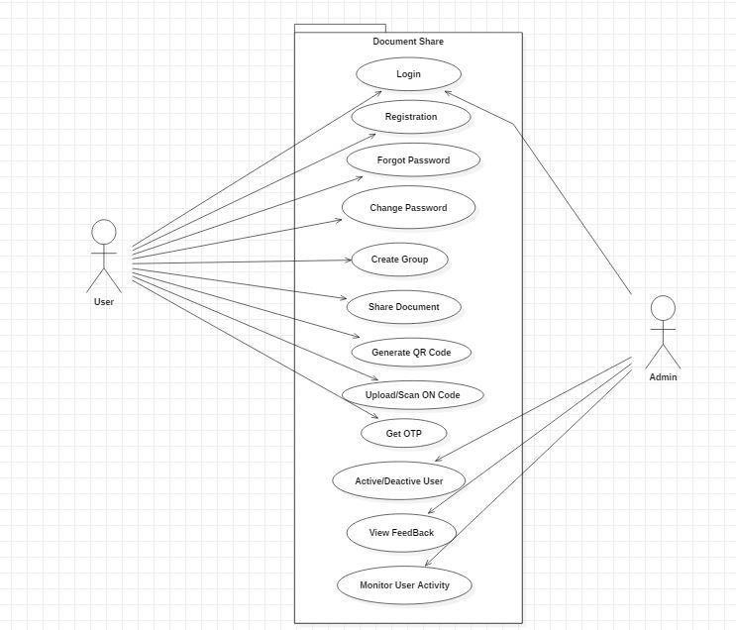

**3.6.4 Sequence Diagram**

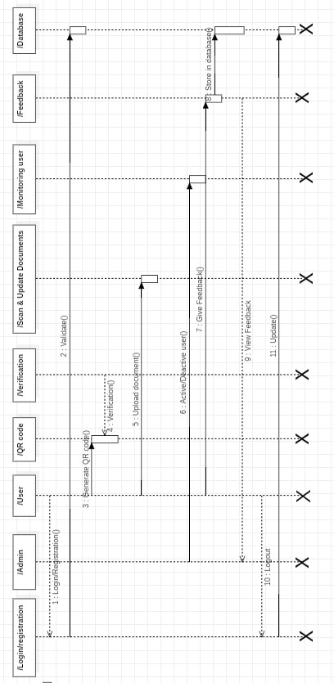

**3.6.5 Sequence Diagram**

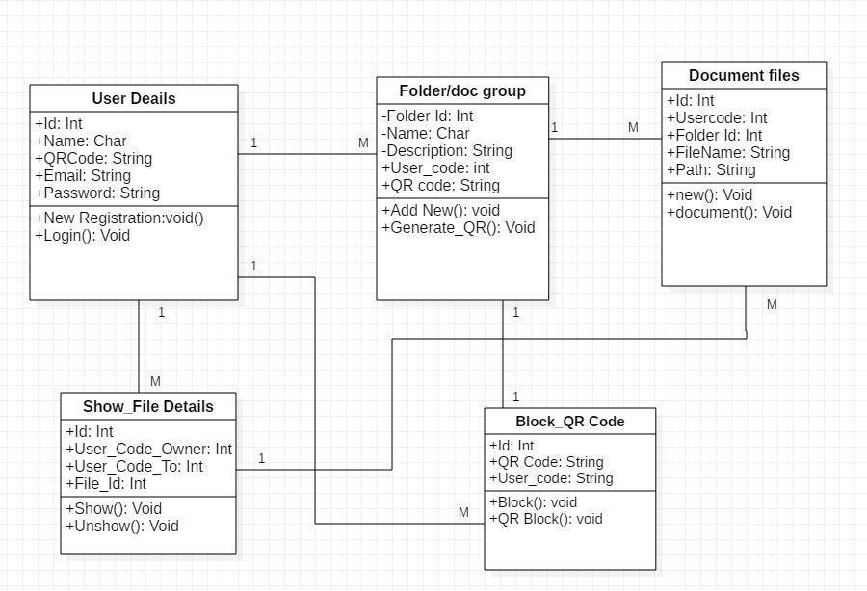

### 3.6.6 State Diagram

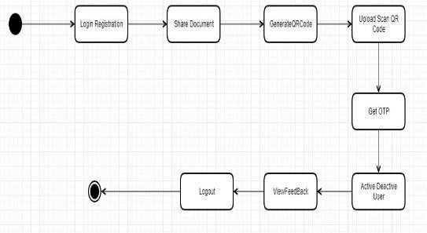

# Chapter 4: System Design

# 4.1 Basic Module

1. **Login and Registration :** The Login and Registration module allows the student to create their own profile on the site and Mange their account to upload and download and delete their documents as per requirements.
2. **QR Code and ID CARD :-** This module help to student generate QR code and Digital Document card for sharing their document securely and easily with any organization . Student can generate different QR Code for group of documents.

1. **Protecting Document with OTP** : Student can protect their document with Mobile OTP so only real person get access with whom student shared the OTP.

1. **Group Share :** Student can create group and so other fellow students can get document access without OTP.

1. **Block and Recover QR Code :-** Any student can block their QR Code show one able to access document. And If student lost ID Card or forgot Account Details can easily recover it with OTP.

1. **Document and Content Search :-** Through this module user can search content as well as document with by name,date,size,extentions etc.

1. **Active and Deactive Account :-** User can deactive/active account for security reason through Mobile OTP.

1. **Mobile Contact share with QR Code :-** This module help use to share important contact and group of contacts with QR code.

1. **Accessed log:-** A record of all those faculty/people who accesed my document through docshare.

# 4.2 Data Base Design

## 4.2.1 Schema Design & Data Integrity and Constraints

**User Details:**

|  |  |  |
| --- | --- | --- |
| **Column Name** | **Data Types** | **Constrain** |
| Id | Int | Primary Key, Not null |
| Name | Varchar(45) | Not null |
| QR Code | Varchar(45) | Not null |
| Email | Varchar(25) | Not null |
| Password | Varchar(8) | Not Null |

**Folder/Doc Group:**

|  |  |  |
| --- | --- | --- |
| **Column Name** | **Data Types** | **Constrain** |
| ID | Int | Primary Key, Not null |
| Name | varchar(45) | Not null |
| Description | Varchar(45) | Not null |
| User_Code | Int | Foreign key,not null |
| QR Code | Varchar(45) | Not null |

**Document Files:**

|  |  |  |
| --- | --- | --- |
| **Column Name** | **Data Types** | **Constrain** |
| ID | Int | Primary Key,Not null |
| User Code | Int | Primary Key,not null |
| Folder Id | Int | Not Null |
| File Name | Varchar(45) | Not Null |
| path | Varchar(45) | Not Null |

**Show_file details :**

|  |  |  |
| --- | --- | --- |
| **Column Name** | **Data Types** | **Constrain** |
| ID | Int | Primary Key,Not null |
| User_ Code_owner | Int | Not null |
| User_ Code_to | Int | Foreign key,not null |
| File_Id | Int | Foreign key,not null |

**Block_QR code :**

|  |  |  |
| --- | --- | --- |
| **Column Name** | **Data Types** | **Constrain** |
| ID | Int | Primary Key,Not null |
| QR code | Varchar(45) | Foreign key,not null |
| User_code | Varchar(45) | Foreign key,not null |

**Data Integrity and Constraints**

* **Primary Key Constraint:** Primary key constraint uniquely identifies each record in a database. A Primary Key must contain unique value and it must not contain null value.

Usually Primary Key is used to index the data inside the table.

* **Not Null Constraint:** Not Null Constraint makes sure that a column is not left null. It forces the person to enter some value else it will show an error.

* **Unique Constraint:** Unique Constraint the name itself suggest that a column will have a unique values. This constraints makes sure that the column don’t have any duplicate value. It can applied to column level or table level.

* **Auto Increment:** The constraint applied to whichever column will see that it increments itself whenever a new record is inserted, so that the duplication is not generated.

# 4.2 Data Relationship Design

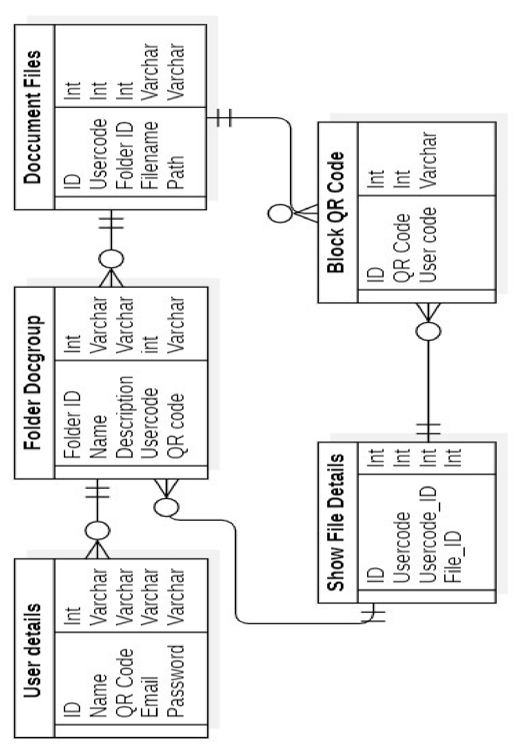

# 4.3 Security Issues

* **Authorization**: Admin provides the facility to provide the registration to the users which can be customer.
* **Authentication:** Only the registered users i.e. it can be customer or a waiter are allowed to login and access the site for using it. For login purpose the user have to give the username and password and from the database they will be authenticated.
* **Information Integrity**: The information that is being provided by the user are not leaked to any of the outside person. The information about the articles and the document can only be changes by the admin only and no user can change it.
* **Detection:** The passwords of the users and admin are alphanumeric password and there is also an option of changing the password even for the admin so that a single password cannot stay for long.

# 4.5 Test Cases

|  |  |  |  |  |
| --- | --- | --- | --- | --- |
| **Test cases** | **Input specified** | **Expected result** | **Actual O/P** | **Test Result or Status** |
| User login | Username=”” Password=”” | Username empty | Username empty | Pass/Fail |
| Username  =”abc”  Password=” abc34” | Verify and redirect to home page | Verify and redirect to home page | Pass/Fail |
| Forget password | Email=”” | Please enter email | Please enter email | Pass/Fail |
| Email=”12345er” | Please enter valid email | Please enter valid email | Pass/Fail |
| Email=”anc@gmai  l.com” | Msg has been sent to your email id | Msg has been sent to your email id | Pass/Fail |
| Mobile.no | Mobile.no= | Specify your mobile.no | Specify your mobile.no | Pass/Fail |
| Mobile.no=5%23w w | Enter correct mob.no | Enter correct mob.no | Pass/Fail |
| Mobile.no=996003 4532 | Mobile enter vaild | Mobile enter vaild | Pass/Fail |
| O  T  P | OTP.no= | Specify your  OTP.no | Specify your OTP  .no | Pass/Fail |
| Mobile.no=5%23w w | Enter correct mob.no | Enter correct  OTP.no | Pass/Fail |
| OTP.no=1010 | OTP enter vaild | OTP enter vaild | Pass/Fail |
| File  Format | File = abc.exe | Invalid file format | Please upload valid file | Pass/Fail |
| File = abc.pdf | Automatically file uploaded | File saved to server folder | Pass/Fail |

# Chapter 5 Implementation and Testing

# 5.1 Implementation Approaches

* **Register**

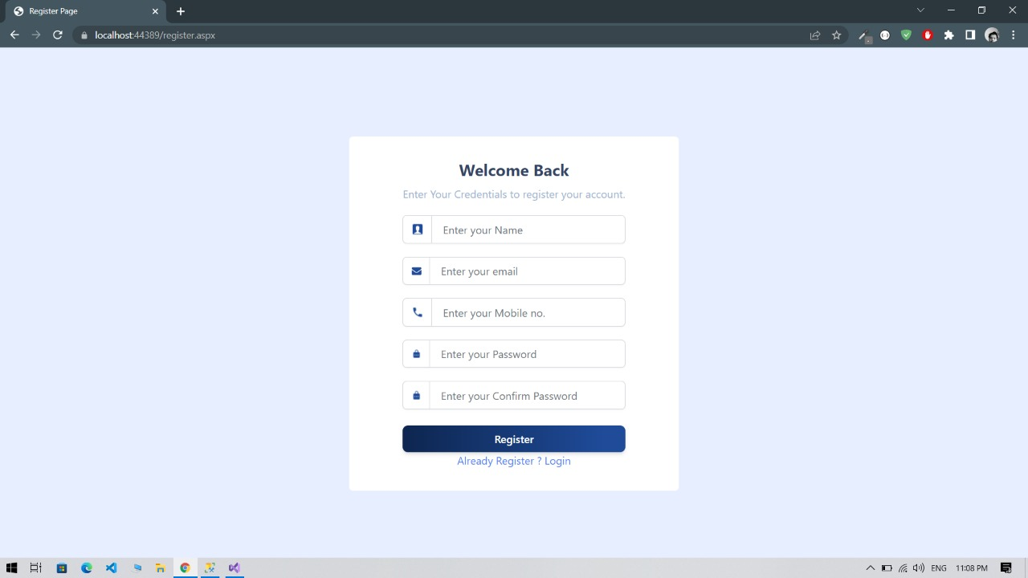

* **Login**

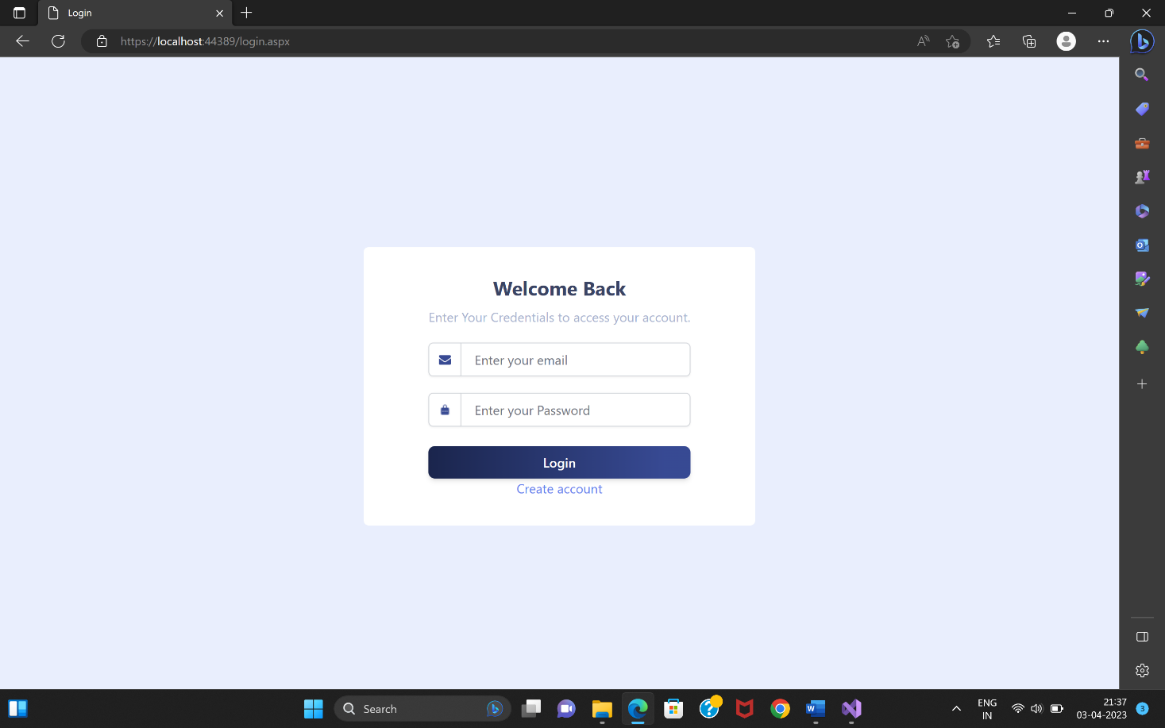

* **File Report**

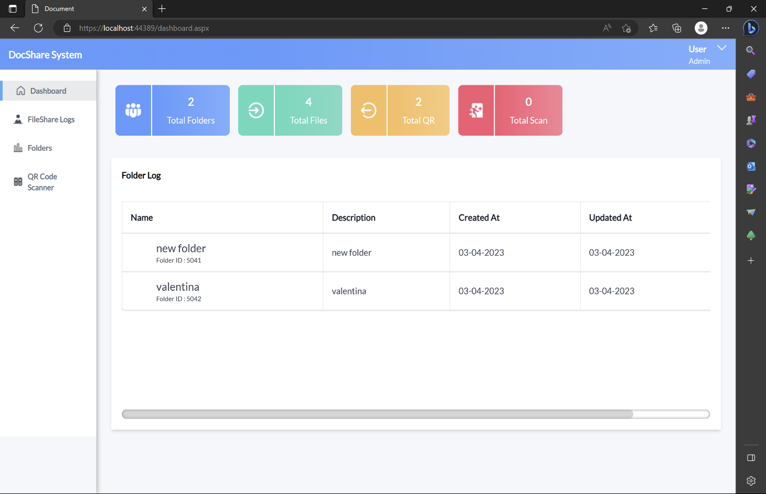

* **Folder Group Reports**

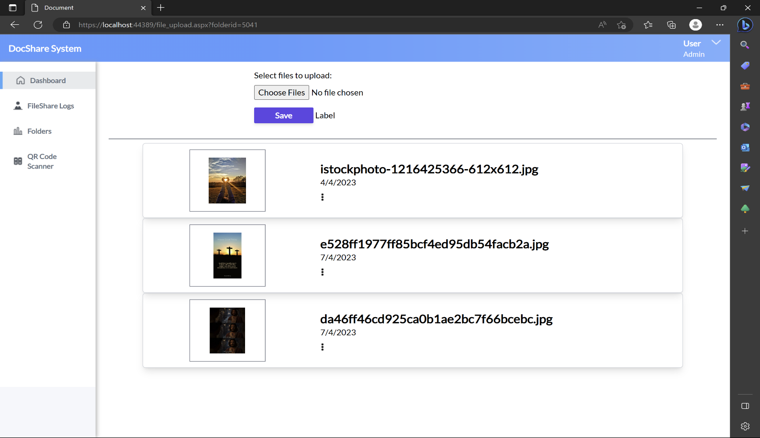

* **Scan QR Reports**

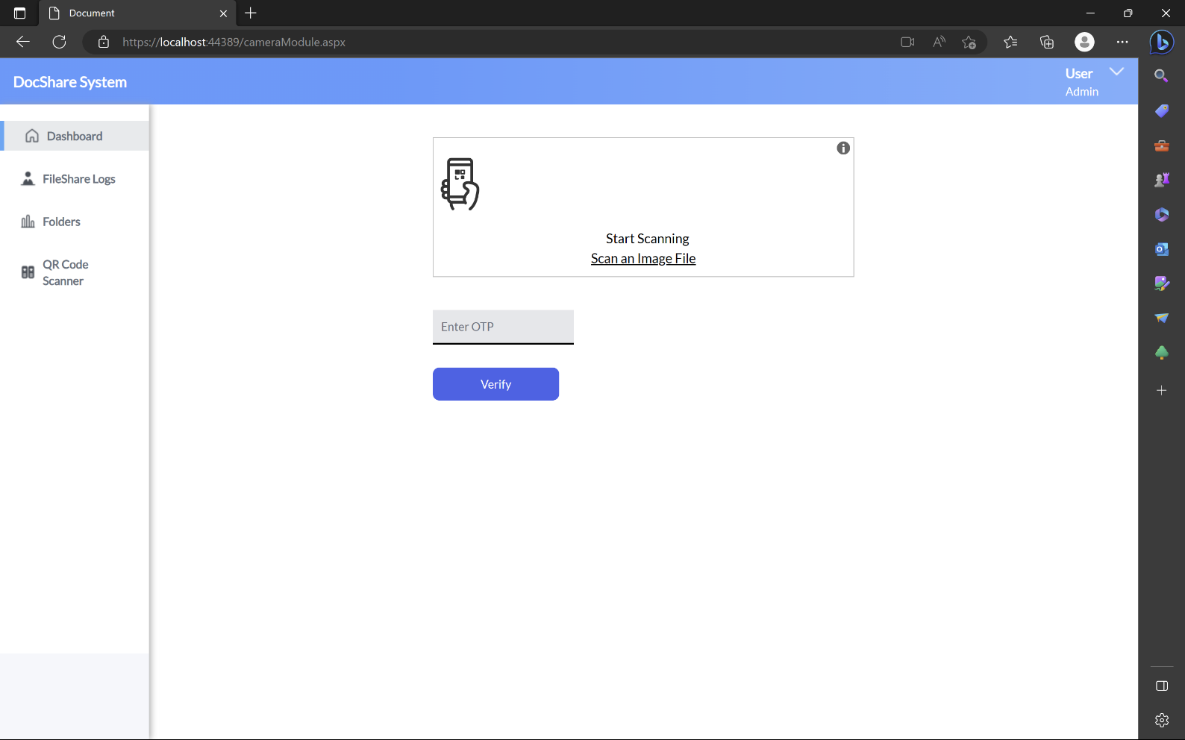

* QR Code

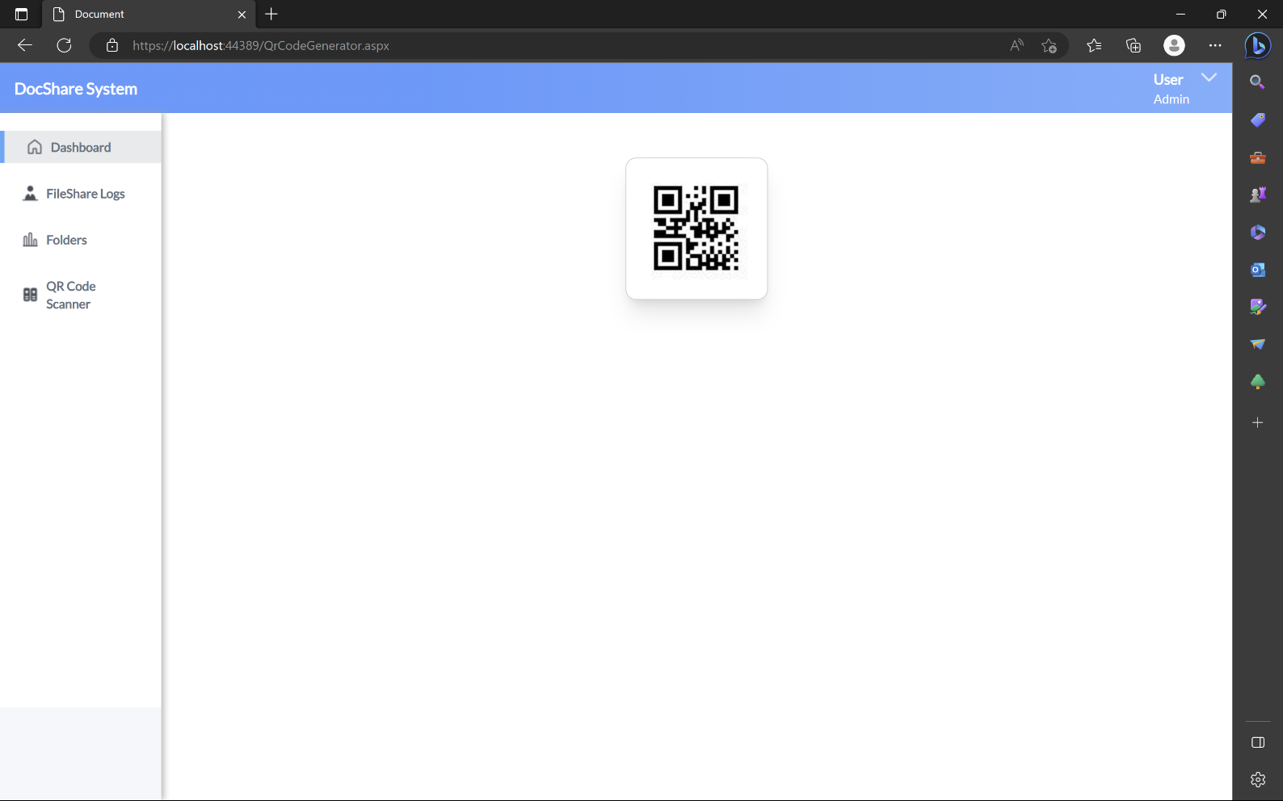

* **File Log Reports**

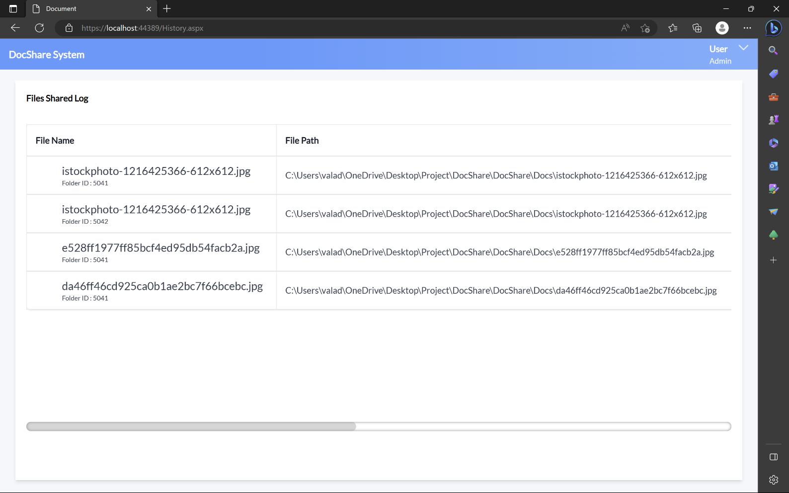

**5.2 Coding Details And Coding Efficiency**

**Login.aspx.cs**

using System;

using System.Collections.Generic;

using System.Web;

using System.Web.UI;

using System.Web.UI.WebControls;

using System.Data;

using System.Web.Services;

namespace DocShare

{

public partial class login : System.Web.UI.Page

{

protected void Page_Load(object sender, EventArgs e)

{

}

[System.Web.Services.WebMethod(EnableSession = true)]

public static string check_login(string name, string pass)

{

Dbconnection db = new Dbconnection();

String message = "no";

DataSet ds = new DataSet();

ds = db.ExecuteDataSet("Select * from dbo.user_detail where email = '" + name + "' and pass='" + pass + "'");

if (ds.Tables[0].Rows.Count > 0)

{

String uname = ds.Tables[0].Rows[0]["name"].ToString();

String dbname = ds.Tables[0].Rows[0]["email"].ToString();

String dbpass = ds.Tables[0].Rows[0]["pass"].ToString();

String usercode = ds.Tables[0].Rows[0]["usercode"].ToString();

if (name.Equals(dbname) && pass.Equals(dbpass))

{

message = "yes";

HttpContext.Current.Session["usercode"] = usercode;

HttpContext.Current.Session["name"] = uname;

HttpContext.Current.Session["email"] = dbname;

}

else

{

message = "no";

}

}

return message;

//return "Hello " + name + Environment.NewLine + "The Current Time is: " + DateTime.Now.ToString();

}

}

}

**Register.aspx.cs**

using System;

using System.Collections.Generic;

using System.Linq;

using System.Web;

using System.Web.UI;

using System.Web.UI.WebControls;

using System.Data;

namespace DocShare

{

public partial class register : System.Web.UI.Page

{

Dbconnection db = new Dbconnection();

protected void Page_Load(object sender, EventArgs e)

{

failmessage_box.Visible = false;

}

protected bool checkauth(string email)

{

if (email != null)

{

DataSet ds = new DataSet();

ds = db.ExecuteDataSet("Select * from user_detail where email='" + email + "'");

if (ds.Tables[0].Rows.Count > 0)

{

return false;

}

else

{

return true;

}

}

else

{

return false;

}

}

protected void loginbtn_Click(object sender, EventArgs e)

{

string name = textname.Text;

string email = txtemail.Text;

string pass = txtpassword.Text;

string conpass = txtconpassword.Text;

string mobile = txtmobile.Text;

if (name.Length > 0 && email.Length > 0 && pass.Length > 0 && conpass.Length > 0)

{

if (pass == conpass)

{

if (checkauth(email))

{

Random r = new Random();

int newUser = r.Next(11111, 99999);

int result = db.executeQuery("insert into user_detail (email,pass,usercode,name,mobile) values ('" + email + "','" + pass + "','" + newUser + "','" + name + "','" + mobile + "')");

if (result > 0)

{

Response.Redirect("login.aspx");

}

else

{

failmessage_box.Visible = true;

Fmessage.InnerText = "Failed to Register !";

}

}

else

{

failmessage_box.Visible = true;

Fmessage.InnerText = "User with same email is already existed !";

}

}

else

{

failmessage_box.Visible = true;

Fmessage.InnerText = "Password and Confirm Password Should be same !";

}

}

else

{

failmessage_box.Visible = true;

Fmessage.InnerText = "Please filled the data";

}

}

}

}

**file_upload.aspx.cs**

using System;

using System.Collections.Generic;

using System.Linq;

using System.Web;

using System.Web.UI;

using System.Web.UI.WebControls;

using System.Data;

using System.IO;

using System.Security.Cryptography;

namespace DocShare

{

public partial class file_upload : System.Web.UI.Page

{

Dbconnection db = new Dbconnection();

protected void Page_Load(object sender, EventArgs e)

{

if (Session["usercode"] != null)

{

}

else

{

Response.Redirect("login.aspx");

}

if (!IsPostBack)

{

bindView();

}

}

private void bindView()

{

String query = "select * from file_details as f join folder_group as fd on f.folderid = fd.id where f.folderid= '" + Request.QueryString["folderid"].ToString() + "' and fd.usercode = '" + Session["usercode"].ToString() + "'";

DataSet ds = new DataSet();

ds = db.ExecuteDataSet(query);

DataList1.DataSource = ds.Tables[0];

DataList1.DataBind();

}

[System.Web.Services.WebMethod(EnableSession = true)]

private static void RemoveById(string id)

{

file_upload fu = new file_upload();

Dbconnection dbconnection = new Dbconnection();

string sql = "delete from file_details where id = " + id + "";

int result = dbconnection.executeQuery(sql);

if (result > 0)

{

fu.bindView();

}

}

protected void Button1_Click(object sender, EventArgs e)

{

foreach (HttpPostedFile postedFile in FileUpload1.PostedFiles)

{

string fileName = Path.GetFileName(postedFile.FileName);

string fileExtension = Path.GetExtension(postedFile.FileName);

/*string input = Server.MapPath("~/Docs/") + fileName;*/

string input = Server.MapPath("Docs/") + fileName;

//string output = Server.MapPath("~/Docs/") + fileName + "_Encrypted";

/*postedFile.SaveAs(Server.MapPath("~/Docs/") + fileName);*/

if (FileUpload1.PostedFile.ContentLength < 20971520)

{

postedFile.SaveAs(Server.MapPath("Docs/") + fileName);

//this.Encrypt(input, output);

DateTime dt = Convert.ToDateTime(DateTime.Now.ToShortDateString());

string month = dt.Month.ToString() + "/" + dt.Year.ToString();

string date = dt.Day.ToString() + "/" + dt.Month.ToString() + "/" + dt.Year.ToString();

Dbconnection db = new Dbconnection();

string folder_id = Request.QueryString["folderid"];

string Query = "insert into file_details(imgname,imgpath,usercode,date1,month1,folderid) values('" + fileName + "','" + input + "','" + Session["usercode"].ToString() + "','" + date + "','" + month + "','" + folder_id + "')";

db.executeQuery(Query);

lblSuccess.Text = string.Format("{0} files have been uploaded successfully.", FileUpload1.PostedFiles.Count);

bindView();

}

else

{

lblSuccess.Text = "Image size must be less than 20 Mb";

return;

}

}

}

}

}

### 5.3.1 Unit Testing

Unit testing is a level of software testing where individual units/ components of a software are tested. The purpose is to validate that each unit of the software performs as designed. A unit is the smallest testable part of any software. It usually has one or a few inputs and usually a single output. In procedural programming a unit may be an individual program, function, procedure, etc.

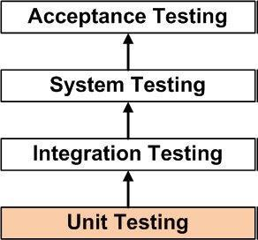

### 5.3.2 Integration Testing

**Integration Testing** is a level of software testing where individual units are combined and tested as a group. The purpose of this level of testing is to expose faults in the interaction between integrated units. Test drivers and test stubs are used to assist in Integration Testing.

Bottom Up is an approach to Integration Testing where bottom level units are tested first and upper-level units step by step after that. This approach is taken when bottom-up development approach is followed. Test Drivers are needed to simulate higher level units which may not be available during the initial phases.

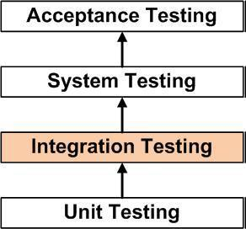

### 5.3.3 Beta Testing

Beta Testing is one of the Acceptance Testing types, which adds value to the product as the end-user (intended real user) validates the product for functionality, usability, reliability, and compatibility.

Inputs provided by the end-users helps in enhancing the quality of the product further and leads to its success. This also helps in decision making to invest further in the future products or the same product for improvisation. Since Beta Testing happens at the end user’s side, it cannot be the controlled activity.

### 

### 5.3.4 Test Case

|  |  |  |  |
| --- | --- | --- | --- |
| Test cases | Input specified | Expected result | Actual result |
| User login | Username=””  Password=”” | Username empty | Username empty |
| Username=”abc”  Password=”abc34” | Verify and redirect to home page | Verify and redirect to home page |
| Mobile.no | Mobile.no= | Specify your mobile.no | Specify your mobile.no |
| Mobile.no=5%23ww | Enter correct mob.no | Enter correct mob.no |
| Mobile.no=9960034532 | Mobile enter vaild | Mobile enter valid |

## 6.2 User Documentation

**1. Registration**

* Brief Description –

This use case allows the user to register and Login and start storing Documents.

* Actors

Any actor who can perform this use case is register.

* Flow of Events
* Basic Flow-

1. Use case begins when a user visits the website and wishes to avail.
2. The system request the user to enter the required information such as first name, last name, contact number, address and email id.
3. Once the user enters the required details, he/she can now access the system.

* Special Requirement

There is no special requirement.

* Pre-condition
* Post Condition

1. Successful Registration

User now has an account and can fully utilize the website.

1. Registration Failed

User has not provided the valid details and is required to perform the previous.

**2. Login**

* Brief Description

This use case describes how the registered users and admin log.

* Actors

Following actor can participate in this use case:

1. User
2. Admin

* Special Requirement

Email Id and Password must be valid.

* Pre-condition
* Post Condition

**3. Add Order**

* Brief Description

This use case allows the actor Share Docs Using QRCODE, Store on Server and Take Documents from others easly.

* Actors

All actor and admin can perform this use case.

* Special Requirement

There is no special requirement.

# 

# Chapter 7: Conclusion

## 7.1 Conclusion

The Project entitled DOC Share was successfully completed.The System is developed with much care of free of error/bugs and at the same time it is efficient and less time consuming.

This project helped us gaining valuable information and practical knowledge on several topics such as designing web pages using HTML and CSS, usage of responsive templates and management of database. The entire system is secure.Also project helped us to understand about the development phases of software development life cycle.

We learned to test different features of the project.Several agents have been created using web services and inter agent communication is done. Technologies in form of xml are used for storing information. Different ontologies have been created for different purpose. For implementing the system .Net technologies like ASP.Net, C#,CSS are used.

## 

## 7.2 Significance of the System

It is just one click away today , more than ever, people can easily share data but to make is secure and store in proper manner this system can be very helpful.

It’s Fast Easy and Comfortable. Ina nutshell, you can easily share your document with the other people, Store new Docs and keep it secure.Because it’s visually appealing and simulating to all of the needy any one can use this system even in Offices and Schools, but its was developed by the students point of view.

**Enhanced Collaboration**: DocShare allows users to work collaboratively on documents in real-time, making it easier for teams to work together and complete projects more efficiently. This feature reduces the need for multiple revisions and helps streamline the document review process.

**Efficient Document Sharing**: DocShare provides a centralized location for document sharing, which reduces the need for emailing files back and forth between users. This feature makes it easier for users to access the documents they need, no matter where they are located.

**Improved Document Security:** DocShare provides a secure environment for document storage and sharing. Users can control who has access to their documents, and the system tracks document changes, so users can see who has edited the document and when.

**Easy to Use:** DocShare is user-friendly and easy to use, making it accessible to users of all technical abilities. The system is designed to be intuitive and straightforward, reducing the learning curve for new users.

**Time and Cost-Effective**: DocShare reduces the time and costs associated with document management and sharing. Users no longer need to spend time organizing, emailing, or printing documents. This feature saves time and reduces operational cost

## 

## 7.3 Limitations of the System

Existing system has several disadvantages and many more difficulties to work well. The proposed system tries to eliminate or reduce these difficulties up to some extent. The proposed system will help the user to reduce the workload and mental conflict. Problem in The Existing System systems are inadequate in providing information and advice to the vendors and customers about Rate plans of dishes. Often agencies are compelled to rely on local information sources and count on their own experience regarding time and cost.

## 

## 7.4 Future Scope of the project

## Integration with cloud storage services: The ability to connect to cloud storage services like Google Drive or Dropbox could be a valuable addition to the project. This would enable users to easily upload and share their documents with others.

## Enhanced collaboration features: The project could include more advanced collaboration features like real-time editing, commenting, and version control. This would allow multiple users to work on a document simultaneously and improve the overall workflow.

## Mobile App: Developing a mobile application for Doc Share could make it easier for users to access and share documents on-the-go.

## Analytics: Including analytics and tracking features could allow users to monitor document engagement and better understand how their content is being used.

## Integration with third-party apps: Integrating with other apps and tools could add more functionality to the project, making it more attractive to potential users.

## Improved Security Features: Strengthening the security of the platform through user authentication, data encryption, and other measures could improve user confidence in the platform.

## AI Integration: Integrating artificial intelligence features like natural language processing could make it easier to search for documents and improve the overall user experience.