Contents
UNIT 1

- hardware
- software
- input devices
- output devices

HARDWARE
Hardware refers to the mechanical device that makes up a computer.

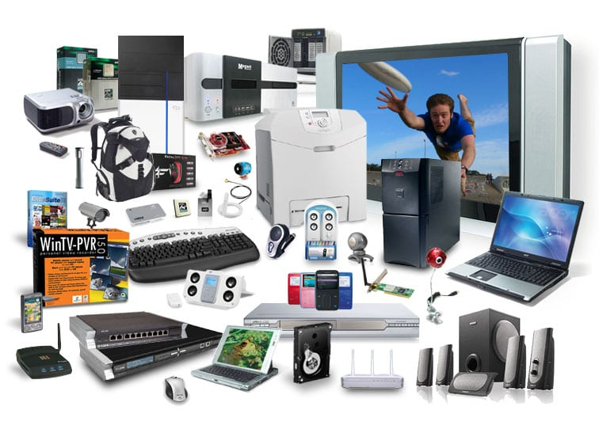

SOFTWARE
Set of instructions data or programs used to operate a computer and execute specific tasks is called a software.



INPUT DEVICES
A piece of equipment or hardware which helps us enter data into the computer.

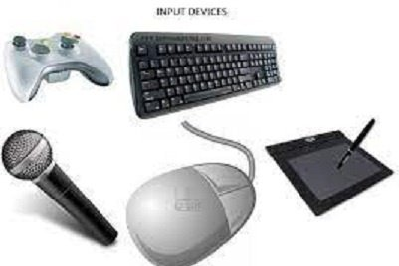

OUTPUT DEVICES
A piece of equipment or hardware which helps us understand the converted piece of data into a readable form.

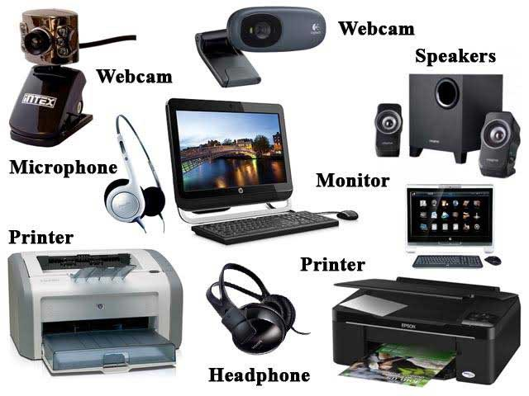

COMPONENTS OF A COMPUTER

- CPU/processor.
- RAM (random access memory)
- Hard drive.
- Power supply unit.
- Video card.
- Network card.
- Bluetooth card (or adapter)

