**EXPERIMENT-11**

**CREATION AND EXECUTION OF PROCEDURES**

select * from customers;

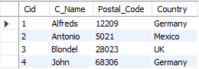

DELIMITER //

create procedure SelectAllCustomers()

begin

select * from customers where postal_code=68306;

end

DELIMITER //

create procedure SelectCustomers()

begin

select * from customers;

end //

DELIMITER //

create procedure countCustomers()

begin

select count(*) from customers;

end //

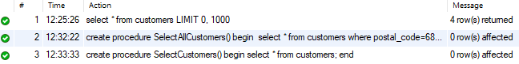

Call SelectAllCustomers();



call SelectCustomers();

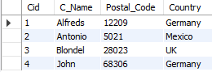

call countCustomers();

