**EXPERIMENT-3**

**Represent all entities and relationships in a tabular fashion(Relational Model)**

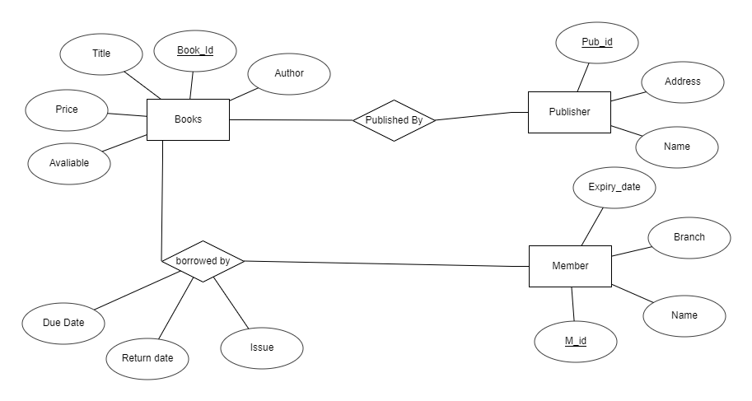

**ER DIAGRAM FOR LIBRARY MANAGEMENT**

|  |  |  |
| --- | --- | --- |
| **Column Name** | **Datatype** | **Constraint** |
| Book_id | numeric | Primary key |
| Title | varchar |  |
| Author | varchar |  |
| price | Numeric |  |
| Available | numeric |  |

|  |  |  |
| --- | --- | --- |
| **Column Name** | **Datatype** | **Constraint** |
| Pub_id | numeric | Primary key |
| Address | varchar |  |
| Name | varchar |  |

|  |  |  |
| --- | --- | --- |
| **Column Name** | **Datatype** | **Constraint** |
| M_id | Numeric | Primary key |
| Name | Varchar |  |
| Branch | Varchar |  |
| Expiry_date | numeric |  |