**EXPERIMENT-9 : VIEWS**

create table Customers(Cid varchar(10),C_Name varchar(50),Postal_Code numeric(20),

Country varchar(20));

insert into Customers values(1,'Alfreds',12209,'Germany');

insert into Customers values(2,'Antonio ',05021,'Mexico');

insert into Customers values(3,'Blondel','28023','UK');

insert into Customers values (4,'John',68306,'Germany');

create view GermanyCustomers as select C_Name,Postal_Code from Customers;

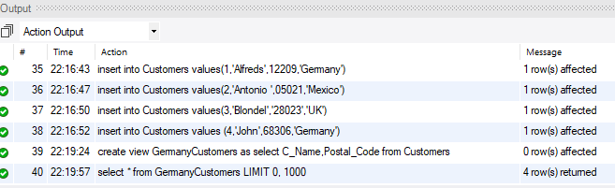

select * from GermanyCustomers;

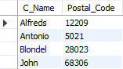

show create view GermanyCustomers;



drop view GermanyCustomers;