**Exp No: 6 Applying DML commands(Data Manipulation Command)**

* **Insert**
* **Update**
* **Delete**
* **Select**

insert into students values(501,'Sindhu','Rani','CSE');

insert into students values(502,'Nayan','Raj','MECH');

insert into students values(503,'Akshara','Sree','EEE');

insert into students values(504,'Niharika','Sai','ECE');

insert into students values(505,'keerthana','Sri','ECE');

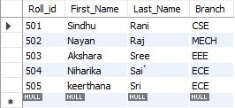

update students set First_Name='Veni',Last_Name='Patel' where Roll_id=502;

select * from students;

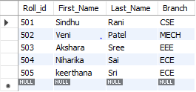

select Roll_id,First_Name from students;

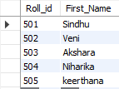

select distinct Roll_id,First_Name,Branch from students;

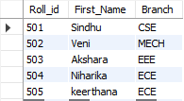

select count(Roll_id) from students;



select * from students where First_Name='Akshara';



delete from students where Roll_id=502;

select * from students;

