**Exp No:7 Practice Queries using ANY, ALL, IN, EXISTS, UNION, INTERSECT Set Operators.**

1. **ANY:**

SELECT ProductName FROM Products WHERE ProductID = ANY (SELECT ProductID FROM OrderDetails WHERE Quantity = 20);

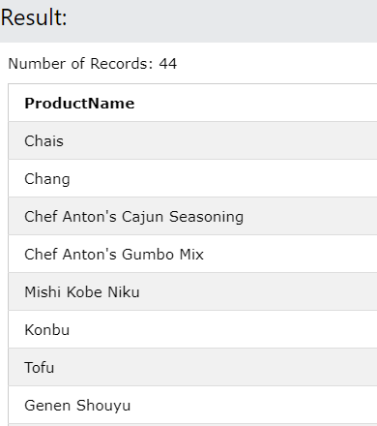

1. **ALL**

SELECT ALL OrderID FROM Orders WHERE TRUE;

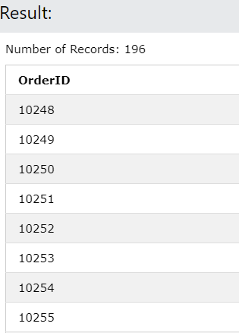

1. **IN**

SELECT * FROM Customers WHERE City IN ('México D.F.', 'London');

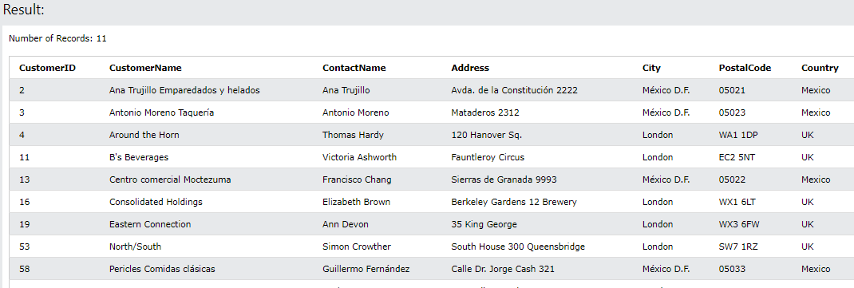

SELECT * FROM Customers WHERE City NOT IN ('México D.F.', 'London','Berlin');

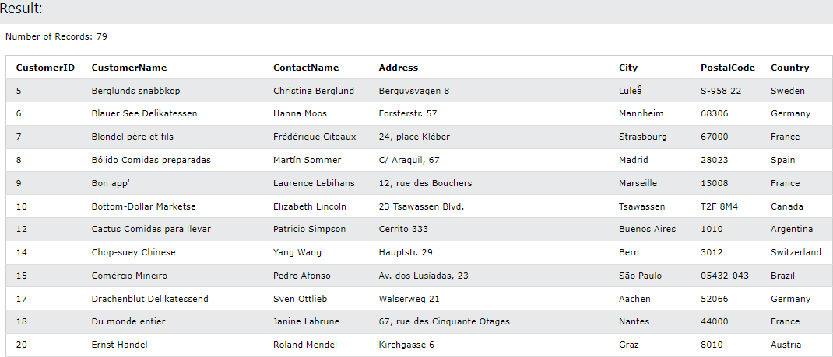

1. **EXISTS**

SELECT SupplierName FROM Suppliers WHERE EXISTS (SELECT ProductName FROM Products WHERE Products.SupplierID = Suppliers.supplierID AND Price = 20);

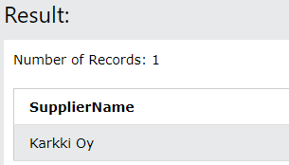

1. **Union**

SELECT City, Country FROM Customers WHERE Country='Germany'

UNION

SELECT City, Country FROM Suppliers WHERE Country='Germany'

ORDER BY City;

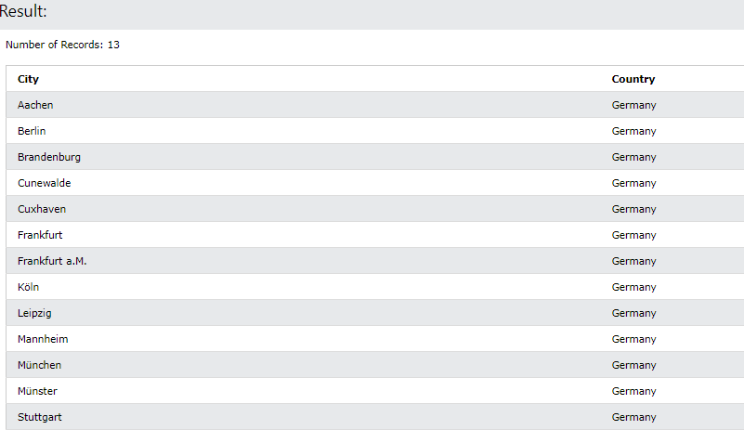

SELECT 'Customer' AS Type, ContactName, City, Country FROM Customers

UNION ALL

SELECT 'Supplier', ContactName, City, Country FROM Suppliers

