**Exp No 8: Practice Queries using Aggregate functions, Group By, Having Clause and Order by Clause.**

**Aggregate functions:**

1. **AVG()**

SELECT AVG(Quantity) FROM OrderDetails;

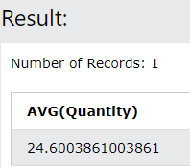

1. SUM()

SELECT SUM(Price) FROM Products;

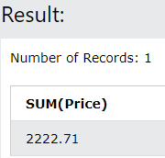

1. COUNT()

SELECT COUNT(OrderID) FROM OrderDetails;

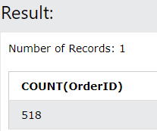

1. MIN()

SELECT MIN(Unit) AS SmallestUnit FROM Products;

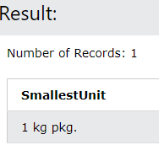

1. MAX()

SELECT MAX(Price) AS LargestPrice FROM Products;

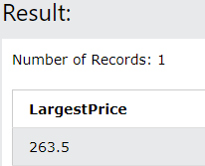

**GroupBy Clause:**

SELECT CustomerID, Country FROM Customers GROUP BY Country;

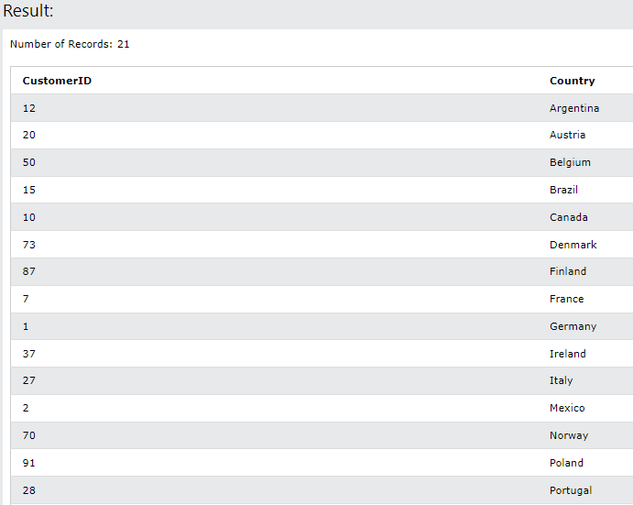

**HAVING Clause:**

SELECT COUNT(CustomerID), Country FROM Customers GROUP BY Country HAVING COUNT(CustomerID) = 5;

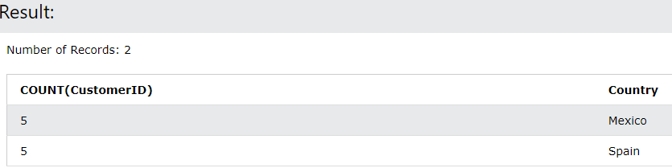

**ORDERBY Clause:**

SELECT * FROM Products ORDER BY Unit;

