DocVision – Technical Documentation

1. Model Choice and Justification
1.1 Vision LLM for Document Classification
Model Used
- OpenRouter provider
- Model: nvidia/nemotron-nano-12b-v2-vl:free
Justification
- Supports multimodal (vision + language) reasoning
- Handles complex document layouts without custom training
- Eliminates need for local GPU infrastructure
- API-based access enables scalable and production-ready inference
- Well-suited for unstructured business documents
1.2 OCR and Text Processing
Framework Used
- LlamaIndex
Justification
- Efficiently manages OCR outputs and extracted text
- Handles multi-page documents and large text blocks
- Designed for future expansion into semantic indexing and retrieval
- Decouples text processing from classification logic
1.3 Logo Detection
Model Used
- Hugging Face computer vision model
- Model: ellabettison/Logo-Detection-finetune

Justification
- Detects logos and institutional symbols
- Enhances document source identification and authenticity checks
- Avoids need for custom dataset creation
- Easily deployable within Docker environments

2. System Architecture
DocVision follows a modular, layered architecture designed for scalability and maintainability.
2.1 Architectural Layers
Presentation Layer
- Streamlit-based web interface
- Handles user interaction and result visualization
API Layer
- FastAPI backend
- Manages request validation, orchestration, and responses
Intelligence Layer
- PDF-to-image conversion
- Vision-based classification (OpenRouter Vision LLM)
- OCR and text extraction (LlamaIndex)
- Logo detection (Hugging Face model)
Storage Layer
- Temporary storage for uploaded and processed files
- Hash-based naming for deduplication
Deployment Layer
- Docker container
- Hosted on Hugging Face Spaces
2.2 Architecture Flow

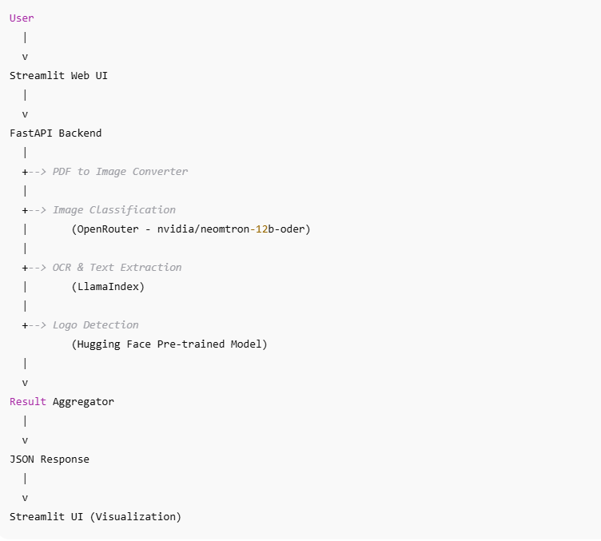

3. API Design
3.1 Design Principles
- Stateless REST architecture
- JSON-based communication
- Clear separation of concerns
- Centralized error handling
- Extensible endpoint structure

3.2.1 Core Endpoint
POST /analyze
Description
Accepts document images or PDFs and returns classification results.
Response Example
{
"document_type": "Invoice",
"confidence": 0.93,
"extracted_text": "...",
"logos_detected": ["Brand Logo"],
"file_hash": "a94a8fe5ccb19ba61c4c0873d391e987"
}
3.2.2 Visual Cues Detection Endpoint
POST /visual_cues
Description
Processes a document image and extracts visual intelligence signals such as logos, layout indicators, and structural cues without performing full document classification.
This endpoint is designed for modular usage, allowing systems to consume visual features independently.
Response Example
{
"logos_detected": ["Company Logo"],
"visual_features": {
"has_logo": true,
"layout_type": "structured",
"text_density": "high"
},
"file_hash": "c81e728d9d4c2f636f067f89cc14862c"
}

4. Technology Stack
- Programming Language: Python
- Backend: FastAPI
- Frontend: Streamlit
- Vision LLM: OpenRouter - nvidia/nemotron-nano-12b-v2-vl:free
- OCR & Text Processing: LlamaIndex
- Logo Detection: Hugging Face model - ellabettison/Logo-Detection-finetune
- Image Processing: Pillow
- Containerization: Docker
- Deployment: Hugging Face Spaces
- Version Control: Git

5. Limitations and Trade-offs
- Dependency on external Vision LLM APIs introduces latency
- OCR accuracy depends on document quality
- Logo detection limited to known pretrained patterns
- No persistent database in current implementation
- Optimized primarily for English-language documents

6. Future Improvements
- Add persistent storage and document history
- Introduce multilingual OCR support
- Implement asynchronous processing for large files
- Add authentication and access control
- Expand classification categories
- Integrate vector databases for semantic document retrieval

7. Conclusion
DocVision demonstrates a production-oriented approach to building an end-to-end document image classification system using Vision LLMs. By combining multimodal reasoning, OCR pipelines, and modular API design, the system reflects real-world enterprise AI practices and provides a strong foundation for future enhancements in intelligent document processing.
*Multimodal Document Processing Flow Diagram
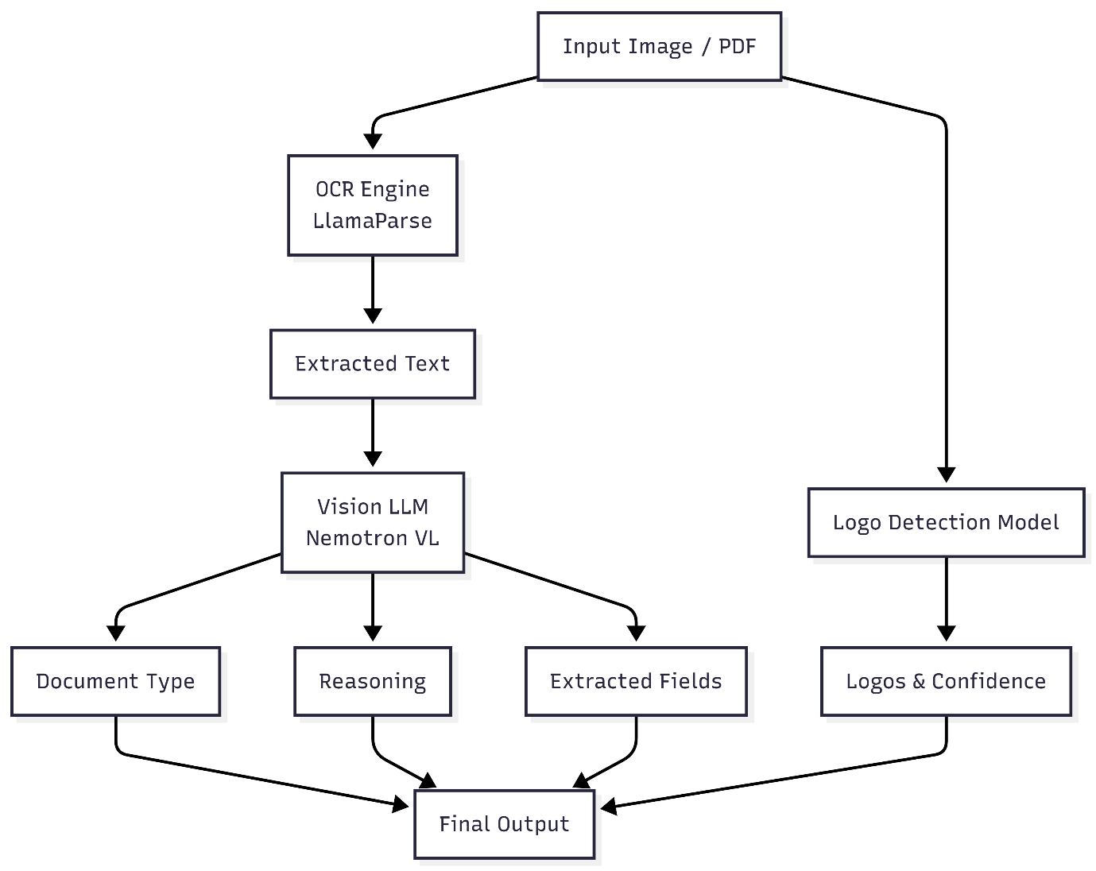

*End-to-End Document Processing Flowchart
