**PORTFOLIO USING HTML & CSS**

***A Summer Internship Report submitted in partial fulfillment of the***

***requirements for the award of degree of***

**BACHELOR OF TECHNOLOGY**

**IN**

**COMPUTER SCIENCE AND ENGINEERING**

## Submitted by:

K. Mani Kanta 20A91A0592



**Department Of Computer Science and Engineering**

**ADITYA ENGINEERING COLLEGE (A)**

**Approved by AICTE, Permanently affiliated to JNTUK & Accredited by NAAC with ‘A++’ Grade**

**Recognized by UGC under the sections 2(f) and 12(B) of the UGC act 1956**

**Aditya Nagar, ADB Road –Surampalem 533437, E.G. Dist., A.P.,**

**2023-2024.**

**ADITYA ENGINEERING COLLEGE (A)**

**Approved by AICTE, Permanently Affiliated to JNTUK & Accredited by NAAC with ‘A++’ Grade**

**Recognized by UGC under the sections 2(f) and 12(B) of the UGC act 1956**

**Aditya Nagar, ADB Road - Surampalem – 533437, E.G.Dist., A.P.,**

**Department Of Computer Science and Engineering**



**CERTIFICATE**

This is to certify that the Internship report entitled *“***PORTFOLIO USING HTML & CSS***”* is being submitted by

**K. Manikanta (20A91A0592)**

In partial fulfillment of the requirements for award of the B.Tech degree in Computer Science and Engineering for the academic year 2023-2024.

**Internship Coordinator Head of the Department**

P. Srilatha, M.Tech.,(Ph.D) Dr.A.Vanathi,M.E.,Ph.D.

Sr.Assistant Professor Associate Professor

Department of CSE Department of CSE

**DECLARATION**

We hereby declare that the project entitled **“PORTFOLIO USING HTML & CSS”** is a genuine project. This work has been submitted to the **ADITYA ENGINEERING COLLEGE,** Surampalem, permanently affiliated to **JAWAHARLAL NEHRU TECHNOLOGICAL UNIVERSITY, KAKINADA** in partial fulfillment of the **B.Tech** degree**.** We further declare that this project work has not been submitted in full or part of the award of any degree of this or any other educational institutions.

**by**

**K. Manikanta (20A91A0592)**

**Internship Completion Certificate**

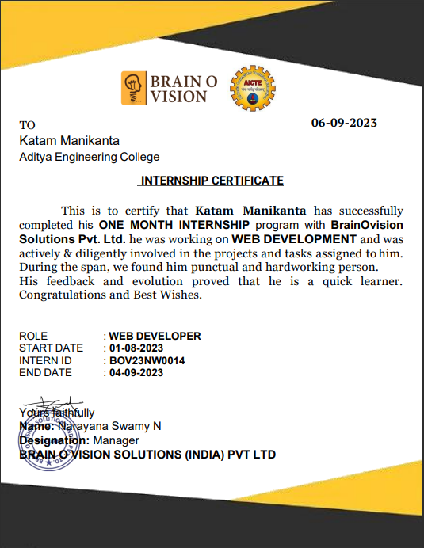

**ACKNOWLEDGEMENT**

First I would like to thank the Manager of **BRAIN O VISION SOLUTIONS(INDIA) PVT LTD**, for giving me the opportunity to do an internship within the organization. I also would like all the people that worked along with me in BRAIN O VISION SOLUTIONS(INDIA) PVT LTD with their patience and openness they created an enjoyable working environment.

It is with immense pleasure that we would like to express our indebted gratitude to our Internship coordinator **P.Srilatha, Sr.Assistant Professor,Department of CSE** who has guided us a lot and encouraged us in every step of the intern project work, her valuable moral support and guidance throughout the Intern project helped us to a greater extent.

Our deepest thanks to **Dr. A.Vanathi, Associate Professor& Head of the Department** for inspiring us all the way and for arranging all the facilities and resources needed for our project.

We wish to thank **Dr. S. Rama Sree, Professor** in CSE and **Dean(Academics)** for her support and suggestions during our project work.

We owe our sincere gratitude to **Dr. M.Sreenivasa Reddy, Principal** for providing a great support and for giving us the opportunity of doing the project.

We are thankful to our **College Management** for providing all the facilities in time to us for completion of our project.

Not to forget, **Faculty,Lab Technicians, non-teaching staff and our friends** who have directly or indirectly helped and supported us in completing our project in time.

# ABSTRACT

WEB DEVELOPMENT is the process of creating and maintaining websites or web applications. It involves various disciplines such as front-end development for user interface design, back-end development for server-side logic, and database management. HTML, CSS, and JavaScript are fundamental languages, and frameworks like React, Angular, or Vue.js are commonly used. Back-end technologies include Node.js, Django, or Ruby on Rails. Web developers use tools for version control, testing, and deployment. The field continuously evolves with emerging technologies like Progressive Web Apps, serverless architecture, and responsive design, shaping the digital landscape.

**Learning Objectives/Internship Objectives**

* Internships are generally thought of to be reserved for college students looking to gain experience in a particular field. However, a wide array of people can benefit from Training Internships in order to receive real world experience and develop their skills.
* An objective for this position should emphasize the skills you already possess in the area and your interest in learning more
* Internships are utilized in a number of different career fields, including architecture, engineering, healthcare, economics, advertising and many more.
* Some internships are used to allow individuals to perform scientific research while others are specifically designed to allow people to gain first-hand experience working.
* Utilizing internships is a great way to build your resume and develop skills that can be emphasized in your resume for future jobs. When you are applying for a Training Internship, make sure to highlight any special skills or talents that can make you stand apart from the rest of the applicants so that you have an improved chance of landing the position.

# WEEKLY OVERVIEW OF INTERNSHIP ACTIVITIES

|  |  |  |  |
| --- | --- | --- | --- |
| **1stWEEK** | **DATE** | **DAY** | **NAME OF THE TOPIC/MODULE COMPLETED** |
| 01/8 /23 | Tuesday | How to use canva for beginners! |
| 02/8 /23 | Wednesday | How to use Cloudflare on Wordpress to speed up and secure your site |
| 03/8 /23 | Thursday | HTML5 intro, HTML editors |
| 04/8 /23 | Friday | HTML Elements, Basic Tags |
| 05/8 /23 | Saturday | HTML Links, HTML Attributes, HTML Comments |
| 07/8 /23 | Monday | HTML Tables, HTML Lists |

|  |  |  |  |
| --- | --- | --- | --- |
| **2nd WEEK** | **DATE** | **DAY** | **NAME OF THE TOPIC/MODULE COMPLETED** |
| 08/8 /23 | Tuesday | Class and ID Attributes |
| 09/8 /23 | Wednesday | HTML Forms |
| 10/8 /23 | Thursday | HTML frames |
| 11/8 /23 | Friday | CSS 3 intro |
| 12/8 /23 | Saturday | CSS syntax |
| 14/8 /23 | Monday | How to add CSS |

|  |  |  |  |
| --- | --- | --- | --- |
| **3rdWEEK** | **DATE** | **DAY** | **NAME OF THE TOPIC/MODULE COMPLETED** |
| 16/8 /23 | Wednesday | CSS SELECTORS |
| 17/8 /23 | Thursday | CSS COMMENTS,CSS PROPERTIES |
| 18/8 /23 | Friday | JAVASCRIPT INTRO,JS SCRIPT TAG,JS OUTPUT,JS COMMENTS |
| 19/8 /23 | Saturday | JS VARIABLES,JS DATATYPES, JS OPERATORS |
| 21/8 /23 | Monday | JS FUNCTIONS,JS ARROW FUNCTION |
| 22/8 /23 | Tuesday | JS ARRAYS |

|  |  |  |  |
| --- | --- | --- | --- |
| **4thWEEK** | **DATE** | **DAY** | **NAME OF THE TOPIC/MODULE COMPLETED** |
| 23/8 /23 | Wednesday | JS EVENTS |
| 24/8 /23 | Thursday | JS DATES |
| 25/8/23 | Friday | JS CONDITIONAL STATEMENTS,JS LOOPS,JS THIS KEYWORD |
| 26/8 /23 | Saturday | DISCUSSION ON LEFT OVER TOPICS |
| 28/8 /23 | Monday | SAMPLE PROJECTS DISCUSS |
| 31/8 /23 | Thursday | DISCUSS ABOUT THE LATEST HTML CSS PROJECTS |

**INDEX**

|  |  |  |  |
| --- | --- | --- | --- |
| **S.No** |  | **Contents** | **Page** |
|  |  |  |  |
| 1. |  | Introduction | 1 |

2. HTML Editors 2

3. Building Blocks Of HTML 3

4. HTML Layouts 4

5. HTML Tags Ordered Alphabetically 5

6. CSS Tutorial 6

* 1. Inline CSS
  2. Internal CSS
  3. External CSS

7. JavaScript 7

8. Project Aims and Objectives 8

# 12. Executive Summary 8

# 13. About the Company 9

# 

# 14. Opportunities 10

# 

# 15. Training 11

# 16. Challenges Faced 12

### **1. INTRODUCTION**

**What is HTML?**

* HTML stands for Hyper Text Markup Language.
* HTML is the standard markup language for creating Web pages.
* HTML describes the structure of a Web page.
* HTML elements tell the browser how to display the content.
* HTML elements label pieces of content such as "this is a heading", "this is a paragraph", "this is a link", etc.

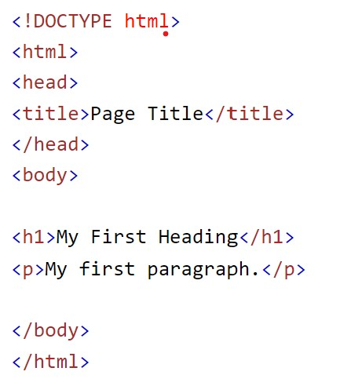

* The <!DOCTYPE html> declaration defines that this document is an HTML5 document.
* The <html> element is the root element of an HTML page.
* The <head> element contains meta information about the HTML page.
* The <title> element specifies a title for the HTML page (which is shown in the browser's title bar or in the page's tab).
* The <body> element defines the document's body, and is a container for all the visible contents, such as headings, paragraphs, images, hyperlinks, tables.
* The <h1> element defines a large heading.
* The <p> element defines a paragraph.

1

#### **2. HTML EDITORS**

Web pages can be created and modified by using professional HTML editors. However, for learning HTML we recommend a simple text editor like Notepad (PC) or TextEdit (Mac). We believe that using a simple text editor is a good way to learn HTML.

Follow the steps below to create your first web page with Notepad or TextEdit.

**Step1:** Open Notepad (PC) **Windows 8 or later:**

Open the **Start Screen** (the window symbol at the bottom left on your screen). Type **Notepad**.

**Windows 7 or earlier:**

##### Open Start > Programs > Accessories > Notepad

**Step 1:** Open TextEdit (Mac)

##### Open Finder > Applications > TextEdit

Also change some preferences to get the application to save files correctly. In **Preferences > Format >** choose **"Plain Text"**

Then under "Open and Save", check the box that says "Display HTML files as HTML code instead of formatted text".

2

**Then open a new document to place the code.**

**Step 2:** Write Some HTML

Write or copy the following HTML code into Notepad:

**Step 3:** Save the HTML Page

Save the file on your computer. Select **File > Save as** in the Notepad menu.

Name the file **"index.htm"** and set the encoding to **UTF-8** (which is the preferred encoding for HTML files).

**Step 4:** View the HTML Page in Your Browser

Open the saved HTML file in your favorite browser (double click on the file, or right-click - and choose "Open with")

**Building Blocks Of HTML**

#### 

#### 

3

#### **4. HTML LAYOUTS**

HTML layouts provide a way to arrange web pages in well-mannered, well-structured, and in responsive form or we can say that HTML layout specifies a way in which the web pages can be arranged. Web-page layout works with arrangement of visual elements of an HTML document. **Web page** layout is the most important part to keep in mind while creating a website so that our website can appear professional with the great look. You can also use CSS and JavaScript based frameworks for creating layouts for responsive and dynamic website designing.

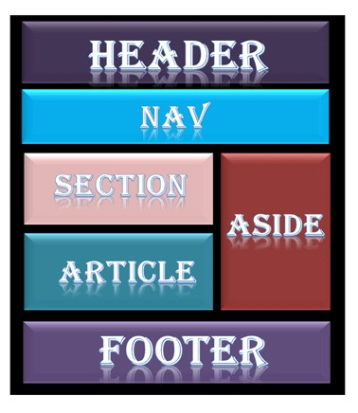

Every website has a specific layout to display content in a specific manner. Following are different HTML5 elements which are used to define of a webpage.

<header>: It is used to define a header for a document or section.

<nav>: It is used to define a container for navigation links

<section>: It is used to define a section in a document

4

<article>: It is used to define an independent self-contained article

<aside>: It is used to define content aside from the content (like a sidebar)

<footer>: It is used to define a footer for a document or a section

<details>: It is used to define additional details

<summary>: It is used to define a heading for the <details> element.

5

#### **5. CSS TUTORIAL**

#### 

CSS stands for Cascading Style Sheet.

* CSS is used to design HTML tags.
* CSS is a widely used language on the web.
* HTML, CSS and JavaScript are used for web designing. It helps the web designers to apply style on HTML tags.

**HOW TO ADD CSS**

CSS is added to HTML pages to format the document according to information in the style sheet. There are three ways to insert CSS in HTML documents.

1. INLINE CSS
2. INTERNAL CSS
3. EXTERNAL CSS

##### **6.1 INLINE CSS**

Inline CSS is used to apply CSS on a single line or element.

For example: **<p** style="color:blue"**>**Hello CSS**</p>**

##### **6.2 INTERNAL CSS**

Internal CSS is used to apply CSS on a single document or page. It can affect all the elements of the page. It is written inside the style tag within head section of html.

For example:**<style>** p{color:blue} **</style>**

##### **6.3 EXTERNAL CSS**

External CSS is used to apply CSS on multiple pages or all pages. Here, we write all the CSS code in a CSS file. Its extension must be .CSS for example style.css.

You need to link this style.css file to your html pages like this:

**<link** rel="stylesheet" type="text/css" href="style.css"**>**

6

#### **6. JAVASCRIPT**

**JavaScript** is the world’s most popular lightweight, interpreted compiled programming language. It is also known as scripting language for web pages. It can be used for [**Client-side**](https://www.geeksforgeeks.org/server-side-client-side-programming/) as well as [**Server-side**](https://www.geeksforgeeks.org/server-side-client-side-programming/) developments.

JavaScript can be added to your HTML file in [two ways:](https://www.geeksforgeeks.org/where-to-put-javascript-in-an-html-document/)

* **Internal JavaScript:** We can add JavaScript code directly to our HTML file by writing the code inside the <script> tag. The <script> tag can either be placed inside the <head> or the <body> tag according to the requirement.
* **External JavaScript File:** We can create a file with .js extension and paste the JavaScript code inside it. After creating the file, add this file in

<script src=”file_name.js”> tag inside <head> tag of the HTML file.

##### **Application of JavaScript**

JavaScript is used to create interactive websites. It is mainly used for:

* Client-side validation,
* Dynamic drop-down menus,
* Displaying date and time,
* Displaying pop-up windows and dialog boxes (like an alert dialog box, confirm dialog box and prompt dialog box),
* Displaying clocks etc.

7

##### **History of JavaScript**

In 1993, **Mosaic**, the first popular web browser, came into existence. In the **year 1994**, **Netscape** was founded by **Marc Andreessen**. He realized that the web needed to become more dynamic. Thus, a 'glue language' was believed to be provided to HTML to make web designing easy for designers and part-time programmers. Consequently, in 1995, the company recruited **Brendan Eich** intending to implement and embed Scheme programming language to the browser. But, before Brendan could start, the company merged with **Sun Microsystems** for adding Java into its Navigator so that it could compete with Microsoft over the web technologies and platforms. Now, two languages were there: Java and the scripting language. Further,

Netscape decided to give a similar name to the scripting language as Java's. It led to 'Javascript'. Finally, in May 1995, Marc Andreessen coined the first code of Javascript named '**Mocha**'. Later, the marketing team replaced the name with '**LiveScript**'. But, due to trademark reasons and certain other reasons, in December 1995, the language was finally renamed to 'JavaScript'. From then, JavaScript came into existence.

8

#### **7. PROJECT AIMS AND OBJECTIVES**

The project aims and objectives that will be achieved after completion of this project are discussed in this subchapter. The aims and objectives are as follows:

**Design the User Interface (UI):**

* Create an HTML file for the structure.
* Design the UI with HTML elements like input fields, buttons, and areas to display weather information.
* Use CSS for styling to make the app visually appealing.

**Fetch Weather Data with JavaScript:**

* Use JavaScript to fetch weather data from a weather API (e.g., OpenWeatherMap).
* Handle user input, make API requests, and update the UI with the fetched data.

**Style the App with CSS:**

* Enhance the visual appeal of the app using CSS. Style the input fields, buttons, and result display.

9

**8. EXECUTIVE SUMMARY**

The report is about my 4 weeks internship program with BOV (**Brainovision Solutions India Private Limited.**).

During my internship program, I have learned and mainly worked on HTML & CSS. All the details have been discussed in detail. All the policies and procedures of the company have been discussed in detail.

As the main purpose of the internship is to learn by working in practical environment and to apply the knowledge acquired during the studies in real world scenario in order to tackle the problems using the knowledge and process. **Brain o vision Solutions India Private Limited.** is an organization which deals with the wing of software development and Technical education. This is the place for students and faculty and other companies to find solution for all your requirements Such as internships, academic projects (Mini & Major project), online courses, Workshops, faculty development programs and to hire a perfect skilled candidates.

**10. OPPORTUNITIES**

During these one month of the internship, I was given the opportunity to perform the following role:

**Intern:**

* Coordinating with the team members and team leads on a regular basis to keep a track of the activities like the meetings held and about the work to be done.
* I learned about developing the applications using different tools.
* For that I have referred the GitHub repositories related to gain the complete knowledge on that.
* Then I have gathered the requirements.
* They also provide us the opportunity to voluntarily interact in other projects as well.
* They have given different tasks to develop different parts of the application.
* Also they have finally conducted some tests to certify with the completion of internship.

1. **TRAINING**

In these 4 weeks of the training, they have provided us the training in Android App Development using different tools.

They have provided us with the training of several technologies like:

* + HTML
  + CSS
  + JS

**HTML:** When you are browsing the web, the pages you are viewing are just text documents sitting on someone else’s computer. The text in a typical web page is wrapped in HTML tags, which tell your browser about the structure of the document. With this information, the browser can decide how to display the information in a way that makes sense.

**CSS:** CSS stands for Cascading Style Sheet. CSS is used to design HTML tags. CSS is a widely used language on the web. HTML, CSS and JavaScript are used for web designing. It helps the web designers to apply style on HTML tags.

**JAVASCRIPT:** JavaScript is the world’s most popular lightweight, interpreted compiled programming language. It is also known as scripting language for web pages. It can be used for [Client-side](https://www.geeksforgeeks.org/server-side-client-side-programming/) as well as [Server-side](https://www.geeksforgeeks.org/server-side-client-side-programming/) developments.

1. **CHALLENGES FACED**

* At the beginning of internship, I faced difficulty for understanding the applications and different tools.
* I faced difficulty in installing the software.
* I faced difficulty in managing college and internship timings.
* I faced difficulty in understanding the advanced topics in android.
* I faced difficulty in managing the memory in pc.
* Even with these difficulties, I am able to complete the internship and it helps me in securing a new job.