**Slide1:**  
Portfolio Website

Presented by

k. mani kanta

**Slide2:**

**Abstract**

WEB DEVELOPMENT is the process of creating and maintaining websites or web applications. It involves various disciplines such as front-end development for user interface design, back-end development for server-side logic, and database management. HTML, CSS, and JavaScript are fundamental languages, and frameworks like React, Angular, or Vue.js are commonly used. Back-end technologies include Node.js, Django, or Ruby on Rails. Web developers use tools for version control, testing, and deployment. The field continuously evolves with emerging technologies like Progressive Web Apps, serverless architecture, and responsive design, shaping the digital landscape.

**Slide3 - 6:**

**Web Development:**

Web development refers to the development of both the front-end framework and back-end framework. My internship mainly focuses on the development of front-end based websites.

**Front end languages:**

The front end portion is built by using some languages which are discussed below:

**HTML:**

HTML stands for Hyper Text Markup Language.HTML is the combination of Hypertext and Markup language. Hypertext defines the link between the web pages. The markup language is used to define the text documentation within tag which defines the structure of web pages.



**CSS:**

Cascading Style Sheets, fondly referred to as CSS ,is a simply designed language intended to simplify the process of making web pages presentable.

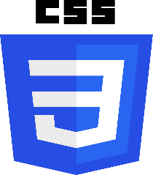

**Bootstrap :**

Bootstrap is a free and open-source tool collection for creating responsive websites and web applications. It is the most popular HTML,CSS, and JavaScript framework for developing responsive ,mobile-first websites.



**JavaScript:**

JavaScript is a famous scripting language used to create the magic on the sites to make the site interactive for the user. It is used to enhancing the functionality of a website to running cool games and web-based software.

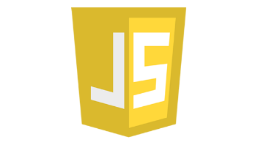

**Back-end technologies:**

**Node.js**

Node.js is an open-source and cross platform runtime environment built on Chrome’s V8 JavaScript engine for executing JavaScript code outside of a browser. It provides an event-driven ,non-blocking(asynchronous) I/O and cross-platform runtime environment for building highly scalable server-side applications using Javascript.

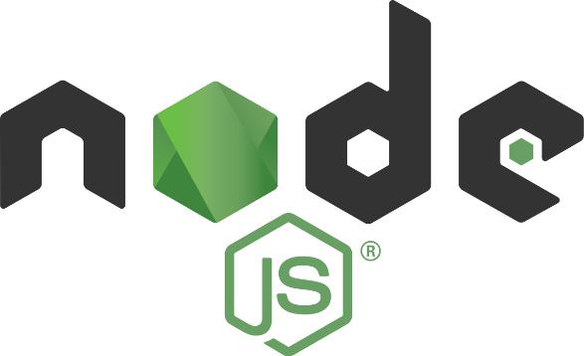

**MongoDB:**

It is most popular NOSQL database, it is an open source document-oriented database. The term ‘‘NoSQL” means ‘non-relational’ .It means that MongoDB isn’t based on the table-like relational database structure but provides an altogether different mechanism for storage and retrieval of data.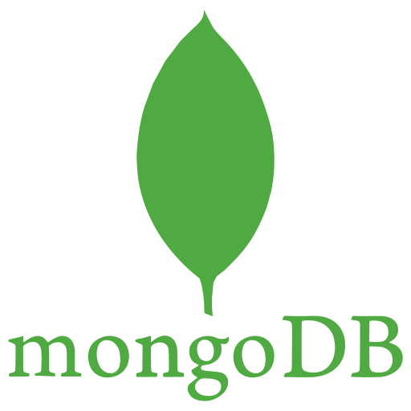

**Slide 7:**

**Project**

A portfolio website is like an online showcase where you can display your work and talents in a neat and organized way.

Imagine it as a digital collection of your best projects, whether they're art, photos, writing, or anything else you're proud of.

People use portfolio websites for various reasons. It's a way to make a great first impression, especially when you're job hunting.

One of the great things about a portfolio website is that it's easy to share.

You can send the link to your website to anyone interested in your work, making it a convenient way to showcase your skills.

Additionally, it's a valuable tool for receiving feedback on your work. People can leave comments or contact you directly to discuss your projects, which can be incredibly beneficial for improvement.

**Slide 8**

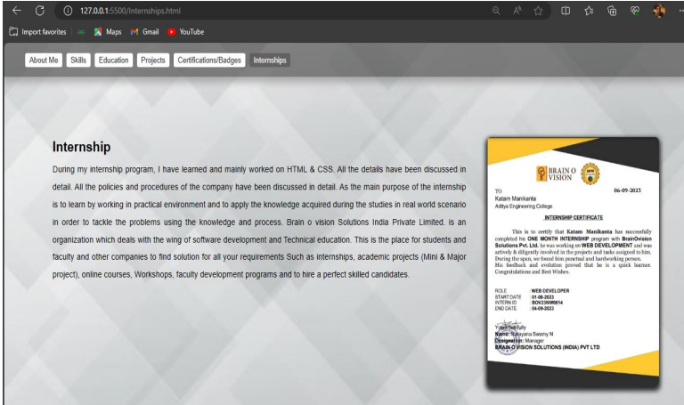

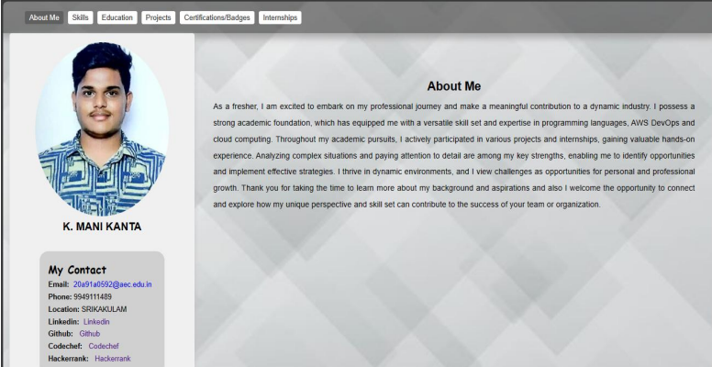

**Slide 9**

**Challenges faced:**

I faced difficulty in understanding tags.

I faced difficulty in managing college and internship timings.

I faced difficulty in understanding the advanced topics in Bootstrap.

I faced difficulty in creating new web pages.

At the beginning of internship, I faced difficulty for understanding the applications and different tools.

**Slide 10**

**Conclusion:**

In summary, our portfolio displays various creative solutions designed specifically for schools and organizations. We're proud of using the internet to make tasks easier, promote honesty, and give students and others more control. We always aim to be efficient, easy to use, and able to change as needed in all our projects. As we deal with the always-changing world of modern education and management, our portfolio shows how dedicated we are to providing good digital solutions.