**ATTENDANCE MANAGEMENT SYSTEM USING REACT**

***A Summer Internship Report submitted in partial fulfillment of the***

***requirements for the award of degree of***

**BACHELOR OF TECHNOLOGY**

**IN**

**COMPUTER SCIENCE AND ENGINEERING**

## Submitted by:

K.V. H. SAI KUMAR

20A91A0596



**Department Of Computer Science and Engineering**

**ADITYA ENGINEERING COLLEGE (A)**

**Approved by AICTE, Permanently affiliated to JNTUK & Accredited by NAAC with ‘A++’ Grade**

**Recognized by UGC under the sections 2(f) and 12(B)of the UGC act 1956**

**Aditya Nagar, ADB Road –Surampalem 533437, E.G. Dist., A.P.,**

**2023-2024.**

**ADITYA ENGINEERING COLLEGE (A)**

**Approved by AICTE, Permanently Affiliated to JNTUK & Accredited by NAAC with ‘A++’ Grade**

**Recognized by UGC under the sections 2(f) and 12(B) of the UGC act 1956**

**Aditya Nagar, ADB Road - Surampalem – 533437, E.G.Dist., A.P.,**

**Department Of Computer Science and Engineering**



**CERTIFICATE**

This is to certify that the Internship report entitled *“***RESOURCE MANAGEMENT SYSTEM USING REACT** *”* is being submitted by

**VEERA HARI SAIKUMAR KOLLI (20A91A0596)**

In partial fulfillment of the requirements for award of the B.Tech degree in Computer Science and Engineering for the academic year 2023-2024.

**Internship Coordinator Head of the Department**

P. Srilatha, M.Tech.,(Ph.D), Dr. A.Vanathi, M.E.,Ph.D.,

Sr. Assistant Professor Associate Professor

Department of CSE Department of CSE

**DECLARATION**

I hereby declare that the project entitled **“RESOURCE MANAGEMENT SYSTEM USING REACT”** is a genuine project. This work has been submitted to the **ADITYA ENGINEERING COLLEGE,** Surampalem, permanently affiliated to **JAWAHARLAL NEHRU TECHNOLOGICAL UNIVERSITY, KAKINADA** in partial fulfillment of the **B.Tech** degree**.** I further declare that this project work has not been submitted in full or part of the award of any degree of this or any other educational institutions.

**by**

**K. V.H. SAIKUMAR (20A91A0596)**

**Internship Completion Certificate**

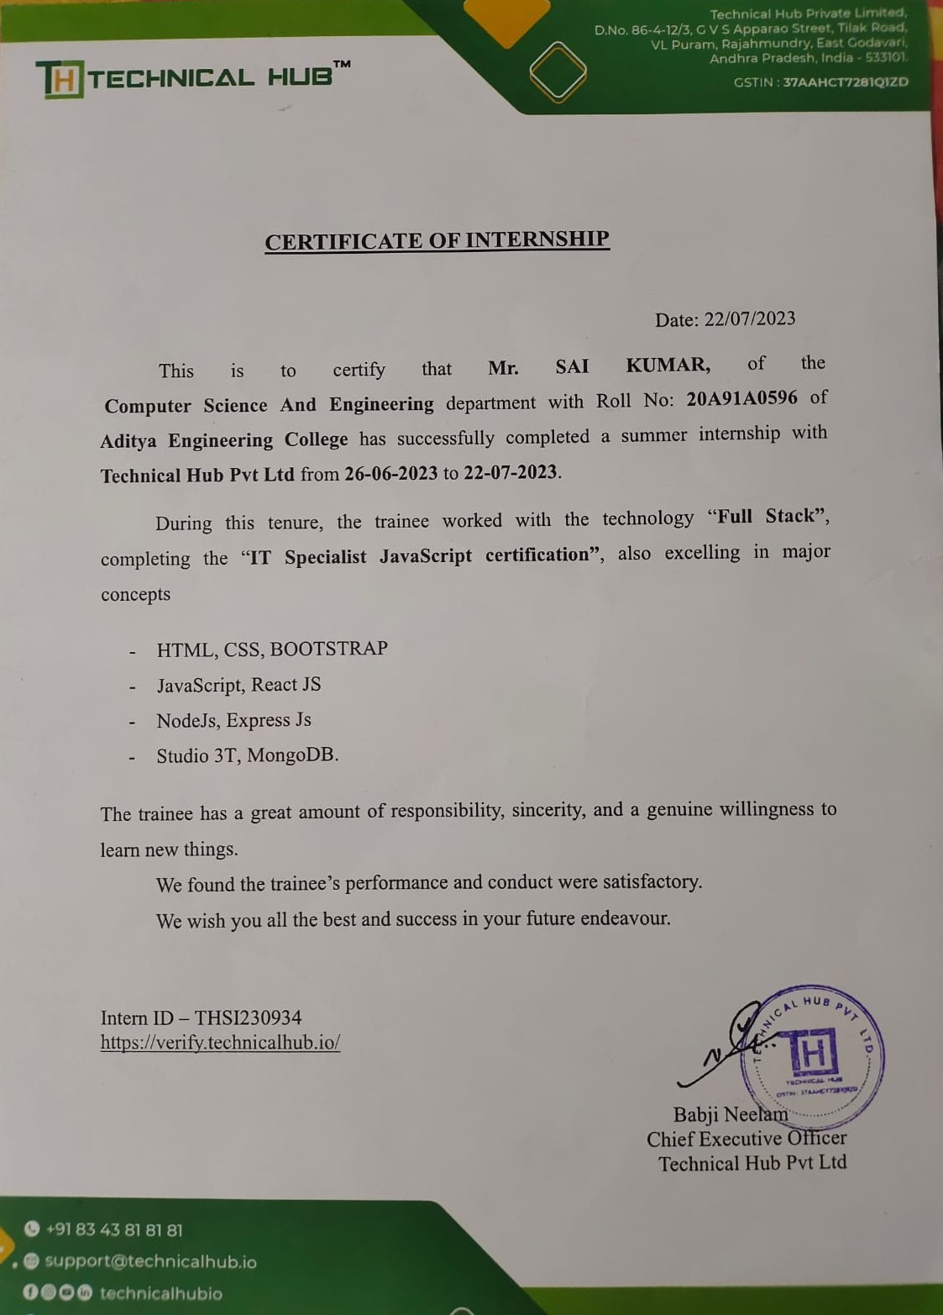

**ACKNOWLEDGEMENT**

First, I would like to thank the Director of Technical Hub **Mr. Babji Neelam**, for giving me the opportunity to do an internship within the organization. I also would like all the people that worked along with me in Technical Hub, Suramplaem with their patience and openness they created an enjoyable working environment.

It is with immense pleasure that we would like to express our indebted gratitude to our Internship coordinator Mr. N. Durga Prasad**,** who has guided us a lot and encouraged us in every step of the intern project work, his valuable moral support and guidance throughout the Intern project helped us to a greater extent.

We are thankful to our beloved guide **P. Srilatha, Sr.Assistant Professor, Department of CSE** who has spared her valuable time and append novel ideas to guide us in limelight. We are indebted to her without whom we not have culminated to the pinnacle of the project.

We also wish to convey our sincere thanks to **Dr. A. Vanathi, Associate Professor, Head of the Department(CSE)** who provided vital information which was necessary for the project.

We wish to thank **Dr. S. Rama Sree, Professor in CSE** and **Dean(Academics)** for her support and suggestions during our project work.

We owe our sincere gratitude to **Dr. M. Sreenivasa Reddy, Principal** for providing a great support and for giving us the opportunity of doing the project.

We are thankful to our **College Management** for providing all the facilities in time to us for completion of our project.

Not to forget, **Faculty, Lab Technicians, non-teaching staff and our friends** who have directly or indirectly helped and supported us in completing our project in time.

**Abstract**

# The Resource Management System is a web application designed to optimize resource allocation and monitoring within organizations. This system showcases the practical application of our acquired skills in Full Stack Web Development.Administrators benefit from a robust platform that efficiently monitors the status and distribution of resources crucial for organizational operations. The system enhances accuracy in resource management and boosts administrative productivity, allowing administrators to allocate resources seamlessly and gain real-time insights into their usage.Users can conveniently check the status of allocated resources and report any queries or issues directly to the admin, promoting transparency and accountability within the organization.

# In conclusion, the Resource Management System represents a natural extension of our expertise, addressing resource allocation challenges within organizations. It serves as a testament to the practical application of our skills and underscores the importance of efficient resource management in today's dynamic business landscape.

# Learning Objectives/Internship Objectives

* Internships are generally thought of to be reserved for college students looking to gain experience in a particular field. However, a wide array of people can benefit from Training Internships in order to receive real world experience and develop their skills.
* An objective for this position should emphasize the skills you already possess in the area and your interest in learning more
* Internships are utilized in several different career fields, including architecture, engineering, healthcare, economics, advertising and many more.
* Some internships are used to allow individuals to perform scientific research while others are specifically designed to allow people to gain first-hand experience working.
* Utilizing internships is a great way to build your resume and develop skills that can be emphasized in your resume for future jobs. When you are applying for a Training Internship, make sure to highlight any special skills or talents that can make you stand apart from the rest of the applicants so that you have an improved chance of landing the position.

# WEEKLY OVERVIEW OF INTERNSHIP ACTIVITIES

|  |  |  |  |
| --- | --- | --- | --- |
| **1stWEEK** | **DATE** | **DAY** | **NAME OF THE TOPIC/MODULE COMPLETED** |
| 26/6/23 | Monday | Reporting at office with all Photocopies of Documents.  Overview to Company Profile & Total Internship Schedule |
| 27/6/23 | Tuesday | Brief Introduction on Full Stack Development using ReactJS. |
| 28/6/23 | Wednesday | Discuss PROS & CONS of ReactJS |
| 29/6/23 | Thursday | Holiday |
| 30/6/23 | Friday | Introduction to ECMAScript 6 |
| 1/7/23 | Saturday | Learning ES6 concepts while implementing them |

|  |  |  |  |
| --- | --- | --- | --- |
| **2nd WEEK** | **DATE** | **DAY** | **NAME OF THE TOPIC/MODULE COMPLETED** |
| 3/7/23 | Monday | Installing Node packages and other required packages |
| 4/7/23 | Tuesday | Learning how to work with Class components |
| 5/7/23 | Wednesday | Learning how to work with Functional components |
| 6/7/23 | Thursday | Learning how to work with Props & Events |
| 7/7/23 | Friday | Introduction to React Hooks |
| 8/7/23 | Saturday | Assigning Projects |

|  |  |  |  |
| --- | --- | --- | --- |
| **3rdWEEK** | **DATE** | **DAY** | **NAME OF THE TOPIC/MODULE COMPLETED** |
| 10/7/23 | Monday | Introduction to Figma & Designing Structure of the Project |
| 11/7/23 | Tuesday | Implementation of Project(Front-End) |
| 12/7/23 | Wednesday | Implementation of Project(Front-End) |
| 13/7/23 | Thursday | Implementation of Project(Front-End) |
| 14/7/23 | Friday | Introduction to Back-End Structure and Services. |
| 15/7/23 | Saturday | Learning how to work with APIs & transfer data between Front-End and Back-End vice-versa |

|  |  |  |  |
| --- | --- | --- | --- |
| **4thWEEK** | **DATE** | **DAY** | **NAME OF THE TOPIC/MODULE COMPLETED** |
| 17/7/23 | Monday | Introduction to MongoDB & CRUD operation’s |
| 18/7/23 | Tuesday | Implementation of Project(Back-End) |
| 19/7/23 | Wednesday | Implementation of Project(Back-End) |
| 20/7/23 | Thursday | Integration of Front-End with Back-End |
| 21/7/23 | Friday | Project submission |
| 22/7/23 | Saturday | PPT presentation and Explanation |

**INDEX**

|  |  |  |  |
| --- | --- | --- | --- |
| **S.No** |  | **Contents** | **Page** |
|  |  |  |  |
| 1. |  | Introduction | 1 |
| 2. |  | Why ReactJS | 2 |
| 3. |  | Back-End Technologies used | 3 |
| 4. |  | Tools used | 4 |
| 5. |  | Executive Summary | 5 |
| 6. |  | About Company | 6 |
| 7. |  | Opportunities | 7 |
| 8. |  | About training | 8 |
| 9. |  | Challenges Faced | 9 |
| 10.  11. |  | Project  Conclusion | 10-14  15 |

**INTRODUCTION**

**FULL STACK DEVELOPMENT**

Full Stack Development is a comprehensive approach to web and software development where developers work on both the front-end (client-side) and back-end (server-side) components of a web application project. This holistic approach allows developers to build and maintain entire systems, from the user interface and user experience to the server infrastructure and databases.

**Key Aspects of Full Stack Development:**

* **Front-End Development:** Front-end developers focus on the user interface (UI) and user experience (UX) aspects of an application. They work with technologies like HTML, CSS, and JavaScript to create responsive and interactive web pages. Modern front-end development often involves the use of frameworks like React.
* **Back-End Development:** Back-end developers are responsible for the server-side logic and databases that power web applications. They work with programming languages like Python, Ruby, Java, Node.js, and PHP to handle data processing, user authentication, and server management. Database technologies such as MySQL, PostgreSQL, MongoDB, and others are commonly used.
* **Server Management:** Full stack developers often handle server deployment, configuration, and maintenance. This includes setting up web servers, managing cloud services, and ensuring the security and scalability of the application.
* **Database Management:** Full stack developers work with databases to store and retrieve data efficiently. They design database schemas, write queries, and optimize database performance.
* **API** **Development**: Full stack developers create APIs (Application Programming Interfaces) that allow different parts of an application to communicate with each other. This is crucial for data exchange between the front-end and back-end components.

1

**WHY ONLY REACT ?**

React developed, and maintained by Facebook, has gained immense popularity as a front-end JavaScript library for building user interfaces. There are several compelling reasons why developers often choose React for front-end development:

* **Component-Based Architecture**: Reacts component-based architecture allows developers to break down complex user interfaces into smaller, reusable components. This modular approach simplifies development, maintenance, and testing, making it easier to manage and scale applications.
* **Virtual DOM:** React uses a Virtual DOM (Document Object Model) to efficiently update the UI. Instead of making direct changes to the actual DOM, React compares the Virtual DOM with the real DOM and updates only the necessary parts. This minimizes the number of DOM manipulations, resulting in improved performance.
* **Declarative Syntax:** React uses a declarative syntax, which means developers describe what the UI should look like based on the application's state. This makes code more predictable, easier to understand, and less error-prone compared to imperative approaches.
* **Reusability:** React components are highly reusable. Developers can create a library of components that can be used across different parts of an application or even in multiple projects. This promotes code efficiency and consistency.
* **Community and Support:** React has a large and active community of developers. This means there are abundant resources, documentation, tutorials, and third-party packages available to assist in development and problem-solving.
* **Performance:** Reacts efficient rendering process and use of a Virtual DOM contribute to high-performance web applications. It can handle complex UIs with minimal performance overhead.

2

**BACK-END TECHNOLOGIES USED**

Back-end technologies used in React application development play a critical role in managing server-side logic, databases, and APIs to support the functionality of the front-end user interface built with React

.

**Server-Side Frameworks:**

* **Node.js:** Node.js is a popular JavaScript runtime that enables developers to use JavaScript for both front-end and back-end development. It's often used with frameworks like Express.js, Koa, or Nest.js to create server-side applications and APIs.
* **Express.JS:** Express.js is a minimal and flexible Node.js web application framework that simplifies the creation of robust and scalable web applications and APIs. It provides a set of powerful features, including routing, middleware support, and template rendering.

**Databases:**

* **MongoDB** : NoSQL databases are suitable for handling unstructured or semi-structured data. MongoDB is a document-oriented NoSQL database, it is often used as a key-value store or for caching data.

**API Development:**

* **RESTful APIs**: Representational State Transfer (REST) is an architectural style for designing networked applications. RESTful APIs are a common choice for communication between the front-end and back-end in React applications. They use HTTP methods like GET, POST, PUT, and DELETE to perform CRUD (Create, Read, Update, Delete) operations on resources.

3

**TOOLS USED**

* **VSCODE**

Visual Studio Code (VSCode) is a free, open-source code editor developed by Microsoft. It's highly popular among developers for its versatility, extensibility, and cross-platform compatibility. VSCode supports a wide range of programming languages, provides features like syntax highlighting, code completion, and integrated debugging. The integrated version control and Git support, along with a powerful terminal, make it a comprehensive tool for software development.

* **FIGMA**

Figma is a cloud-based design and prototyping tool widely used for user interface (UI) and user experience (UX) design. It allows designers and teams to collaborate in real time on web and app design projects from anywhere. Figma offers features like vector editing, interactive prototypes, and design components that simplify the design process and promote consistency.

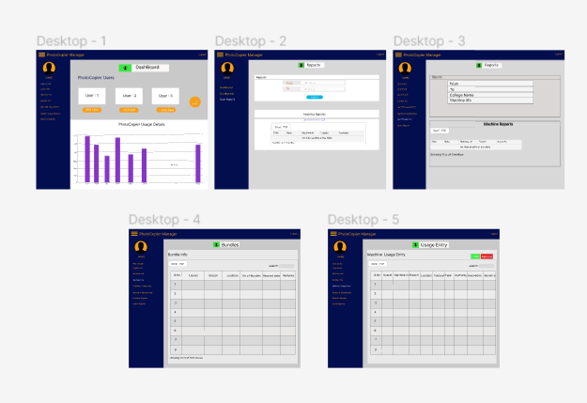

4

# EXECUTIVE SUMMARY

This report is about my 4 weeks offline internship program with Technical Hub. In this comprehensive report, I have discussed about every major aspect of the company which I observed and perceived during my offline internship program. During my offline internship program, I have learned and mainly worked on Full Stack Development.

All the details have been discussed in detail. All the policies and procedures of the company have been discussed in detail. As them a in purpose of the internship is to learn by working in practical environment and to apply the knowledge acquired during the studies in real world scenario in order to tackle the problems using the knowledge and skill learned during the academic process. I have learned about different technologies and tools like ReactJS, Nodejs, ExpressJS and MongoDB.

I have learned about different Technologies and Tools like:

* ReactJS
* MongoDB
* NodeJS
* Figma
* Vscode

5

# ABOUT THE COMPANY

Technical Hub is an organization which is founded by Babji Neelam in Aditya Engineering College to teach students more about technology and coding.

As the demand-supply gap scenario, exponential opportunities, and dynamic challenges in the 21st century call for a change in our thinking on engineering practice and education. A transformation on the current engineering education is the need of the hour. Growth of new knowledge together with rapidly evolving technological skills, the skill to communicate across disciplines, the ability to lead team-centered projects, contextualized problem formulation, and hands-on experience are the present demands of the global industry.

On contrary to the present demands, students churned out from engineering colleges are not equipped to meet the current industry needs due to the growing gap between engineering practice, education and research which requires a lot of concern.. Technical Hub trains students in various disciplines beyond technological labels besides equipping them with skills and creativity required for advancement in their careers. Through its various programs Technical Hub provides adequate opportunities for an unmatched knowledge base by imparting all necessary skills to students and makes them job ready.

**Mission**: “To promote and support Micro, Small & Medium Enterprises (MSMEs) Sector” by providing integrated support services encompassing Marketing, Technology, Finance, and other services.

**Vision:** “To be a premier Organization fostering the growth of Micro, Small and Medium Enterprises (MSMEs) Sector”.

6

# OPPORTUNITIES

During these four weeks of the internship, I was given the opportunity to perform the following role:

**Intern:**

* Coordinating with the team members and team leads on a regular basis to keep a track of the activities like the meetings held and about the work to be done.
* I learned about developing the applications using different languages.
* For that I have referred the W3Schools website related to gain the complete knowledge on the required topic.
* Then I have gathered the requirements.
* They also provide us the opportunity to voluntarily interact in other projects as well.
* They have given different tasks to develop different divisions of the application.
* They have conducted tests at last to certify with the completion of internship.

7

# TRAINING

In these 4 weeks of the training, they have provided us the training in Full Stack Development using ReactJS.

They have provided us with the training of several technologies like:

* **BOOTSTRAP:**

It is developed mobile first strategy in which we optimize the code for mobile devices first and scale up components using CSS media queries.

* **JAVASCRIPT:**

It supports about object-oriented, functional and imperative styles of programming. It also exists outside of the Internet.

* **MONGODB:**

It understands about the how MONGODB stores the data. We can easily install this feature and works very efficiently.

* **NODE.JS:**

It is a open source server environment developed in JavaScript. It runs on various platforms. It uses asynchronous programming.

* **ReactJS:**

It is a JavaScript library for building user interfaces with reusable components.

8

**CHALLENGES FACED**

* At the beginning of internship, I faced difficulty for understanding the applications and different tools.
* I faced difficulty in understanding tags.
* I faced difficulty in managing college and internship timings.
* I faced difficulty in understanding the advanced topics in Bootstrap.
* I faced difficulty in creating new web pages.
* I faces difficulty in understanding backend services.
* I faced difficulty in integrating Front-End with Back-End.
* Even with these difficulties, I am able to complete the internship and it helps me in securing a new job.

9

**PROJECT**

**Title:** RESOURCE MANAGEMENT SYSTEM USING REACT

**Description:** Resource management system is a web application which is used to manage the resources and monitors the usage of the resources and users. The users can check their status and report queries to the administrator.

**Prerequisite**: React Application development requires the following packages are installed on system before developing the application.

* NodeJS
* MongoDB
* Express JS
* React
* React-Dom

**Visual Studio Code:** Visual Studio code is one of the best tool used to develop the web application as it provides some tools and package for the development.

**Figma:** Figma is a cloud-based design and prototyping tool widely used for user interface (UI) and user experience (UX) design. It allows designers and teams to collaborate in real time on web and app design projects from anywhere.

10

**Project Execution Images**

**Launching Application:**

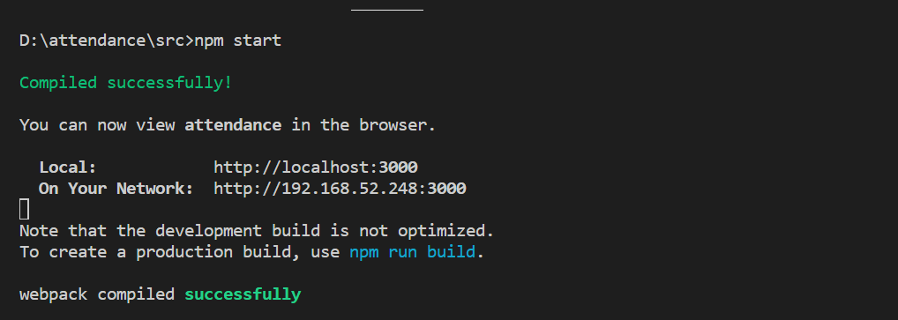

**Launching Back-End server:**

11

**Login Page:**



**Admin Home page:**

12

**Login info page:**

**User Home Page:**

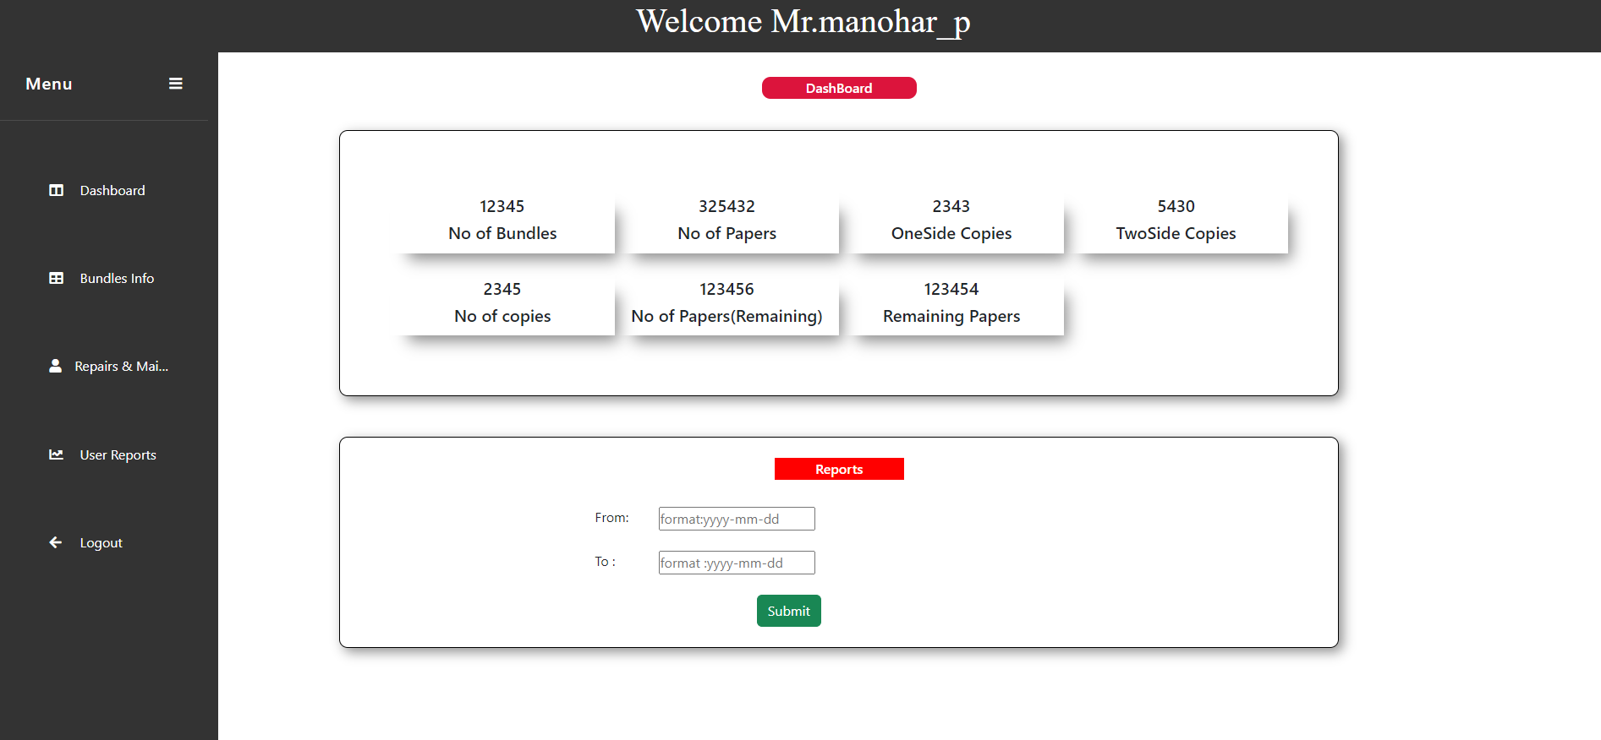

13

**Database Storage:**

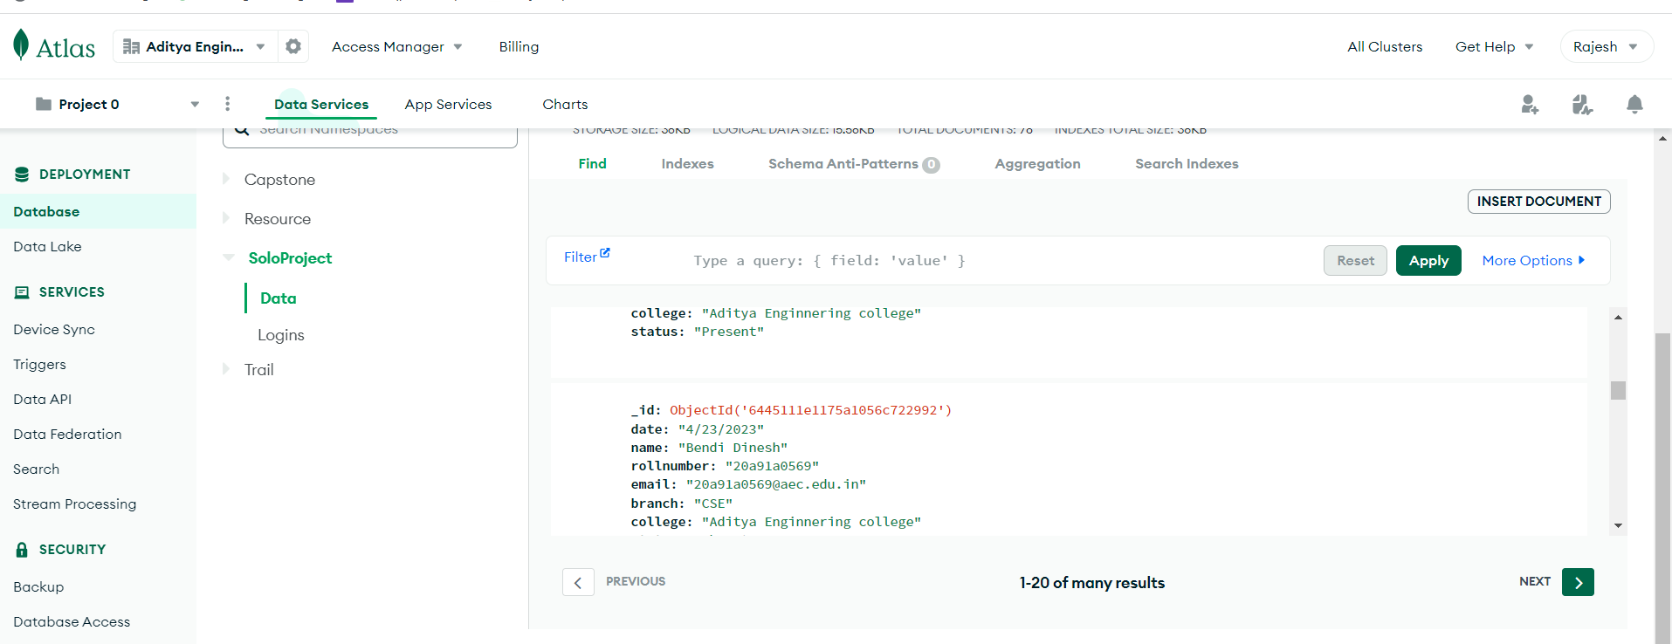

14

**Conclusion**

In conclusion, the Resource Management System serves as a pivotal solution for organizations looking to optimize the allocation and monitoring of resources. Leveraging web technology, it simplifies administrative tasks, enabling administrators to efficiently manage and distribute resources to users within the organization.

This system also promotes transparency and engagement among users by providing them with easy access to resource status and a direct channel for reporting queries or issues to administrators, fostering a sense of accountability and collaboration. Beyond its fundamental functionalities, it offers valuable insights through data analytics, empowering administrators to make informed decisions to enhance resource utilization and overall organizational effectiveness.

In an increasingly digital-dependent world, the Resource Management System stands as a user-friendly, efficient, and effective tool for managing resources and facilitating seamless communication within the organization. Its adaptability and convenience make it an invaluable asset in modern organizational management, contributing to overall success and efficiency.

15