Slide 1:

ATTENDANCE MANAGEMENT SYSTEM  
 presented by

E.Rajesh

Slide 2:

**Abstract**

# The Attendance Management System is a web application developed to enhance academic efficiency by simplifying attendance tracking and student information management in educational institutions. Administrators benefit from a robust platform that efficiently records and manages student attendance, offering insights for optimizing academic processes in real-time. This system not only improves accuracy but also elevates administrative productivity. Additionally, the system empowers students to conveniently check their attendance records, promoting transparency and accountability in monitoring their academic progress. Throughout the project, participants gained valuable experience in Full Stack Web Development, enriching their understanding of its potential applications for businesses.

**Slide3:**

**FULL STACK DEVELOPMENT**

Full Stack Development is a comprehensive approach to web and software development where developers work on both the front-end (client-side) and back-end (server-side) components of a web application project. This holistic approach allows developers to build and maintain entire systems, from the user interface and user experience to the server infrastructure and databases.

**Key Aspects of Full Stack Development:**

* **Front-End Development:** Front-end developers focus on the user interface (UI) and user experience (UX) aspects of an application. They work with technologies like HTML, CSS, and JavaScript to create responsive and interactive web pages. Modern front-end development often involves the use of frameworks like React.
* **Back-End Development:** Back-end developers are responsible for the server-side logic and databases that power web applications. They work with programming languages to handle data processing, user authentication, and server management.

**Slide 4&5:**

**Technologies used**

**ReactJS:** React JS is a tool for building websites. It helps make interactive web pages, like those with dynamic content or forms. It uses small reusable components, making development efficient. React makes web apps more responsive and user-friendly.



**Nodejs**

Node.js is a software platform used for running JavaScript on servers. It allows developers to build web applications using JavaScript for both client and server-side code. Node.js is known for its speed and efficiency, making it a popular choice for scalable and real-time applications. It has a large community and a wide range of libraries for various tasks.



**MongoDB:** MongoDB is a type of database for storing information. It's like a digital filing cabinet for data. MongoDB uses documents to organize data, which are like digital folders. It's good for handling large amounts of information in a flexible and scalable way.

**Slide6**

**Tools used**

**Figma**

Figma is a cloud-based design and prototyping tool used for creating user interfaces, graphics, and other visual design assets. It is widely used by web designers, user experience (UX) designers, and graphic designers to create interactive and high-fidelity prototypes for their projects.

**VSCode:**

VSCode is a code editor tool for programmers. It helps write and edit code with useful features. It's popular for its flexibility and customization options.



**Slide 7:**

**Project and its outcome**

Attendance management system is a web application which is used by an organisation which is used to take and track the attendance in the organisation. The administrator manages attendance and student details. The student can view his status about his attendance.

The administrator can download the absentees details and mails are sent automatically to absentees.

Initially I gathered the information about what are things that are needed to be implement

In the system.

Then I designed how the website should really look using the Figma.

Then I implemented the front-end part using the react js.

After completing the front-end designing part, I stated gathering the requirements need to implement the back-end for the application.

After completing the back-end , I successfully integrated the Front-end with back-end.

**Slide 8&9:**

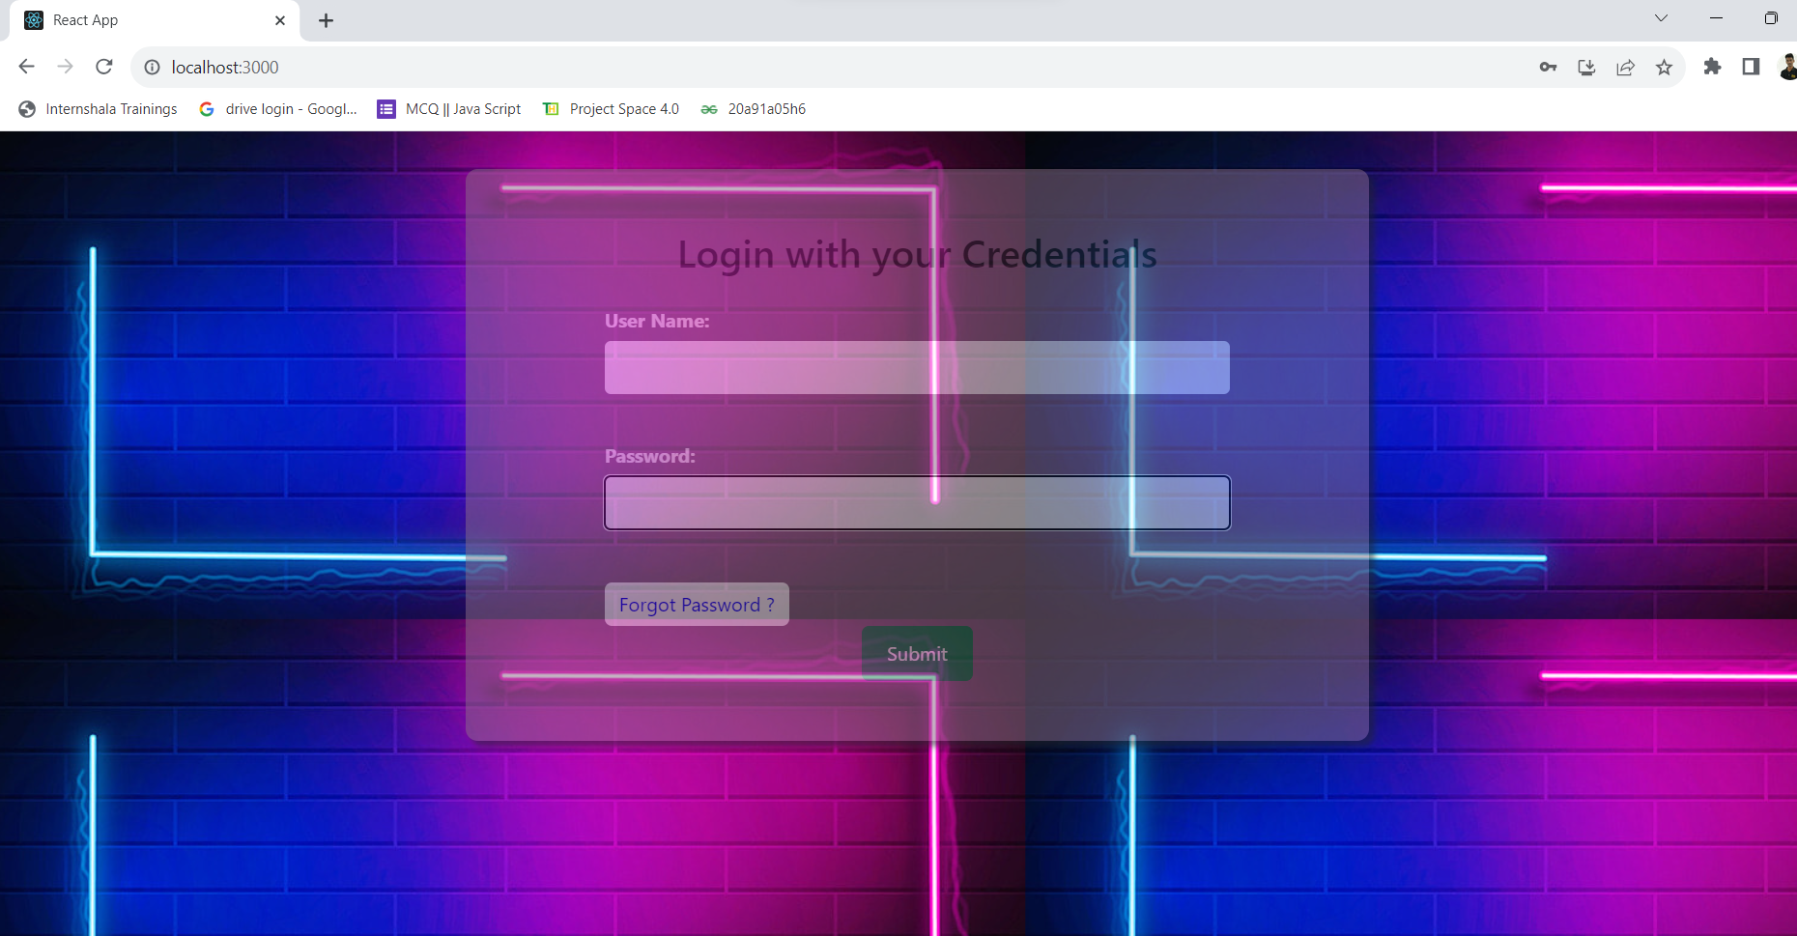**

**Slide 10**

**Challenges faced:**

I faced difficulty in understanding tags.

I faced difficulty in managing college and internship timings.

I faced difficulty in understanding the advanced topics in Bootstrap.

I faced difficulty in creating new web pages.

I faces difficulty in understanding backend services.

I faced difficulty in integrating Front-End with Back-End.

**Slide 11**

**Conclusion**In summary, the Attendance Management System is essential for schools and businesses looking to track attendance and manage student information easily. It uses the internet to make administrative tasks simpler, like adding or removing students.

This system also helps students see their attendance records, which makes them more responsible. It provides useful data that helps administrators make smart choices to improve attendance and how well the organization works**.**

**Slide 12:**

**Thank you**