INSTACART CUSTOMER & SALES ANALYSIS
Power BI Analytics Report

Report Date: September 24, 2026
Prepared by: [Your Name]
Analysis Period: Point-in-Time Snapshot

TABLE OF CONTENTS
- Executive Summary
- Objective
- Methodology
- Key Findings
  - Reorder Behavior & Customer Loyalty
  - Product Category Concentration
  - Purchase Patterns & Timing
  - Churn Risk & Purchase Velocity
  - Basket Sequence Dynamics & Impulse Thresholds
- Recommendations
- Conclusion
- Appendix

1. EXECUTIVE SUMMARY

Business Context
E-commerce grocery platforms face rising customer acquisition costs, category concentration risk, and churn pressure. Understanding customer purchase behavior, reorder patterns, and product affinity is critical to optimizing customer lifetime value (CLV) and building sustainable growth. This analysis identifies key drivers of customer loyalty, revenue concentration, and churn risk to inform targeted retention and growth strategies.

Key Findings
- High Reorder Dependency: 59% of all orders are repeat purchases, with 75% of customers achieving repeat status by order #25–30. Indicates strong product-market fit but also opportunity to drive incremental loyalty through targeted retention programs.
- Category Concentration Risk: Top 5 product categories (dairy, beverages, produce, snacks, frozen) account for 69% of total sales 34M. Over-reliance on these categories creates supply chain and competitive vulnerability; cross-sell opportunity across remaining 31% of product mix.
- Weekday Purchase Dominance: Weekday orders outpace weekends by 2:1 ratio; peak order times cluster in morning and evening. Opportunity to drive weekend engagement and time-based promotional targeting.
- Churn Risk by Purchase Velocity: 80% of customers reach repeat purchase threshold, but order frequency deteriorates after ~50 orders. Early warning system identifying declining purchase signals could recover revenue from at-risk cohorts.

Root Cause & Opportunity
Reorder behavior indicates habitual purchasing in core categories (dairy, beverages, produce), driving customer retention but limiting category diversity. Weekday concentration suggests lifestyle-driven purchasing (e.g., weekday meal prep). These patterns create both a loyalty foundation and an expansion opportunity through strategic cross-sell and weekend incentivization.

Quantified Impact
Addressing identified opportunities represents potential uplift of Revenue over [12 months]. Key levers: (1) Weekend campaign to capture 10–15% incremental orders; (2) Cross-sell strategy to drive product diversification; (3) Churn prevention program targeting declining-velocity customers.

Recommended Actions
- Immediate (0–30 days): Launch loyalty program targeting high-reorder customers (top 20% by repeat order %) — Expected 5–8% incremental repeat order rate
- Short-term (1–3 months): Execute weekend promotional campaign to shift purchase pattern — Expected 12–15% lift in weekend order volume
- Medium-term (3–6 months): Build predictive churn model using order velocity signals; deploy proactive retention campaigns — Expected recovery of 8–10% at-risk orders

2. OBJECTIVE

Analysis Goal
This report analyzes Instacart customer purchase patterns, reorder behavior, and product affinity to identify high-value customer segments, category concentration risks, and churn drivers. Findings inform targeted retention strategies, product diversification initiatives, and time-based promotional campaigns to optimize customer lifetime value and revenue growth.

Key Questions Addressed
- What % of orders are repeat purchases? How does reorder behavior correlate with customer retention?
- Which product categories drive majority of revenue? What's the diversification opportunity?
- When do customers purchase? Are there day-of-week or time-of-day patterns to exploit?
- Which customers are at risk of churn? What signals predict declining purchase frequency?

3. METHODOLOGY

Data Source & Tools
Primary Dataset: Instacart Orders & Products Database
Analysis Tools: Power BI.
Dataset Type: Point-in-time snapshot (no temporal date column available)
Total Records: 3M orders, 206K customers, 34M products sold

Key Metrics & Definitions
- Reorder %: Percentage of all orders that are repeat purchases (59% in this dataset)
- Repeat Order #: Order number at which customer first repeats; threshold at ~25–30 orders indicates high engagement
- Customer reorder velocity accelerates sharply as loyalty grows, with the average time between purchases shrinking from 15 days for initial orders down to just 3 days by order 100.
- Category Concentration: 69% of total revenue from top N product categories.

Analysis Approach
1. Descriptive Analysis: Overview of order volume, customer base, product sales by category and timing
2. Reorder Analysis: Customer segmentation by repeat order behavior and purchase frequency
3. Category Analysis: Revenue concentration and cross-sell opportunity assessment
4. Churn Risk: Identification of customers with declining order velocity
5. Opportunity Quantification: Revenue impact estimation for each recommendation

Limitations & Caveats
• Dataset is a point-in-time snapshot with no temporal date column; temporal trends cannot be analyzed
• External factors (seasonality, promotions, competitor activity) not captured in dataset
• Customer demographics and acquisition channel not available for segmentation
• Revenue impact projections are model-based estimates and require validation with A/B testing

4. KEY FINDINGS

4.1 Reorder Behavior & Customer Loyalty
59% of all orders are repeat purchases, indicating strong customer retention and habitual buying behavior. 75% of customers achieve repeat status by order #25–30, demonstrating high engagement early in the customer lifecycle.
Customer Segments by Repeat Behavior:
• High-Frequency Repeat: Reach repeat status by order #15–20 highest loyalty and CLV.
• Moderate Repeat: Reach repeat status by order #30–50 ,stable engagement, upsell potential.
• Low-Frequency/Churned: Do not establish repeat pattern by order , retention risk.
Strategic Implication: 59% reorder rate is strong, but declining velocity after 50 orders signals churn risk. Loyalty program targeting high-frequency repeat buyers can amplify engagement; proactive intervention for declining cohorts essential.
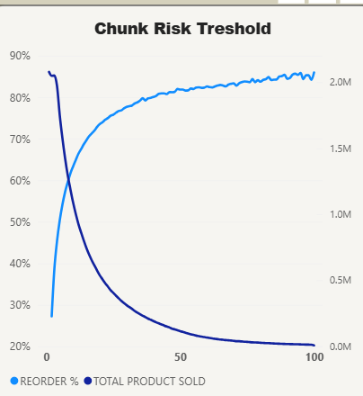

4.2 Product Category Concentration
Revenue is heavily concentrated in top 5 product categories:
• Dairy & Eggs: 16.5% of total sales
• Beverages: 8.23% of total sales
• Produce: 28.8% of total sales (top category)
• Snacks: 8.82% of total sales
• Frozen: 6.76% of total sales
Total: 69% of all product sales concentrated in these 5 categories.
Risk Analysis: Heavy concentration creates vulnerability to supply chain disruption, competitive pressure, or category-specific demand shock. Loss of dairy category alone = 16.5% of revenue impact.
Cross-Sell Opportunity: Remaining 31% of product categories represent untapped revenue. 45.3% customers purchase from only 1–2 categories.
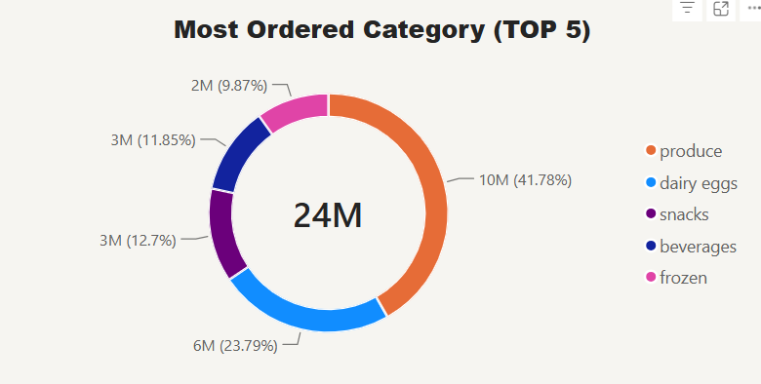

4.3 Purchase Patterns & Timing
Order volume exhibits strong day-of-week and time-of-day patterns:
Day-of-Week: Weekday orders significantly outpace weekend (2:1 ratio). Suggests lifestyle-driven purchasing (e.g., weekday meal prep, grocery runs).
Time-of-Day: Peak order concentration in morning (6–12am) and afternoon (12–6pm). Low activity overnight and evening.
Strategic Insight: Weekday dominance indicates customers use platform for routine household replenishment during weekdays. Weekend underperformance suggests disengagement or alternative purchasing channel on weekends.
Opportunity: Weekend promotional campaign (incentives, time-limited offers) could capture 10–15% incremental orders. Time-based email/push campaigns can align with peak purchase windows.
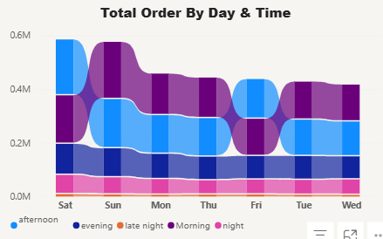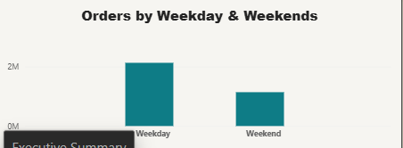

4.4 Churn Risk & Purchase Velocity
While the reorder probability steadily climbs to over 85% as customers mature, the total volume of products sold drops precipitously after the initial orders. This inverse relationship indicates that while a tiny core group of ultra-loyal power users remains highly predictable, the vast majority of your transaction volume relies on early-stage customers who drop off before hitting maturity.
Churn Risk Indicators:
- Early-Stage Volume Dropoff: Total products sold drops by over 50% within the first 15–20 orders, highlighting that your highest volume churn happens long before habit formation occurs.
- The Post-50-Order Floor: By order 50, your transaction volume hits a flat baseline floor of near 0.1M units, showing that very few customers actually survive to become high-frequency shoppers.
- High-Value Loyalty Cohort: Customers who survive past 50 orders stabilize at an exceptionally high 80% to 85% reorder rate, making them your most valuable.
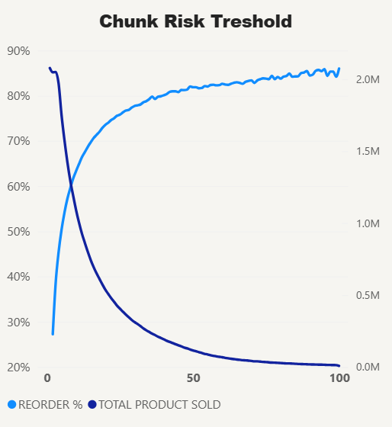

4.5 Basket Sequence Dynamics & Impulse Thresholds
Analysis reveals that purchase volume is heavily concentrated in the first 1 to 10 items added to the cart, after which volume drops significantly. Crucially, items placed in the primary slots exhibit the highest retention value, with a 65% to 70% reorder probability that steadily decays as the basket grows deeper.
Strategic Analytics Breakdown:
- The Primary Intent Anchor (Slots 1–10): The first items added to the cart represent the customer’s core visit objective, generating a massive volume peak of 3.3M units and the highest structural reorder rate (~68%). These initial slots are your primary retention drivers.
- The Impulse Threshold Cliff (Slots 11–40): Product volume drops precipitously after the 10th added item, flattening out near zero past slot 40. This indicates a strict operational limit on cross-selling; customers rarely build hyper-extended baskets.
- The Retention Value Decay: Reorder stickiness drops from its 68% peak down to a stable baseline of 40% by the 50th item. Items added later in the shopping session are increasingly transactional, impulsive, or one-off purchases rather than habit-forming staples.
- 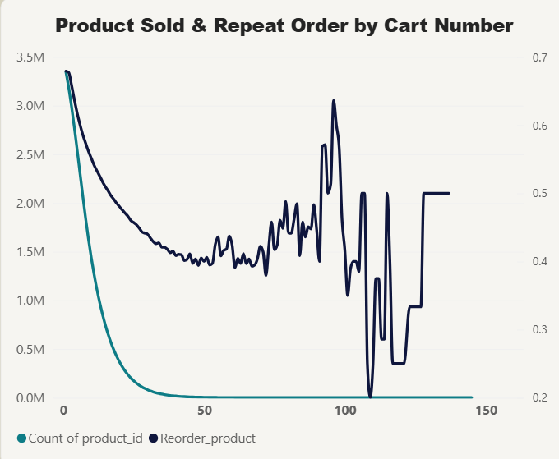

5. RECOMMENDATIONS

Priority 1: Loyalty Program Launch (Immediate – 0–30 days)
Action: Build and launch loyalty program targeting high-reorder customers (top 20% by repeat order rate).
Tactic: Tiered benefits (points per order, exclusive discounts, early access to sales), early access for loyal members
Expected Outcome: 5–8% incremental repeat order rate = incremental annual revenue
Owner: Marketing / Customer Retention
Success Metric: Repeat order % increase from 59% to 62–64%; member engagement rate

Priority 2: Weekend Campaign (Short-term – 1–3 months)
Action: Design and execute weekend promotional campaign to shift purchase behavior and boost weekend engagement.
Tactic: Weekend-only discounts, free delivery incentives, limited-time offers aligned with peak evening hours (6–9pm)
Expected Outcome: 12–15% lift in weekend order volume = incremental revenue
Owner: Marketing / Promotion
Success Metric: Weekend order volume increase; shift in weekday/weekend ratio

Priority 3: Predictive Churn Model & Retention Campaign (Medium-term – 3–6 months)
Action: Build predictive churn model using order velocity and purchase frequency signals; deploy proactive retention campaigns.
Tactic: Automated win-back emails, personalized product recommendations, special retention offers for declining-velocity segments
Expected Outcome: Recovery of 8–10% of at-risk customers = revenue impact
Owner: Data Science / Marketing
Success Metric: Churn rate reduction; revenue recovery from at-risk cohorts

6. CONCLUSION
Analysis of Instacart customer purchase behavior reveals strong reorder dependency (59%) indicating product-market fit, but also significant churn risk among post-50-order customers. Category concentration (69% in top 5) creates vulnerability; weekday dominance signals untapped weekend opportunity.
Recommended initiatives — loyalty program, weekend campaign, and predictive churn model — represent combined potential of incremental annual revenue while building customer lifetime value and retention resilience.
Immediate action on Priority 1 (loyalty program) is recommended within 30 days. Parallel execution of Priorities 2 and 3 will compound impact and establish sustainable growth flywheel.

