Tennis Prediction Engine
Problem Area: Predictive Analytics
Problem Statement: Using purely human intuition, analysing tennis match outcomes can be time-consuming and inconsistent.

Analysis

Real-world use cases
To understand the problem area, and the requirements/constraints it presents, I researched 2 practical applications of match prediction.

Broadcast/media analytics for viewers
Win probability displays and predictions prior to tournaments are commonplace nowadays, and algorithms that power these are often required to be real-time, indicating that for some use cases, there is a constraint on the efficiency of such models.
For example, during the Wimbledon Grand Slam, the IBM Watson model combines both past results, and live point-by-point data to deliver real-time projections of who is likely to triumph.

Talent identification and coaching
Studies researching machine learning applications in optimising performance (Sampaio, Oliveira, Marinho, Neiva, & Morais, 2024), have achieved up to 90.4% accuracy in predicting future high performers with logistic regression, and 93-99% accuracy in prediction of Grand Slam match winners using Decision Trees. This might be used by companies sponsoring players, for example, to calculate ROI, or for players to adjust their tactics, for example, whether to serve wide or down the T based on past results. This suggests that there are large financial incentives to building accurate prediction models, and that automated methods have a part to play in the data-driven evaluation of player performance.

Techniques

Logistic regression
Methods of modelling outcomes of tennis matches have progressed significantly over time. Initially, models such as Logistic Regression were used for their low complexity, and the fact that they were designed for such binary classification problems (Friligkos, Papaioannou, & Kaklamanis, 2023). Essentially, this involves fitting a sigmoid curve (logistic, S-shaped curve) to a dataset. As an input, some linear combination of the features would be used ($b_{0}+b_{1}x_{1}+b_{2}x_{2}…b_{n}x_{n}$), and the output of the model was compared to a certain threshold to determine the predicted result. This strategy would grasp simple relationships (for example, correlating higher rank to higher win probability), however, non-linearity (for example, the impact of the playing surface) would not be captured. Aside from this, it required a numerical encoding of categorical data, which often leads to issues with models assuming some form of ordinality where it doesn’t exist.

Decision trees
Similar to logistic regression, decision trees are supervised learning algorithms specifically for classification. It can be thought of as a flowchart, asking binary questions at each node, following the respective path, until a leaf is reached containing the eventual classification. To build a decision tree, a training set of features and labels is passed into the constructor, and a certain threshold value for a certain feature is chosen to split. Data that falls below the threshold (and the respective labels) is used to build the left subtree (recursively), and the rest is for the right subtree.
When handling categorical data, the standard approach is one-hot encoding. For example, instead of one feature named ‘Surface’ which can be ‘Hard’, ‘Clay’, ‘Grass’, there would be 3 features: ‘Surface_Hard’, ‘Surface_Clay’, ‘Surface_Grass’, with a 1 located in the correct feature. This prevents the ordinality issue of numerical encoding and prevents an exponential time complexity in considering all splits for a certain category ($2^{k}-1$ splits for a feature of $k$ categories).
To decide on this best split, there exist several different metrics, with the 2 most common being entropy, and Gini impurity.
Entropy can be thought of as measuring ‘how many bits are needed, on average, to represent a certain label using an optimal encoding?’ (assuming base 2). As a result, entropy heavily favours splits which reduce the variation in output labels, eventually reaching a minimum value of 0 when all labels are of a single category. In practice, however, it is computationally expensive as it requires computing logarithms for every element in the probability distribution.
Gini impurity, on the other hand, simply sums the of squares of each probability, and subtracts this value for one. Intuitively, if you randomly sampled one element, and randomly sampled one of the labels, the probability of the label being incorrect is the Gini impurity.
Decision trees, however, are incredibly sensitive to changes in the training data, often leading to significant overfitting, and creating overly complex trees that do not generalise well outside of training. Techniques to combat this, such as enforcing a maximum depth, or a minimum gain when making a split, can help to reduce this, but the greedy nature of the algorithm (making locally optimal decisions at each node) means that it is difficult to directly remove.

Random Forest
This is a type of ensemble learning algorithm to tackle the limitations of the decision tree. As the name suggest, it is composed of many decision trees, each trained on some random subset taken from the full training data (with replacement), with the hope being that this leads to different features being considered, and allows interactions missed by a single decision tree. For example, one tree may start with break point conversion, and another tree with the Elo ranking difference. A vote across all decision trees creates a probability distribution across categories, and the one with the highest probability is selected (argmax). This can also serve as a confidence metric of sorts – whether the decision was unanimous across most trees, or more evenly spread.

Choice
Based on my research, an implementation of a Random Forest algorithm would be achievable (compared to larger time-series based deep learning models), robust and generalisable.

Prototype of critical path
As a proof-of-concept, I will implement a simple Decision Tree.
This implements the key algorithms (entropy calculation, data splitting, prediction), however it will need to be fully encapsulated and potentially optimised.
import numpy as np
​
​
#####################
# Utility functions #
#####################
​
def entropy(y):
# Get the different classes that exist in the output, and their counts
classes, counts = np.unique(y, return_counts=True)
# Turn in to probability distribution (sums to 1)
prob = counts / counts.sum()
# We want to penalise having an even distribution - we prefer the data to be mostly in a specific class
# We calculate the average number of bits (log2) needed to describe the class of a random sample
return -np.sum(prob * np.log2(prob))
​
#####################
# Helper structures #
#####################
​
class DecisionNode:
def __init__(self, feature, threshold, left, right, value=None):
self.feature = feature # The index of the feature we split our data on
self.threshold = threshold # If under threshold, go to left node, otherwise right node
self.left = left # The left node
self.right = right # The right node
self.value = value # If this is a leaf node, the predicted class
​
def __str__(self, depth=0):
indent = " " * depth
if self.is_leaf():
return f"{indent}Leaf(value={self.value})"
​
s = f"{indent}Node(feature={self.feature}, threshold={self.threshold:.4f})\n"
s += self.left.__str__(depth + 1) + "\n"
s += self.right.__str__(depth + 1)
return s
​
@staticmethod
def make_leaf(value):
return DecisionNode(None, None, None, None, value)
​
def is_leaf(self):
return self.value is not None
​
######################
# Main class + logic #
######################
​
class DecisionTree:
def __init__(self, x, y, max_depth=None, min_gain=1e-7):
self.root = DecisionTree._build(x, y, 0, max_depth, min_gain)
​
@staticmethod
def _best_split(x, y, min_gain):
n_samples, n_features = x.shape
​
best = {
'feature' : None,
'threshold' : None,
'gain' : min_gain,
# Caching for performance
'masks' : (None, None),
'y_split' : (None, None)
}
old_entropy = entropy(y)
​
for feature in range(n_features):
values = np.sort(np.unique(x[:, feature]))
# Average between adjacent values
thresholds = (values[:-1] + values[1:]) / 2
​
for t in thresholds:
left_mask = x[:, feature] <= t
right_mask = x[:, feature] > t
​
# If none of the data is contained in one of the masks, then this is a useless threshold
if not any(left_mask) or not any(right_mask):
continue
​
y_left, y_right = y[left_mask], y[right_mask]
​
# .mean() on a boolean mask gets what fraction of the values are put into mask
# We use it as our weight (left_mask.mean() + right_mask.mean() == 1)
new_entropy = (left_mask.mean() * entropy(y_left) +
right_mask.mean() * entropy(y_right))
​
# The gain is just the reduction in entropy
gain = old_entropy - new_entropy
if gain > best['gain']:
best['feature'] = feature
best['threshold'] = t
best['gain'] = gain
best['masks'] = (left_mask, right_mask)
best['y_split'] = (y_left, y_right)

return best
​
@staticmethod
def _build(x, y, depth, max_depth, min_gain):
# If we've gone to our maximum depth, or we've only got 1 remaining class
classes, counts = np.unique(y, return_counts=True)
if (max_depth is not None and depth >= max_depth) or len(classes) == 1:
# We use the highest count to choose our value at the end
return DecisionNode.make_leaf(classes[np.argmax(counts)])

best = DecisionTree._best_split(x, y, min_gain)
# No useful splits
if best['gain'] <= min_gain:
return DecisionNode.make_leaf(classes[np.argmax(counts)])
​
left_mask, right_mask = best['masks']
y_left, y_right = best['y_split']

left = DecisionTree._build(x[left_mask], y_left, depth + 1, max_depth, min_gain)
right = DecisionTree._build(x[right_mask], y_right, depth + 1, max_depth, min_gain)
​
return DecisionNode(
best['feature'],
best['threshold'],
left,
right,
)
​
@staticmethod
def _predict_helper(node, x):
if node.is_leaf():
return node.value

return DecisionTree._predict_helper(
node.left if x[node.feature] <= node.threshold else node.right,
x
)

def predict(self, x):
return np.array([DecisionTree._predict_helper(self.root, xr) for xr in x])

Using this simple implementation, I tested against a simplistic dataset known as ‘Iris’ focussed on classification of flowers based on measurements.
import numpy as np
from sklearn.datasets import load_iris
from sklearn.model_selection import train_test_split
import minforest as mf
​
if __name__ == "__main__":
iris = load_iris()
print(iris.DESCR)
x = iris.data.astype(np.float32)
y = iris.target.astype(np.int32)
​
​
x_train, x_test, y_train, y_test = train_test_split(x, y, test_size=0.2, random_state=42)

tree = mf.DecisionTree(x, y)
​
print(tree.root)
preds = tree.predict(x_test)
print(np.mean(preds == y_test))
Upon execution, this produced the following tree:
Node(feature=2, threshold=2.4500)
Leaf(value=0)
Node(feature=3, threshold=1.7500)
Node(feature=2, threshold=4.9500)
Node(feature=3, threshold=1.6500)
Leaf(value=1)
Leaf(value=2)
Node(feature=3, threshold=1.5500)
Leaf(value=2)
Node(feature=0, threshold=6.9500)
Leaf(value=1)
Leaf(value=2)
Node(feature=2, threshold=4.8500)
Node(feature=0, threshold=5.9500)
Leaf(value=1)
Leaf(value=2)
Leaf(value=2
This achieves an accuracy of 100% on the test dataset, and captures key features, such petal length being less than 2.45 directly corresponding to Setosa.

Objectives
Having researched the problem area to understand use cases, SOTA models, and limitations, I set out the following objectives:
- Build a Random Forest based prediction engine capable of taking in information about a match and outputting a result.
- Ensure the prediction engine is robust and relatively efficient (<0.5s for inference, no requirements set for training).
- Validate and benchmark it on existing datasets (e.g. those collected by Tennis Abstract).
- Ensure a modular design so it is simple to integrate in any system.

Documented design
By use of a Hierarchy Chart, I decomposed the Prediction Engine into 4 main subproblems:
- Data Acquisition: Collection, aggregation, and preprocessing of data for use in the model.
- Feature Engineering: Deriving relevant variables/metrics from data to provide to model.
- Random Forest Model: The actual implementation of the Random Forest algorithm.
- Evaluation: Calculating accuracy, getting probability scores, and backtesting on past seasons.
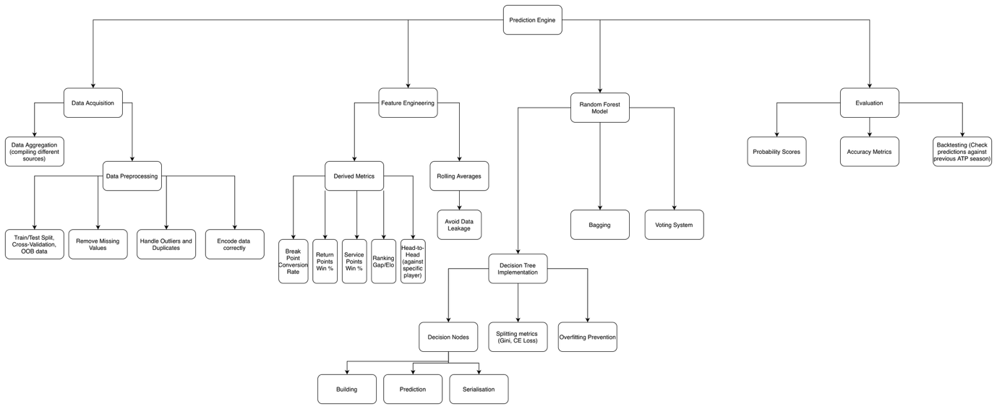

Algorithms
The two flowcharts below describe (at a high level) the process of entropy calculation and finding the best feature and threshold to split on, respectively:
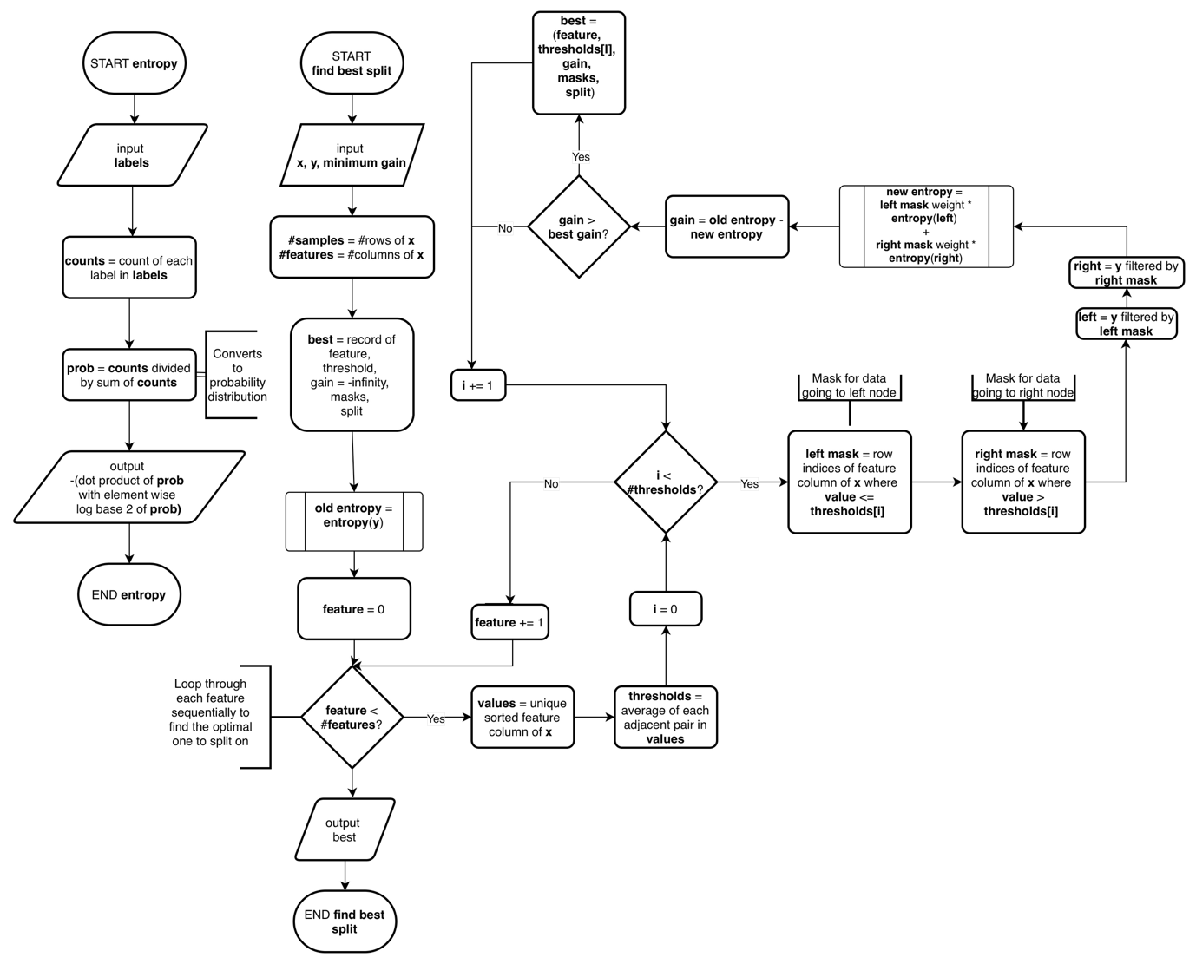

Technical solution

Testing

Evaluation

