# README

* Ruby version ruby 2.3.0p0

* System used OSX Sierra 10.12.1

* Download application

open terminal

navigate to folder

type bundle install

rake db:migrate

type rails s

* open browser

http://localhost:3000

*Test

user not allow to enter empty post

flash message on successful post

flash message on post deleted

user allow to enter 150 characters only

0 remaining means user will not be able to enter anymore characters

flash message will appear for 2 seconds only

Running tests:

* Characters counting down

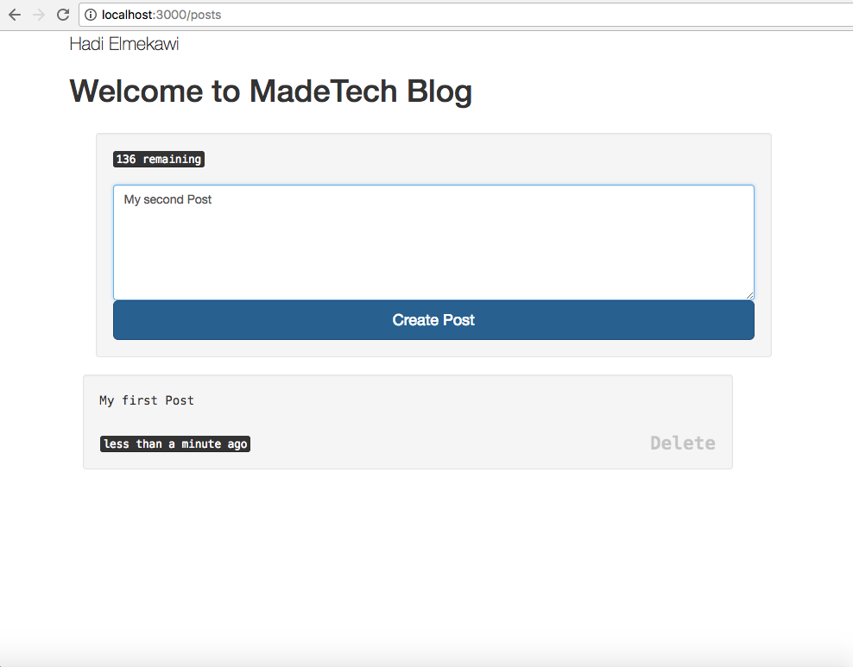

* Flash Message

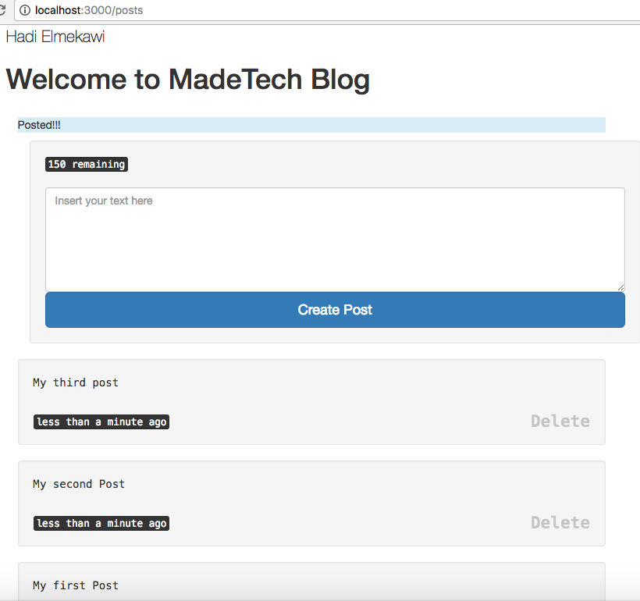

* Delete, flash message

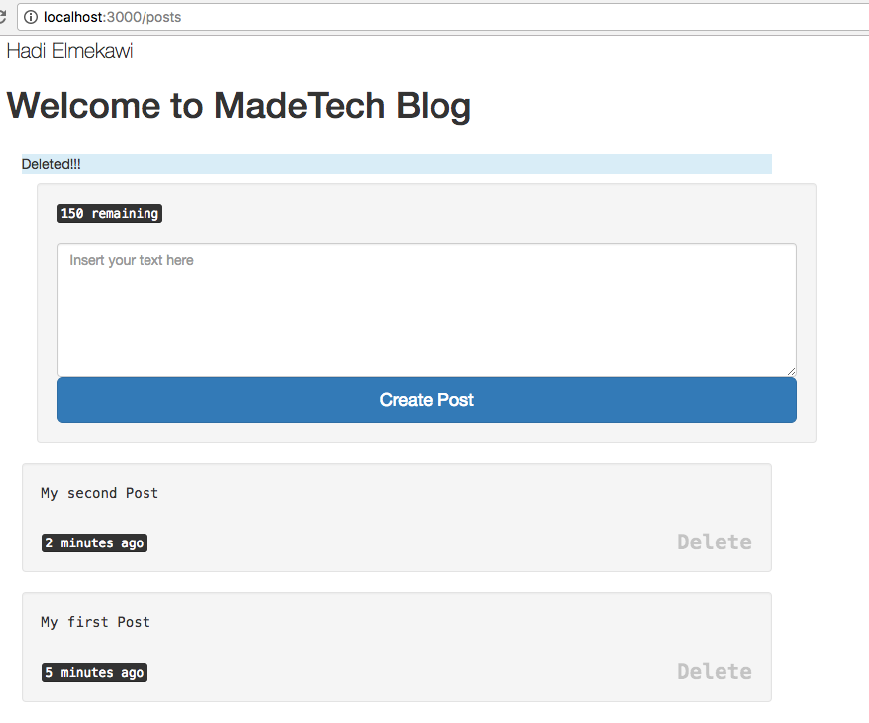

* Error message



* 0 Characters remaining



* New line format

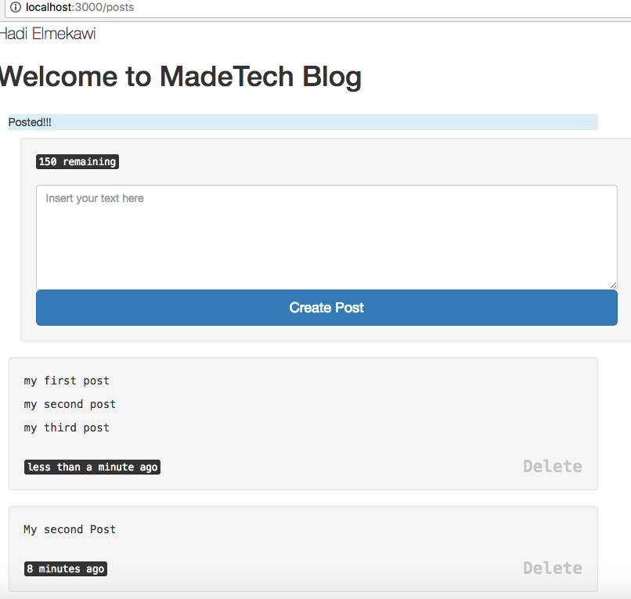

//Hadi Elmekawi 16 Jan 2017