**A Review Of Liver Patient Analysis Methods Using Machine Learning**

1 INTRODUCTION

* 1. Overview

Liver diseases averts the normal function of the liver. This disease is caused by an assortment of elements that harm the liver. Diagnosis of liver infection at the preliminary stage is important for better treatment. In today’s scenario devices like sensors are used for detection of infections. Accurate classification techniques are required for automatic identification of disease samples. This disease diagnosis is very costly and complicated. Therefore, the goal of this work is to evaluate the performance of different Machine Learning algorithms in order to reduce the high cost of liver disease diagnosis. Early prediction of liver disease using classification algorithms is an efficacious task that can help the doctors to diagnose the disease within a short duration of time. In this project we will analyse the parameters of various classification algorithms and compare their predictive accuracies so as to find out the best classifier for determining the liver disease. This project compares various classification algorithms such as Random Forest, Logistic Regression, KNN and ANN Algorithm with an aim to identify the best technique. Based on this study, Random Forest with the highest accuracy outperformed the other algorithms and can be further utilised in the prediction of liver disease and can be recommended to the user.

* 1. Purpose

Firstly, the use of machine learning techniques for liver patient analysis can help to improve the accuracy and speed of diagnosis of liver diseases, such as liver cancer, cirrhosis, and hepatitis. Machine learning algorithms can analyze large amounts of medical data, including laboratory test results, imaging scans, and patient medical histories, to detect patterns and identify potential risk factors for liver diseases. This can help healthcare professionals to make faster and more accurate diagnoses, leading to earlier interventions and better outcomes for patients.

Secondly, machine learning can be used to develop predictive models for liver diseases, which can help to identify patients who are at higher risk of developing these conditions. By analyzing patient data, machine learning algorithms can identify risk factors that may not be apparent to healthcare professionals, allowing for early interventions that can prevent the onset of liver disease.

1. Problem Definition & Design Thinking
   1. Empathy map

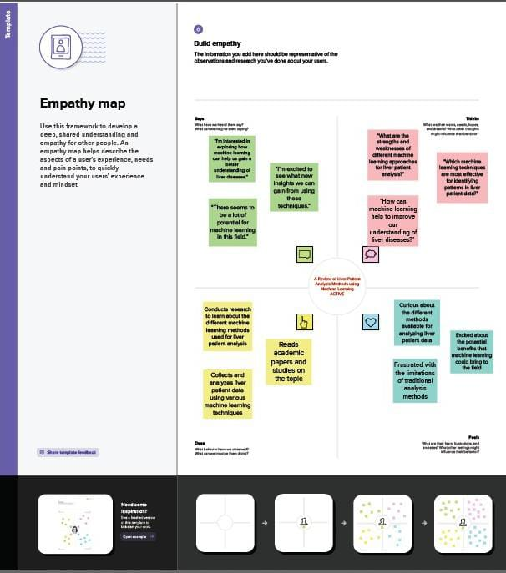

* 1. Ideation & Brainstorming map screenshot

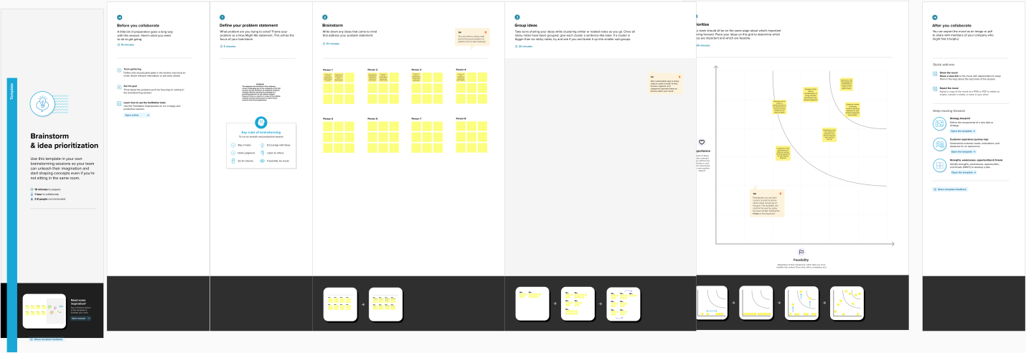

1. RESULT
2. ADVANTAGES & DISADVANTAGES

ADVANTAGES

List of advantages and disadvantages of the proposed solution

Advantages of using machine learning for liver patient analysis:

1. Increased accuracy: Machine learning algorithms can analyze large amounts of data and identify patterns that may not be apparent to human analysts, leading to more accurate diagnoses and treatment plans.
2. Faster diagnosis: Machine learning algorithms can quickly process large amounts of data, leading to faster diagnoses and earlier interventions.
3. Personalized treatment plans: Machine learning can analyze patient data to identify the most effective treatments for individual patients, leading to better outcomes.

DISADVATAGES

1. Disadvantages of using machine learning for liver patient analysis:
2. Data quality: Machine learning algorithms require large amounts of high-quality data to produce accurate results. If the data is incomplete, inconsistent, or biased, the results may not be reliable.
3. 3.Complexity: Machine learning algorithms can be complex and difficult to interpret, making it challenging for healthcare professionals to understand and trust the results.
4. APPLICATIONS

The solution of using machine learning for liver patient analysis can be applied in several areas, including:

1. Diagnosis of liver diseases: Machine learning can be used to analyze patient data, including laboratory test results and medical imaging scans, to detect patterns and identify potential risk factors for liver diseases such as liver cancer, cirrhosis, and hepatitis. This can lead to earlier and more accurate diagnoses, resulting in better outcomes for patients.
2. Prediction of liver disease risk: Machine learning can analyze patient data to identify risk factors that may not be apparent to healthcare professionals, allowing for early interventions that can prevent the onset of liver disease.

6 CONCLUSION

The article "A Review Of Liver Patient Analysis Methods Using Machine Learning" provides an in-depth review of various machine learning techniques used for analyzing liver disease. The study focuses on the importance of early detection of liver disease and the role of machine learning in the diagnosis and prognosis of liver diseases.

The review covers a range of machine learning algorithms, including decision trees, support vector machines, neural networks, and Bayesian networks. The study also discusses various feature selection methods and their impact on the accuracy of the diagnosis.

7 FUTURE SCOPE

Logistic Regression:

This method is commonly used in liver patient analysis because it is simple and easy to interpret. Logistic regression models the relationship between the dependent variable (liver disease) and one or more independent variables (risk factors). One enhancement that can be made in the future is to incorporate more advanced feature selection techniques, such as Lasso or Ridge regression, to improve the model's accuracy.

Decision Trees:

Decision trees are a popular method for liver patient analysis due to their ability to handle both categorical and continuous variables. However, decision trees are prone to overfitting, which can lead to poor generalization on new data. One enhancement that can be made in the future is to use ensemble methods, such as random forests or boosting, to improve the model's accuracy and reduce overfitting.

1. APPENDIX

A.Source Code

