TEAM:9 THE CHAKRAVYUH

Introduction

One of the significant challenges that consumers face in today’s market is the limited availability of precise and up to date information regarding the product’s update. This issue is often compounded by the involvement of intermediaries, such as suppliers, who may not be fully committed to their role. As a result of this lack of accurate and timely information, consumers may experience a loss of confidence in the products they purchase and also results in loss to the manufacturer.

Solution

Proposal: Develop a blockchain-based application to provide end-to-end visibility for product tracking, ensuring transparency and preventing malpractice. The application would allow consumers to track the status of their orders, from the initial stage of production to final delivery.

For example, in the case of car manufacturing and delivery, the application would enable consumers to monitor the progress of their car's production and delivery, and identify any potential malpractice by the supplier or middlemen.

By leveraging blockchain technology, our application would ensure transparency in the supply chain, even if multiple organizations are involved. This would increase consumer confidence and improve the efficiency of the supply chain.

Fabric components

Ledger (3)

Smart contract (3)

Organisations (manuf,suppl,appl)

Channel (1)

High level diagram

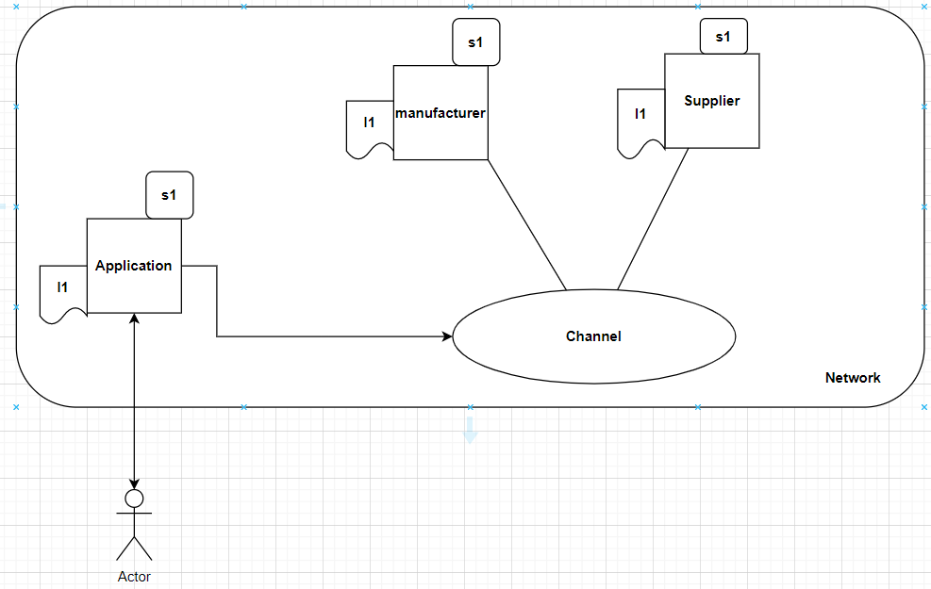

Smart contract

Ledger (

Carmodel

Carcolor

consumerMbno

orderStatus

orderId

showroomId

manufacturerUpates

code

//manufacturer getting order from showroom

Carmodel:’carmodel’;

Carcolor:’carcolor’;

Consumermbno: ‘consumermbno’

System.out.println(‘getting order from consumer’)

// Define the initial order status and details

orderStatus = 'Ordered';

orderDetails = {

'customermbno': customermbno,

'carModel': carModel,

'orderStatus': orderStatus,

'manufacturerUpdates':

Showroomed=’showroomid’:

System.out.println('Updating order status for order: ', orderId);

// Update the order status and add the manufacturer update to the list

orderDetails.orderStatus = 'In Progress';

orderDetails.manufacturerUpdates.push({

'manufacturerName': manufacturerName,

'updateMessage': updateMessage

System.out.println('Getting order details for order: ', orderId);

//view the order details through+\* the applications

'carModel': carModel,

'orderStatus': orderStatus,

'manufacturerUpdates':