LAB Logbook
Name: Arramali Dakshayani
SID:2530951
Lab1
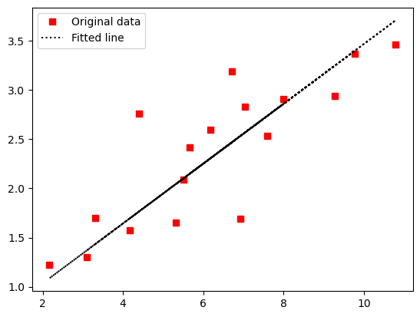

Lab2
1.The accuracy of the model is 0.906

2.
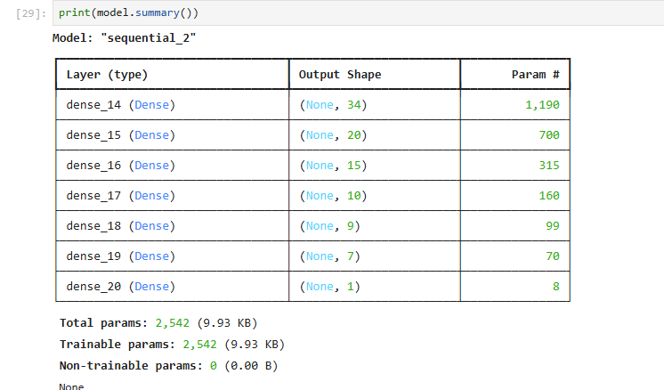
3.
O1=0.828
O2=0.828

Lab3
Model accuracy is 0.89230
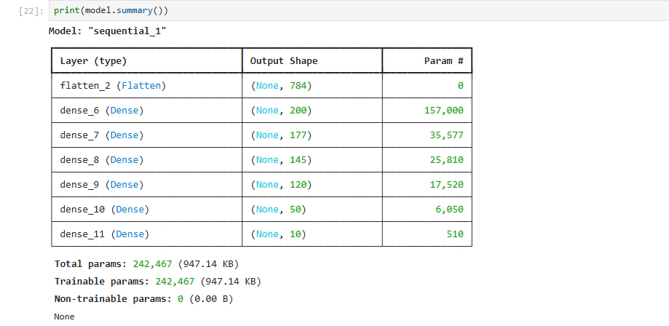

Lab4
