Welcome to this Solarus Ebook about

How to do this : Work with Solarus...

Intermediate Guide

« This book is still under construction »

Terms and Conditions

The content in this guide is for your information and doesn't have an exhaustive characterization of the software. It is only for giving you some basic knowledge to understand more, how to do this...; with the software. The editor, writer and others can not be held responsible for all the errors or/and part errors and others. The images in this document were found on the web with the keyword "Free" and some other images and more in this file are also considered Free and available thank's to some peoples and the web.

Even if the content is free, it doesn't give you and others, the right to use the document files freely, dismantle and others at any time. This Ebook is free, can be distributed freely, saved for safe keeping. No money is made from it and can be made of it.

Thank's to the peoples from http://www.solarus-games.org, that have helped me to understand more this great software. Also for giving me authorization to take images to put into the pages. Note that it is not an official Solarus guide. The Zelda assets are owned by Nintendo. They are used under non-commercial and press purposes. There are considered as « Fair Use ». I hold no responsibility on how the book affects others. Note that the author dont make any profits of any kinds at any times from this document and it's content. This book can not be sold by any ones, can not be profitable.

Also you agree to not pursue, not sue, ask money and others; the persons making this document possible. Note that you also agree all terms, conditions and others that can be modified, added, deleted and others at any times by the author of this book. This is writen to protect the peoples of Solarus, of Nintendo as my self.

About this Ebook and the Creator of It

This document can be used as a basic intermediate guide using Solarus Game Engine. When we say as an intermediate guide, we assume that you know how to install and use a software, open windows, create and save some files, use a mouse, use a keyboard, copy and replace some files, etc.

In this guide we will use the software:
"Solarus version 1.5"

About the Author

Trough the years, the author have created many free pdf guides. This made with the acceptence and authorizations of peoples, for doing some printscreens images to put into the pages. He have created some free pdf guides oriented for the software Futurepinball, a basic Milkshape3d pdf guide; and have created some readings for other subjects. The comments of the peoples about these said, they are easy to understand; and fun to learn.

The author hope that this book will help you have fun with this great software that is called Solarus. The author want to give his thank's to the many peoples that have contributed there time, in this personnal free project. Without them it would not have been possible.

Thank's to all, and have a nice reading!

How to create a quest

First you go at the "Top Text Menu" where it is writen (File), then from it you choose (New Quest). It should then ask where you want to put your quest, after a quest properties will open looking as this:
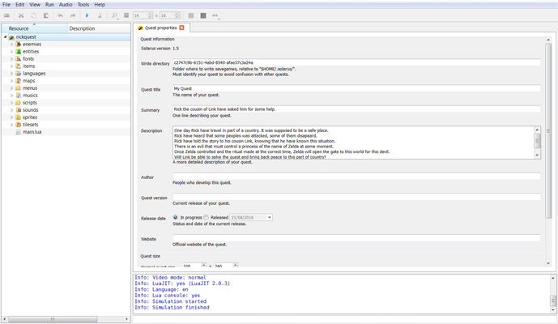 | In (Blue) it is the tree of your components making the game.  In (Green) is where you give a unique directory name, for game saving informations.  In (Red) is your quest title, it is also the title you see in a window when you run your quest.  In (Brown) is a brief description of your game  In (Purple) is a longer description of your game.  I'm sure you have guessed the rest. For «Quest Size » just leave it to it's default state (320 by 240) at this time.  In (Orange) is the infos that Solarus give, i would call it the « Actions Infos » since Solarus do some actions and give infos.

Replacing your game ressources by the ALTTP package

For this you should first know where is the new quest you just have created. Then simply unzip the Zelda ALTTP package, the files should already be in it's own repertoire. Note that Solarus must be closed before replacing the files. After simply copy all the the directory's to the place that have all the same directory's. If your computer ask to "Replace" then just say Yes!

After you should re-open again your quest of Solarus. In the Solarus Quest Maker you should notice the "Tree" that have the files. If in a directory you see some file that have some (Question Mark) as " ? ". Then with your mouse point the file and right click to see some menu apear, it should have the option as "add......". Once done the (Question Mark Icon) should change to some (Wooden Artistic Palette).

Tilesets example in Solarus
Simply go to the "Tilesets Directory" and (Double-Click) on a name. Here "Light World" have been double-clicked.
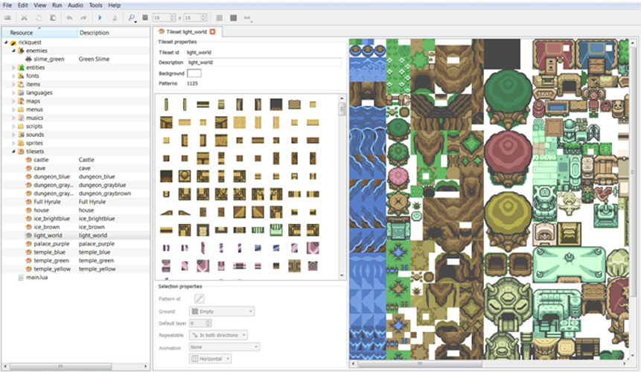 | When you create a map where the player move, it have some informations like if the tile is « Lower » of the player, or if it's at the « Same Level » of the player, or if it is « Above » the player.  An example : I could say is that (Grass) would be « Lower » then the player, some (Tree Body) could be at the same level of the player; and the (Clouds) would be higher of the player. Some tiles can act differently like some tree, the player could decide to pass in front or go at the back of it.

Tileset Properties example

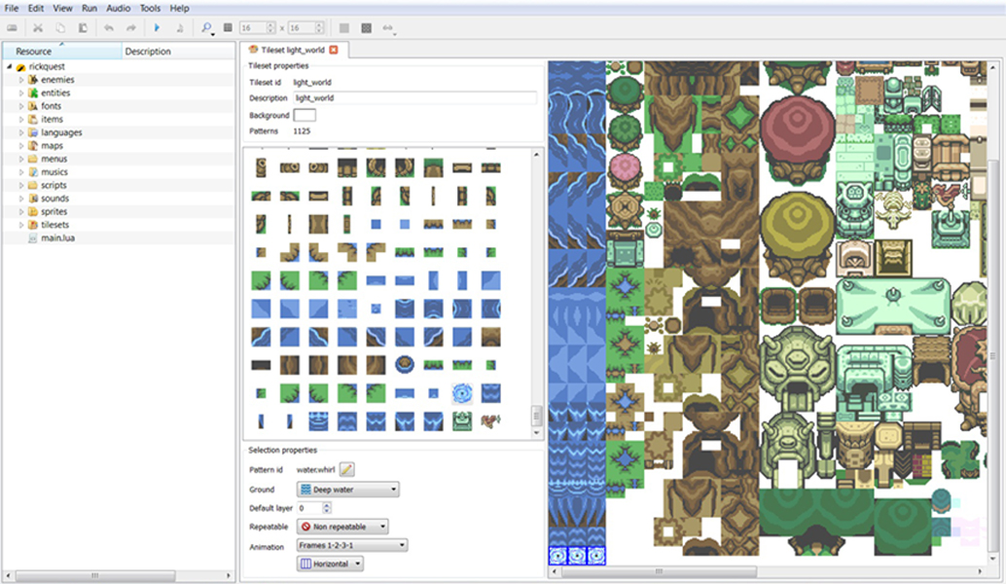  1  2  3 | On this image i have clicked with the mouse some « Swirl » tile near some bird (1).  Where it is circled (2) it is the « Tile Properties » of what is clicked.  Patern ID : is the (Unique) name of the tile.  Ground : indicate what type of ground it is, in this example the ground is (Deep Water) wich mean the player Link must have some (Palm Item) to be able to swim in the (Deep Water).  Repeatable : indicate when you put the tile on a map, if you can draw the tile many times by dragging the tile; like using with some shortcut keyboard keys. If you want you can try to put a tile on your map that is « Repeatable », and a tile that is not Repeatable, just to figure the difference.  Animation : Here the (Swirl Clicked) is animated, it say it goes from the (frame 1 to 3) then return to frame 1 to loop. You can see (3) the frames 1 to 3. It also say's that the next frame is (Horizontal) of the first frame.

How to create a new map

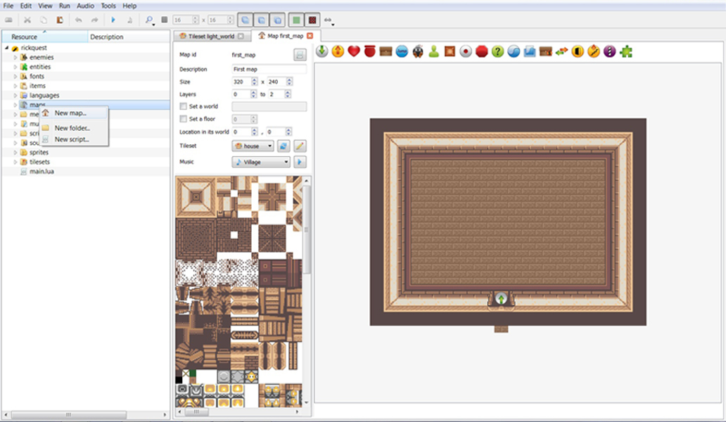 | To create a map you simply go to your left, where is the (Tree) of your quest. You should then point with your mouse the section that is writen « Map ».  After you do a (Right Mouse Button) click, this will make apear some menu.  Simply click with your mouse the option « New Map ».
This part : have some infos, like the (Size) of your map. The (Tileset) wich make you select some tiles, that can change the look. (Music) is the music that play in the map, but can be changed trough script. Many options you can do. Near the (Magnify) you can make apear the (Grid or Not).
This part : is the pieces that compose the tileset. You can click on some tile, then click on the (Map Beside) to put the tile where you want. By (Keeping pressed) the mouse button you can resize some tiles. You can also (Right-Click) mouse button on the map to put many. You can cancel your tile selected by simply clicking on the keyboard (Escape). Feel comfortable with trying.

