Agenda

* MySQL basic and queries,
* sub-queries
* joins

Day – 1

MySQL Basic Queries

* Types of SQL Queries
* Create table and constraints used in table creation
* Insert the data
* Update the data
* Delete the data
* Alter the table
* Drop the table
* Truncate the table

Day – 2

How to retrieve the data from table

* Select query
* Joins
* Sub queries

Before start executing any Queries in MySQL,

First we have to create a database,

create database orcldec23

Second we have to login to the database by using a query called Use

use orcldec23

how to retrieve the list of tables available in the current database

show tables;

SQL Queries

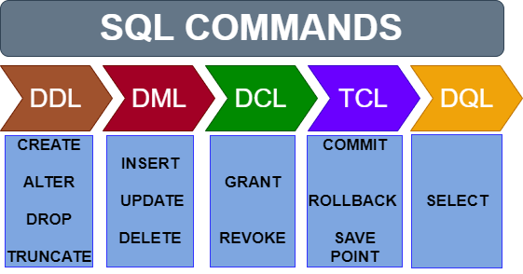

|  |  |  |
| --- | --- | --- |
| DDL – Data Definition Language | | |
| All these queries are used to create or modify the structure of the table | | |
| 1. | create table | used to define the structure of a table |
| 2 | alter table | used to modify the structure of the existed table |
| 3 | truncate | used to remove the data present in the table |
| 4 | drop | remove the data and structure of the table |

|  |  |  |
| --- | --- | --- |
| DML – Data Manipulation Language | | |
| All these queries are used to create or modify the data in a table | | |
| 1. | insert | used to add a new data to the table |
| 2 | update | used to modify the existed data |
| 3 | delete | used to remove the data from table |

|  |  |  |
| --- | --- | --- |
| DRL – Data Retrieval Language or Data Query Language | | |
| 1. | select | used to get or retrieve or fetch the required data from one or more tables. |

|  |  |  |
| --- | --- | --- |
| TCL – Transaction Control Language | | |
| All these queries are used to make the changes permanent or revert all the changes | | |
| 1. | commit | save the changes permanently in database |
| 2 | rollback | revert all the changes or don't save |
| 3 | savepoint | book mark the point |

|  |  |  |
| --- | --- | --- |
| DCL – Data Security and Privileges Language | | |
| All these queries are used to add or remove privileges to the user | | |
| 1. | grant | Add or provide the privileges to the user |
| 2 | revoke | Remove the added privileges to the user |

DBA 🡪 Database Administrator

The DCL Queries are executed by DBA

DDL 🡪 Data Definition Language

* Used to define the structure of the table
* Structure of the table contains
  + Number of columns
  + Type of each column
  + Size of each column
  + Criteria to validate the input

How to create the structure of the table?

Query: CREATE TABLE

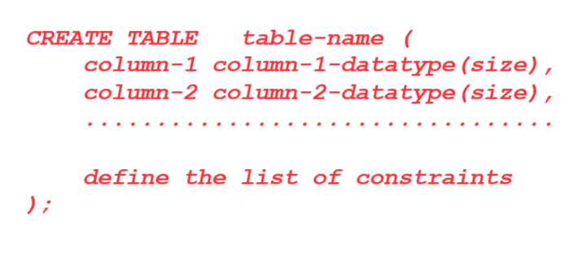

Example:

Create a table called Student with the below columns

|  |  |  |  |
| --- | --- | --- | --- |
| Htno | Numeric | int |  |
| Sname | Alpha numeric | varchar | 20 |
| M1 | Numeric | int | 3 |
| M2 | Numeric | int | 3 |
| Total | Numeric | int | 4 |
| Average | Fractional data | decimal | 5,2 |

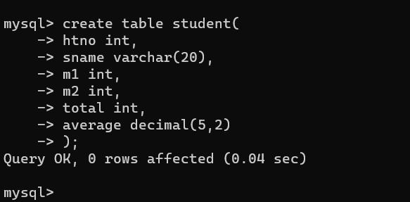

Syntax to create a table

Different data types available in MySQL

Alpha numeric values:

* Char 🡪 Upto 255 characters 🡪 Fixed amount of memory
* varchar 🡪 maximum size of up to 65535 characters 🡪 variable amount of memory

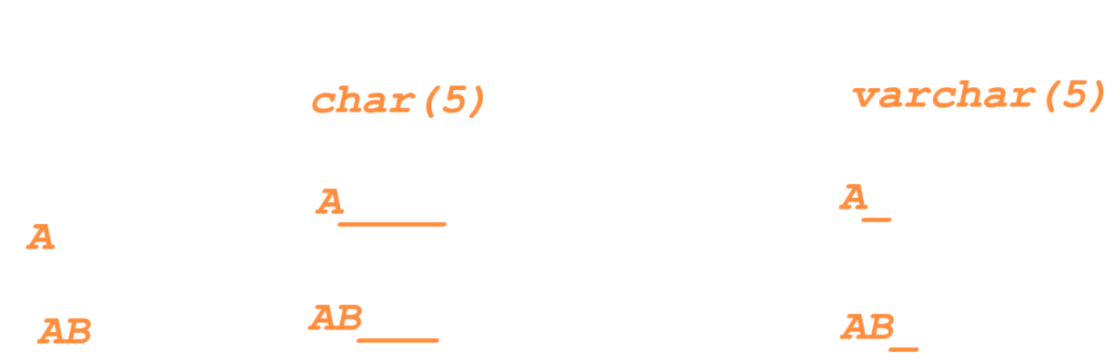

In real time, varchar is recommended to declare the columns of type Alpha numeric

Numeric type of data -- Numbers

* Int 🡪 Integers represent numbers without fractions and can have SIGNED and UNSIGNED attributes
* Decimal 🡪 stores the exact value

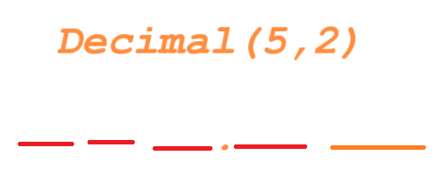

* Float 🡪 A precision from 0 to 23 results in a 4-byte single-precision FLOAT column
* Double 🡪 A precision from 24 to 53 results in an 8-byte double-precision DOUBLE

How to insert the data into a table or how to create a new row in the existed table?

Query: INSERT

Note: All Alpha-numeric and Date type of values should be enclosed in Single quotes

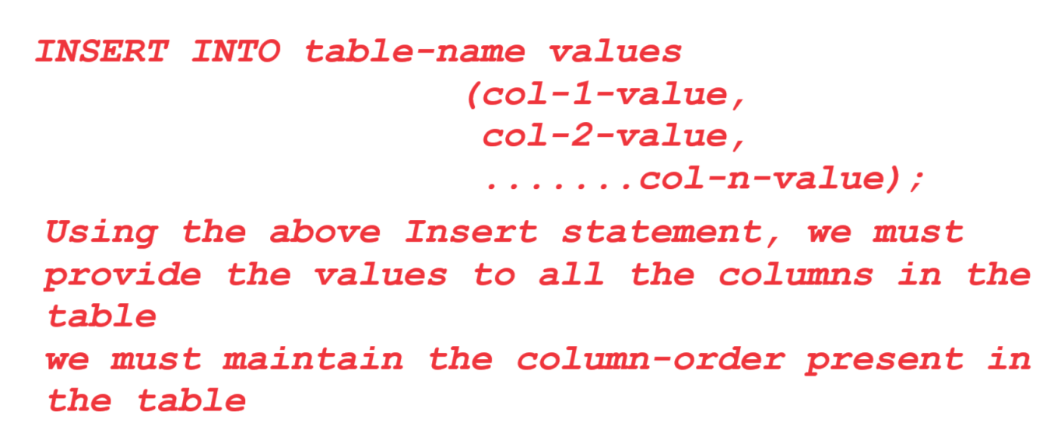

Example:

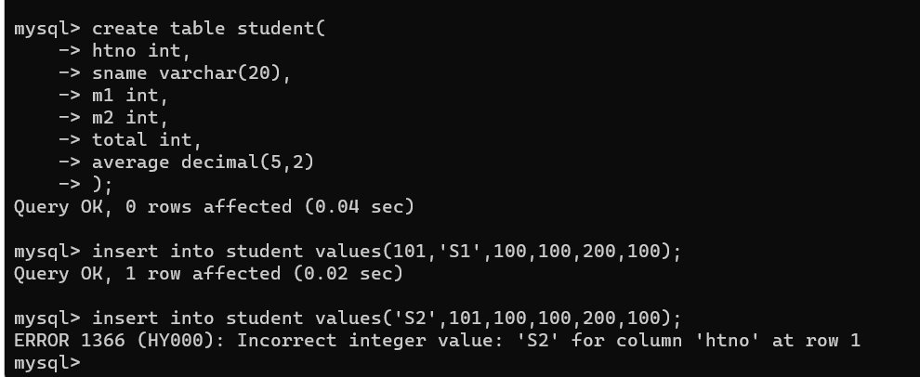

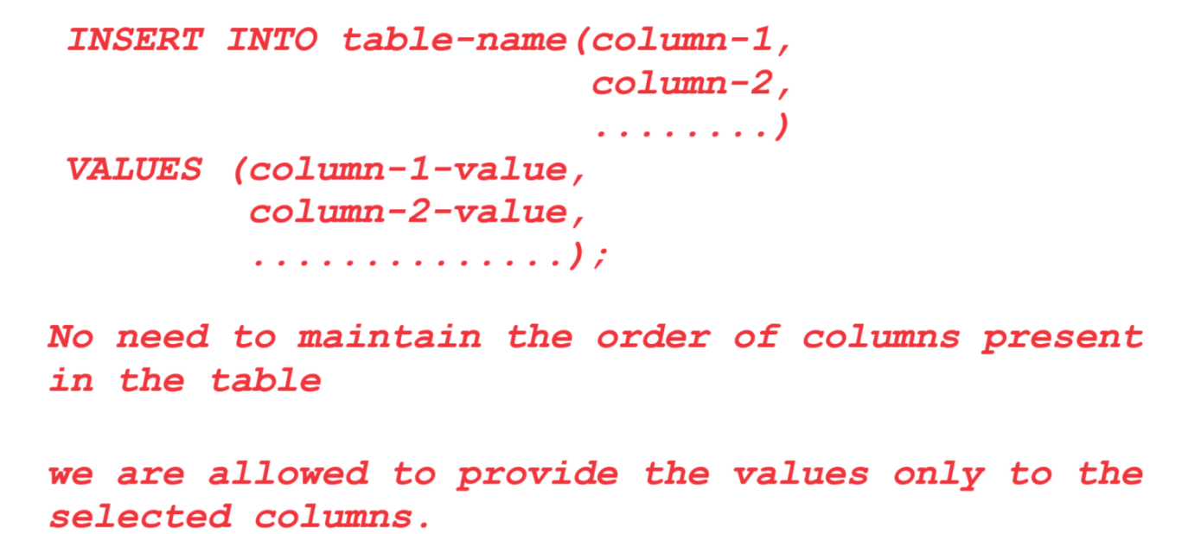

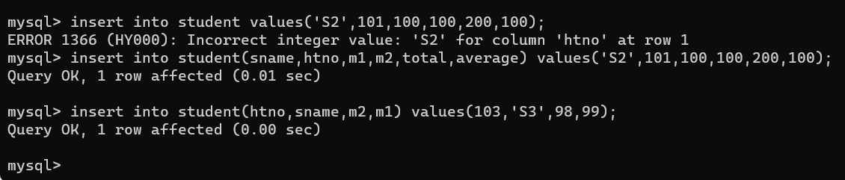

How to retrieve the data or rows present in the table?

Query: SELECT

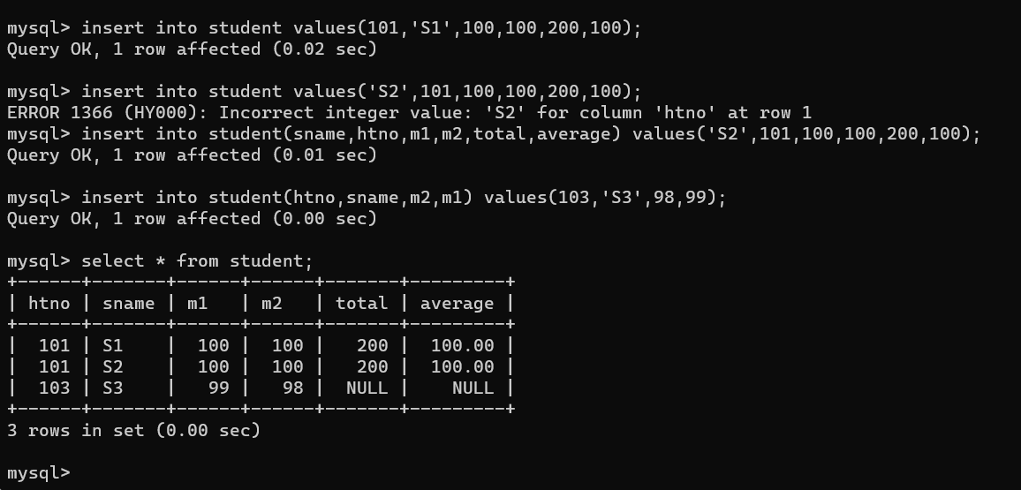

How to update the rows present in the table or how to modify the data present in the table?

QUERY: UPDATE

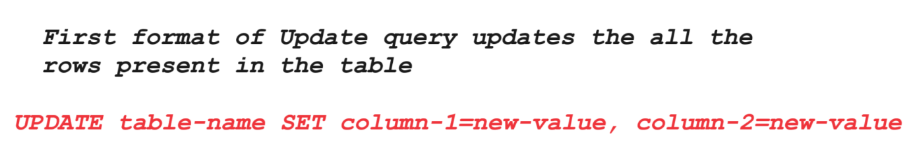

Write a SQL query to update the total and average columns to all the rows present in the table?

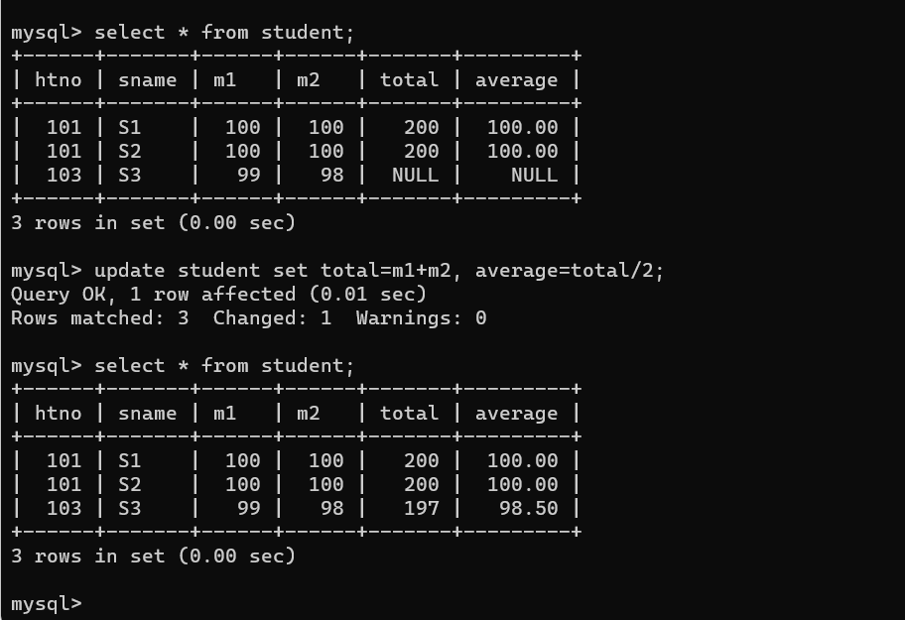

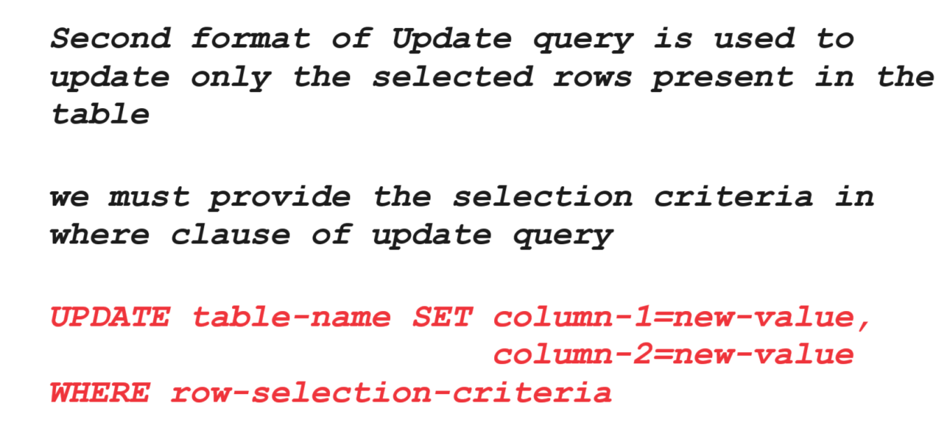

Example:

1. Write a SQL query to change the HTNO of S2 student from 101 to 103

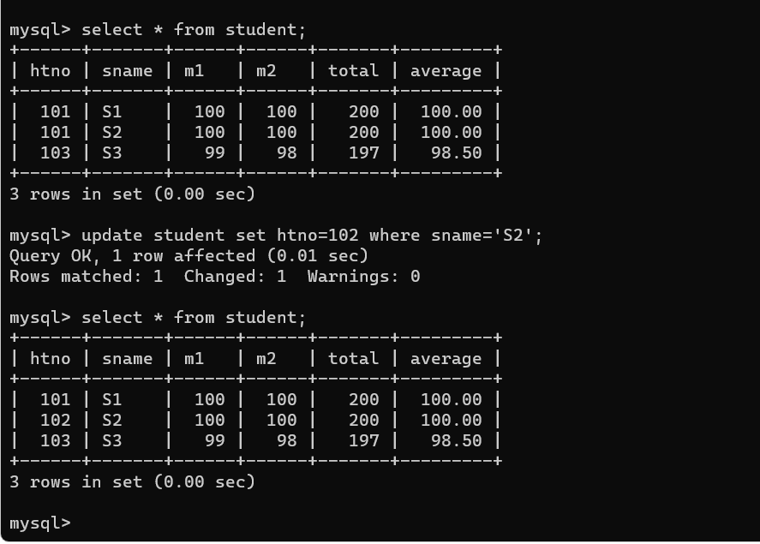

Delete Query

* Used to remove the rows present inside the table

We have two different formats of Delete query

1. Removes all the rows present inside the table
2. Removes the selected rows present inside the table

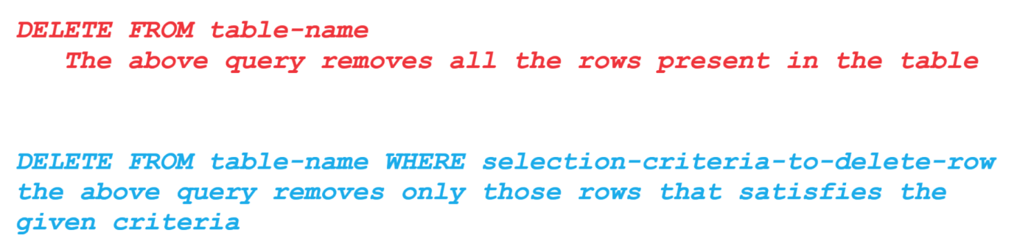

Q1) SQL query to remove the student information whose htno is 102

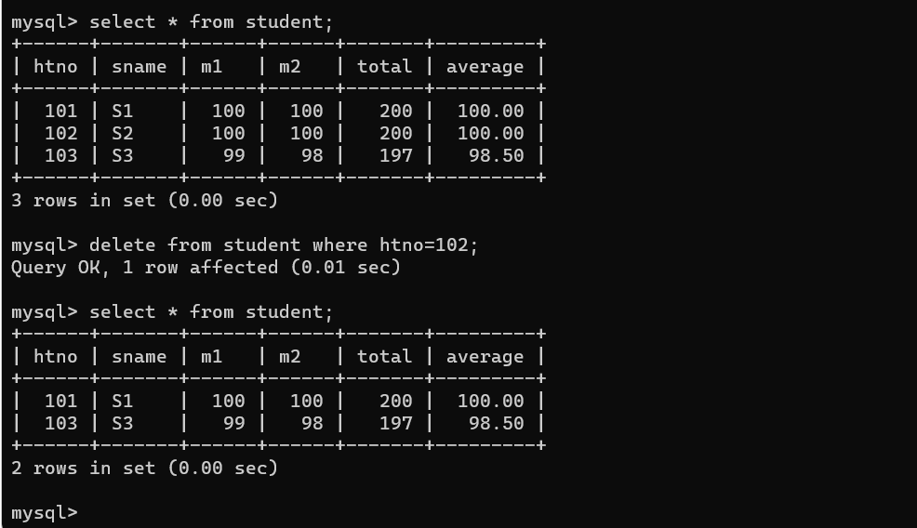

Q2) SQL query to remove all the rows present in the student table?

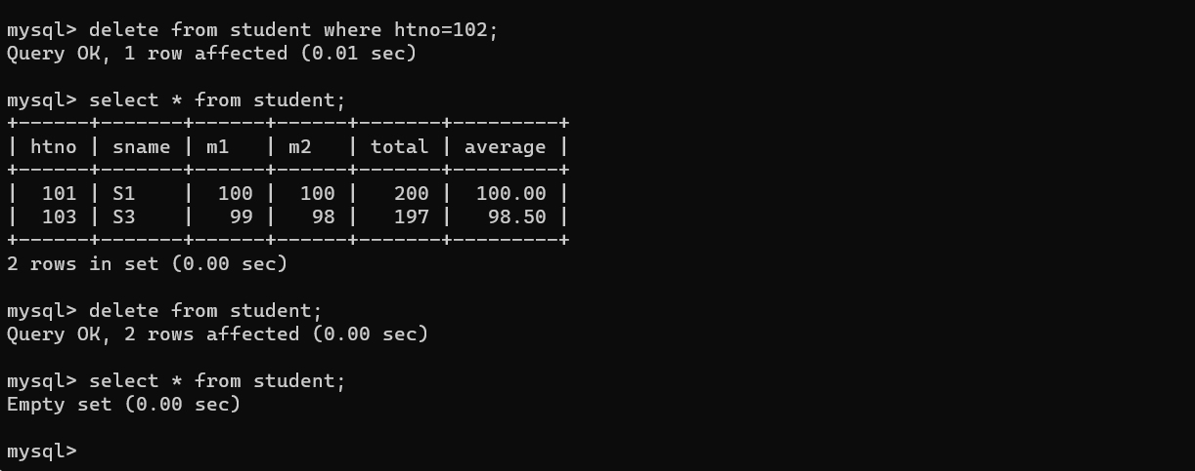

Other Data types of MySQL

1. Used to store the value for Date of birth, date of manufacturing, date of expiry and so on
   * Date 🡪 YYYY-MM-DD format (year, month, and date)
   * Datetime 🡪 YYYY-MM-DD HH:MM:SS ( year, month, and date, and hours, minutes, and seconds)
   * Timestamp 🡪 YYYY-MM-DD HH:MM:SS ( year, month, and date, and hours, minutes, and seconds)
   * Time 🡪 HH:MM:SS format (hours, minutes, and seconds)
   * Year 🡪 allows YYYY

* Note: the values for all the columns should be enclosed in Single Quotes

Example

-- create the employees table

CREATE TABLE employees(

employee_id INT,

first_name varchar(45),

last_name varchar(45),

date_of_birth date,

first_day_at_work datetime,

start_to_work time,

salary decimal(5,2),

certified year

);

-- insert data into the table

INSERT INTO employees (employee_id, first_name, last_name, date_of_birth)

VALUES (1, 'John', 'Sanders', '2000-01-19', '2020-11-18 10:00:00', '08:00:00', '2021');

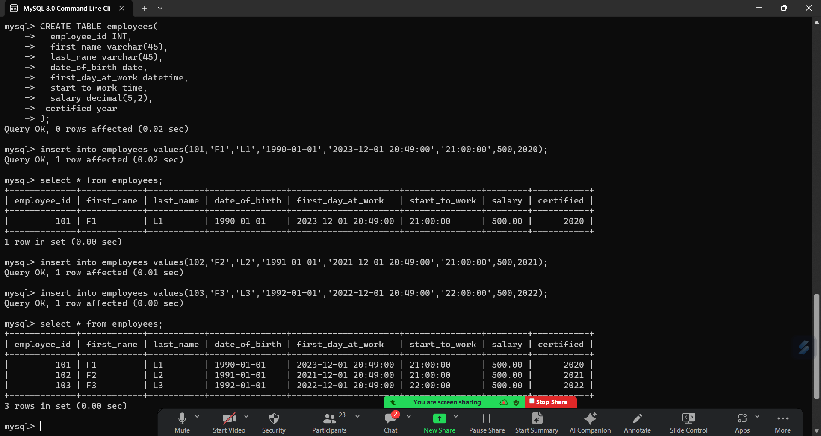

Boolean 🡪

* boolean data types can only accept either true or false values
* we no need to specify the size to Boolean data type
* to define the Boolean values, we no need to enclose the value in single quotes

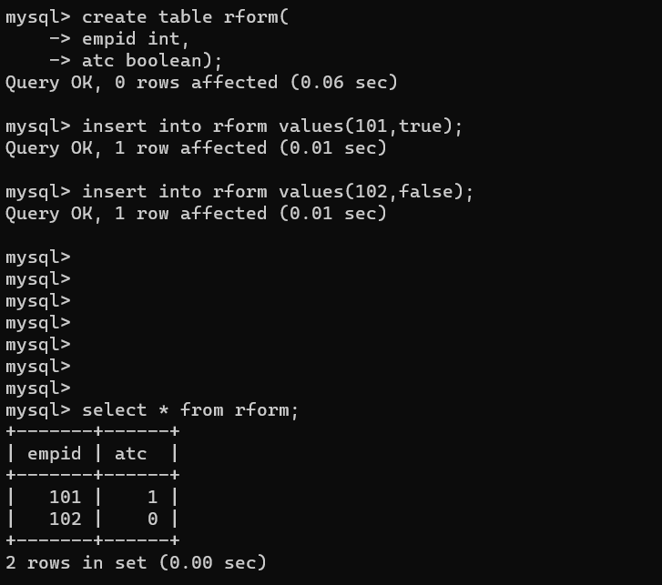

ENUM

* Is used to define the set of valid values.

Example:

CREATE TABLE clothes (

product_ID int,

name varchar(10),

fabric varchar(10),

size enum ('small', 'medium', 'large')

);

INSERT INTO clothes (product_ID, name, fabric, size)

VALUES (1, 'dresses', 'cotton', 'small');

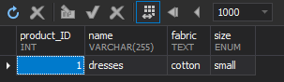

INSERT INTO clothes (product_ID, name, fabric, size)

VALUES (2, 'dresses', 'silk', 'extra large');

Will get Error