Constraint’s purpose

Are used to define criteria to validate the data.

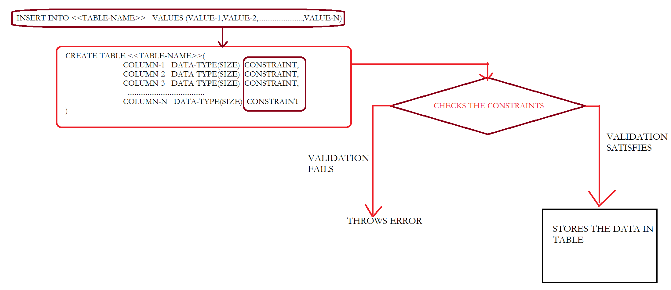

Different SQL constraints available in SQL

* Not Null
* Unique
* Primary Key
* Check
* Default
* Foreign Key

|  |  |
| --- | --- |
| Not Null | Won’t allow any null values  But it allows duplicate values  We must some value to this column |
| Unique | Won’t allow duplicate values  But it allows Null values. |
| Primary key | Combination of Not Null and Unique  That means it won’t allow null values as well as duplicate value |
| Check | Used to define the condition |
| Default | Used to define the default value to the column  whenever the user skipped that column from the input values list |

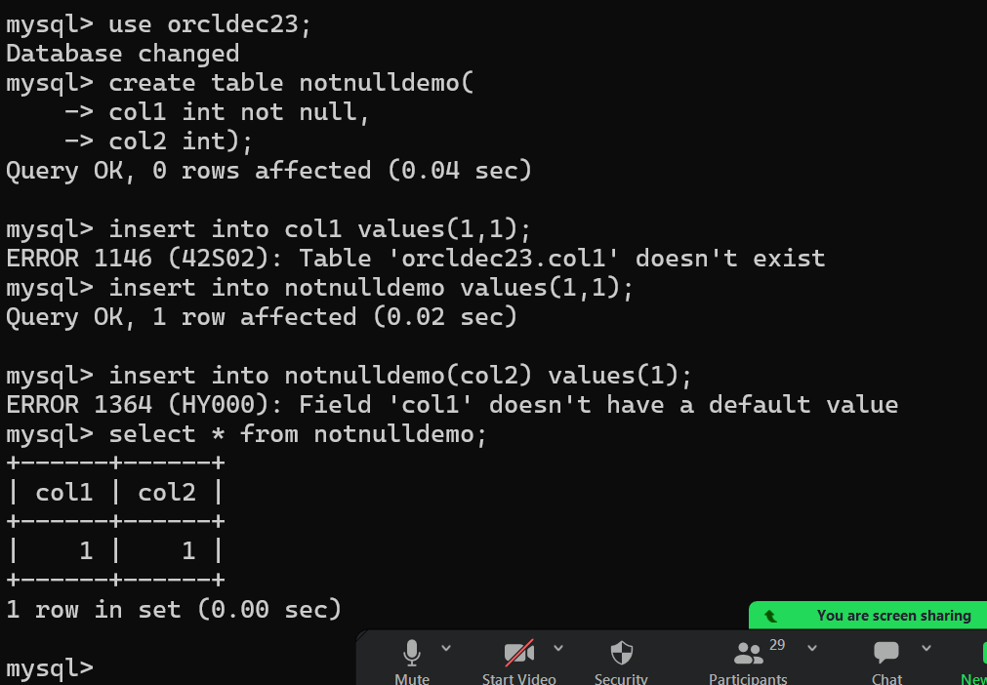

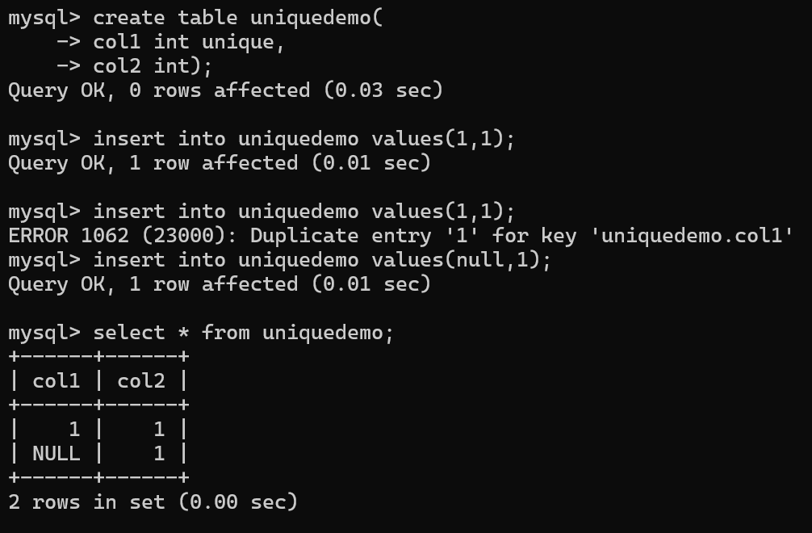

Primary key = not null + Unique

Note:

We are not allowed to define more than one primary key constraint in a table

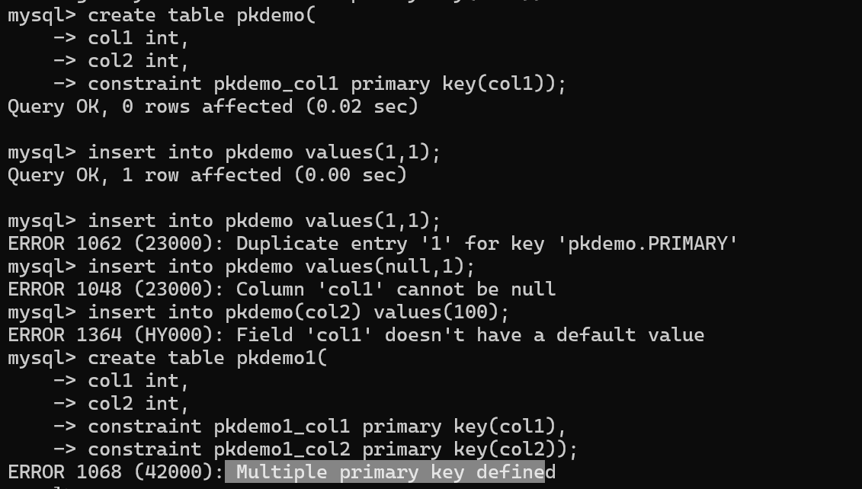

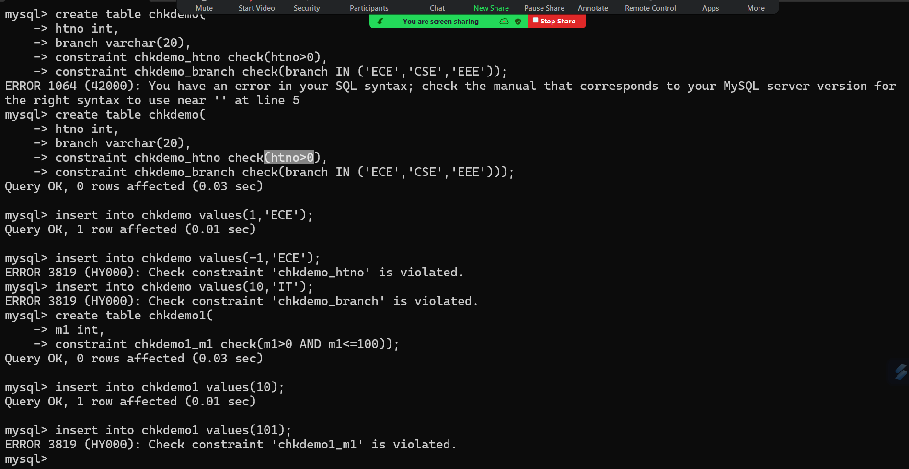

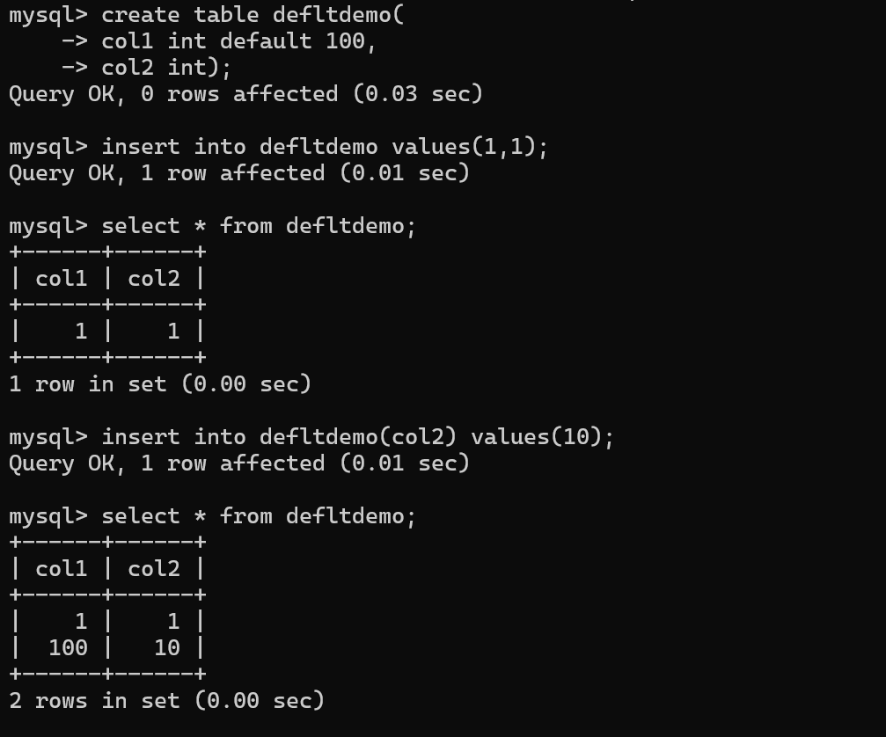

Note:

In real time, going with table level constraints using the below syntax is recommended

CONSTRAINT constraint-name constraint-type(column-name-to-apply-constraint)

Foreign key constraint

What is foreign key?

A Column in the current table or child table is declared as a primary key in another table or parent table is called foreign key.

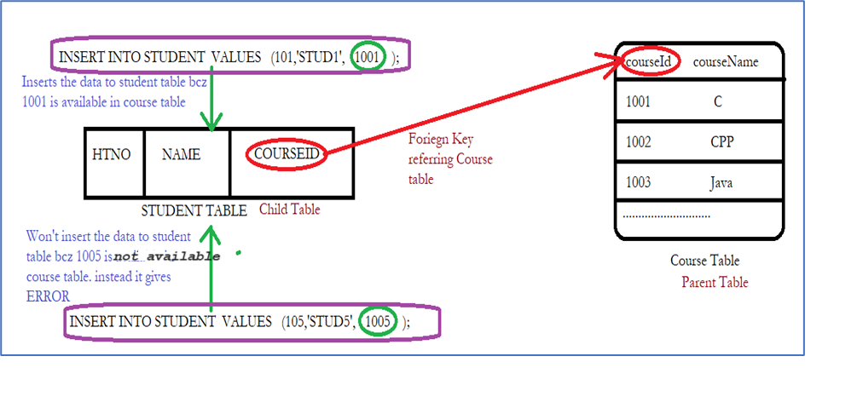

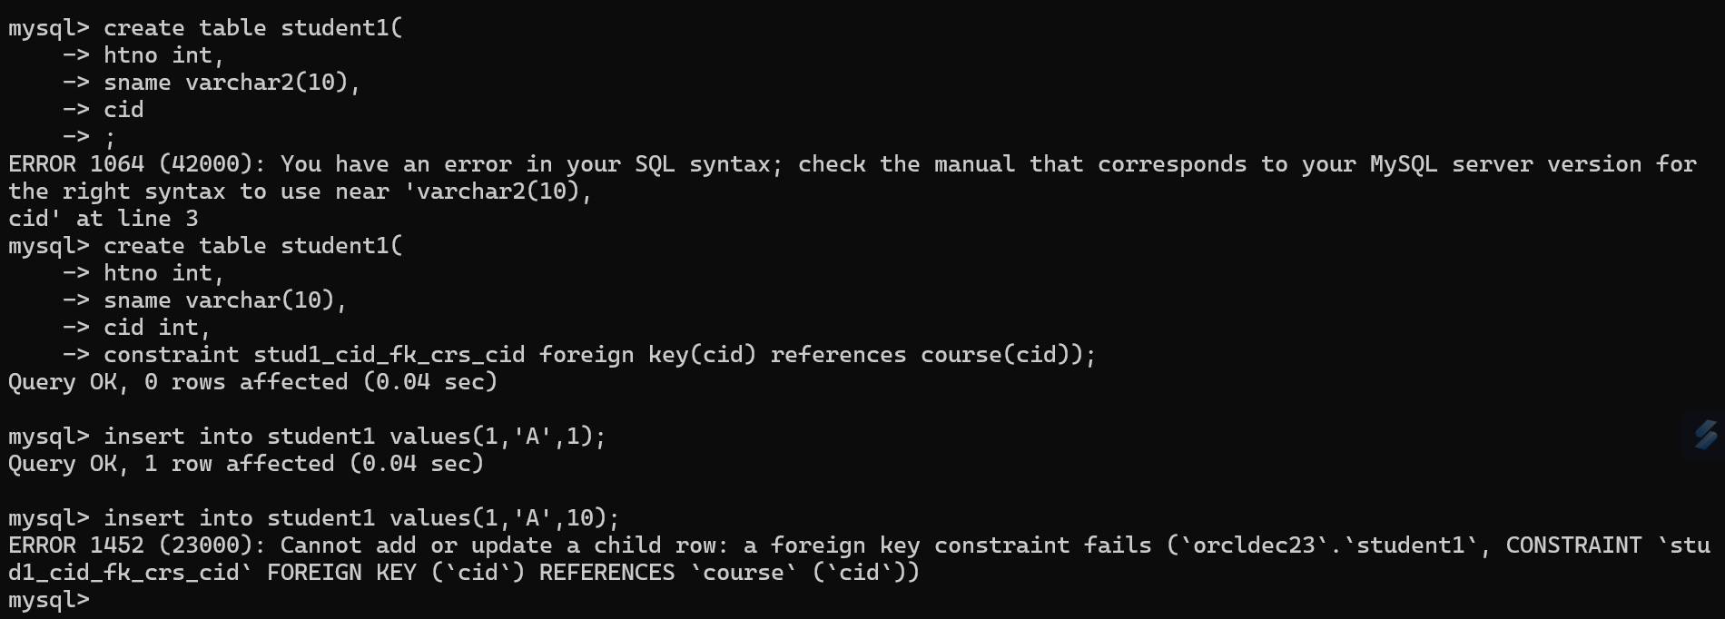

Alter Table

This query is used to modify the structure of the existed table

Below are list of modification that are allowed:

* Adding or modifying or removing the column
* Adding or removing the constraints

CREATE TABLE DEPARTMENT

(

DEPTCODE INT,

DeptName CHAR(30),

LOCATION VARCHAR(33)

);

CREATE TABLE EMPLOYEE

(

EmpCode INT(4),

EmpFName VARCHAR(15),

EmpLName VARCHAR(15),

Job VARCHAR(45),

Manager CHAR(4),

HireDate DATE,

Salary INT(6),

Commission INT(6),

DEPTCODE INT(2)

);

SQL Query to add a primary key constraint to department table?

ALTER TABLE DEPARTMENT

ADD PRIMARY KEY (DEPTCODE);

SQL Query to change the size of deptname from 30 to 45

ALTER TABLE DEPARTMENT

Modify deptname char(45);

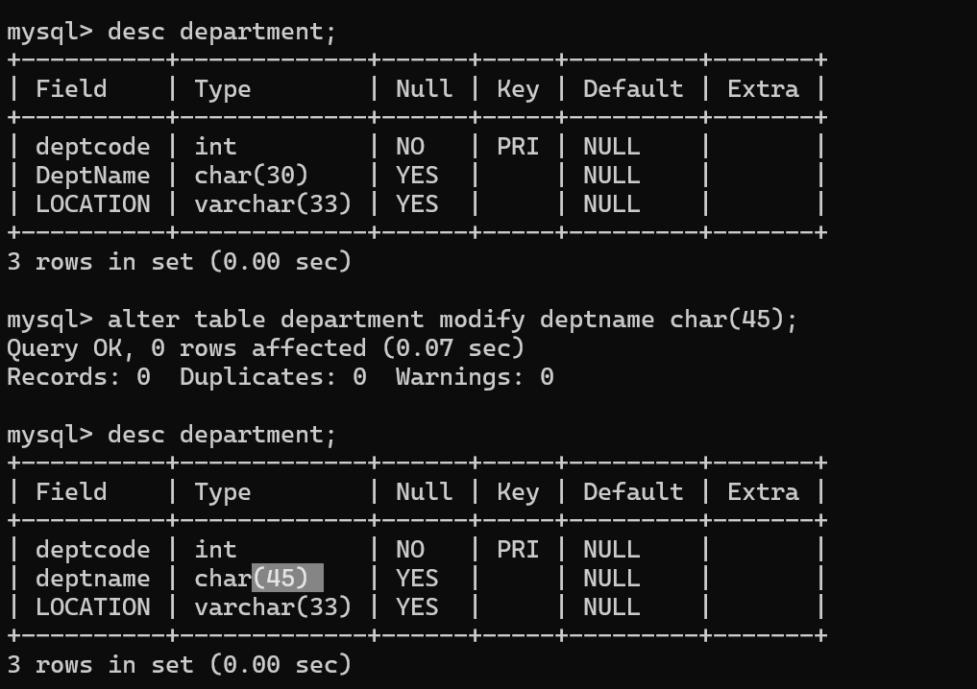

SQL Query to add unique constraint to deptname

ALTER TABLE DEPARTMENT

Modify COLUMN DeptName DeptName CHAR(30) UNIQUE;

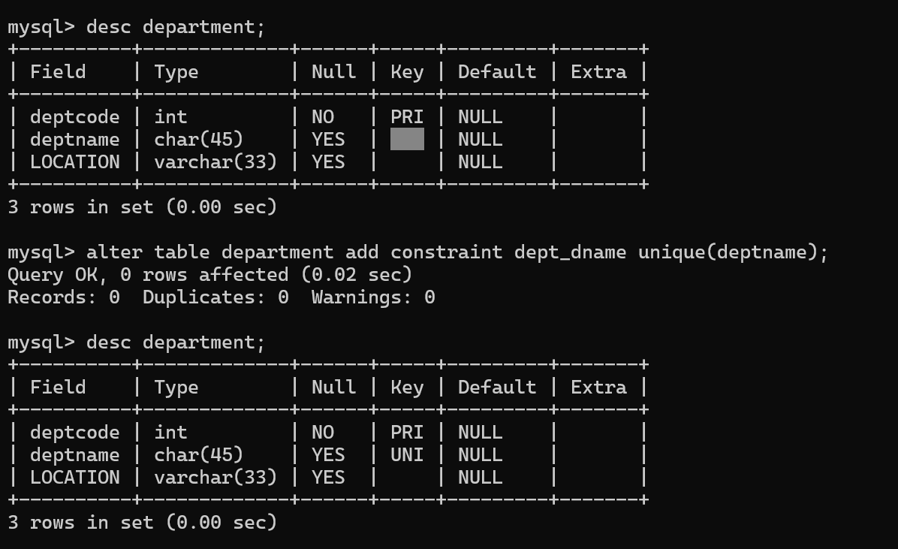

SQL Query to add Not Null constraint to Location

ALTER TABLE DEPARTMENT

CHANGE COLUMN LOCATION LOCATION VARCHAR(33) NOT NULL;

SQL Query to add a primary key constraint to employee table

ALTER TABLE EMPLOYEE

ADD PRIMARY KEY (EmpCode);

SQL Query to add a Foreign key constraint to employee table

SQL Query to add a dob column to employee table

ALTER TABLE EMPLOYEE

ADD COLUMN DOB DATE

AFTER EmpLName;

SQL Query to delete a dob column from employee table

ALTER TABLE EMPLOYEE

DROP COLUMN DOB;

Truncate

* Is used to remove complete data from the table (all rows present in the table)

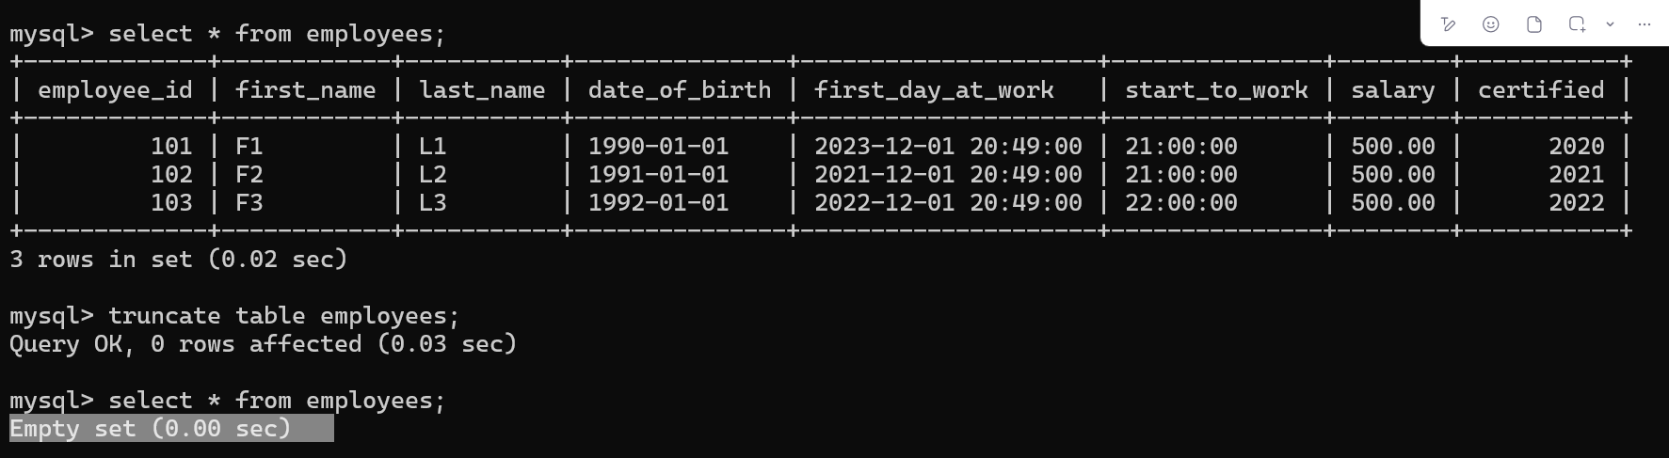

What is the difference between Truncate and Delete?

|  |  |
| --- | --- |
| Delete | Truncate |
| DML Query | DDL Query |
| Allows to remove all or specific rows from the table | Allows to remove all the rows from the table (no option to remove selected rows from the table) |
| We can get back the deleted rows if required using rollback | We can’t get the deleted data back |

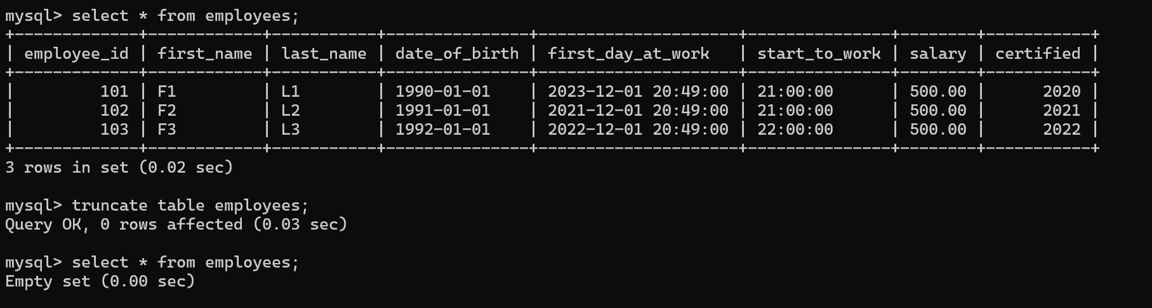

Drop

* Used to remove the structure of the table along with the data present inside the table

|  |  |
| --- | --- |
| Drop | Truncate |
| Drop removes the structure along with the data present inside the table | Truncate removes only the data present inside the table by keeping the structure of the table as it is. |

