**Apple Gadgets**

Name: P.Anusri

E-Mail: [patibandlaanusri@gmail.com](mailto:patibandlaanusri@gmail.com)

PhoneNo: 7013843523

RollNo: 20NN1A12A7

College No: Vignan’s Nirula Institute of Technology and Science for Women.

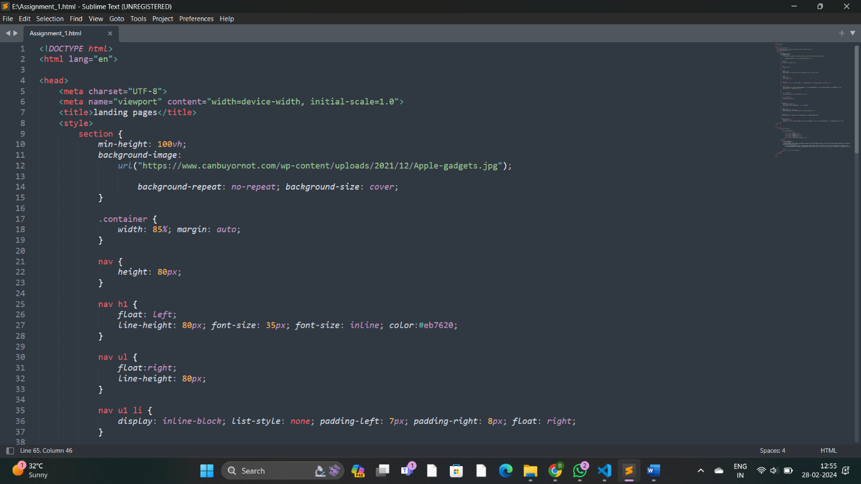**Source Code:**

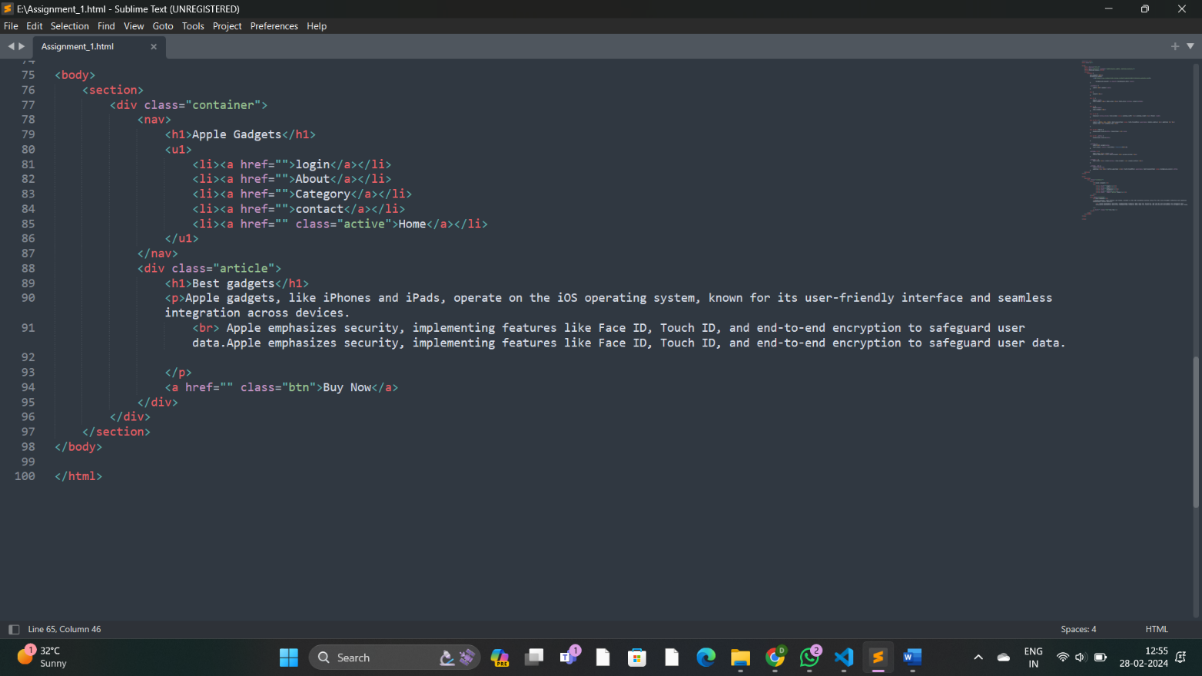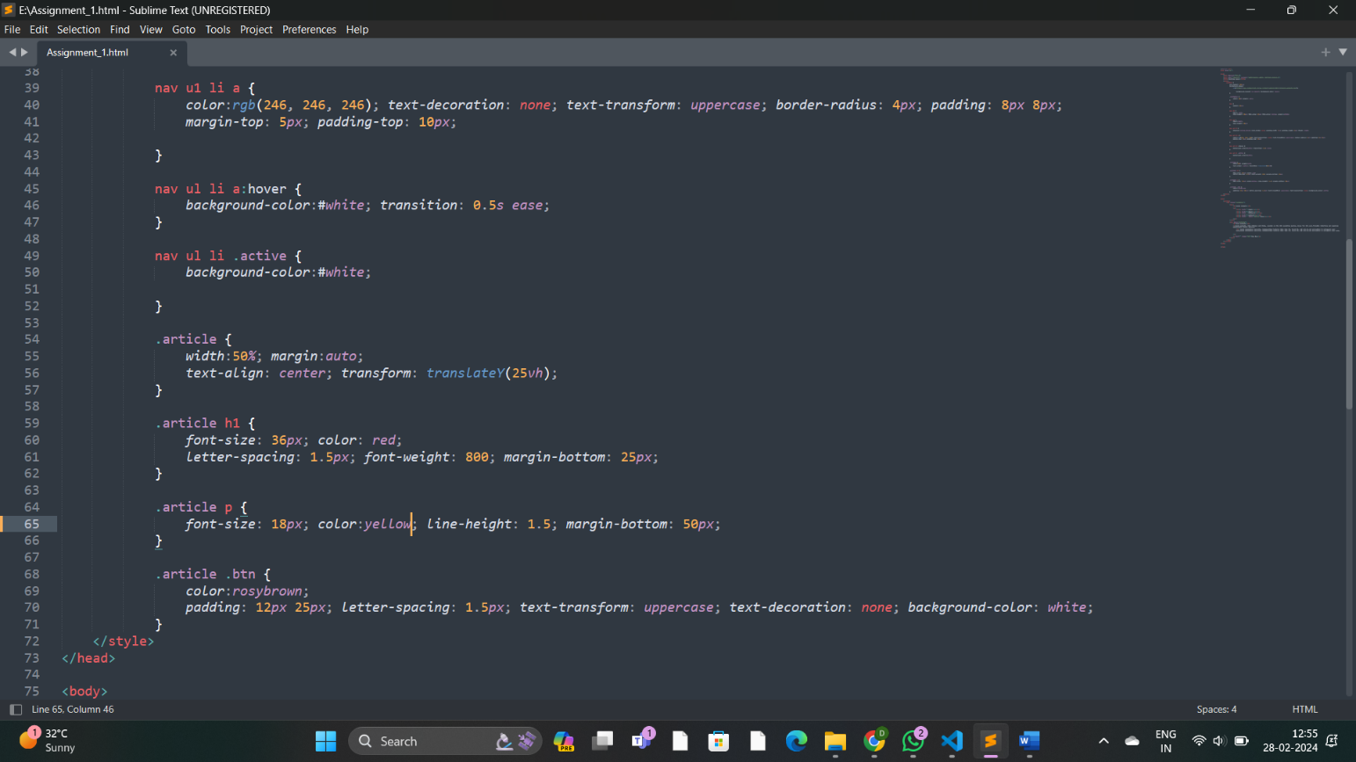

Output:

mar