# ASSIGNMENT 3- A simple RESTFUL API using React.js, DataBase Creation, and Creating Index

**Name:Anusri Patibandla**

**Roll no:20NN1A12A7**

**E-Mail:patibandlaanusri@gmail.com**

**College:Vignan’s Nirua Institute of science and Techonolgy for Womens**

# RestFul API code

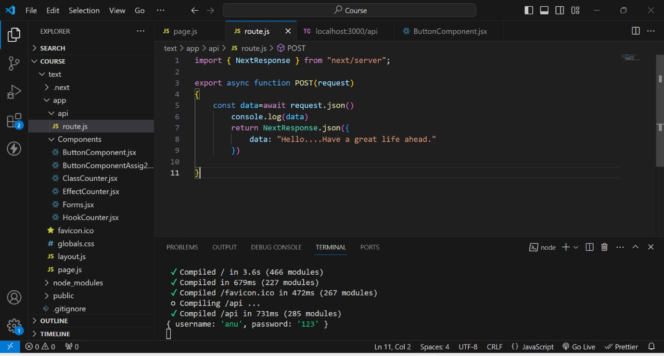

**Rest Output on ThunderClient**

**This is the output when we create an API using REST.**

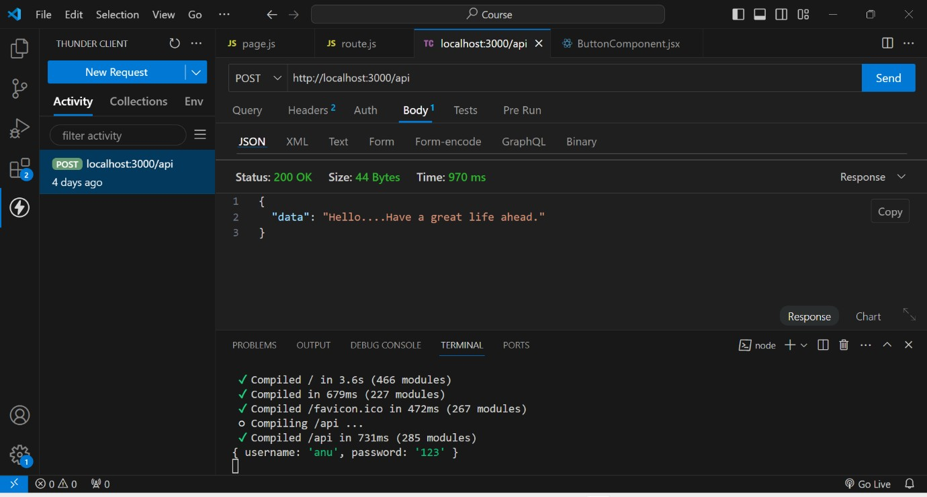

# DataBase Creation

1st we created a database named test

In that test we created a collection named Students

And finally by using ADD DATA , we added data of the students like rno, name, age.

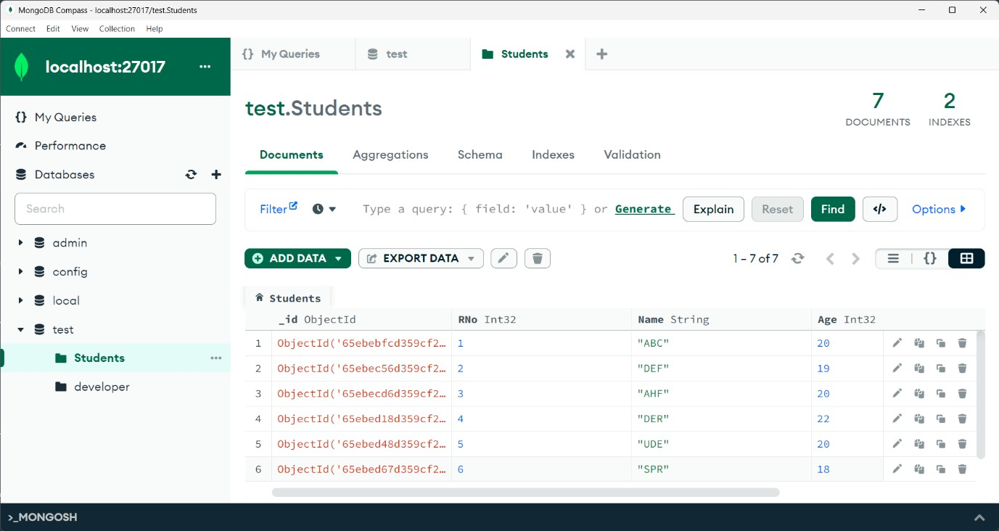

# Indexing Creation

As rno is the unique attribute throug which we identify a student uniquely. So, here I created an index based on Rno. And assigned unique key to it.

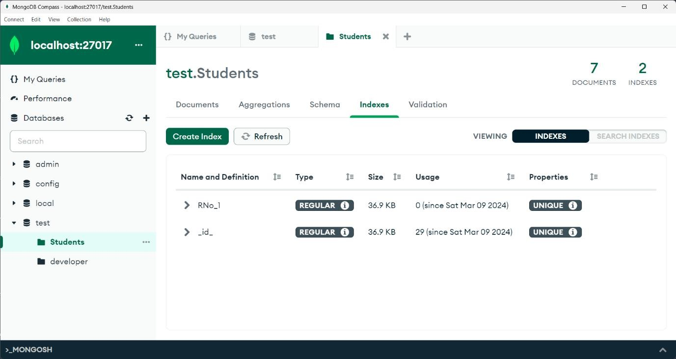

# Indexing usage

As we gave Rno as unique, If we try to insert a duplicate document that is existed it shows an error like..duplicate collection.

