1. **Homepage Slider**

**Video Link->** <https://youtu.be/F__wQ-Qn6bQ>

* Log in to your WordPress Administration Screen (Dashboard).
* Click the ‘Sliders’ tab on left sidebar.
* Click the ‘Add New’ sub-tab or Edit the Existing Sliders.
* Start filling in the blanks: enter your Slider title in the upper field, and enter your Slider’s content in the ‘Slider Options’ textarea box below it. There is also the Read More Link Box as well.
* On the right sidebar, you can see the ‘Featured Image’ section. This is the Slider’s image and you can upload/remove the image.
* When you are ready, click Publish/Update.

1. **Homepage Welcome Section**

**Video Link->**<https://youtu.be/2Ni5CBoR6R0>

* Log in to your WordPress Administration Screen (Dashboard).
* Click the ‘Pages’ Tab.
* Select and edit the ‘About’ Page.( ‘Acerca de’ page For ES)

1. **Homepage Product Catalogue/Product Categories**

**Video Link->**<https://youtu.be/Yfm0-WZ2Kkc>

* Log in to your WordPress Administration Screen (Dashboard).
* Click the ‘Products’ Tab.
* Click on the ‘Category’ sub-tab.

**For the Section Title:**

* Go to the ‘appearance’ Tab.
* Click the ‘customizer’ sub-tab.
* Go to the ‘Theme Options’ & find the ‘Home Catalogue options’ section.

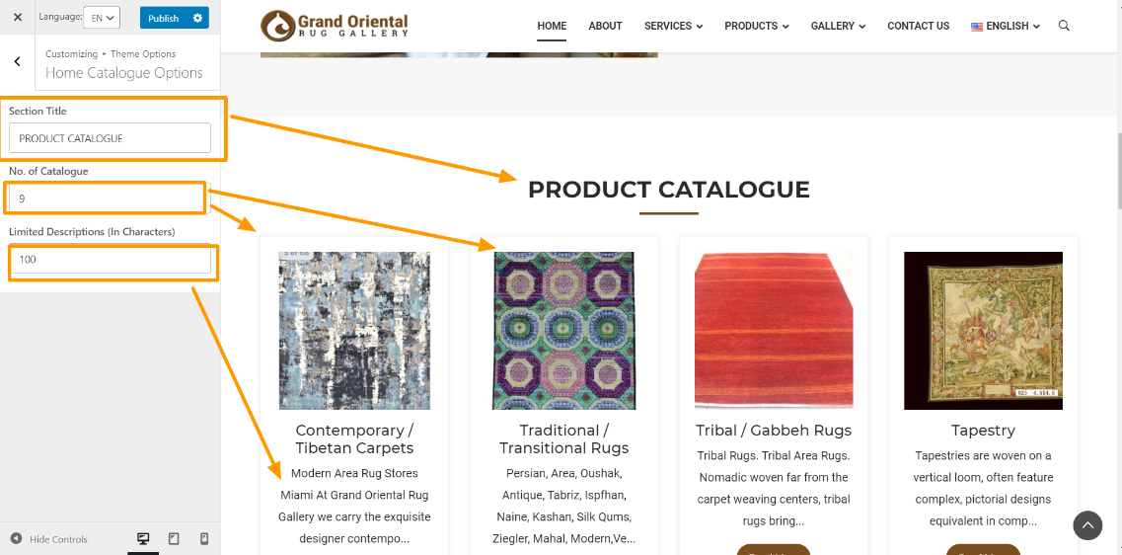

1. **Homepage Featured Product**

**Video Link->** <https://youtu.be/b9R8GSY4y0c>

* Log in to your WordPress Administration Screen (Dashboard).
* Click the ‘Products’ Tab.
* Click on the ‘All Products’ sub-tab.
* Find the product you would like to feature and click the Featured Star. Featured products will have the star icon filled in.



1. **Homepage Testimonials Section**

**Video Link->**<https://youtu.be/6jtqfp_sa3Q>

* Log in to your WordPress Administration Screen (Dashboard).
* Click the ‘Testimonials’ Tab.
* Click on the ‘Add New’ sub-tab or edit the existing testimonials.

**For the Section Title:**

* Go to the ‘appearance’ Tab.
* Click the ‘customizer’ sub-tab.
* Go to the ‘Theme Options’ & find the ‘Home Testimonial options’ section.

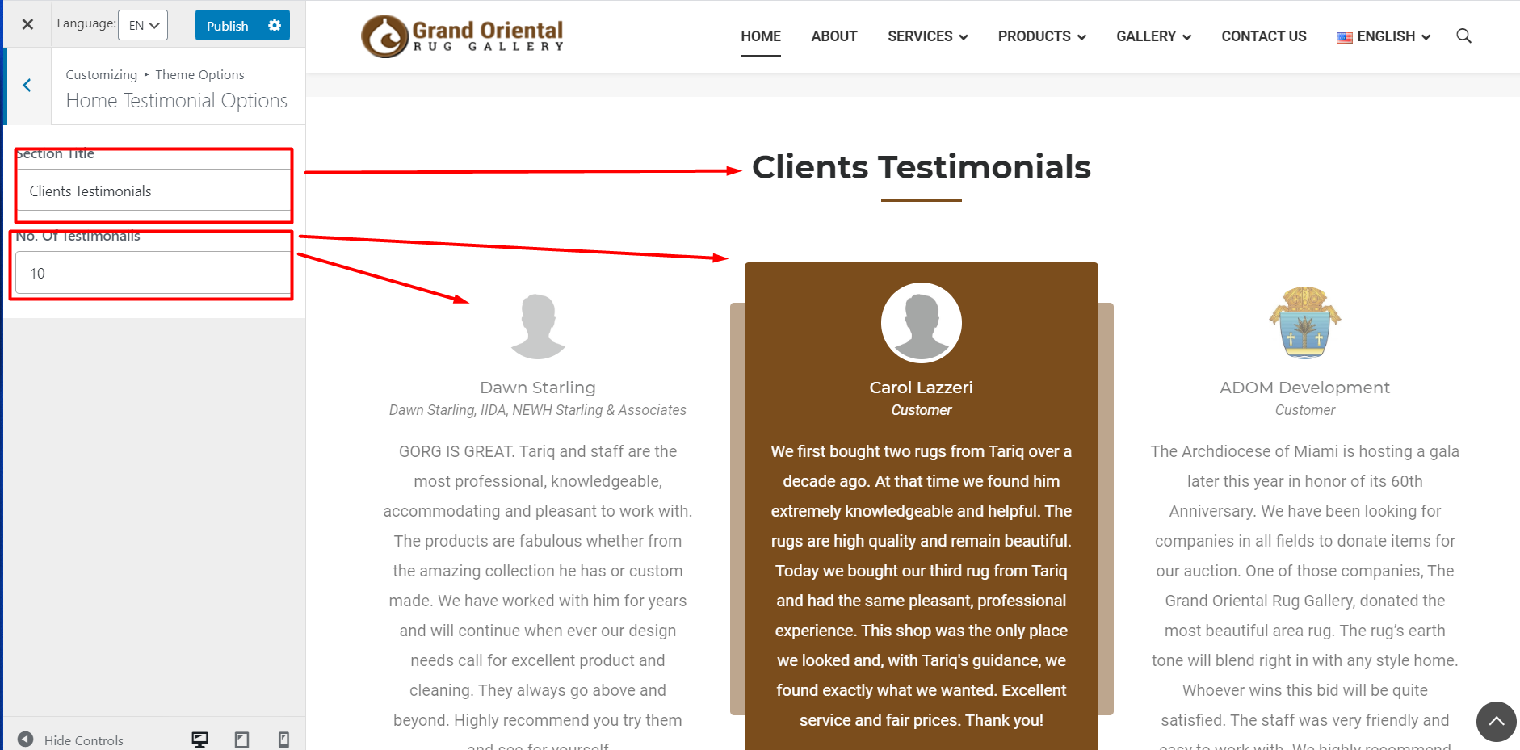

1. **Homepage Contact form & Google Map**

**Video Link->** <https://youtu.be/ImaH2WOK1-E>

**-Contact Form**

* Log in to your WordPress Administration Screen (Dashboard).
* Click the **‘Contact’** Tab.
* Click on the **‘Contact form’** sub-tab.

**-Google Map**

* Go to the **‘appearance’** Tab.
* Click the **‘customizer’** sub-tab.
* Go to the **‘Theme Options->Contact Us options’** section.
* Find the **‘Google Map Iframe’** textarea section.

1. **All Footer Section**

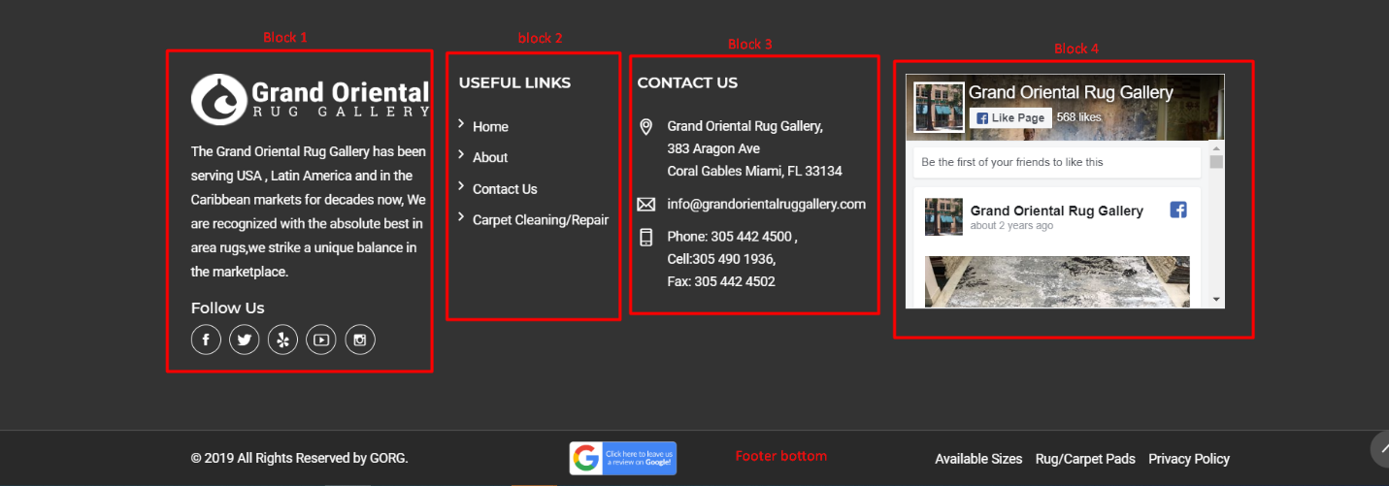

**Video Link->** <https://youtu.be/VdFF4R4QU10>

* 1. **Footer Block 1**
* Go to the **‘appearance’** Tab.
* Click the **‘customizer’** sub-tab.
* Go to the **‘Theme Options->Footer options’** section.
  1. **Footer Block 2**
* First, go to the **‘appearance->menus’** Tab.
* Create a New Menu and save it.
* Then, go to the **appearance->widgets** section.
* Find the **footer quick links** widgets section and select the **Navigation** **Menu** widget from the left **available widgets** area on this section.
  1. **Footer block 3**
* Go to the **‘appearance’** Tab.
* Click the **‘customizer’** sub-tab.
* Go to the **‘Theme Options->Contact us options’** section.
  1. **Fooger block 4**
* go to the **appearance->widgets** section.
* Find the **footer Facebook** widget area.
  1. **Footer Bottom**

-You can change the **footer copy right text** and **google review image with link** from:

* Go to the **‘appearance’** Tab.
* Click the **‘customizer’** sub-tab.
* Go to the **‘Theme Options->Footer options’** section.

-For add/edit the **footer bottom** menu:

* First, go to the **‘appearance->menus’** Tab.
* Create a New Menu and save it.
* Then, go to the **appearance->widgets** section.
* Find the **footer bottom menu** widgets section and select the **Navigation** **Menu** widget from the left **available widgets** area on this section.

1. **Header & Footer Social Links**

**Video Link->** <https://youtu.be/e_HpudEqm-8>

* Go to the **‘appearance’** Tab.
* Click the **‘customizer’** sub-tab.
* Go to the **‘Theme Options->social media options’** section.

1. **Header Logo & Menus**

**Video Link->** <https://youtu.be/VfE8fbmwO5U>

* Header Logo
* Go to the **‘appearance’** Tab.
* Click the **‘customizer’** sub-tab.
* Go to the **‘Site Identity’** section.
* Header Menus
* Go to the **‘appearance->menus’** Tab.
* Select the ‘Main menu’.

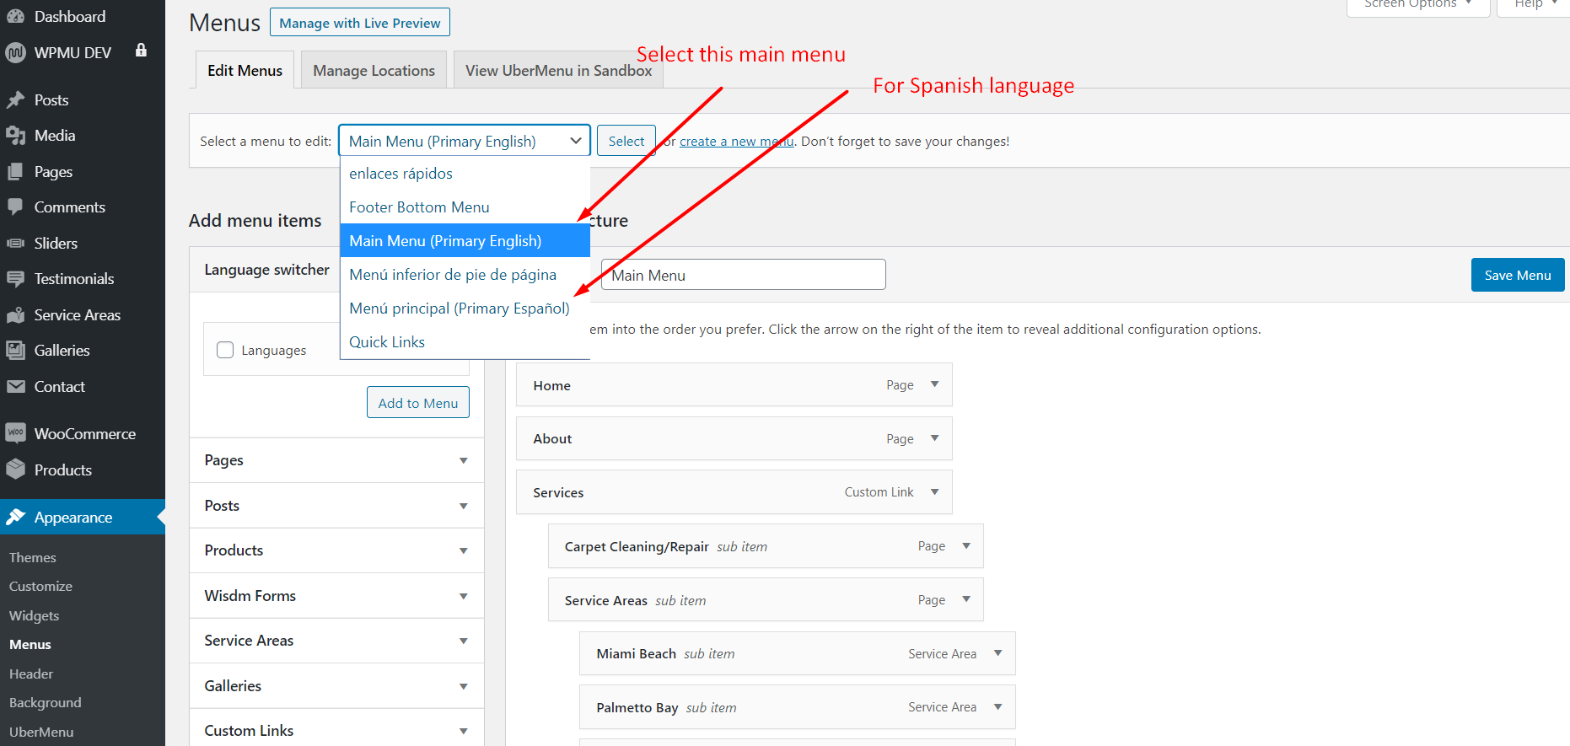

1. **About Us Page**

**Video Link->**<https://youtu.be/7V6VwjL76gc>

* Go to the **‘Pages’** Tab.
* Find & Edit the **about** page.
* Finally, click on the **update** button.

1. **Services- Carpet Cleaning/Repair**

**Video Link->** <https://youtu.be/8vGEmjr2lL4>

* Go to the **‘Pages’** Tab.
* Find & Edit the **carpet cleaning/repair** page.
* Finally, click on the **update** button.

1. **Services-Service Areas**

**Video Link->** <https://youtu.be/h91lr2wzFGo>

* Go to the **‘Service Areas’** Tab on the left sidebar.
* You can add the new service areas by clicking on the **‘Add New’** sub-tab or you can edit the existing **Service areas**.

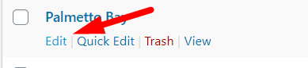

* Finally, click on the **Publish/Update** button.

1. **Add/Update Products**

**Video Link->**<https://youtu.be/M_t1wVhBW8U>

* Go to the **‘Products’** Tab.
* Click the **‘Add New’** sub-tab or Edit the Existing Products.
* Enter the Product title, description & price and Upload the **Product Image**.
* Finally, click on the **Publish/update** button.

1. **Product Attributes & Tags**

**Video Link->** <https://youtu.be/kYKcjYMd4E8>

-Go to Products > Attributes to add, edit, and remove attributes. Official Documentation of **Product Attributes** [Here](https://docs.woocommerce.com/document/managing-product-taxonomies/#section-8) .

1. **Products Filter Sidebar on Product Page**

**Video Link->** <https://youtu.be/kghxtG-SjlY>

-Go to the Official Documentation of **Product Filter** Plugin. [Click Here](https://docs.woocommerce.com/document/product-filters/).

1. **Gallery Page**

**Video Link->**<https://youtu.be/j0pVE_8dAAY>

* Go to the **‘Galleries’** Tab.
* Click the **‘Add New’** sub-tab or Edit the Existing Gallery.
* Enter the Gallery title on the upper field and Upload/remove the gallery Images on the **Gallery Options** Section.
* You can input image caption/alt tag/description etc. by clicking the single image.

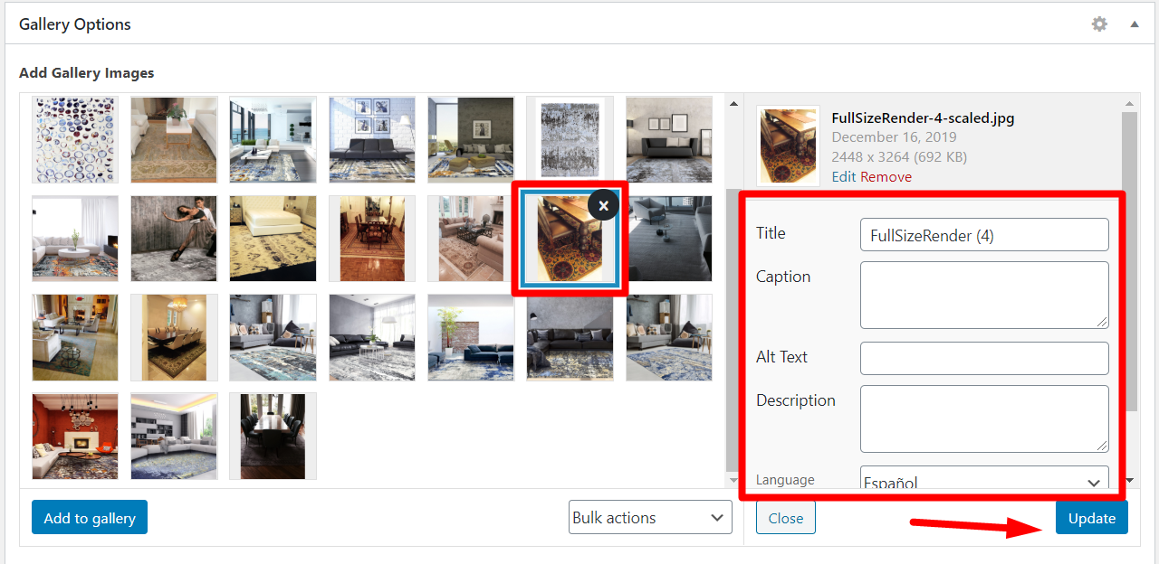

* Finally, click on the **Publish/update** button.

1. **Contact Page**

**Video Link->** <https://youtu.be/LZGppcgjnX8>

* Go to the **‘appearance’** Tab.
* Click the **‘customizer’** sub-tab.
* Go to the **‘Theme Options->contact us options’** section. Here are the all contact information about GORG.