**Steps to follow for Debugging in the Dev-C++**

**Step 1:** Choose tools menu, click compiler options

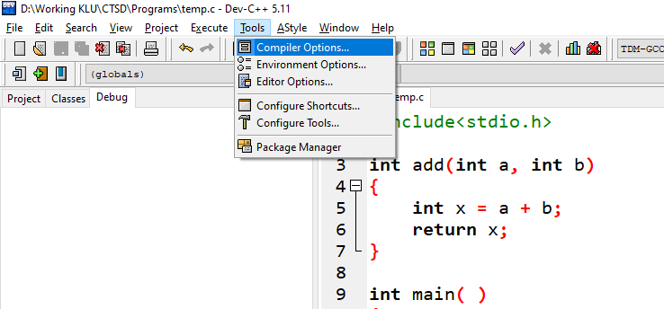

**Step 2:** Choose **TDM-GCC 4.9.2 64-bit Debug** from drop down list. Click the two checkboxes and type **–g** in the textbox as shown in the figure. Then click ok.

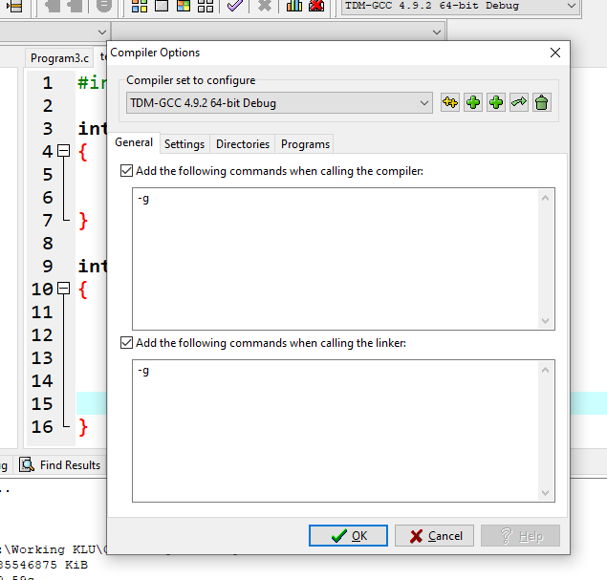

**Step 3**: I like to add check point for variable **x** and **ans** in the given code.

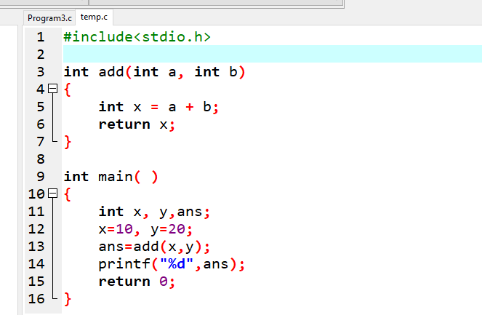

Click the line number 5 and 13. A red line will appear as shown in the figure below.

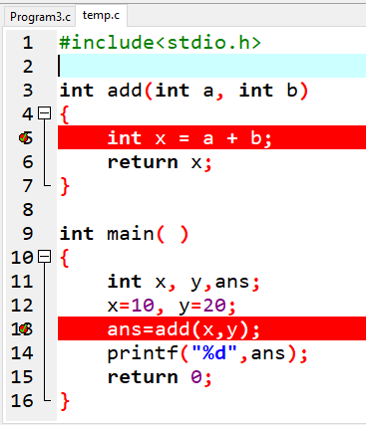

**Step 4:** On the right side, in the project explorer, right click on debug tab. An **Add watch** menu will appear. Click it.

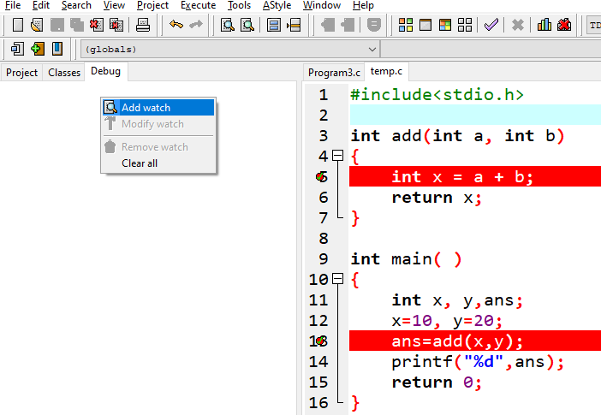

**Step 5:** A pop up menu will appear. Type the variable name you want to watch. Here it is **x** and **ans** variable.

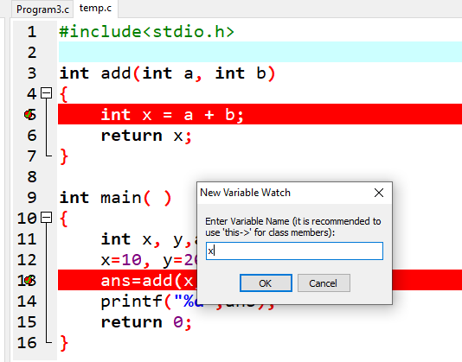

**Step 6:** After including **x and ans** variable, the debug menu tab will look as given below.

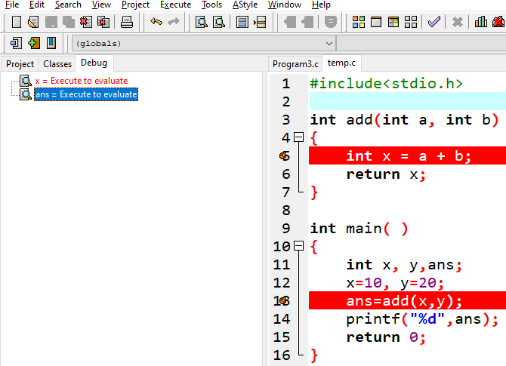

**Step 7**: click debug button, the x value will be changed as given below in the debug tab.

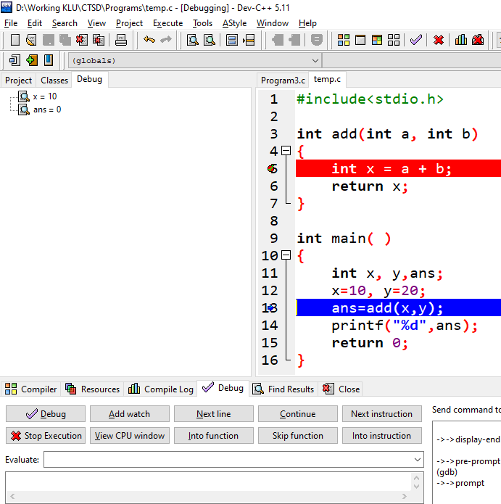

**Step 8:** you can click the next line button for line by line execution till the end of the program. Here, blue line indicates current line execution.

