SAFERTEK BACKEND WITH ALL QUERIES AND OUTPUT SCREENSHOTS

2100030888

M.N.D.Praveen

INSERTING DATA

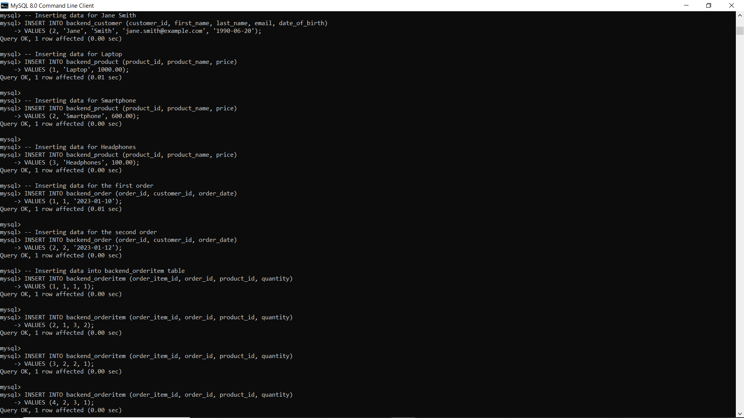

**ALL Queries**

1 = >

SELECT * FROM backend_customer;

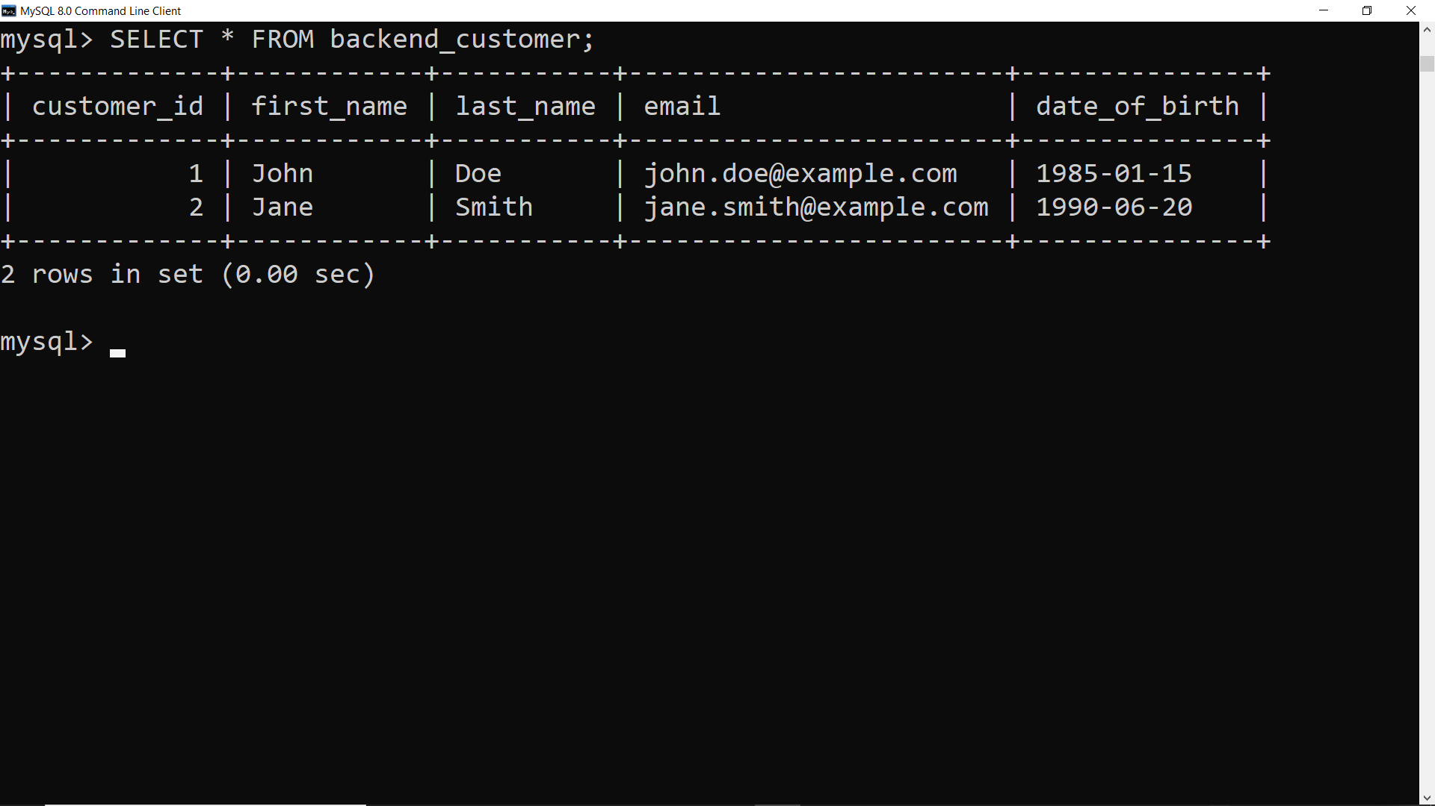

2 = >

SELECT * FROM backend_order WHERE order_date BETWEEN '2023-01-01' AND '2023-01-31';

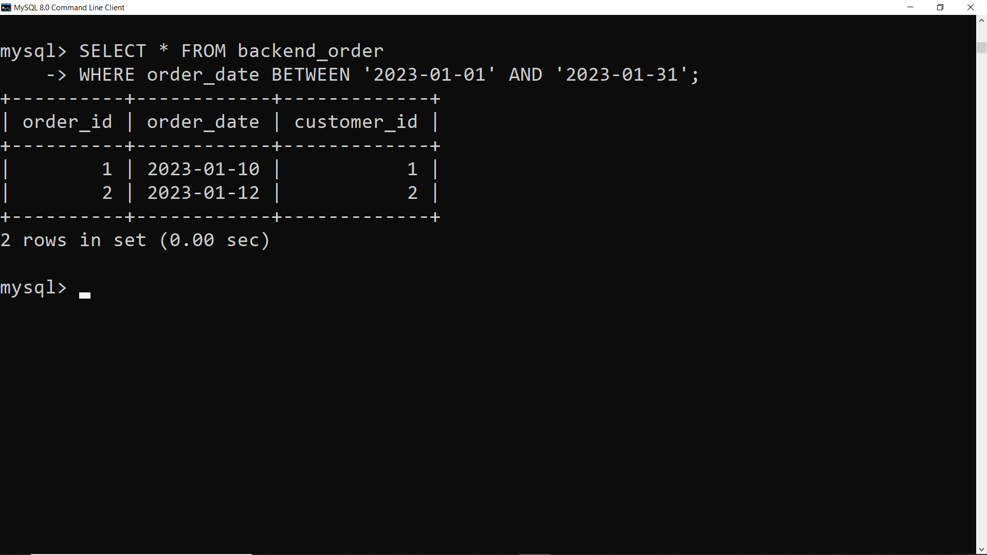

3 = >

SELECT backend_order.order_id, backend_order.order_date, backend_customer.first_name, backend_customer.last_name, backend_customer.email

FROM backend_order

JOIN backend_customer ON backend_order.customer_id = backend_customer.customer_id;  
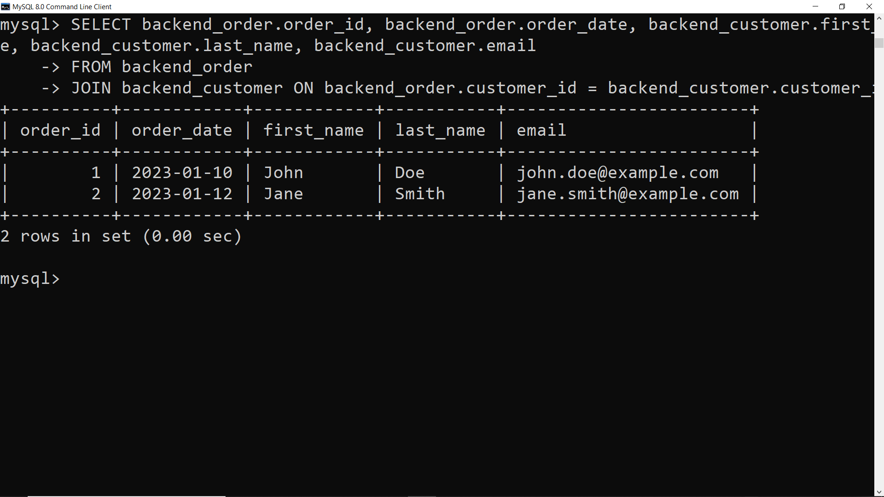

4 = >

SELECT backend_customer.customer_id, backend_customer.first_name, backend_customer.last_name,

SUM(backend_product.price * backend_orderitem.quantity) AS TotalSpent

FROM backend_customer

JOIN backend_order ON backend_customer.customer_id = backend_order.customer_id

JOIN backend_orderitem ON backend_order.order_id = backend_orderitem.order_id

JOIN backend_product ON backend_orderitem.product_id = backend_product.product_id

GROUP BY backend_customer.customer_id, backend_customer.first_name, backend_customer.last_name;

5 = >

SELECT backend_customer.customer_id, backend_customer.first_name, backend_customer.last_name,

SUM(backend_product.price * backend_orderitem.quantity) AS TotalSpent

FROM backend_customer

JOIN backend_order ON backend_customer.customer_id = backend_order.customer_id

JOIN backend_orderitem ON backend_order.order_id = backend_orderitem.order_id

JOIN backend_product ON backend_orderitem.product_id = backend_product.product_id

GROUP BY backend_customer.customer_id, backend_customer.first_name, backend_customer.last_name;

6= >

SELECT backend_product.product_id, backend_product.product_name,

SUM(backend_orderitem.quantity) AS TotalOrdered

FROM backend_orderitem

JOIN backend_product ON backend_orderitem.product_id = backend_product.product_id

GROUP BY backend_product.product_id, backend_product.product_name

ORDER BY TotalOrdered DESC

LIMIT 1;

7=>

SELECT DATE_FORMAT(order_date, '%Y-%m') AS Month,

COUNT(*) AS TotalOrders,

SUM(backend_product.price * backend_orderitem.quantity) AS TotalSales

FROM backend_order

JOIN backend_orderitem ON backend_order.order_id = backend_orderitem.order_id

JOIN backend_product ON backend_orderitem.product_id = backend_product.product_id

WHERE YEAR(order_date) = 2023

GROUP BY Month;

8=>

SELECT backend_customer.customer_id, backend_customer.first_name, backend_customer.last_name,

SUM(backend_product.price * backend_orderitem.quantity) AS TotalSpent

FROM backend_customer

JOIN backend_order ON backend_customer.customer_id = backend_order.customer_id

JOIN backend_orderitem ON backend_order.order_id = backend_orderitem.order_id

JOIN backend_product ON backend_orderitem.product_id = backend_product.product_id

GROUP BY backend_customer.customer_id, backend_customer.first_name, backend_customer.last_name

HAVING TotalSpent > 1000;

